Russia and Ukraine January Prayer Focus
Wednesday – 1
Please pray for the health of Halyna from FEBC-Ukraine’s Helpline – she was diagnosed with cancer, and is currently undergoing chemotherapy.

Thursday – 2
Please pray for listeners like Turar, from Kazakhstan, who heard the Gospel through FEBC-Kazakhstan’s TikTok programs. “Could you send me a Bible? I want to find out more,” said Turar. “I used to be a devoted Muslim, and even a minister in a mosque. But after a while, I realized there was no truth there, so I turned away from Islam. Now I am looking for the true path.” Turar is speaking regularly with FEBC’s broadcasters about Jesus and Christianity. Please pray for him to see the truth of the Gospel and to put his faith in Christ.

Friday – 3
Please pray for FEBC-Moldova’s new children's program. This is a new project that is already receiving a great response from listeners. Please pray for many children to become “friends with Jesus” through these programs and for God’s leading as we develop this project further.
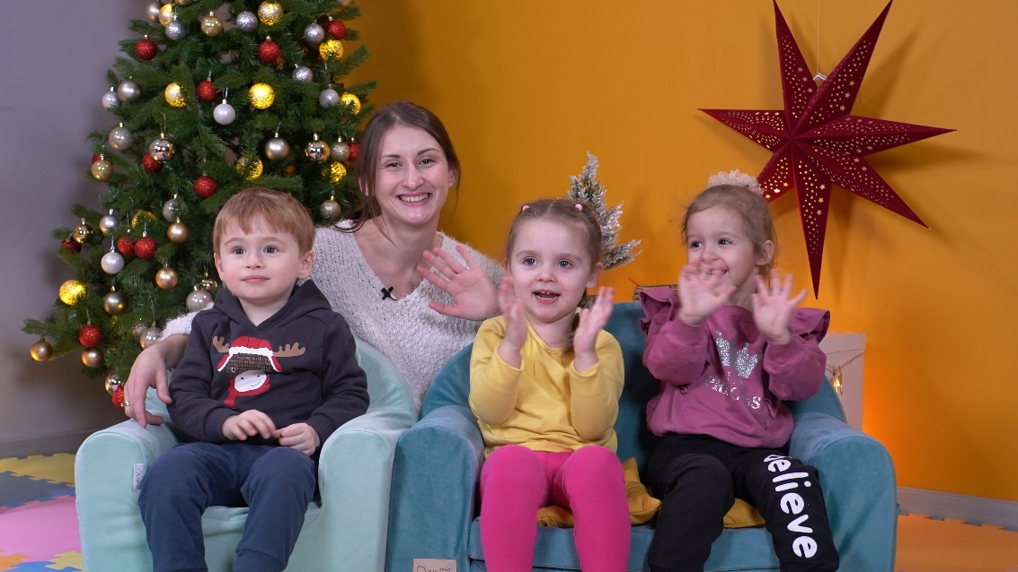

Saturday – 4
“Hi! I’m looking for a church that I could go to, could you help me?” said Artem, when he called FEBC-Ukraine’s helpline. FEBC’s prayer counselor was very excited to hear this, because Artem had called the helpline a month earlier, wanting to end his life. Please pray for listeners like Artem, who are receiving prayer and support in their most desperate moments. Please pray for Artem to come to know Jesus and place his faith in Him.
Sunday – 5
Please pray for FEBC-Russia’s ministry to local ethnic minorities, such as the Buryat people. We partner with local broadcasters and pastors to create videos that share the Gospel in accessible ways. These communities are facing real consequences from the war in Ukraine, as many people from these regions enlisted because of economic problems.

Monday – 6
Please pray for listeners from Kazakhstan, like Erlan. FEBC-Kazakhstan’s team recently travelled to his city, where they were able to meet with Erlan and other listeners they had been in contact with. We gave him a Bible and prayed with him. Erlan is currently searching for the truth, and is experiencing persecution from Muslims around him. Please pray for strength and for him to come to faith in the Lord.

Tuesday – 7
Please pray for Vika and Katya from FEBC-Ukraine’s Helpline, who are both pregnant. Please pray for the health of the mothers and their babies.

Wednesday – 8
Please pray for listeners like Oleg, who was depressed, drunk, and suicidal after his wife divorced him. “I don’t want to hear about God,” he said when he called FEBC. “I don’t believe in God. He can’t help me. But fine, you can pray for me.” After FEBC’s prayer counselor prayed, Oleg was no longer feeling suicidal, and even smiled. “Thank you, thank you so much. You really helped me.” Please pray for Oleg to come to the saving knowledge of Jesus Christ.

Thursday – 9
FEBC-Moldova’s vloggers are having a great impact on viewers, reaching them with the message of Christ in an easily accessible way, and following up with conversations with viewers who have questions about Jesus. Please pray for this part of the ministry to continue to grow, and that the Lord brings the right people to the ministry.
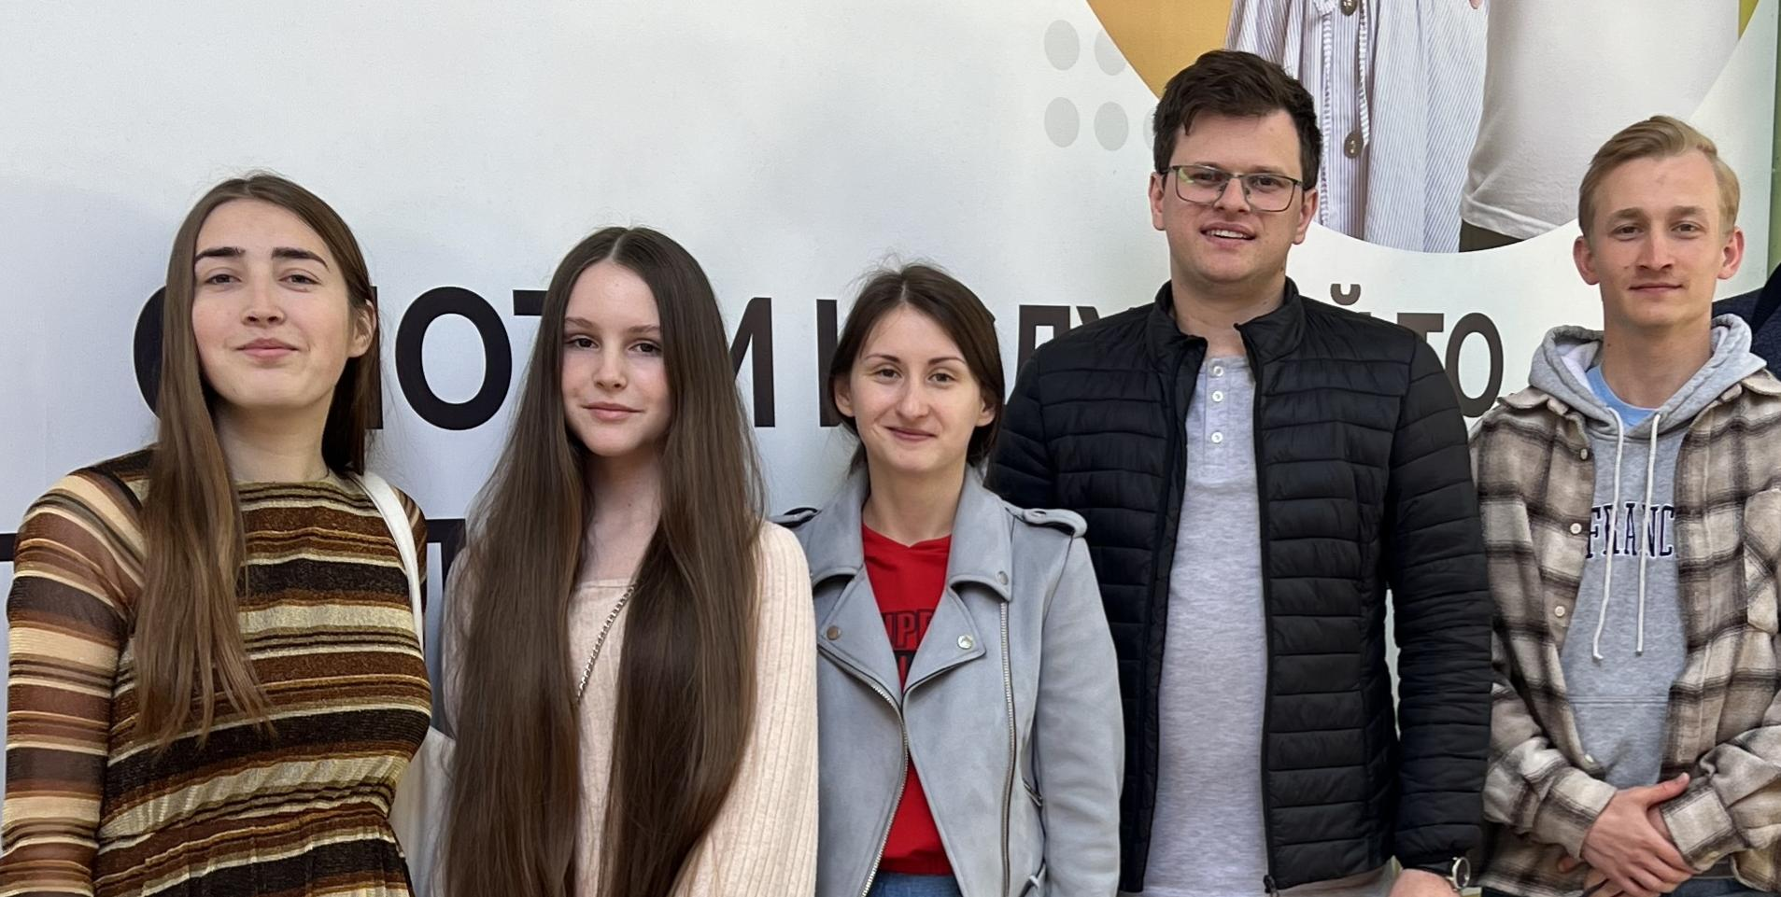

Friday – 10
“I’ve lost everything,” said Artem. “The military sent me home. Nobody needs me.” Artem felt hopeless, and reached out to FEBC-Ukraine for help. “Yes, could we please pray together?” said Artem excitedly when FEBC’s follow-up counselor suggested it. Artem prayed eagerly. Please pray for listeners like Artem, who feel a deep spiritual need for God, often without realizing it. Please pray for Artem to give his life to Jesus.

Saturday – 11
Please pray for the protection of FEBC-Ukraine’s team members (cities are currently experiencing heavy shelling). Please also pray for a mild winter in Ukraine, so that people can heat their homes and have a steady power supply (for no heavy shelling or frequent power outages). And please pray for the Ukrainian soldiers, who have to face the brunt of any bad weather.

Sunday – 12
Please pray for FEBC-Moldova’s teen meetings, where local non-Christian teens come together to meet FEBC-Moldova’s broadcasters and experience the community which is so lacking in their lives. They hear the Gospel message at these meetings, have Bible studies, and are able to have deeper personal conversations with FEBC’s broadcasters. Teens are beginning to attend church services, reading the Bible and praying, and are giving their lives to Christ. Please pray for God to move powerfully among the youth in Moldova.
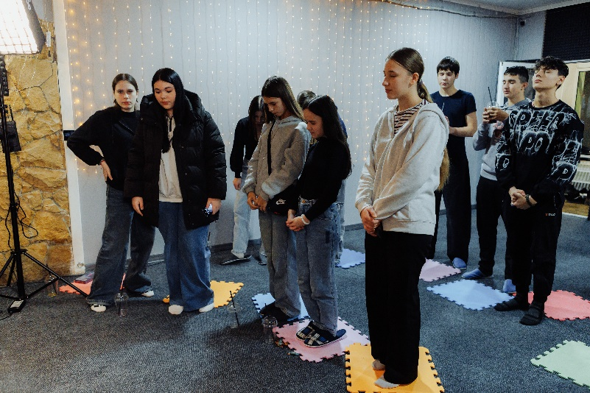

Monday – 13
“I told my mom that I was going to kill myself,” said Elena. “I didn’t mean it, we were arguing. But after I said it, I couldn’t stop thinking about it.” Elena had been depressed for some time, and grew up in a difficult household. “I’m so thankful for you,” Elena said. I’ve learned a lot—suicide is a sin, but God saves. Thank you for teaching me how to pray.” Please pray for Elena as she begins her journey towards Christ and seeks further help.

Tuesday – 14
Please pray for God to perform a miracle – to bring a swift end of the war in Ukraine. Please pray for the return of all prisoners of war. The brother of one of our team members is currently in captivity.

Wednesday – 15
Please pray for a new Bible project being developed for young people in Moldova. Please pray for Arsenie, and for God to guide FEBC’s leadership and to bring the right people to join the project.
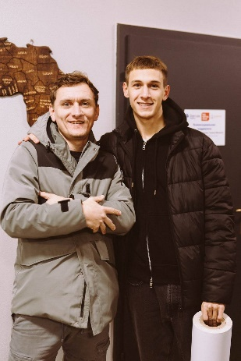

Thursday – 16
“Thank you for being with me during the darkest time of my life,” said Karina, a teenage girl from Ukraine. Karina was in the hospital after a suicide attempt. “I am in such a better place,” she said. She read a poem that she had written about God’s love to FEBC’s prayer counselor. “Thank you for sharing God’s love with me. Now I know that He is always with me.” Please pray for Karina and for other teens who are struggling with depression and hopelessness, much more common since the war began.

Friday – 17
Please pray for Roman, the husband of our follow-up worker Nataly in Ukraine. Please pray for his physical and psychological recovery after being wounded at the frontlines. Please also pray for the daughter of our broadcaster, Andriy, who is undergoing treatment abroad.

Saturday – 18
Please pray for the young members of FEBC-Kazakhstan’s team who are evangelizing other young people through social media. There is a cultural fear of Christianity in the Kazakh culture, and they receive a great deal of pushback. At the same time, many young people are seeing what the life of a Christian looks like, and are asking to visit churches. Please pray for courage, creativity, and emotional and spiritual strength for these young broadcasters.
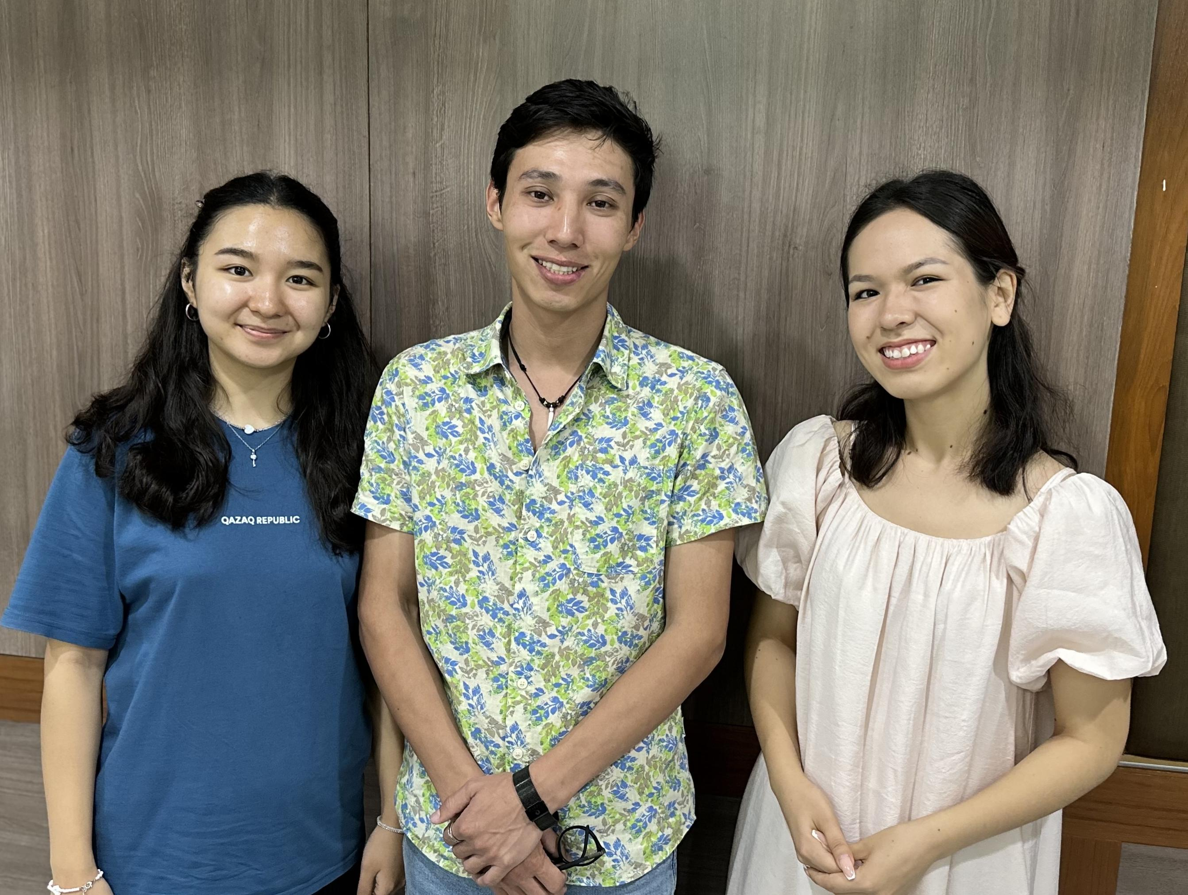

Sunday – 19
“I’m sitting on the balcony right now, smoking and thinking, ‘Should I jump, or talk to you?’” said Maksim, a Ukrainian soldier who was feeling abandoned after leaving the military. “I’ve lost so many people since the war started. The number of soldiers I’ve seen die on the battlefield…and at home, a couple of my family members also died. What’s the point?” Please pray for people like Maksim, who faced a great deal of loss in the war. Maksim prayed with FEBC’s prayer counselor. Please pray for Maksim to find hope and purpose in a relationship with Jesus.

Monday – 20
Please pray for the release of the husband of our follow-up worker Kateryna, from Ukraine, from military service. They currently have three children. According to the law, he should be demobilized, but the court keeps delaying the decision.

Tuesday – 21
Please pray for health issues among FEBC-Kazakhstan’s staff, including chronic illnesses, illness among the children of the staff, and a cancer diagnosis. We know that God is with us and continuing to bless our work, but we pray that He removes these illnesses so that we can put all of our strength into our ministry.

Wednesday – 22
“I’ve never felt like this before, I can’t seem to do anything anymore,” said a young man named Evgeny, who just went through a breakup. “I’m heartbroken. She said she doesn’t love me.” FEBC’s prayer counselors shared the Gospel with him, and Evgeny asked for them to pray for him. One of the most common problems people have when they call FEBC is relationship troubles, and many give their lives to Christ in the process. Please pray for Evgeny to put his trust in Jesus and receive healing and life from His loving Father.

Thursday – 23
Please pray for our prayer helpline ministry in Ukraine: many requests come in from people struggling with suicidal thoughts, especially teenagers. Please pray for wisdom for our follow-up workers and for God to reveal meaning in life to those who have lost it.
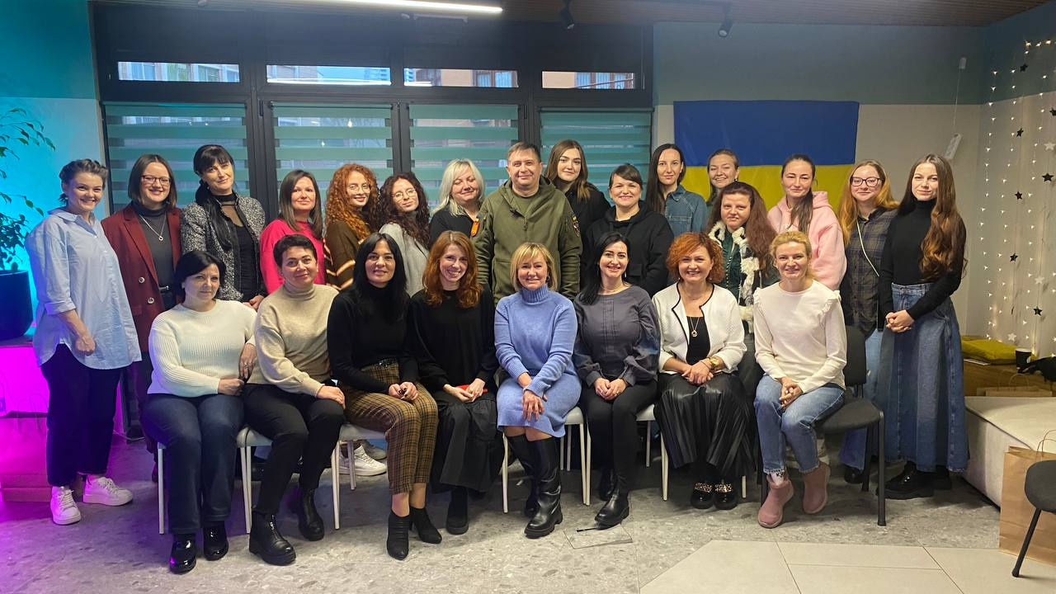

Friday – 24
Please pray for FEBC’s listeners in Kazakhstan, many of whom are hearing the Gospel for the first time. There is a great deal of resistance to the message, and threats and danger for those who even look into the faith. Please pray for the Lord to reveal His truth and love to them, especially in this Christmas season.

Saturday – 25
“I never understood what love was…if this is how God loves me,” said Inna, a wife and mother living in an abusive marriage. Inna was being abused, and this scared her. But what scared her most was the possibility of being left alone. After hearing the Gospel from FEBC’s prayer counselor, Inna was amazed by the love of God. “How could God have paid such a great price for me?” Please pray for Inna on her new journey with Christ and for His leading in her situation as she continues to seek help, now with the knowledge that she is truly loved.
Sunday – 26
Please pray for FEBC-Ukraine’s in-person women’s meetings which take place in our studio. Please also pray for Inna, who hosts these meetings where these women hear the Good News and are invited to pray together.
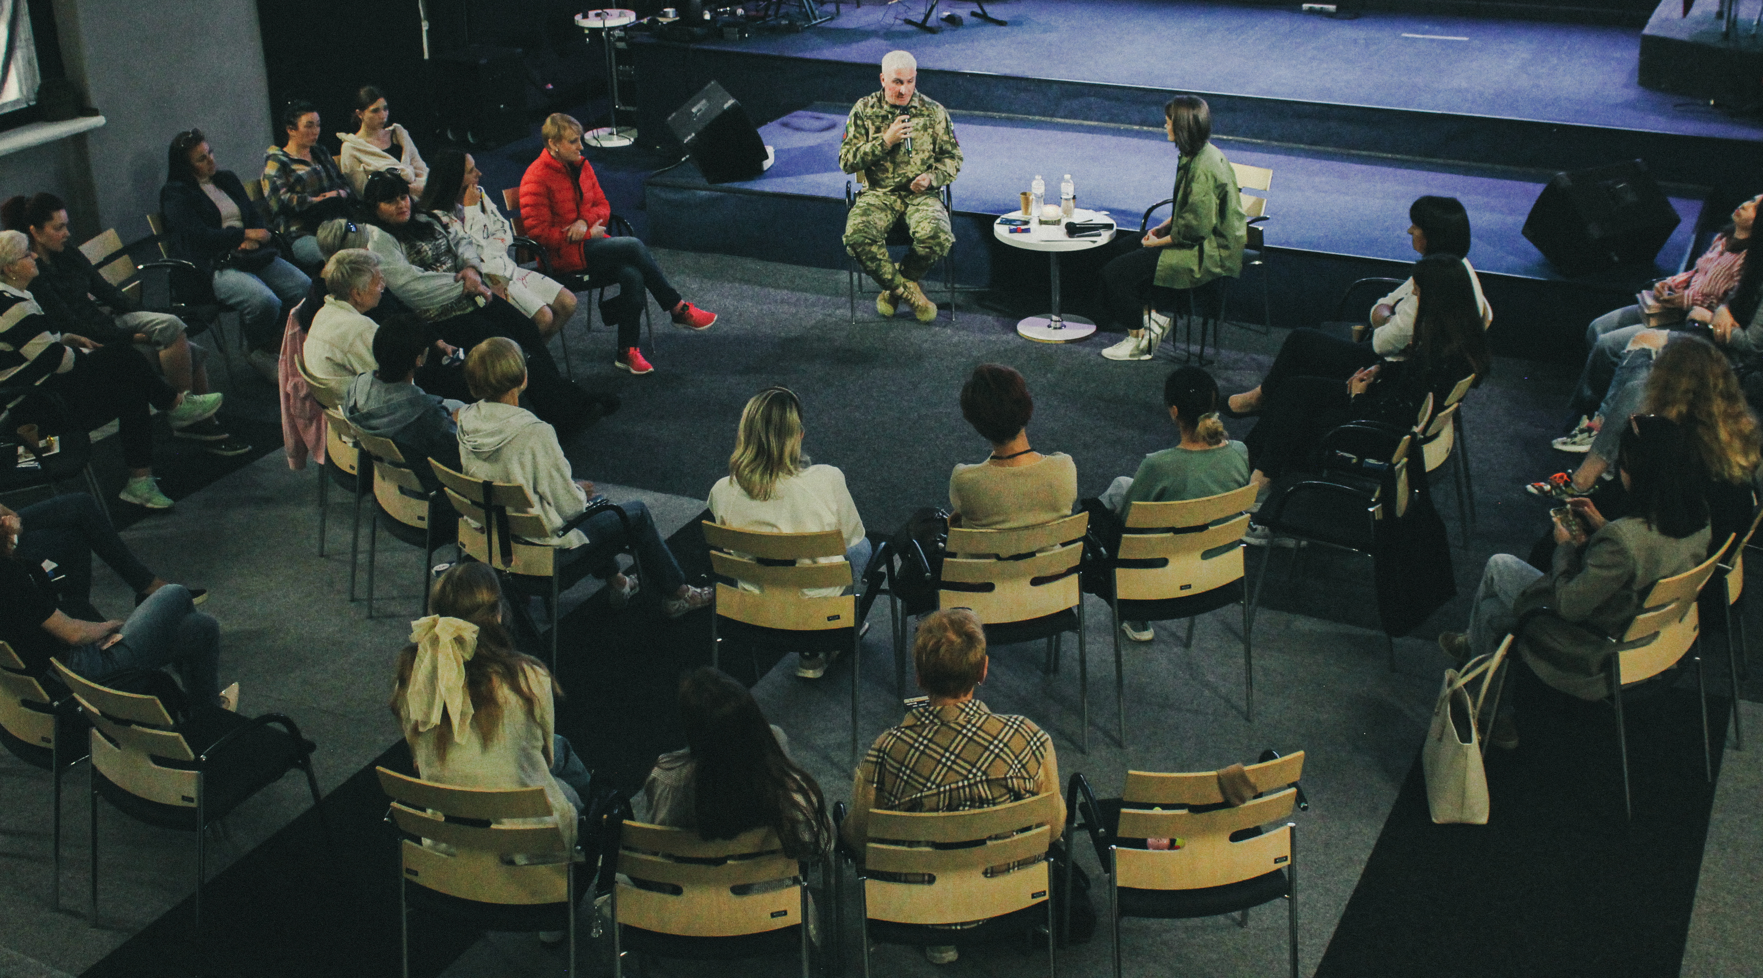

Monday – 27
A pacifistic pastor in Russia was recently arrested and charged for speaking out about the war in Ukraine. As the Russian government continues to crackdown on free speech, we are continuing to spread the Good News, seeing countless lives transformed. Please pray for the FEBC-Russia team as they find new ways to continue sharing the Gospel in these difficult times.

Tuesday – 28
“I’ve visit every Orthodox church I can, looking for God,” said Lyudmila. “I need God’s help to save my son. I see him heading in a bad direction.” FEBC’s prayer counselor shared the Gospel with Lyudmila, and when she heard about God’s love, she realized that she was the one who needed to be saved. She put her faith in Jesus, asking for God’s forgiveness. “Thank you for sharing Jesus with me! I thought I knew about Him already, but now I truly do! I believe he can save my son too!” Please pray for Lyudmila in her new walk with Christ, and for her son to come to know the Lord as well!

Wednesday – 29
Please pray for wisdom and discernment for FEBC-Ukraine’s leadership, including Eduard, Ihor, Max, Inna, among others. Please pray for the strengthening of a prayerful spirit, and for non-believing family members of the team to come to repentance.

Thursday – 30
Please pray for listeners like Sergey, who was looking for God as he struggled with his disability. “I know that Jesus is supposed to have died for our sins, but that’s all. I went to church, but I didn’t understand anything they said. I just want God to help me with my disability.” When Sergey learned that he could have a relationship with God, he prayed with FEBC’s prayer counselor, putting his faith in Jesus, and was connected with a local church. Please pray for Sergey as he begins his journey with Christ.

Friday – 31
Please pray for FEBC-Russia’s children’s programming that is currently being developed. We have seen children’s programs have a strong impact on children, who become interested in Jesus and want to “become friends” with Him. We also see parents begin to open their hearts to the Gospel through the influence of their children.

