FEBC-Eurasia April Prayer Focus
Tuesday – 1
“The last few years had left their mark on my mind,” said a listener from Ukraine named Alina. “I was full of fears and anxieties, and an obsessive fear of death was starting to take over my life. It was through you that I learned how powerful the Word of God was. That it could set my mind at ease. When I prayed to accept Christ, I felt the love of God, and my fears were finally gone.” Please pray for listeners like Alina as they begin their journeys with Christ.

Wednesday – 2
Please pray for the young people joining FEBC-Moldova’s team as vloggers for Christ. Like this young man in the middle, Christian, who is partnering with the team to reach his peers with the Gospel. “I really believe in what you are doing,” said Christian. “Thank you for helping me with advice and equipment. I really want to learn from you!”
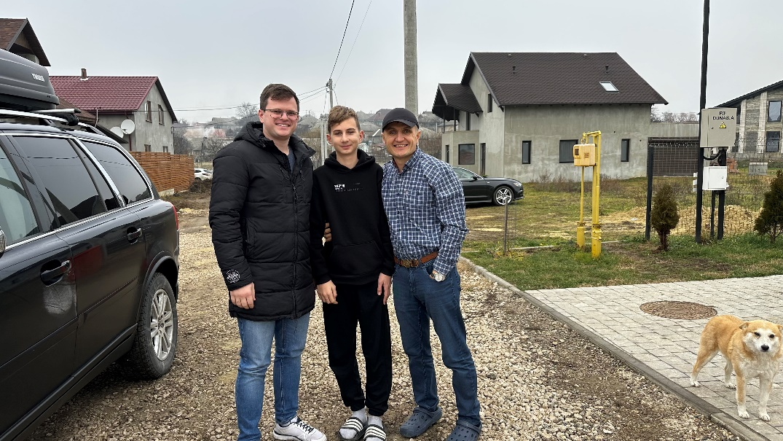

Thursday – 3
“I felt alone, abandoned. Like life itself had abandoned me,” said Vadim, a disabled man. “As I learned about God’s salvation, God’s love, my heart started to open. When I heard that He would never leave me, that He was always with me, I couldn’t handle it. It was too good to be true. Now I know that I am God’s child, and I pray to him every day. Thank you for being there for me when I felt like there was no one.”

Friday – 4
Please pray for the hosts of FEBC-Kyrgyzstan’s Bible program, Altynbek and Ilyas. They are hosting a live program where they tell the Muslim community about Jesus and teach them about the Bible.
Saturday – 5
“I am in my 60s,” said Tatiana, “and I thought I was doing okay. But my life has changed so dramatically thanks to your programs. I was able to forgive my dad, who had hurt me so long ago. For years, I held onto the pain, the bitterness. Even though he’s gone now, I remember him with love. But first, and most importantly, you introduced me to my Savior. I found faith through your programs, and now my life is completely different. Thank you from the bottom of my heart!”

Sunday – 6
Please pray for FEBC-Russia’s program promoting adoption and helping orphans. “I learned so much from your programs—all the different ways we can help the children. My husband and I are not able to adopt, but now I am volunteering with these kids. It is amazing to see them open up to the world, to begin to change. And they are so open to learning more about Jesus.”
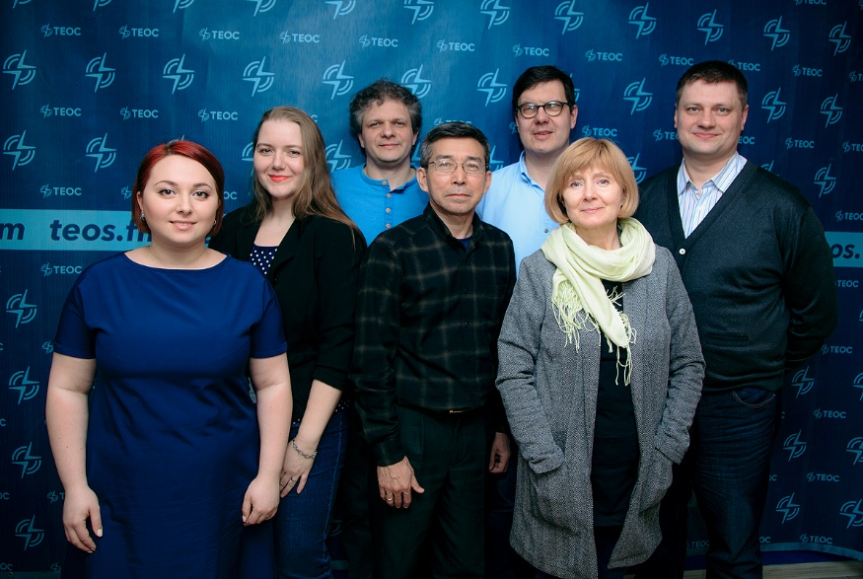

Monday – 7
A woman named Raisa called to thank FEBC for praying with her daughter, who was suicidal. “Because of your prayers, my daughter accepted Christ! Now, she reads the Bible for an hour at a time and prays to the Lord! She talks to me, and even lets herself be hugged! Thank God for your ministry! He is doing great things through you!” Please pray for FEBC’s prayer evangelists, who are helping listeners dealing with crisis situations and are leading many to the Lord. Please pray for spiritual, emotional, and physical strength for these prayer evangelists, and for the Lord to bless their families.

Tuesday – 8
Please pray for God’s comfort and support for FEBC-Kazakhstan’s youth team. These young people have a great impact on their Muslim peers who watch their videos. Many begin to ask questions about church and Christianity, and even come to church meetings to see for themselves (something that was unheard of before). Several members of the youth team are going through difficult times in their personal lives and need our support. Please join us in praying for the Lord to draw near to them and give them comfort and strength.

Wednesday – 9
“I am bedridden, and sometimes, this was unbearable. It was hard not to despair. One of the only bright spots of my life were your programs. Over time, you led me to Christ, and now, I look at the world differently. With God’s help, and your help, I am living with joy and peace.” Please pray for listeners like Borislav, who found Christ in their suffering.

Thursday – 10
Please pray for FEBC-Moldova’s follow-up team. Our volunteers are working with listener comments, sharing Christ with them and inviting them to church. And our trained helpline evangelists help listeners with more serious issues, sharing Christ’s love with them and leading many to Christ.
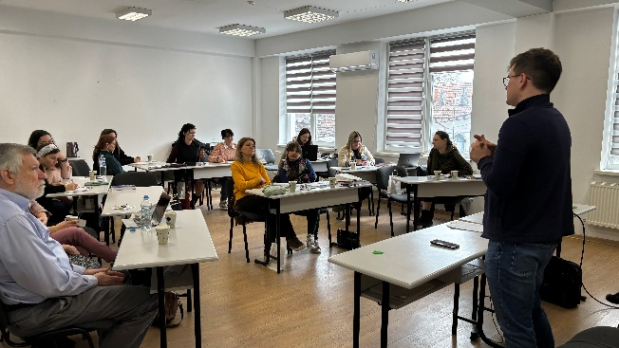

Friday – 11
“I’m just so tired,” said Artem, a man from Ukraine. “I just buried my mother. I need…I need help. That’s why I’m reaching out to you. Maybe you can do something for me.” Artem was an alcoholic, and the death of his mother was driving him to further depths of addiction. “Everything just seems so meaningless.” We prayed with Artem, sharing God’s love with him and inviting him to put his faith in Christ. “Thank you,” said Artem, crying. “I didn’t think I would ever feel this again. I didn’t think I could still feel hope.” Artem put his faith in Christ that day, and was connected with those who could help him with his addiction. Please pray for him as he begins his journey with Christ.

Saturday – 12
Please pray for the health of the director of FEBC-Kyrgyzstan, Ulanbek. He is having some heart issues. Ulanbek and his team are reaching many Muslims in Kyrgyzstan with the Gospel and the truth of the Bible.
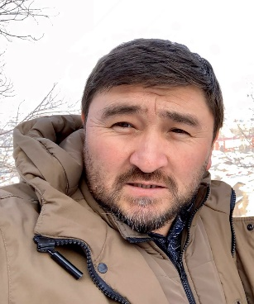

Sunday – 13
“I listen to your programs everyday while I am ironing my children’s clothes or cooking them food. No matter what I am doing, though, I always manage to write down the things you stay. They are so full of life! I believe in Allah—my whole family does—but every day, I want more and more to start believing in your God, in Jesus.” Please pray for FEBC’s Muslim listeners to break through the obstacles standing in their way and come to the saving knowledge of Jesus Christ.

Monday – 14
Please pray for the listeners who come by FEBC-Ukraine’s Kyiv studio every week to speak with broadcasters, receive prayer, and hear the Gospel. Many listeners give their lives to Christ during these “tea breaks” they have with broadcasters.
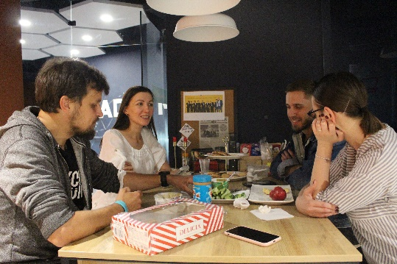

Tuesday – 15
Maira is a young married woman from the city of Kulsary, in western Kazakhstan. She converted to Christianity from Islam and now tries to attend church in her city. Her husband is Muslim, and they have a young daughter. We ask you to pray for the strengthening of her faith and for the salvation of her entire family. In western Kazakhstan, the power of Islam is very strong, and it is not easy for believers to evangelize.
Wednesday – 16
Please pray for FEBC-Moldova’s upcoming training meeting. We are building up our new team members and helping them understand our mission of inspiring people to follow Jesus through Media. Please pray for us as we learn and grow together to help us reach many in Moldova for the cause of Christ!

Thursday – 17
“My husband and I weren’t religious, but we were pretty sure there was something supernatural in the world. But as we watched your programs, we realized that there was more than just ‘something supernatural,’ there was God. We’ve even started reading the Bible together.” Please pray for couples like Irina and her husband, who are close to the faith. They are planning to come to church soon. Please pray that they come to the saving knowledge of Jesus Christ.

Friday – 18
Please pray for FEBC-Kyrgyzstan’s new project for young women who have experienced violence, loneliness, betrayal and shame. We want to introduce them to Jesus and give them hope.

Saturday – 19
“I used to live for male approval,” said Irina, a young woman from Ukraine. “At first, men show a lot of love, give gifts, spend money on me. And time after time, I was betrayed, abandoned, forgotten. But as I listened to you, I learned that there was someone who really loved me. I remember praying the prayer you said on air, repeating it word for word. Now, God is in my heart! And your programs about relationships are helping me change my life!” Please pray for Irina on her journey with Christ.

Sunday – 20
Please pray for an end to the war in Ukraine. So many lives have already been lost, and so many may still be lost. Recently, 9 young children died in an attack which killed 20 overall. Please pray for God’s hand over this war, to bring peace to the region, and to bring many people into His kingdom.
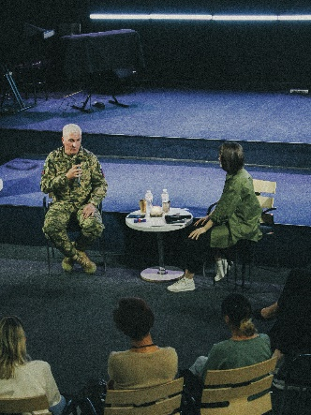
Monday – 21
Please pray for listeners like Evie, a teenager from Moldova. She, like many teenagers in Moldova, had a difficult home life, and this made it difficult for her to trust God. “I want to let God in,” she said to FEBC-Moldova’s broadcaster. “But my thoughts and fears feel too loud, too strong.” Evie has been reading the Bible with our broadcaster, and has even started coming to church. Please pray for Evie to put her faith in Jesus and begin to live her life with Him in her heart.

Tuesday – 22
“I thank God for sending me your programs,” said Ivan. “They opened my eyes to the possibility of their being God—something I had never even considered. Now, I am a Christian, and your programs are helping me grow in my relationship with Jesus. Thank you!” Please pray for listeners like Ivan who are coming to faith in Christ through FEBC-Russia’s programs.

Wednesday – 23
Please pray for FEBC-Kyrgyzstan’s ministry to Muslims as the fast of Ramadan came to an end in March. This is an important time and we are believing that many Muslims will be exposed to the Good News through our programs. This is a time when God is working. We covet your prayers!
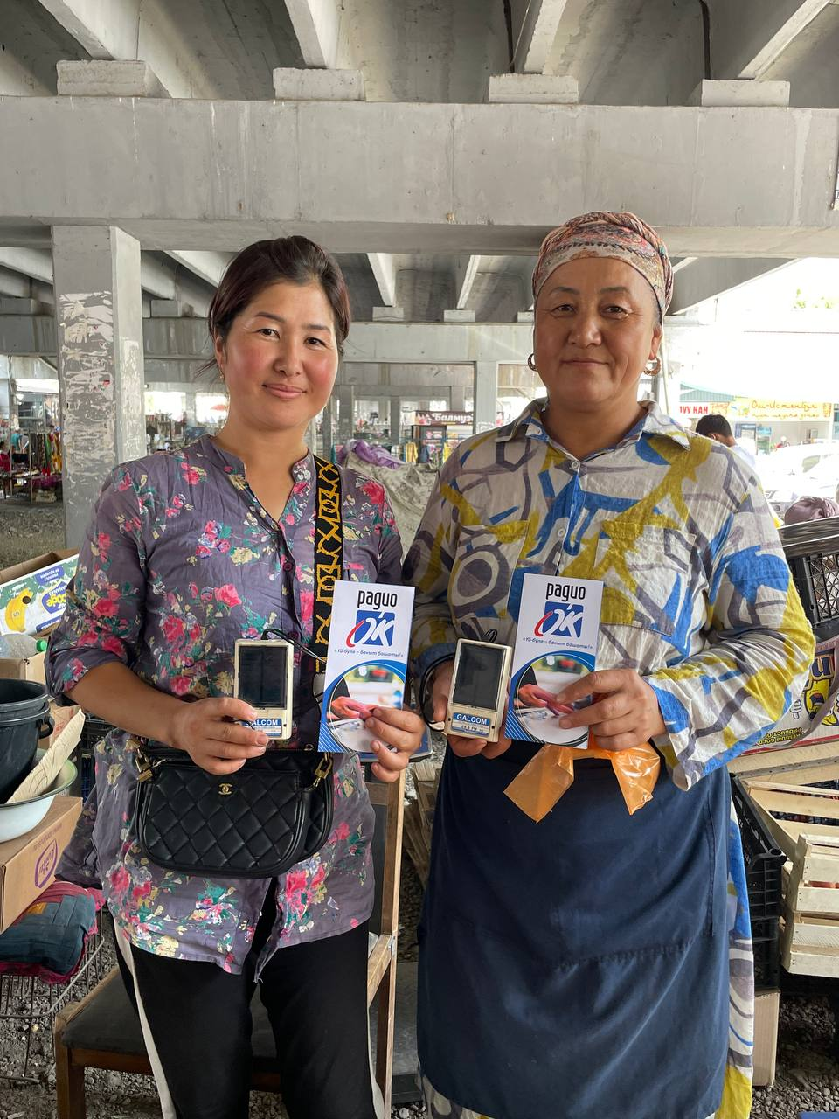

Thursday – 24
“When I first called you, it was like I couldn’t understand what you were saying. I was so upset about what had happened to me. I had been robbed by someone, and someone close to me had helped them rob me. But as you started talking about Jesus, about forgiveness, about salvation, something broke in me. I still don’t know if I can be saved. My heart is not clean, I’ve sinned so much.” Dima cried as FEBC’s prayer evangelist prayed for him. “That’s the first time someone has prayed for me. Nothing like this has ever happened to me. I want to accept Jesus—I do. But I don’t know if I can. But you have done something to me…put something into my heart. I can’t explain it. Thank you so much!” Please pray for Dima to come to the saving knowledge of Jesus Christ.

Friday – 25
Please pray for FEBC-Kazakhstan’s follow-up ministry. Many listeners write to us after hearing our programs, and the needs are so great. Abuse, hopelessness, anger, and all kinds of spiritual darkness. The people who write to us live all over Kazakhstan, and there is not always a church nearby we can send them to, making things more difficult. Please pray for our team, who wholeheartedly serve our listeners, sharing the hope of Christ with them. This is a deeply challenging ministry that they are doing.

Saturday – 26
“I have a bad stutter,” says Diana, from Moldova. “I didn’t trust doctors. They were never able to help me. So I thought I would reach out to you. Maybe God could help me if no one else could. It took a long time—talking with you about God, watching your programs—but now, I can say that I believe in Jesus as my Savior! I still have problems, but now, I look at them through the love of God. I even started to stutter less often!”

Sunday – 27
Please pray for Arthur, FEBC-Kyrgyzstan’s new team member, who will be providing technical support. He will be helping improve the quality of our radio broadcasts, monitor the uninterrupted broadcasting of our stations, update software, and set up video broadcasts. “I am honored to be joining this team! They are doing powerful things in our country, sharing the light of Christ! Please, brothers and sisters, pray for us to reach our people!”

Monday – 28
“Thank you for your programs, and your helpline,” said a former soldier from Ukraine. “I was injured in the war, and now I’m in a hospital in a different part of the country. It is like the person in me is waking up, not the soldier. I want peace—no more death. I want to preach peace. I am finding that peace through my relationship with Jesus, and I am learning what that means from you. Your spiritual support has been so important to me. Thank you, friends! Your programs, and our prayers together, have been very dear to me. I invite all my friends who are soldiers to listen to you and call you. You are changing lives.” Please pray for soldiers who are coming from the war and are in need of the healing hope of Christ.

Tuesday – 29
Please pray for Ruslan and Talgat, part of FEBC-Kazakhstan’s team, who are going on a missionary trip to the city of Atyrau. They will be meeting with some of our listeners there, and with other non-Christian’s who are looking for the truth. Please pray for the Lord’s protection and blessing on this trip.

Wednesday – 30
“I turned to an AI chat for help,” said Elena, who was dealing with grief after losing a loved one. “It couldn’t offer me anything real. When I got tired of it, the chat actually suggested I contact you. That was the best advice it could have given! I was already open to the idea of God, but I can’t say that I had any idea of how to come to Him. I didn’t know it, but my heart was ready to listen when you talked about God’s love. Thank you for praying for me and bringing me to my Father!”

