FEBC-Eurasia September Prayer Needs
Sunday – 1
Please pray for the safety of FEBC-Ukraine’s broadcasters are serving as chaplains in the military. Maxim, Sergey, Alexsandra, Ruslan, and Dmitry. And please pray for the Lord to use them to impact the lives of the soldiers around them.
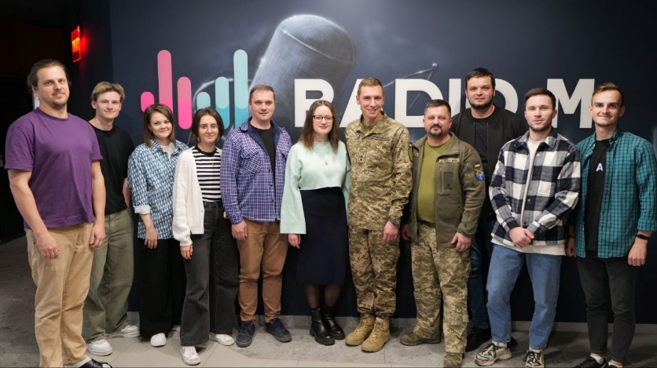

Monday – 2
Please pray for FEBC’s ministry in Kazakhstan as they work to reach the people of Kazakhstan with the Good News. Many Kazakhs believe the stereotype that if you are Kazakh, you must be Muslim. It is seen as a national identity. Please pray that they come to see Jesus as more than a prophet.

Tuesday – 3
Please pray for the health several members of FEBC-Kyrgyzstan’s team—Zulfiya, Ainura, Zarema, and Mina—and their family members, who are experiencing serious medical problems. Even in the midst of their struggles, they have continued broadcasting, sharing the Good News with their people.

Wednesday – 4
Please pray for listeners like Roman, from Russia, who responded to a video talking about alcoholism. “I feel like I’m waking up from a hangover. I’m realizing how much I’ve messed up. I’ve done things I shouldn’t have. I can feel it weighing on me—I finally realized that it’s sin. Please help me, brothers.” Roman was prayed with and connected with a rehab center where he can get further help. Please help for the many listeners who are struggling with alcoholism in Russia.

Thursday – 5
Please pray for the husband of one of FEBC-Ukraine’s prayer helpline evangelists, Roman. He was injured in the war. Please pray for his full recovery.

Friday – 6
Please pray for the new people who have joined the FEBC-Kazakhstan team to flourish and grow, bringing their passion for seeing people come to know the Lord to their programs.
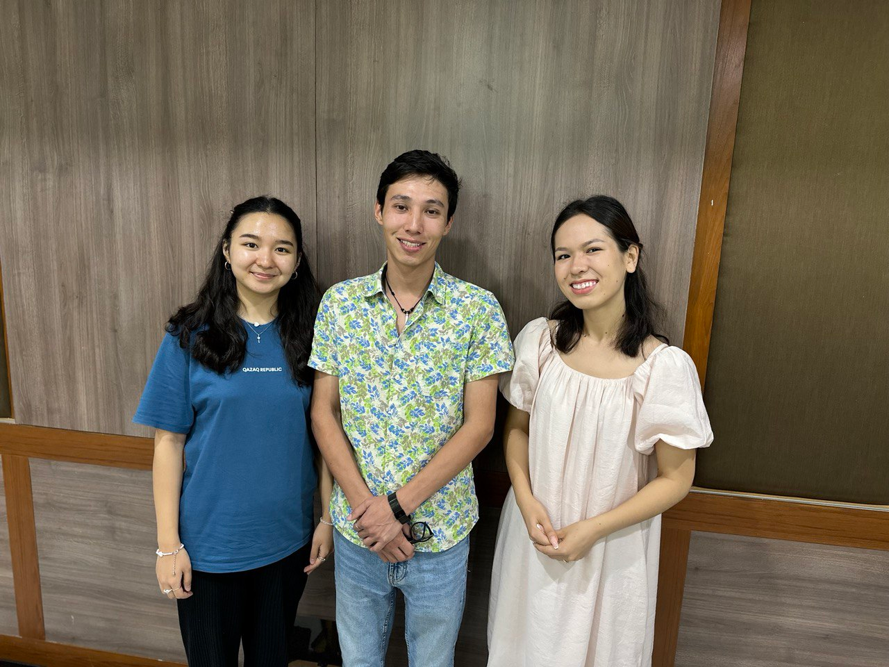

Saturday – 7
Please pray that the Lord brings the right people to join FEBC-Kyrgyzstan’s team as they look to add more broadcasters. FEBC-Kyrgyzstan has many talented female broadcasters, but there is a need for more male broadcasters. Please pray for the Lord to bring the right people to join the team.

Sunday – 8
A listener named Alena, from Russia, writes: “I’m not a Christian, but I’m interested in spirituality. I’ve been listening to your program, and I have a question. How does a relationship with God actually affect your life?” Our broadcaster shared with Alena what happens when we begin to open our hearts to God. He explained how to spiritually be born again and how this changes your life. “Thank you for telling me about your faith in God. I’m fascinated by this, and it’s so important to understand the spiritual life.” Please pray for Alena to continue seeking by reading the New Testament, as our broadcaster suggested, and that she puts her faith in Jesus.

Monday – 9
Please pray for FEBC-Ukraine’s prayer helpline evangelists, who are facing a great deal of spiritual and moral pressure. Please pray for wisdom, restoration, and renewal, so that they can continue to provide life changing outreach to FEBC’s listeners.

Tuesday – 10
Please pray for the FEBC-Kazakhstan team as they put their newly remodeled studio to work, making videos and putting on events in the studio space. This has been a powerful way to share the Gospel directly with listeners and to invite them to church.

Wednesday – 11
Please pray for FEBC-Moldova’s new children’s program, and the children who will help host the program, Erik and Emily. Many of Moldova’s youth are going through very difficult times, including poverty, hunger, parents with addictions, or absent parents. These programs share a Gospel message through Bible stories shared in engaging ways. Please pray that God works mightily in the lives of our young viewers and in their families.


Thursday – 12
Many listeners in Ukraine are being overwhelmed by the constant pressure of the war. “I’m very worried about the explosions. They keep getting closer. I’m afraid the roof will collapse soon. I used to be able to cope with this, but I can’t anymore. My strength is gone. This is overkill. I think I even scare the children myself. I can’t eat, or cook, or wash dishes anymore. I stopped taking care of myself.” FEBC’s follow-up evangelist shared about God’s love with Oksana, inviting her to put her faith in Jesus and trust God to take care of her. Oksana put her faith in Jesus. Please pray for listener like Oksana, who are being overwhelmed by the stresses of the war.

Friday – 13
Please pray for Sergey, one of FEBC Russia’s counselors, who is helping lead many people across Russia come to Christ and visit local churches. Please pray for strength and wisdom.

Saturday – 14
Please pray for the team in Ukraine as they prepare the studio for the winter. It is predicted that shelling will lead to many power outages. This can make broadcasting difficult, requiring the use of a generator.

Sunday – 15
Please pray for FEBC-Kazakhstan’s ministry to young Kazakhs. The popularity of Islam continues to increase among the youth. They are searching for something real, please pray that they find the truth of Christ as they search.

Monday – 16
Please pray for the host of FEBC-Moldova’s Bible program, Arseniy. Arseniy participates in several ministries, also working with refugees. Please pray for wisdom and strength as Arseniy produces these programs and interacts with listeners. May God draw many to Himself through this program.
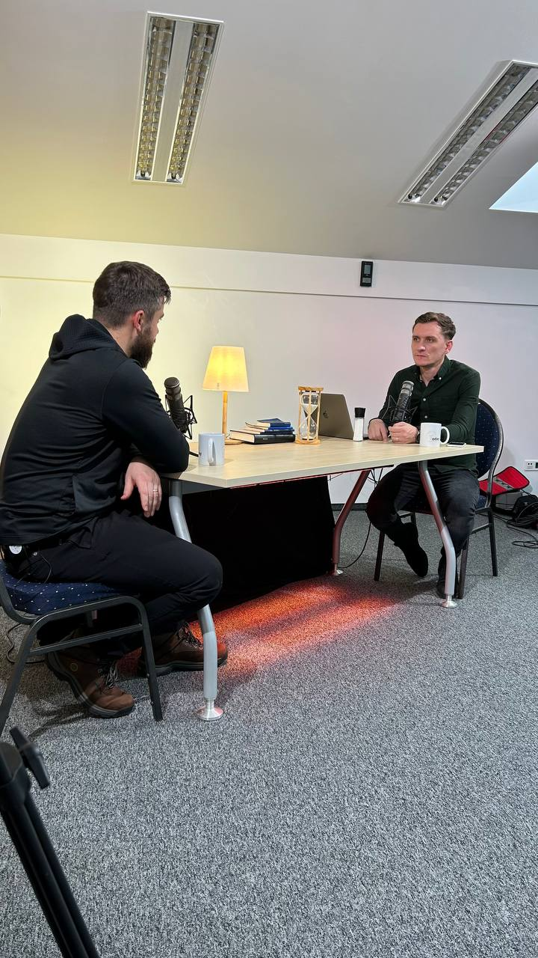

Tuesday – 17
Please pray for listeners like Marina, who called FEBC because she couldn’t overcome her guilt after having an abortion. “We didn’t have any money,” she said. “We couldn’t afford having another child. But now…I’m so filled with guilt! I even want to end my life!” We shared the Gospel with Marina, telling her about God’s love and forgiveness in Jesus. Marina prayed with us, putting her faith in Jesus. Please pray for listeners like Marina to come to a saving knowledge of Jesus Christ and receive healing from their pasts.

Wednesday – 18
Please pray for Anastasia, the head of our department of strategic placement of video materials. God is using her powerfully in Russia in these difficult circumstances. She is also helping to create a strategic plan to reach the maximum number of listeners in our new Central Asian fields. May God give her wisdom and guidance.

Thursday – 19
Please pray for a new expanded ministry to military families in Ukraine. Our volunteer chaplains and broadcasters regularly travel to meet with families in war-torn areas. As the needs are great, and continue to increase, we will now be holding more events in cities across Ukraine as well as creating more programs made with these families in mind.
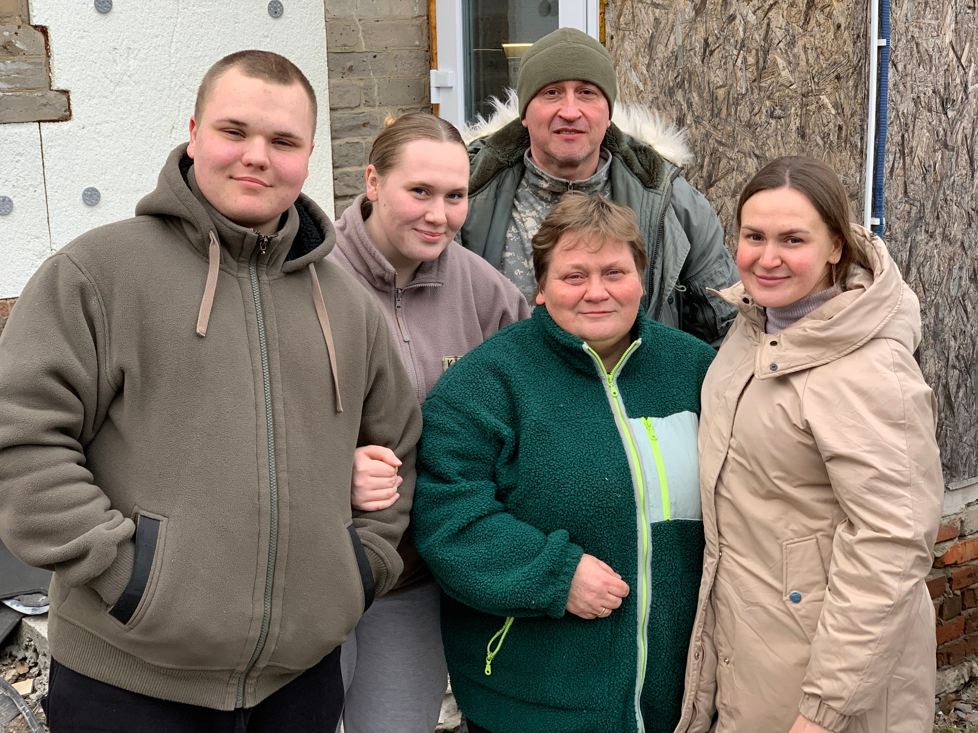

Friday – 20
Please pray for the search for a new radio technician for FEBC-Kyrgyzstan to help fix and maintain equipment at FEBC-Kyrgyzstan’s 6 FM stations.

Saturday – 21
Please pray for a massive new effort to translate FEBC-Russia’s Bible programs into other languages in the region. This includes many Muslim countries and people groups. Please pray for God’s favor and protection as we do this, since it can be dangerous to preach Christ in several of these regions.

Sunday – 22
“I love listening to your programs,” said Elena, a listener from Ukraine. “They’re so filled with light and joy! But whenever I’m not listening, I’m filled with sadness. All I want to do is cry.” Our follow-up evangelist invited Elena to put her faith in Christ. After they prayed, Elena was amazed, “I feel that same lightness and joy I felt when I was watching your programs!” Elena promised to start reading the Bible, “I’ll start today! Thank you so much! I didn’t know that I can have this same joy inside as I felt from you all!” Please pray for many more listeners in similar situations as Elena to turn to Christ and lay their burdens down before him.

Monday – 23
Please pray for Yevhen Goltsov, one of FEBC-Ukraine’s volunteer chaplains. He is serving countless soldiers and their families. He recently fractured his leg. Please pray for his quick healing.
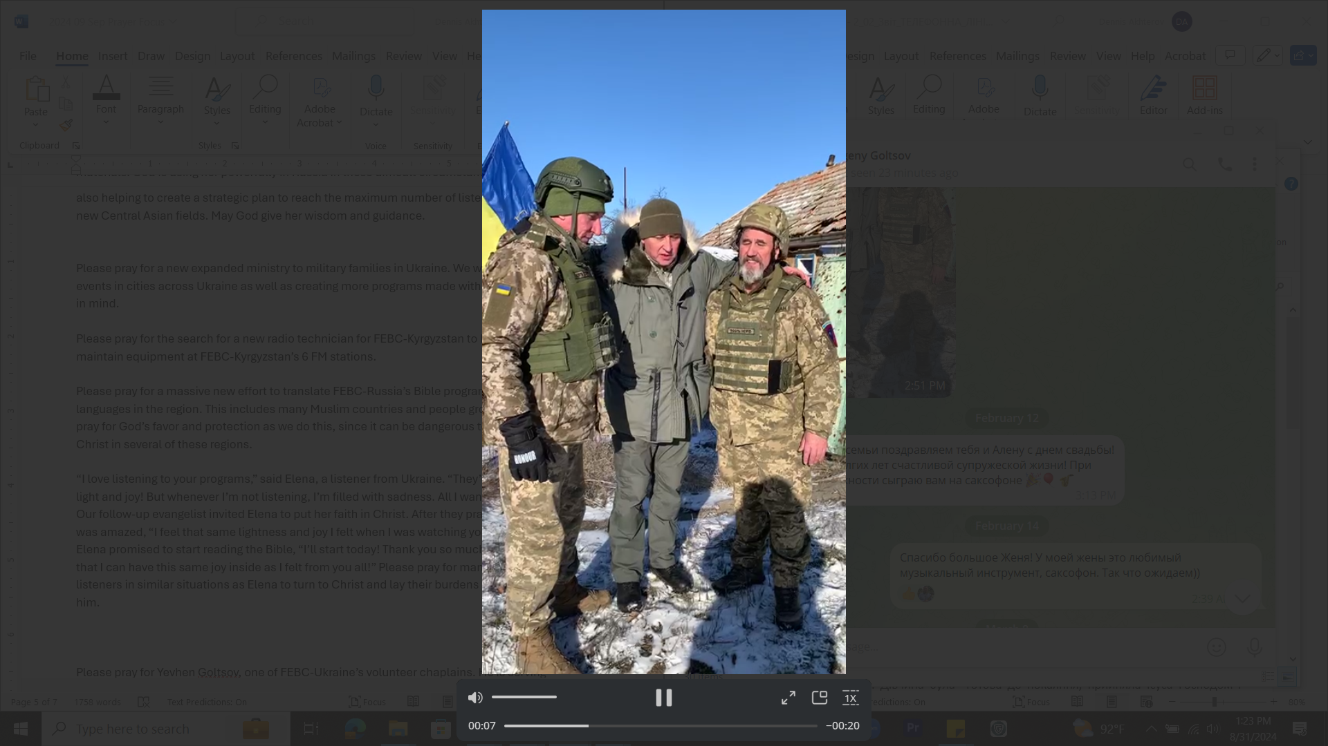

Tuesday – 24
Please pray for FEBC-Kyrgyzstan’s project producing and sharing short Bible programs online. These programs can reach a wide audience, young people are more likely to watch short videos, and Muslim viewers are more likely to see a short Bible program. These types of videos also invite responses from the audience. One-on-one interactions with listeners are very effective for evangelism.

Wednesday – 25
Please pray for the Lord to send the right people to join FEBC-Russia’s team. With the changing situation in the country, we have a new programming strategy, and are launching many new projects. Please pray that we are able to find the people with the right hearts and the right talent to join these teams.

Thursday – 26
Please pray for listeners who have had to flee their homes to escape the war in Ukraine. “I’ve had to move all over Ukraine,” said a listener named Anichka, the mother of one child. “And where I am now, there are a lot of problems. It’s all been so overwhelming. I’m having thoughts that scare me—thoughts that tell me to end my life.” After offering Anichka support and advice, our follow-up evangelist shared the Gospel with her and invited her to put her faith in Jesus. Anichka put her faith in Jesus, saying, “I feel such a lightness in my heart! Thank you so much for talking with me! And thank you for your programs!”

Friday – 27
Please pray for Iryna, from FEBC-Ukraine, whose mother is seriously ill. Please pray for God’s hand to be on them as they go through this incredibly difficult time.

Saturday – 28
Please pray for FEBC-Kyrgyzstan’s director Ulanbek, who recently experienced serious health problems. Please pray for a quick and full recovery.
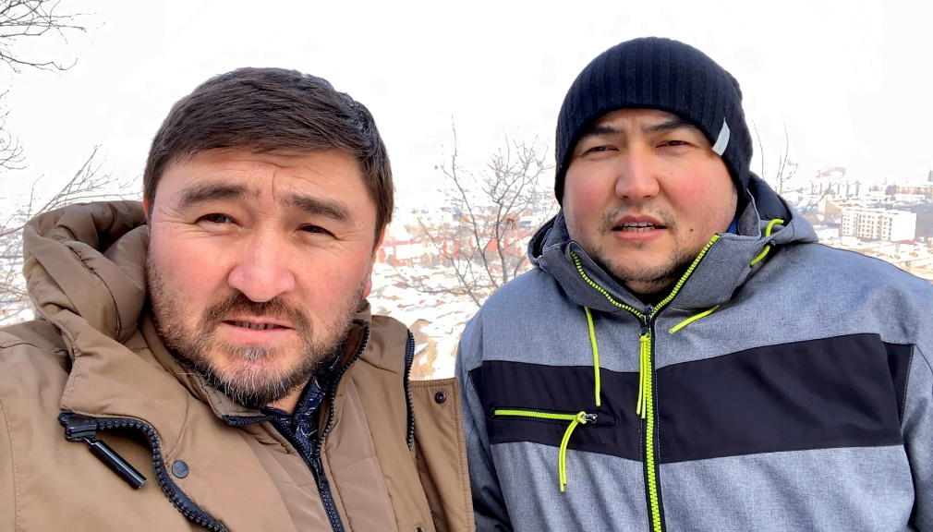

Sunday – 29
Please pray for the political situation in Russia, where the government continues to restrict freedoms. Targeted arrests and persecution of Christians and Christian has continued to increase. Please pray for the safety of FEBC-Russia’s staff and for the continued freedom to preach the Gospel in Russia.

Monday – 30
“Over the last two years, my mother, my father, and now, my wife all died,” said a listener from Ukraine named David. “It’s just me and my 10-year-old daughter now.” Our follow-up evangelist supported David, listening to him and offering advice. She shared with him about the Holy Spirit, who comforts, teaches, and gives wisdom. And told him about God, who can become his Heavenly Father. “I feel such a weight…I had never agreed with Christianity. I didn’t think it was real.” David put his faith in Jesus, and the Lord touched his heart—David wept. “Thank you for helping me realize that I am not alone, that God is with me. I am infinitely grateful to you!”

