Russia & Ukraine August Prayer Focus

Thursday – 1
Please pray for three evangelistic counselors in Ukraine, Natalia, 36, Viktoria, 37, and Natalia, 26. They take phone calls from Ukrainian listeners every day. These sisters in Christ are professionally trained counselors, and they are passionate evangelists as well. Pray for strength, wisdom, and the power of the Holy Spirit to continuously encourage these ladies.

Friday – 2
Please pray for listeners like Marina, from Russia, who felt all alone in life, betrayed and without hope. But then, “I found your program and started listening,” she said. “You showed me a different side of Christianity! I didn’t think there were any answers there for me…You helped me overcome my fear of people, and now, I want to go to church to get to know more about Christianity.”

Saturday – 3
Please pray for FEBC-Moldova’s Bible programs, both short videos and longer programs. People’s lives are being changed. Young people who are atheists are watching, reaching out to the host, and asking questions about God, the Bible, and how to be saved.


Sunday – 4
“I’ve been living under some kind of heaviness, a cloud,” said a listener from Ukraine named Marina. “I had a breakdown in front of my family. I need to be free. My life has been a mess, filled with betrayal. I’ve even been involved with witchcraft. And this war, it’s all so heavy…” Marina prayed a prayer of repentance, with FEBC-Ukraine’s follow-up evangelist, inviting Jesus to be Lord and Savior of her life. “I feel so light, it’s like a stone fell off my back,” she said. Please pray for Marina as she begins her journey with Christ.

Monday – 5
Please pray for spiritual and emotional strength for the FEBC-Ukraine team as they serve listeners in the midst of the constant stresses of the war. So many listeners are turning to the Lord as our broadcasters share the hope and love of Christ through their programs.
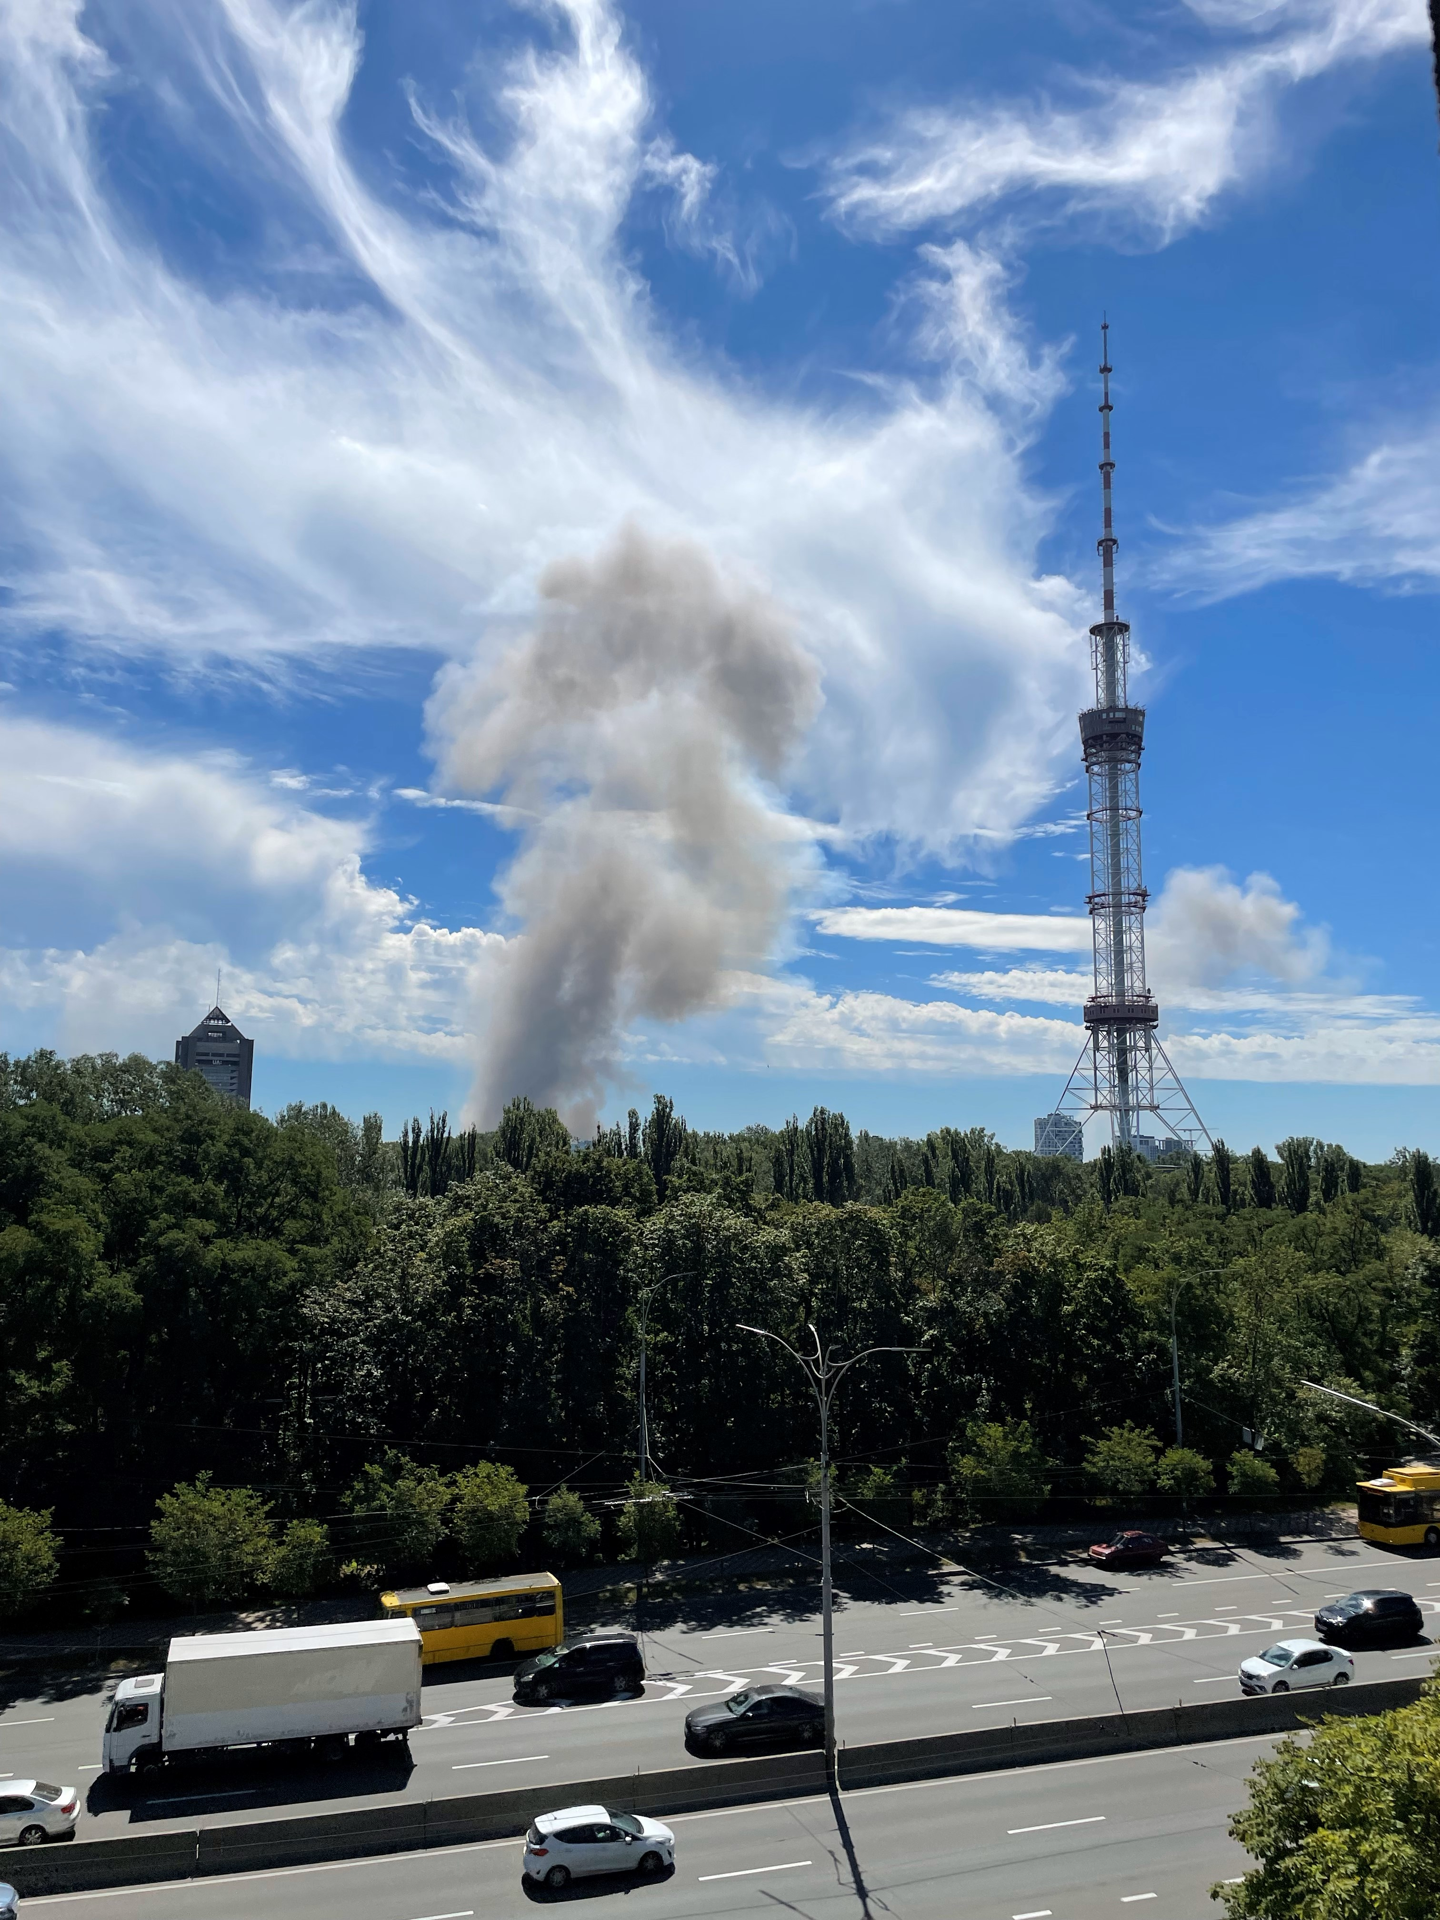

Tuesday – 6
Please pray for listeners like Andrey, who was a long-time listener to FEBC-Russia, but wasn’t willing to take the next step. “Thanks to you, I became interested in reading the Bible and going to church…but I didn’t have the courage to actually go to a church.” Andrey asked FEBC’s broadcaster for prayer when he was very sick. “I didn’t really expect anything,” he said. “But the next morning, I was completely better. I’ve never experienced anything like this before! I have to go to church now!” Please pray for Andrey to give his life to the Lord.

Wednesday – 7
Please pray for FEBC-Russia’s team that works with listener comments. Recently, the number of listener comments have multiplied. Please pray for God to bring the right people to the team.

Thursday – 8
Please pray for listeners like Svetlana, from Ukraine, who was very depressed. “I have nowhere else to turn,” she said. “My life has been very hard, I’ve faced a lot of rejection. I don’t know what to do with the pain.” FEBC’s follow-up evangelist shared with her about Christ and they prayed together. Svetlana put her faith in Christ on the call, “I didn’t know that I could come to God with my problems, that He is there for me all the time. Thank you so, so much! My heart feels so much lighter!”

Friday – 9
Please pray for Max, Sergey and the other members of the FEBC-Ukraine team, who are serving in the Ukrainian military. Please pray for God’s protection, for God to use them to serve those around them, and for their spiritual and emotional strength. Please also pray for their families.

Saturday – 10
Please pray for listeners who are searching for the truth, like Evgeny, from Russia. “I grew up in poverty…had a difficult life. I tried going to an Orthodox church, put the priests couldn’t answer my questions. That’s when I started listening to your programs. The way you talked about Christianity was so interesting. I really want to talk with a minister like you.” Please pray that Evgeny puts his faith in Christ and accepts a connection to a local church.

Sunday – 11
Please pray for FEBC-Kazakhstan’s new program, where guests who are successful in business are invited to talk about God and to share their testimonies. There are already some powerfully testimonies. Please pray for many listeners to be reached through these programs.

Monday – 12
Please pray for FEBC-Ukraine’s young listeners who are losing parents in the war. A teenage listener named Lena was in grief. “He died four days ago,” she said. “I keep remembering the hard times we’ve had. He wasn’t perfect. But I’ve been thinking about using Tarot cards to reach him.” FEBC’s follow-up evangelist shared Christ with Lena, praying for her and her mother. Lena put her faith in Jesus, and they discussed how to pray and the importance of coming to church. Please pray for Lena on her journey and for other young listeners like her to come to know the Lord.

Tuesday – 13
Please pray for FEBC workers who are working in the hardest hit areas of Ukraine. Particularly pray for Pokrovsk, where FEBC has a station. The city might fall under Russian control soon, many listeners are terrified.

Wednesday – 14
Please pray for listeners like Serafima, from Russia, who has been going to church, but hasn’t yet put her faith in Jesus. “Thank you for your program! I grew up being blamed for everything my siblings did wrong, and I was left with a constant feeling of guilt. Now, even when I read the Bible, I only saw my mistakes. But I didn’t see God’s love for me.” Please pray for Serafima to come to faith in Christ.

Thursday – 15
Please pray for Ilya and Alina, who are managing and developing the FEBC-Moldova team. Please pray for their family and their health as they inspire many Moldovans to follow Christ!
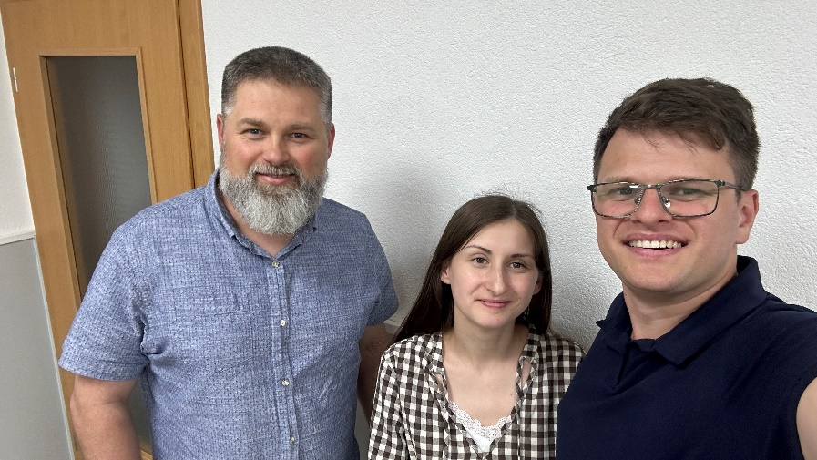

Friday – 16
Please pray for listeners like Alina, who called FEBC’s follow-up line because her relationship ended. Relationships remain the most common problem listeners call FEBC with. Alina was crying, in despair, thinking her life was over. FEBC’s follow-up evangelist shared with her about God’s love and care for His children. Alina put her faith in Jesus, inviting Him into her life. “Please help me see things as You do,” she prayed. “Thank you so much! I will be watching all the rest of your programs!”

Saturday – 17
Please pray for our listeners in Zaporizhzhia, where FEBC will be holding listeners’ meetings, ministering to the widows there. Please pray for safety and God’s healing power.
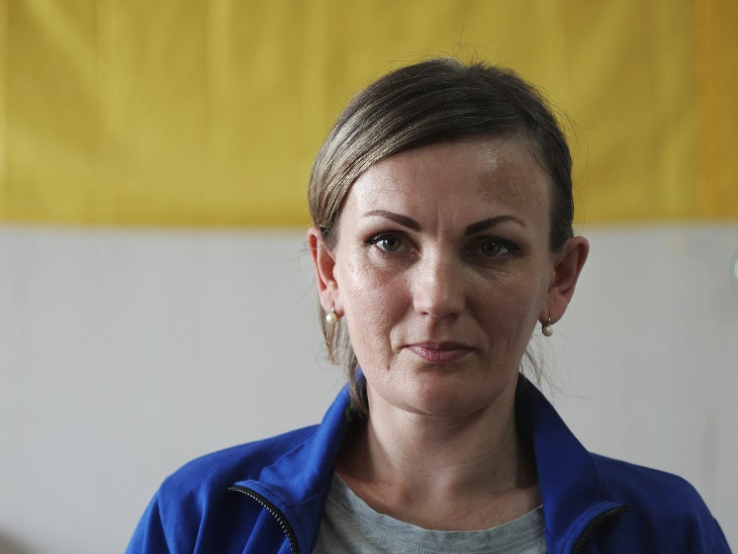

Sunday – 18
Please pray for the young people of Russia, who are undergoing a great deal of stress, with society becoming a darker, more sinister place. Like Masha, from Russia, who contacted one of FEBC-Russia’s broadcasters. “I feel all alone, like I don’t belong here.” She would sometimes hurt herself to feel better. “I know I need help, but I don’t know where to turn.” Please pray for Masha to come to know the Lord and to accept the help she needs.

Monday – 19
Please pray for emotional and spiritual strength for the FEBC-Russia team as they face increased governmental pressure and increased risk of military draft.

Tuesday – 20
Please pray for listeners like Pyotr, who was at the end of his rope, thinking about committing suicide. He talked about the difficulty of living through this war, the loss of his home, and the death of his brother. At first, he didn’t take the idea of praying seriously. He had never prayed before, never been to church. But as he continued speaking with FEBC’s follow-up evangelist, he decided to pray. As they prayed, Pyotr put his faith in Jesus. “I’ve never felt anything like this before,” he said. “I have joy in my heart! I’m going to tell my three best friends to call you, please pray with them! They really need to know Jesus too!”

Wednesday – 21
Please pray for Emma, Iryna, and Inna as they host regular women’s meetings where they encourage and strengthen women who are widows and whose husbands are away at war, by praying with them, reading Scriptures, and leading them to Christ.

Thursday – 22
Please pray for listeners in Russia who are eager to find the real Gospel, like Mikhail. He travelled across the country to meet with one of FEBC-Russia’s broadcasters to find out more about the truth of Christianity. Please pray for him to come to the saving knowledge of Jesus Christ.

Friday – 23
Please pray for FEBC-Russia’s ministry to Muslim listeners. Islam is the second largest religion in Russia, and these videos provide a great opportunity to reach Russian-speaking Muslims across the region.

Saturday – 24
Please pray for listeners like Nastya, from Ukraine, who are struggling to survive financially in the difficult situation in Ukraine. Many have to flee their homes in order to escape the war, and prices have risen exponentially. Nastya was in despair until she prayed with FEBC-Ukraine’s follow-up evangelist. Please pray for FEBC’s listeners who are suffering because of the war, and for the Lord to bring the war to an end.

Sunday – 25
Please pray for FEBC-Moldova’s new children’s programs that are currently being filmed. They are short programs in formats that children enjoy to watch, and share Bible stories. Please pray that they reach a wide audience and lead many families to the Lord.

Monday – 26
Please pray for listeners who are being put under pressure by the government, like one listener who was put under home arrest for making a post about the government. “I started thinking about God for the first time when they put me here. Why would God allow this?” Please pray that this listener comes to know the Lord, and for the Lord to change the hearts of those who are in power.

Tuesday – 27
FEBC-Ukraine’s programs have been a real support for soldiers who are on the frontlines, facing heavy fighting and terrible losses. Over the last year, hundreds of radios have been handed out to soldiers and their families in areas that have been heavily affected by the war.
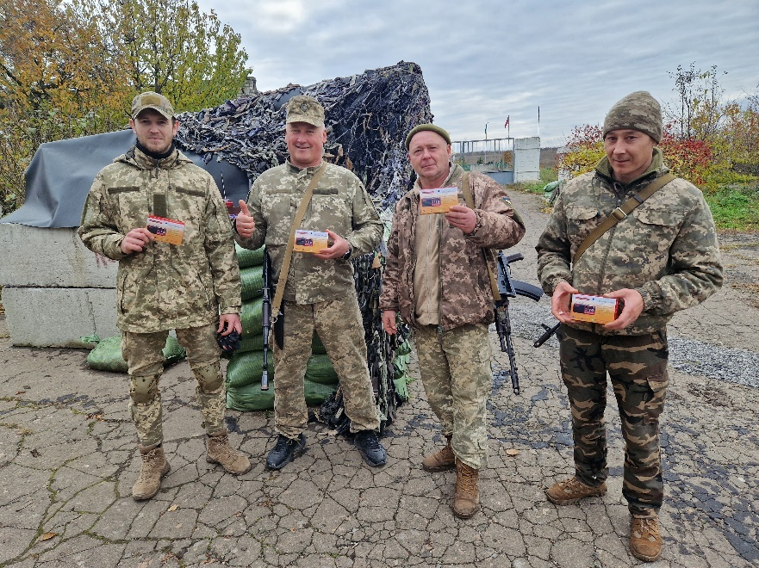

Wednesday – 28
Please pray for soldiers who come from the war traumatized and damaged. A listener named Misha called FEBC-Ukraine, saying, “I have my combat knife in my hands. I’m planning on ending my life…it hurts so much.” FEBC’s follow-up evangelist shared with Misha about God as a Father, the meaning God gives to life, and Jesus’s sacrifice on the cross. They prayed together at the end of the call, and Misha said he knew of a church he could attend. Please pray for Misha to attend this church and to give his life to Christ. And please pray for the many other soldiers in his situation.

Thursday – 29
Please pray for FEBC-Russia’s follow-up evangelists who are helping listeners through difficult situations and spiritual darkness that is blanketing the country. Many people feel as if they can’t speak openly about their thoughts and opinions, with many people having already been arrested for showing dissent. They are looking for hope, and are finding it in Christ through FEBC-Russia’s programs and through conversations with FEBC-Russia’s follow-up evangelists.

Friday – 30
Please pray for listeners like Lyudmila, from Russia, who put her faith in Jesus during one of FEBC’s programs. “I was in a really bad place,” she said, “after fighting with my family. But your program was like a healing light. I realized that I needed to come to the light, pray, and ask God for forgiveness.” Please pray for Lyudmilla as she begins her journey with Christ.

Saturday – 31
Please pray for FEBC-Kyrgyzstan’s team, Ulanbek, Nooruz, Mina, Seil, and many others. They are working in difficult circumstances, but are seeing many listeners come to Christ after speaking with broadcasters or meeting with them in person. This is in the midst of a resurgence of the popularity of Islam. Please pray for breakthrough in the country.

