Russia & Ukraine July Prayer Focus

Monday – 1

Please pray for listeners like Diana, from Ukraine, who was having a nervous breakdown while her husband was away at war. “It’s just my young son and me. There’s no one else—no one to help us.” As Diana spoke with one of FEBC’s follow-up evangelists, she began to open her heart to God, praying for the first time. “I didn’t know He cared,” Diana said. “I’m going to read what you suggested from the Bible,” she said at the end of the call.

Tuesday – 2

“I want to give my life to Jesus,” said a listener named Lyudmila, from Russia. “The only person in my life who every prayed for me was my grandmother. My parents drank really heavily, and they were always arguing with each other. But, because of my grandmother, when I started going through hard times, I knew I had to turn to God. I started reading the Bible by myself, but I didn’t really understand anything. So I went to an Orthodox church, but I came home without any answers to my questions.” FEBC-Russia broadcasters prayed with Lyudmila and connected her with a local church. Please pray for Lyudmila as she is on her journey to Christ, and for the many other listeners who are looking for God, but are not able to find Him in powerless religion.

Wednesday – 3

“I start trembling every time the siren sounds,” said Angelina. “I can’t help myself. I am anxious all the time—no, I’m scared. Scared that a rocket will fly through my window and end my life. I don’t know the last time I slept through the night.” Please pray for the many listeners like Angelina, who are being traumatized by the war. We have not yet seen the full impact the war is having on the people of Ukraine.

Thursday – 4

Praise God that we were able to hold another women’s meeting for the wives and daughters of soldiers. This meeting was held in the city of Mykolaiv, not far from the frontlines. God moved powerfully in this meeting—25 women accepted Jesus as their Lord and Savior. Please pray for the women whose lives are being transformed by the Gospel that was shared with them.

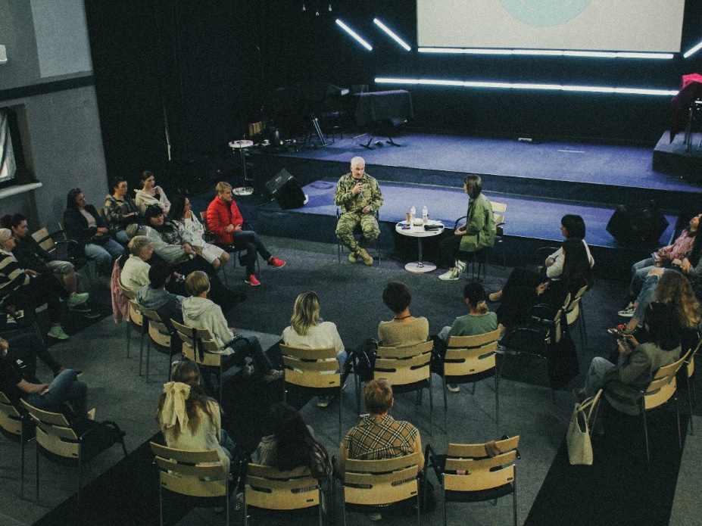

Friday – 5

“When I came home from the war, it felt like I was carrying the weight of the world. You told me that there was only one thing that could fill the emptiness in my soul. You work up that desire for God in my again. Hearing you read the Bible…it really moved me…I want to read the Bible for myself.” Please pray for listeners like David, who are listening to FEBC-Ukraine’s Bible programs and opening their hearts to the Lord.

Satruday – 6

Please pray for Ukraine, as it has recently been under heavy attack, with dozens of deaths, including when a rocket hit a children’s hospital. A rocket also recently fell near the location of FEBC-Ukraine’s old studio.

Sunday – 7

“There aren’t many open Christians where I live,” said one listener. “So when I came across your program online, I was amazed by what I heard. This was the only way I had to learn about Jesus Christ. Over time, I realized that my atheism was wrong, and that I wanted to follow Christ.” She wrote to FEBC-Russia’s broadcaster and they began to study the Bible together. Please pray for the many listeners in closed countries who are hearing the Gospel online through FEBC.

Monday – 8

Please pray for the city of Mykolaiv, where FEBC-Ukraine has a station. Mykolaiv is regularly under heavy missile attack, and the people are under a great deal of pressure. Please pray for peace, healing, and restoration to come to this city, and for the Word of God to transform the lives of many.

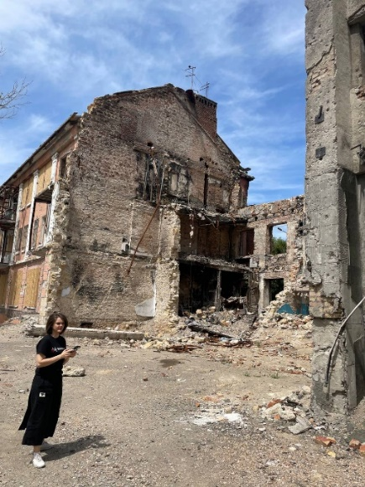

Tuesday – 9

Please pray for listeners like Elena, whose husband was away at war. “He hasn’t been in touch now for several days, and I’m so scared that something happened!” This is a struggle many listeners in Ukraine are facing, wondering if their loved ones will come home alive. Elena prayed with FEBC’s prayer evangelist and they connected her with a local church. Please pray for Elena to put her faith in Christ.

Wednesday – 10

Many of FEBC-Kyrgyzstan’s listeners live in small villages with no churches, or even Christians. All they have is a small solar radio. “My husband hangs the radio around his neck every day when he goes to work,” said one Kyrgyz woman. Please pray for listeners like this who are coming to know the Lord through FEBC’s programs.

Thursday – 11

Please pray for listeners like Peter, who had tried several times to commit suicide. “It’s not that I want to die,” he said. “I’m just so tired. I can’t handle my life anymore.” FEBC’s prayer counselors spoke with Peter about his life, sharing Christ with him. They prayed together, and Peter put his faith in Jesus. He was also connected with a believer in his neighborhood. “Thank you so much!” he said. “I’ll be listening to all of your programs!”

Friday – 12

FEBC-Ukraine broadcaster, Ihor, recently visited the city of Kropyvnytskyi to meet with a group of young people. He was invited by Sasha, a teen who didn’t believe in God until he started watching Ihor’s program. He shared how Ihor inspired him to search for God. Please pray for listeners like Sasha, who come to know the Lord through FEBC’s programs.

Saturday – 13

“Please help me get saved!” wrote one FEBC-Russia listener named Sofia. “I’ve done everything I need to…more than once, but it hasn’t worked.” Sofia had gone to an Orthodox church several times, and bought a cross, but her relationship with God had not changed. She didn’t know what she was doing wrong. FEBC’s follow-up evangelist shared the Gospel with Sofia and helped her understand how to read the Bible. Please pray for her as she begins her journey to Christ.

Sunday – 14

Please pray for the regular meetings being held for teenagers by FEBC-Kazakhstan’s team. Many young Kazakh teens are afraid of attending a Christian church because it feels so foreign to them. In-person meetings help them grow comfortable with Christians and make it easier for them to take the step of visiting a church.

Monday – 15

“Our parents are pressuring us to have an abortion,” said a young couple when they called FEBC. FEBC’s prayer counselors encouraged them, helped them come up with a plan, and told them about the Lord. “I want to know God,” said the young woman. They prayed together with FEBC’s prayer evangelist. “Thank you for supporting us! We felt all alone and didn’t know what to do. But now we have hope!”

Tuesday – 16

Please pray for soldiers who come home injured, physically and psychologically. Many have trouble coping with their injuries and traumas. FEBC-Ukraine produces programs dedicated to soldiers, helping them deal with their pain, problems, and fears. There is a great need for the healing and restoring power of Jesus in their lives.

Wednesday – 17

“You’re a shaman, right?” wrote Evgeniy, a listener from the Buryat region of Russia. He had started to watch one of FEBC-Russia’s testimonies from a former shaman but hadn’t watched to the end of the video yet. Buryat is a heavily Buddhist region, but many people will also go to shamans for help with their problems. FEBC’s follow-up volunteer evangelist responded, “No, we’re Christians—even better!” They shared Christ with Evgeniy, and connected him with a local pastor, who he spoke to. Please pray for the many listeners in the Buryat region who are trapped in demonic practices find freedom in Christ.

Thursday – 18

Please pray for FEBC-Moldova’s new programs for women. These are short videos that deal with a variety of spiritual and life issues women face from a Christ-centered perspective. This is a new project, but we see the potential for it to have a great influence, drawing many women to have conversations about Christ and how to live their lives in light of the Gospel.

Friday – 19

“I can hear explosions from my home,” said Ella, a listener from Ukraine. “I personally know four people who have died. I feel constant fear, constant anxiety. I’m barely sleeping—I’m even afraid to go to the store.” Ella prayed with FEBC’s follow-up evangelists and was given resources to help. Please pray for listeners like Ella who are experiencing a great deal of stress. Many people’s lives are falling apart. Please pray for listeners to turn to the Lord through FEBC’s programs, to find the hope and peace that can only be found in Him.

Saturday – 20

Please pray for the members of the FEBC-Ukraine team who are now serving in the army. Please pray for their protection, for strength, for God’s blessing on them as they serve the soldiers around them, and that God blesses and takes care of their families while they are away.

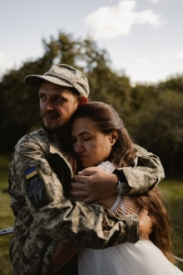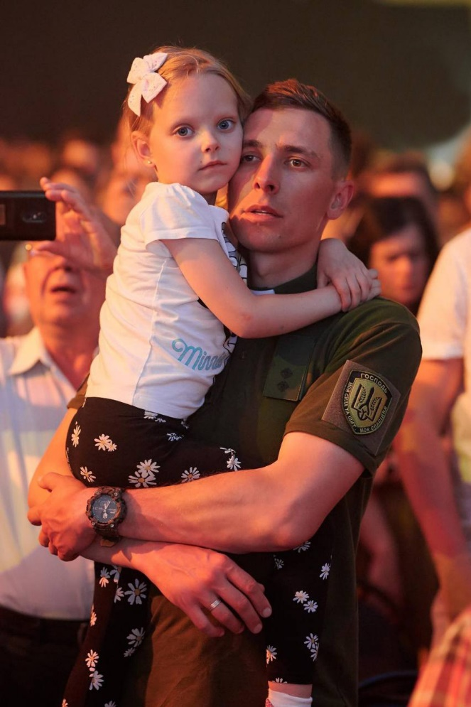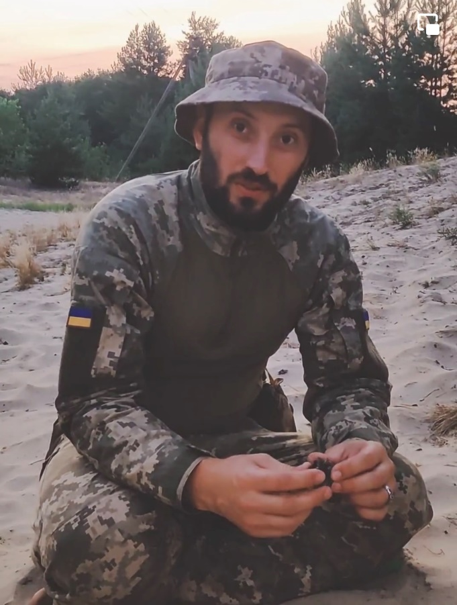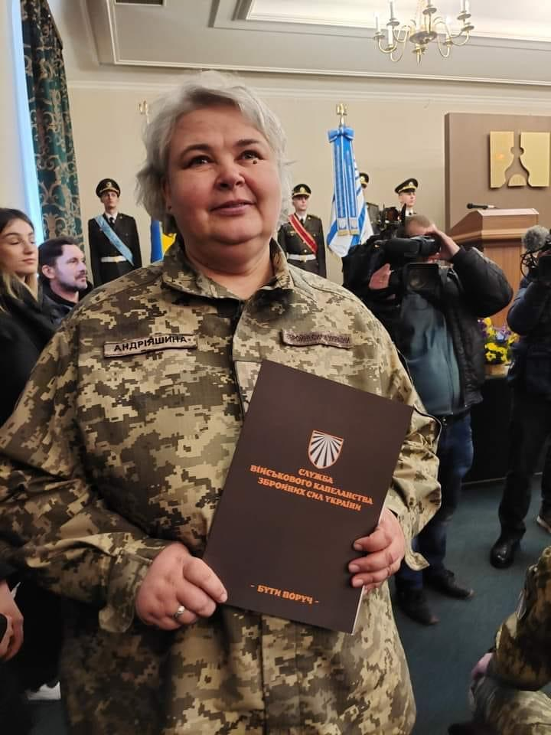

Sunday – 21

“I remember when I wrote to you several years ago,” wrote Alexey, a Russian listener, to one of FEBC-Russia’s broadcasters. “I was sure that my life would work out exactly the way I had planned. You told me there was someone higher who was in charge. I could not believe this because I was an atheist. But recent events in my life have forced me to rethink things. Since I’ve been watching your program regularly, I’ve realized that God loves me. And if I trus Him, He will help me, guide me, protect me, and give me wisdom. It’s not easy to trust in God since I’m used to making all my decisions myself. But I’m realizing that I’m not alone in this life. Thank you so much!

Monday – 22

Please pray for FEBC-Kyrgyzstan’s broadcasters as they are working in a hostile environment that is growing increasingly radical. Please pray for favor from the government and for many listeners to respond and receive the Gospel.

Tuesday – 23

Please pray for listeners like Amgalan from Russia, who called FEBC when he was going through a crisis. “I am a Buddhist,” he said. “But you prayed for me once, when I wanted to take my own life. It was the only thing that helped.” FEBC’s prayer counselor prayed with Amgalan and talked to him about the Lord. “I will watch your programs,” he said. Please pray for Amgalan and many other Buddhist listeners in the Buryat region to come to the Lord.

Wednesday – 24

Please pray for listeners like Victoria, who started listening to FEBC-Ukraine’s radio programs 3 months ago. She was just baptized in a church. She wrote to Inna, the broadcaster she had seen, and Inna began evangelizing her personally. She joined a Bible study that Inna was a part of, and 3 months later, she gave her life to Christ. Please pray for our broadcasters who spend countless hours evangelizing listeners in person after their programs.

Thursday – 25

Please pray for FEBC-Kazakhstan’s follow-up evangelists as they share the Gospel with listeners who are going through serious life events. Many suicides and abortions have been averted through their ministering and prayers.

Friday – 26

Please pray for listeners like Oleg, from Russia, who had a happy family and a good job, but had recently started thinking a lot about God. “I was so grateful to find your program. You helped me understand that God cared about me and that I could come to Him myself. I want to know more about this.” Please pray for Alexey and many other listeners beginning their journeys towards Christ.

Saturday – 27

Please pray for FEBC-Moldova’s prayer helpline counselors, who are helping avert suicides and abortions, and are leading listeners to Christ. Moldovans are going through a spiritual crisis. There is widespread antagonism towards Evangelical Christianity among religious people, and many young people are atheists. However, the spiritual emptiness people are living with is leading many to begin searching for something real. Please pray for our listeners to continue to come to Christ through FEBC-Moldova’s programs and through FEBC-Moldova’s follow-up evangelists.

Sunday – 28

I really started to feel how empty life was,” said a listener in Russia named Alexey. “Then I started listening to your programs. I recently started thinking about the meaning of life, about God. I started understanding a lot about God, about repentance and turning to Him in faith.” Please pray for Alexey, who has started reading the New Testament, and is beginning his search for God.

Monday – 29

Please pray for Muslim listeners who have become increasingly responsive to FEBC’s Russian programs. Some of these are negative responses, but many are also responding positively to the message of Christ. Please pray for many to come to the saving knowledge of Christ.

Tuesday – 30

Please pray for listeners like Polina, from Russia, who didn’t know how to pray or where to go to church—she had never been to church before. “The only prayer I know is the Lord’s Prayer,” she said. “I memorized it and repeat it every day.” Polina knew of an evangelical church, but was afraid to go because she didn’t understand what it was. FEBC’s follow-up evangelist spoke with her, telling her about Jesus Christ and His love. She also explained what an evangelical church believed, relieving her of her fears. “I’ll go with my friend now,” she said. “She invited me to church many times, but I was always too afraid. Thank you!”

Wednesday – 31

Please pray for a new generator for FEBC-Ukraine to help with regular power outages. This generator will ensure that FEBC-Ukraine can stay on the air and online in the midst of long power outages, and allow for heating and lights to be powered as well. Please pray for the team, as they are under a great deal of pressure with increased bombings and the risk of being drafted.