Russia & Ukraine May 2024 Prayer Focus

Saturday – 1

Please pray for FEBC-Ukraine’s team members who have become chaplains. “Please pray for us to be able to do our ministry to the soldiers, and to create programs for Ukrainian listeners, through the power of the Holy Spirit—with joy, effectively and fruitfully. Please also pray for God’s protection and good health for me and my unit, especially as we are in a dangerous region.”

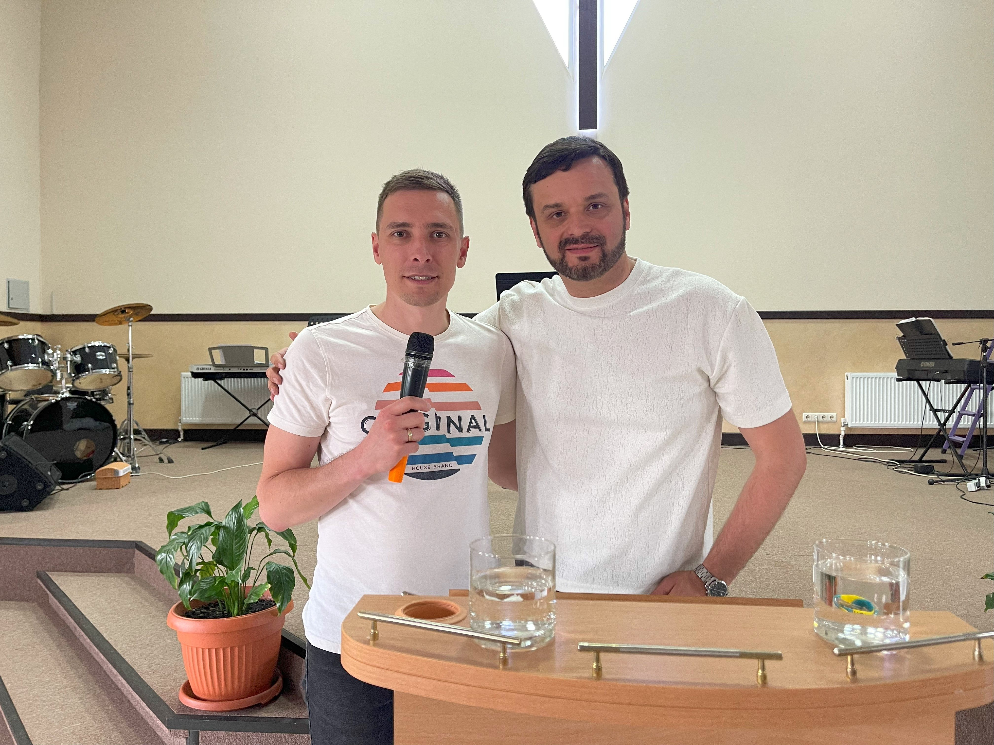

Sunday – 2

Please pray for listeners like Elena, from Ukraine, who was going through a difficult time in her life, and was suicidal. “I don’t know what to do,” she said. “It feels hopeless.” After speaking with FEBC-Ukraine’s follow up evangelists, she put her faith in Christ, giving Him her burdens. “I know I’m not going to have to deal with this alone now. I can feel that God is with me.” Elena was connected with a pastor. Please pray for her as she takes her first steps towards Christ.

Monday – 3

Please pray for those members of FEBC-Russia’s staff that are still having to live abroad due to pressure from authorities. Please pray for this situation to be resolved soon.

Tuesday – 4

Please pray for listeners like Alina, who was being overwhelmed by anxiety and fear, and was afraid that she would go insane. “Please help me, I don’t want to lose my mind.” Alina put her faith in Jesus while talking with FEBC’s follow up evangelist. “I want Jesus to rule in my life,” she said.

Wednesday – 5

Please pray for FEBC-Ukraine’s project to support the families of people in the military. Please pray for an upcoming meeting for military wives in Kyiv, and one soon after in Ivano-Frankivsk. The majority of these women are not believers and are praying and reading the Bible for the first time in their lives.

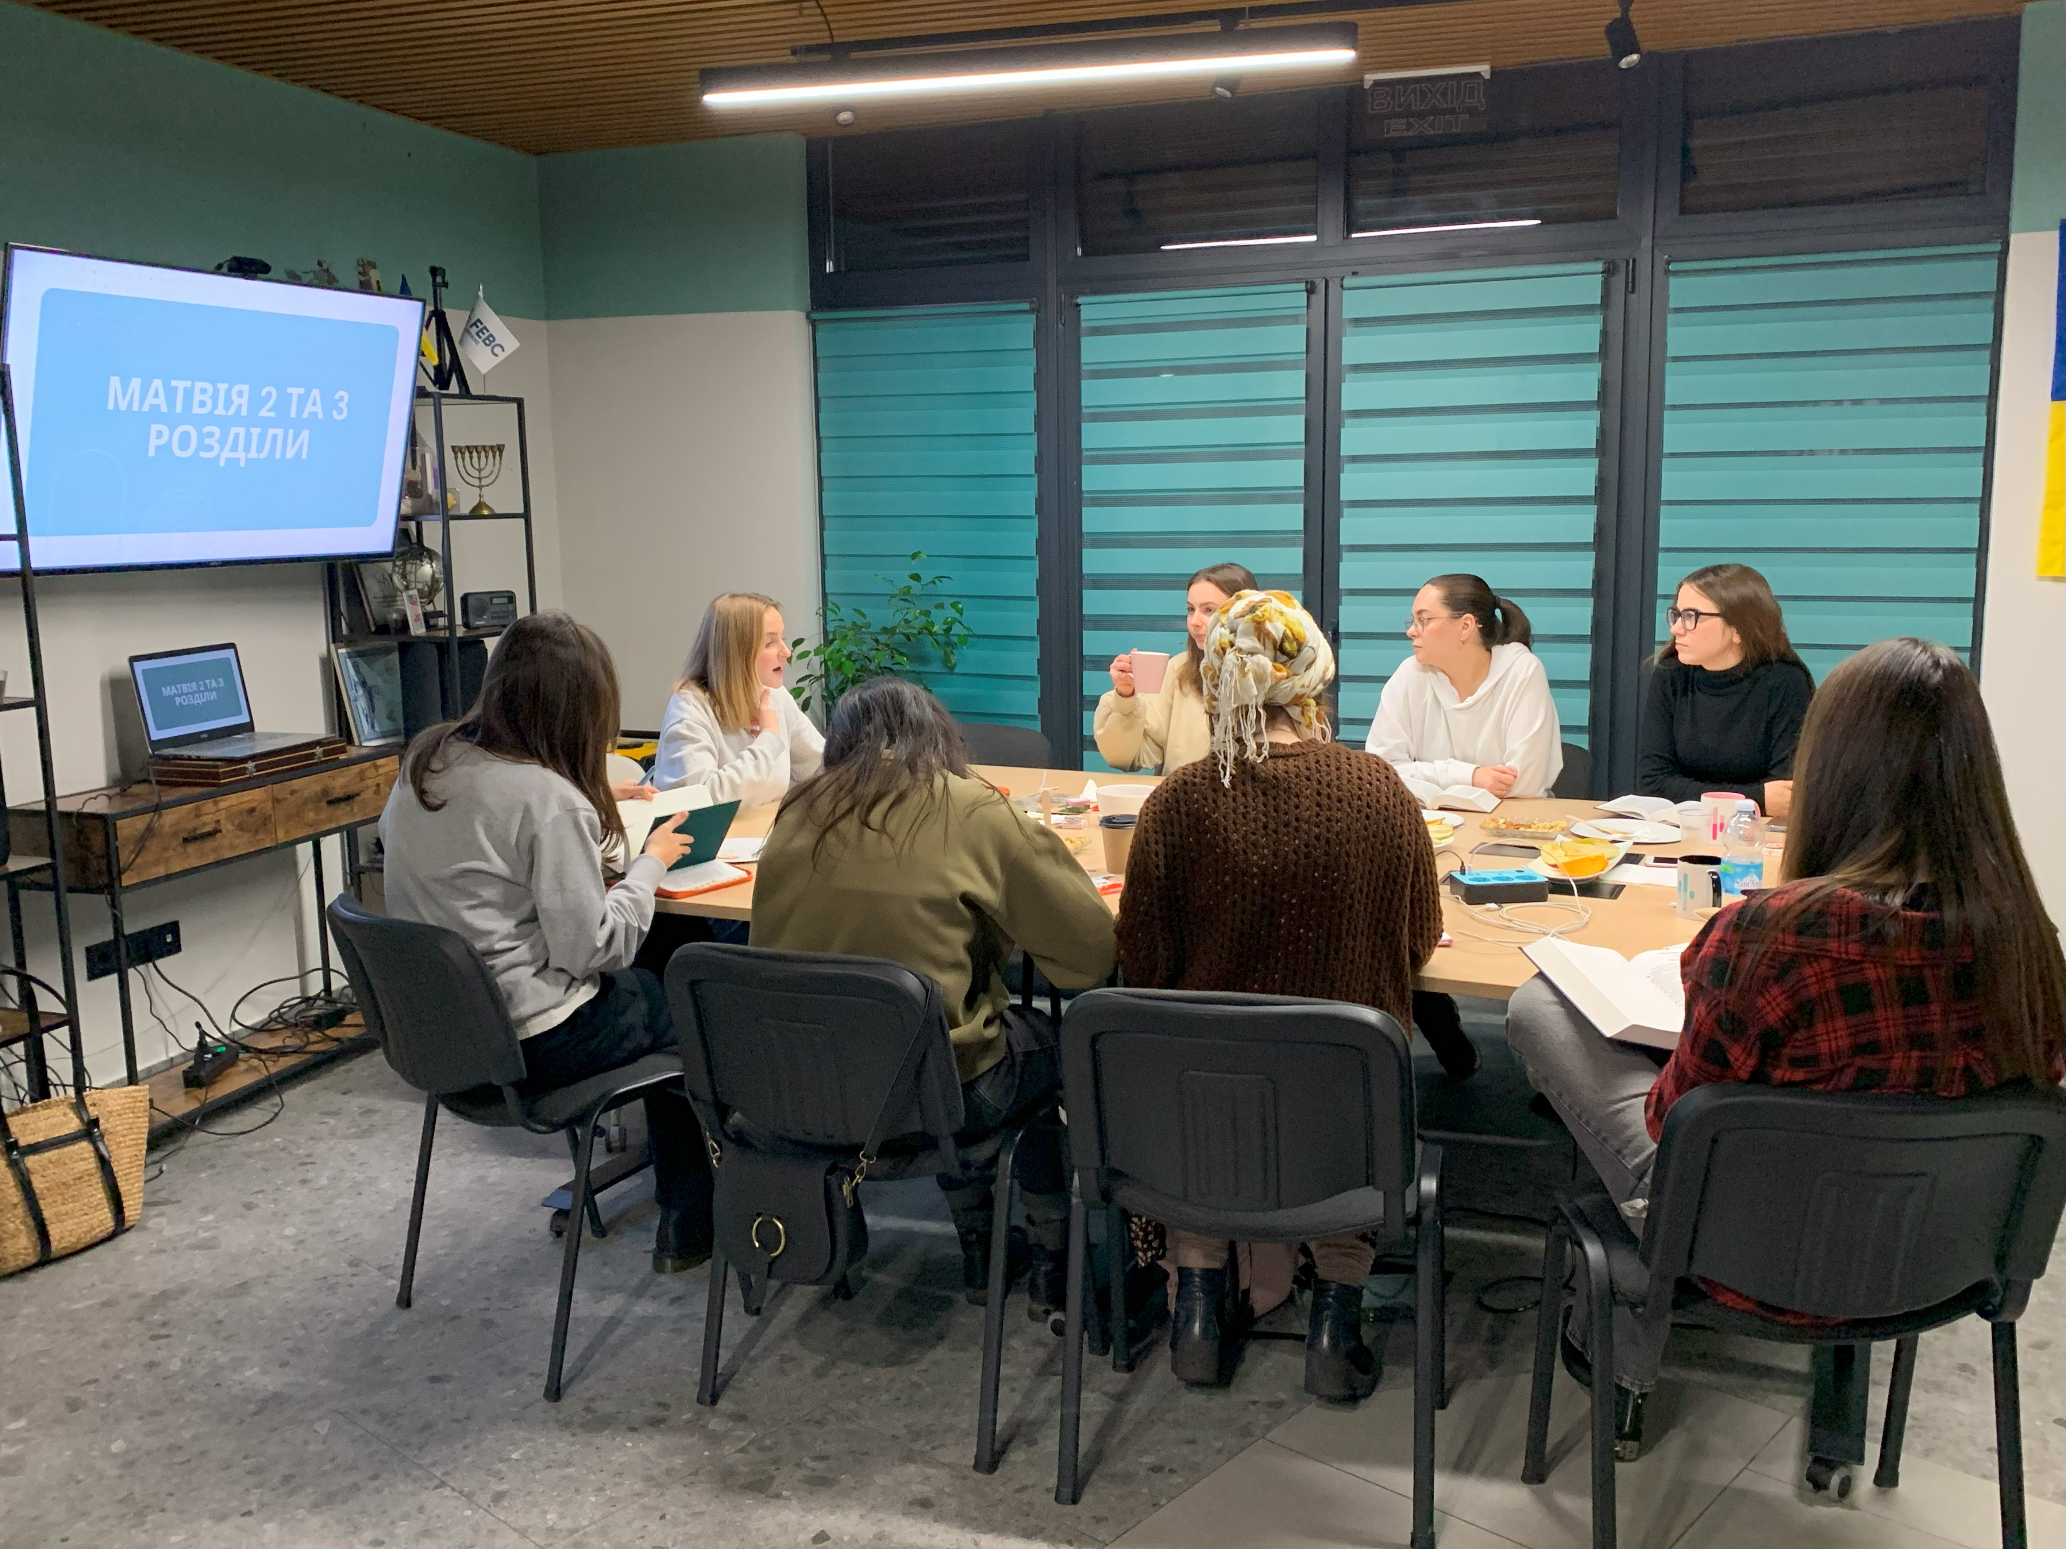

Thursday – 6

Please pray for listeners like Maxim, who started reading the Bible after speaking with FEBC-Ukraine’s follow up evangelist. “I was overwhelmed by my life. I felt out of control. I only knew what the Bible said vaguely. But after talking with you, and accepting Jesus, I feel such a strong desire to study the Bible! Thank you!”

Friday – 7

Please pray for the freedom to preach the Gospel to be preserved in Russia, it is under great attack. Please pray for FEBC-Russia’s millions of listeners, many of whose hearts are opening to the Gospel in the midst of the increasing darkness.

Saturday – 8

“I feel so alone,” said a listener named Natasha. “I feel like I’m trapped, and I don’t know where to turn.” After FEBC’s follow-up evangelist prayed with Natasha, she put her faith in Jesus. He then explained to her that she could pray directly to God and didn’t need to pray through anyone or anything else. “Thank you for telling me about Jesus!” she said.

Sunday – 9

Please pray for upcoming events being held for teenagers that FEBC-Ukraine will be putting on. Please pray for God’s wisdom and blessing, and for many teenagers to come to know the Lord through these meetings. Many teenagers are struggling with feelings of fear and hopelessness, not knowing what their futures will look like.

Monday – 10

Please pray for listeners like Natasha in Ukraine, whose husband came home from the war injured. Many families are having to deal with husbands, fathers, and sons coming home injured physically and emotionally. “It’s hard for us,” she said. “I had to quit my job to help take care of him. It’s hard for him, too. He’s depressed, and he’s having to learn how to walk again.” Please pray for Natasha and the many other families who are facing similar situations.

Tuesday – 11

Please pray for the health of the husband of one of FEBC-Russia’s broadcasters. There was positive progress, but there has now been a decline. Please pray for the Lord’s healing and for peace for the family.

Wednesday – 12

“I was crippled by fear of others,” said a listener named Vera. “Anytime I would be criticized, I took it very personally. It made me afraid to try anything, for fear that I would fail.” FEBC’s evangelist shared what the Bible had to say about fear of man, and told her that God wanted to have a relationship with her. “I’m so lonely,” Vera said in response. FEBC’s evangelist shared the Gospel with Vera, telling her about Jesus’s love, and Vera put her faith in Jesus. Please pray for her as she takes her first steps with Christ.

Thursday – 13

Please pray for FEBC-Ukraine’s new team members who are currently going through training. May they catch FEBC’s heart and mission to reach the people of Ukraine with the Gospel of Jesus Christ through Media.

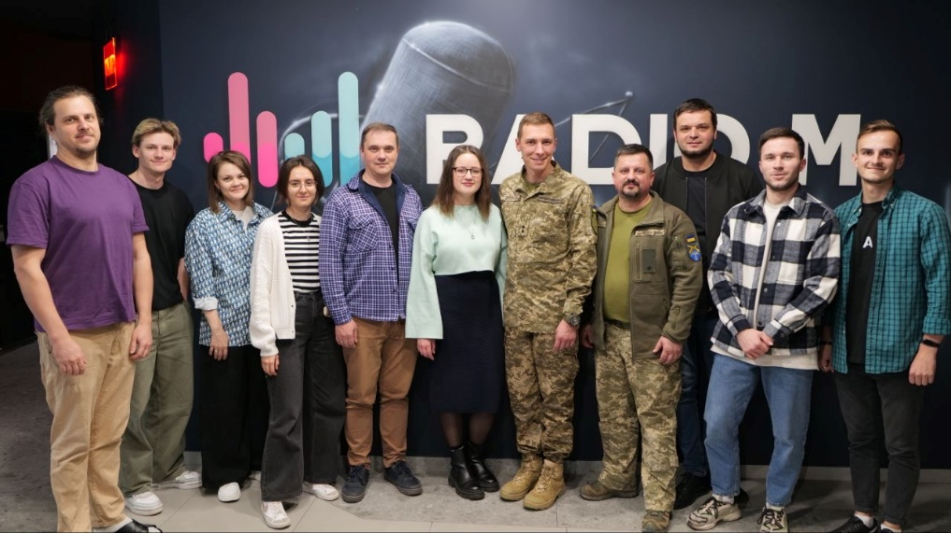

Friday – 14

Please pray for listeners like Maria, from Ukraine, who was devastated after her relationship ended. She felt hopeless and was wanting to end her life when she called FEBC. FEBC’s evangelists spoke with her, encouraging her and sharing the Gospel with her. They prayed together three times, during one of which, Maria gave her life to Christ. “You saved me!” she said, crying. “Thank you so much!”

Saturday – 15

Please pray for a member of FEBC-Russia’s evangelistic follow-up team, Christina, whose husband just died in an accident. He was close to the FEBC-Russia team and this is deeply felt by them all. Please pray for his family as they deal with this loss.

Sunday – 16

‘I don’t understand myself,” said Nastya, a listener from Ukraine. “I have a feeling of constant discomfort inside, like something is not right.” FEBC’s evangelist shared the Gospel with Nastya, sharing with her the value she had in the Lord’s eyes. “All the feelings of worthlessness and discomfort went away at once,” she said after putting her faith in Jesus and praying with FEBC’s evangelist. “Thank you!”

Monday – 17

Please pray for the men of FEBC-Ukraine, who could be drafted into the Ukrainian army. Please pray for God’s protection, and that he works through them powerfully as they minister to the people of Ukraine.

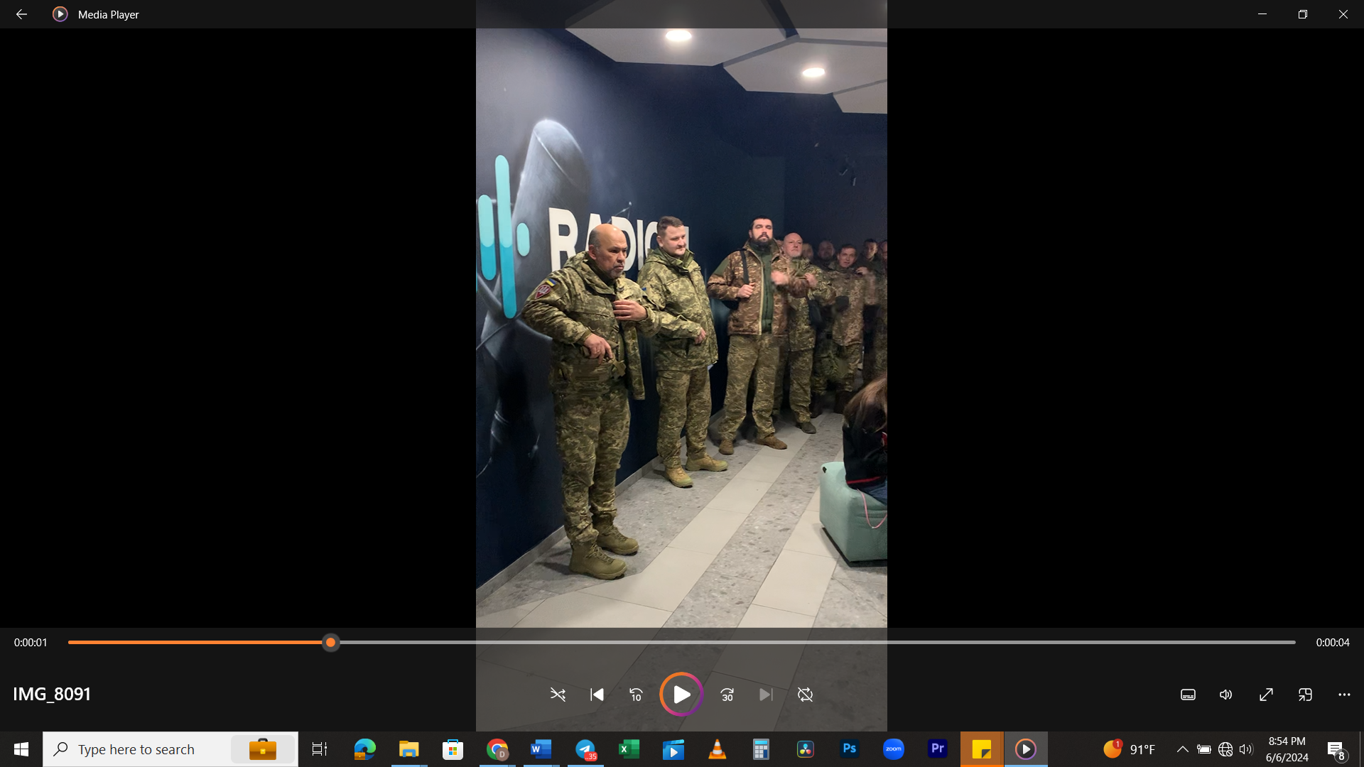

Tuesday – 18

“I’m so angry all the time!” said a listener named Zoya, from Ukraine. “Nobody seems to understand me. I constantly end up in arguments. What do I do?” FEBC’s follow-up evangelist told Zoya about God’s love, that she could have a relationship with Him and learn from Him. Zoya prayed with FEBC’s evangelist, putting her faith in Jesus and asking for Him to rule in her heart. “I’m not so angry at the people who hurt me anymore,” she said. “Oh, I just want to live again! I want to ask forgiveness for what I’ve said and thought!” Please pray for Zoya as she learns to walk with Christ.

Wednesday – 19

Please pray for the leadership team of Moldova as they expand the team of broadcasters and bloggers. Several new young bloggers have joined the team, who are very strong with listener interactions, responding to comments and sharing the Gospel with listeners.



Thursday – 20

Please pray for listeners like Diana, whose marriage is unraveling while her husband is away at war. “He’s cheating on me,” Diana said. There is much infidelity plaguing marriages in Ukraine as couples are living apart for months at a time. Diana put her faith in Jesus during her talk with FEBC’s evangelist and decided to move forward with prayer and God’s help. Please pray for Diana’s marriage and for the many marriages that are being damaged and broken through infidelity in Ukraine.

Friday – 21

Please pray for the families of FEBC-Ukraine team members who are separated. Some wives and children are still living abroad for safety. Others are in Ukraine, but their husbands are serving in the military as chaplains. Please pray for protection and provision for these families. And for them to be able to see one another.

Saturday – 22

Please pray for Ukrainian listeners who experienced a lot of trauma and are now dealing with the effects. “When the war started, we lived in a warzone,” said one Ukrainian listener named Nadia. “It was scary. I felt empty from fear, I was nauseous, had terrible headaches. When we left, this all stopped. I got pregnant, had a child, everything was fine. But then it came back. The doctors say I’m healthy. What’s wrong with me?” Please pray for Nadia to come to the saving knowledge of Christ. An FEBC evangelist prayed with her and she was encouraged to go to a nearby church.

Sunday – 23

As Islamic influence in Qazaqstan experiences unprecedented growth, doors are opening to evangelize the youth. Please pray for FEBC-Qazaqstan’s ministry to young people online, as they engage with young people one-on-one when they respond to videos, inviting them to youth gatherings, and, eventually to church. This helps those listeners who are afraid to visit a Christian church, but are interested in Jesus.

Monday – 24

Please pray for listeners like Timofey, who wanted to commit suicide when he called FEBC. He was helped, prayed with, and he gave his life to Christ. He was connected with a local pastor and he agreed to call back. “I’m calling to thank you for your help,” he said. “I feel like a completely different person now. The pastor came to visit me, and invited me to church. I think I’m going to go. Thank you for giving me a helping hand when I needed it most.” Many callers call FEBC in extreme circumstances, and receive life-saving help. Please pray for these callers, and for FEBC’s evangelists, who are responding to such calls.

Tuesday – 25

Please pray for FEBC-Ukraine’s helpline follow-up evangelists who are handling some very traumatic calls—and are seeing many listeners come to Christ. Some of our evangelists have husbands in the military, which is added stress. Please pray for emotional and spiritual strength, for the Lord to bless their families, and for the safety of their husbands.

Wednesday – 26

A single father called FEBC because he was lonely, felt hopeless, and was drinking. An FEBC evangelist told him about the Love of Jesus and the power of the Word of God. He put his faith in Jesus and asked God to help him live his life for Him. “My heart felt so light after I prayed with you,” he said. Please pray for listeners who are finding new life in Jesus through FEBC’s programs and conversations with FEBC’s broadcasters and follow-up evangelists.

Thursday – 27

Please pray for the energy infrastructure in Ukraine, there are power blackouts every day. Please pray for families who are struggling without electricity, internet connection, and water. “Your programs bring me so much peace,” wrote one listener, “but my Internet isn’t strong enough for me to watch right now. Please pray for me.” Please also pray for FEBC-Ukraine to be able to continue sharing the Gospel in the midst of these interruptions.

Friday – 28

A soldier named Dmitry called FEBC, saying, “I need to talk to someone. I haven’t been able to sleep. I was injured in the war, and now, I have so many problems.” At first, Dmitry didn’t know if he could really trust Christians, but as they continued talking, he began to open up more about his struggles. Then they began to talk about God, about prayer, and sin. “I knew that I was a sinner,” he said. “Now I know that I need Jesus to be my Lord and Savior.” Please pray for Dmitry, who gave his life to Jesus on this call, and for many more listeners to come to a saving knowledge of Jesus Christ.

Saturday – 29

Please join us in praying for an end to the war in Ukraine. So many people have died, countless soldiers, and many have had to flee their homes to escape the war. Please pray for peace and healing to come to Ukraine and the Ukrainian people, and for the Good News to flourish and spread throughout the country.

Sunday – 30

“I’ve completely shut down,” said a listener named Sasha. “All my positive emotions are gone. I only feel anxious now. Help me.” As FEBC’s evangelist shared Christ with Sasha, Sasha was very open to what he was hearing. “I’ve always been interested in God, I even bought a Bible once…it’s here somewhere, laying around.” Sasha prayed with FEBC’s evangelist and agreed to read his Bible. Please pray for him as he begins his journey of faith.