Russia & Ukraine April 2024 Prayer Focus

Monday – 1
Please pray for safety for FEBC-Russia’s broadcasters, such as Ivan, who are experiencing pressure from the government. Some have had to leave the country, and their families.

Tuesday – 2

4We are currently in the process of updating the equipment in the Kyiv station, which will result in better coverage of the Kyiv region. Please pray for the technical advisors who are updating the system, and for the people whose lives will be changed through this message.

Wednesday – 3
Please pray for listeners like Anna, who called FEBC because she was on the verge of divorce with her husband. “We have two children; I don’t want our marriage to end. I made a lot of mistakes. I almost destroyed my family.” An FEBC follow-up worker helped her and prayed with her over the situation. Then Anna wanted to come to God and put her faith in Jesus. Please pray for her as she begins her journey with Christ and for her relationship.

Thursday – 4
Please pray for continued freedom to preach the Gospel in Russia. Recent laws may make this more difficult. Please pray for God’s favor and protection.

Friday – 5
Please pray for the people of Ukraine, as attacks have been particularly heavy lately, across the country, but especially in Kyiv. A rocket landed a kilometer away from the studio in Kyiv. Please pray for an end to these constant attacks, which cause a great deal of stress to the people of Ukraine. Please pray for the FEBC-Ukraine team’s safety.
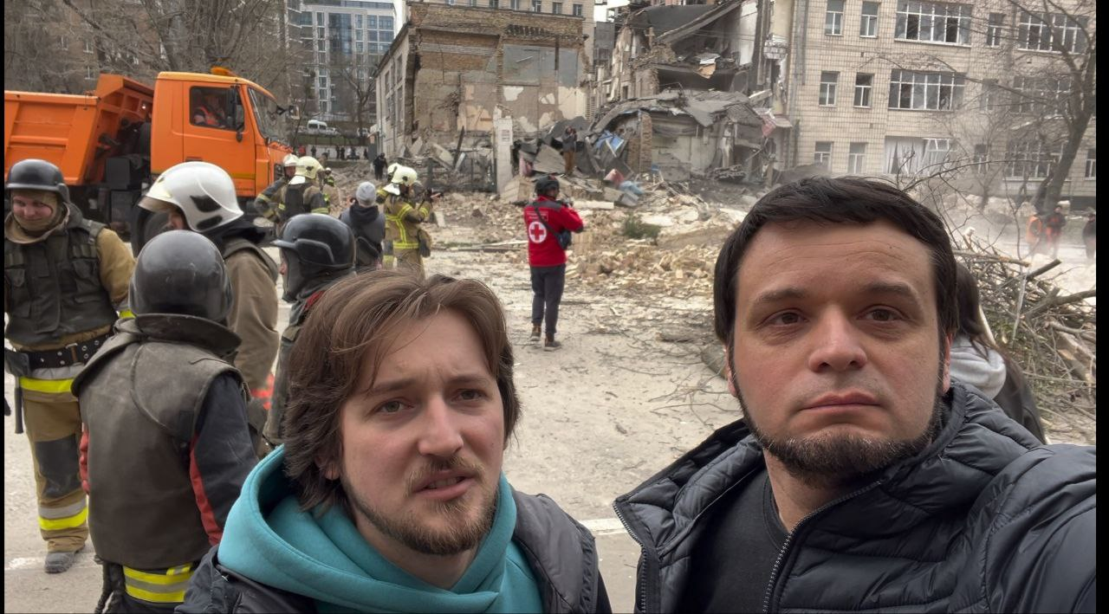

Saturday – 6
Please pray for listeners like Lena, who called FEBC because her husband was a gambling addict. It had gotten so bad that he wanted to end his life. FEBC’s follow-up worker prayed with Lena and gave her resources on how to help her husband. She was also connected with a local pastor. After meeting with the pastor, she and her entire family put their faith in Christ. Please pray for this family, and for the many listeners who are put in touch with churches and ministers in their area.

Sunday – 7
Many churches are facing persecution in Russia, especially in smaller cities. This may continue to grow more severe. Please pray for the church in Russia, and for FEBC-Russia to be able to continue broadcasting the Good News.

Monday – 8
Please pray for the situation with the Kazakhstan government to improve, to allow for more religious freedom, so that FEBC-Kazakhstan can share the Gospel more openly. The ministry is putting on some events with the government, helping people with common social problems. Please pray for these events to draw people to FEBC-Kazakhstan’s ministry and for relations with the government to improve.

Tuesday – 9
Please pray for FEBC listeners like Marta, who called FEBC because she wanted to have an abortion. She spoke to FEBC’s follow-up worker, and they walked through what the Bible had to say about the issue. During the call, Marta wanted to put her faith in Jesus, and they prayed together. “Thank you so much! I know what to do now! I’m going to have this child, I’m no longer afraid.”

Wednesday – 10
Please pray for a new long-from FEBC-Russia video project to reach many Russian-speaking people. Please pray that it reaches many in this time of darkness and deception.

Thursday – 11
Please pray about the problem of Islamization in Kyrgyzstan. Mosques and madrassas are being built everywhere. There is a great need for the Gospel, and sharing the Good News is becoming more difficult due to the rise of Islam. Please pray for FEBC-Kyrgyzstan to continue to shine the light of Christ in the midst of the spreading darkness.

Friday – 12
Please pray for listeners like Elena, whose marriage was in a bad state because of her husband’s adultery. “We decided to stay together, but things are not the same. I don’t trust him. And it was one thing after another. The war started, and I’ve lost close family members. I feel lost, like I’m lost at sea.” FEBC-Ukraine’s follow-up worker helped Elena with her situation and invited her to pray. Elena put her faith in Jesus during the call. “Thank you…I feel so much peace. You helped me look at this with new eyes.” Please pray for the many listeners who are dealing with this problem of adultery, as many have been separated from their spouses for significant periods of time.

Saturday – 13
Please pray for the husband of FEBC-Russia’s broadcaster, Natalia Pronina. The situation is serious. Please pray for healing, and for comfort for their family.

Sunday – 14
Please pray for a new FEBC-Kazakhstan program on family relationships between parents and children. This is a much-needed program for this region, and it can create an open door for Muslim listeners to hear the Gospel. Please pray that it reaches and transforms the lives of many.

Monday – 15
Please pray for listeners like Marina, who was struggling with her divorce and felt alone. “I try to get away from the pain by drinking with my friends, but I can’t talk to them about my problems. I just lock myself in the bathroom and cry when I’m alone.” Marina absolutely did not want to visit a church, but she was willing to pray with FEBC’s follow-up worker. Afterwards, she said, “When I repeated the words of your prayer after you, I felt a great relief in my soul.” Please pray for Marina to come to put her faith in Christ and begin attending a local church.
Tuesday – 16
Please pray for FEBC-Russia’s follow-up team, who are regularly working with listeners who are going through serious issues. Please pray for spiritual, mental, and physical strength, and for wisdom as they help people going through difficult times and situations.

Wednesday – 17
Government persecution, and the suppression of free speech, has been increasing in Kyrgyzstan. The government is exerting control over the media—many journalists have been imprisoned—and they are looking very closely at what is being done through media. Please pray for FEBC-Kyrgyzstan’s ministry to continue to be able to work to share the Gospel with the people of Kazakhstan.

Thursday – 18
Please pray for listeners like Marusya, who was being tormented and paralyzed by anxiety and fear. She called FEBC and asked for help and FEBC’s evangelist prayed with her. Marusya had many questions about prayer and who God was. She put her faith in Jesus and cried as she prayed with the evangelist. “I can feel God’s peace,” she said. “And now I know that He loves me.”

Friday – 19
Please pray for new FEBC-Russia projects producing short videos for teens and children, talking about Christian topics and stories from the Bible in understandable and interesting ways. Please pray for success for each of these projects so that they reach many listeners.

Saturday – 20
There is a widespread problem of Islamization among the young people of Kazakhstan. Many are participating in Islamic traditions without understanding what they are doing, because it has become the popular thing to do. Please pray for FEBC-Kazakhstan’s young listeners—many of them write in to the ministry, interested in Christianity, but having trouble accepting who Jesus is. Please pray for the Lord to open the door to reach the young people of Kazakhstan with the Gospel of Grace.

Sunday – 21
“I started drinking…a lot; and often,” said a listener named Yeva. “Everything seems to be good in my life, I have everything, so why do I drink? I couldn’t even go to work today because I drank so much this weekend.” At first, Yeva wouldn’t pray with FEBC’s evangelist because there weren’t any icons nearby. “How could we pray without icons?” FEBC’s evangelist shared with her that God could be prayed to at any time and any place, and shared with her about the meaning of the death of Jesus Christ on the cross. Then Marusya prayed and put her faith in Jesus. Please pray for her as her new life with Jesus Christ begins.

Monday – 22
Please pray for Noor, a new FEBC-Kyrgyzstan employee who has joined the social media team. Please pray that he helps expand the social media ministry to reach more listeners with the Good News. And please pray for the Lord to bring new people to the ministry.

Tuesday – 23
Please pray for the translation of a Bible program into the Buryat language. The Buryat people are heavily steeped in Buddhism and paganism, but we are seeing a good response to new programs made for the Buryat people.

Wednesday – 24
Please pray for listeners like Ira, who was riddled with stress, anxiety, and loneliness. “My husband was drafted into the war—I can’t handle this.” FEBC’s evangelist encouraged her to seek help from God, focusing on the importance of and power of the Word of God, about faith and relationship with God, and seeking help from others. Ira put her faith in God, asking him to help her deal with this situation, and was connected with a local pastor. Please pray for the many listeners in Ukraine who are in similar situations during this war.

Thursday – 25
Please pray for FEBC-Kazakhstan’s counseling team, who are responding to hundreds of listeners with serious issues, including domestic violence, suicide, abuse, in addition to other widespread family and social issues. Because of the Islamic influence in the country, this is a great opportunity to share Scripture and the Gospel with listeners in a personal way.

Friday – 26
Please pray for the FEBC-Kyrgyzstan team as they are serving in difficult conditions in the country and in their personal lives. Many have family members who are not believers and can put pressure on them. Please pray for strength to continue sharing the Gospel despite persecution.

Saturday – 27
“I’ve made so many mistakes in my life,” said Olga. “I don’t know how my daughter will ever be able to forgive and love me after everything I’ve done in my life.” Olga had called FEBC’s prayer helpline many times, but she had yet to put her faith in Jesus. After FEBC’s evangelist shared the Gospel with Olga, talking through her guilt from a Biblical perspective, Olga put her faith in Jesus and prayed with the evangelist. “Thank you so much!” she said. “I’ve been helped by your prayer helpline so many times, but this time I finally understand what you were trying to tell me!”

Sunday – 28
Please pray for the translation of a Bible program into the Chechen language. The Chechen region is heavily Muslim, so please pray for God’s blessing over the project and protection on those involved. Please pray that many Muslim’s hear the Good News and put their faith in Christ.
Monday – 29
Please pray for the women of Kyrgyzstan who are living under violence and are being put down. FEBC-Kyrgyzstan created a program last year called Noble Womanhood, telling Kyrgyz women about their value before God. Please pray for this program to reach women who are living through violence and are in desperate need of the hope of the Gospel.

Tuesday – 30
Please pray for listeners like Ivan, from Ukraine, who was a soldier until he was wounded. Now, he was a civilian with two broken legs. “I don’t want to live anymore,” he said, crying. FEBC’s evangelist told Ivan about having a relationship with God and prayed with him. Ivan became calm after the prayer. “I want this. I want to give my life to God,” he said. They prayed together, and Ivan put his faith in Jesus. “You gave me hope,” he said. “I don’t want to end my life anymore.” Please pray for the many soldiers returning from the war damaged and broken; they need the hope of Jesus Christ desperately.

