FEBC-Russia & Ukraine February Prayer Focus

Thursday – 1
A soldier named Dmytro called FEBC-Ukraine’s follow up counselors because he was at the end of his rope. “I’ve been in this war for so long. I hate it. I know that alcohol doesn’t solve anything, but I can’t quit.” The soldier shared his struggles with the counselor, about the guilt he felt over the arguments he had with his loved ones. The counselor listened and gave the soldier advice. Then they shared the Gospel with him. “Thank you for spending your time on a person like me. I know that God wanted me to call you.” Please pray for Dmytro to give his life to Christ, and for the many other soldiers who are suffering in the war.

Friday – 2
Please pray for Ihor Sereda as he encourages, supports, and manages the team of FEBC-Ukraine broadcasters. Please pray for the broadcasters to be strengthened spiritually and emotionally.
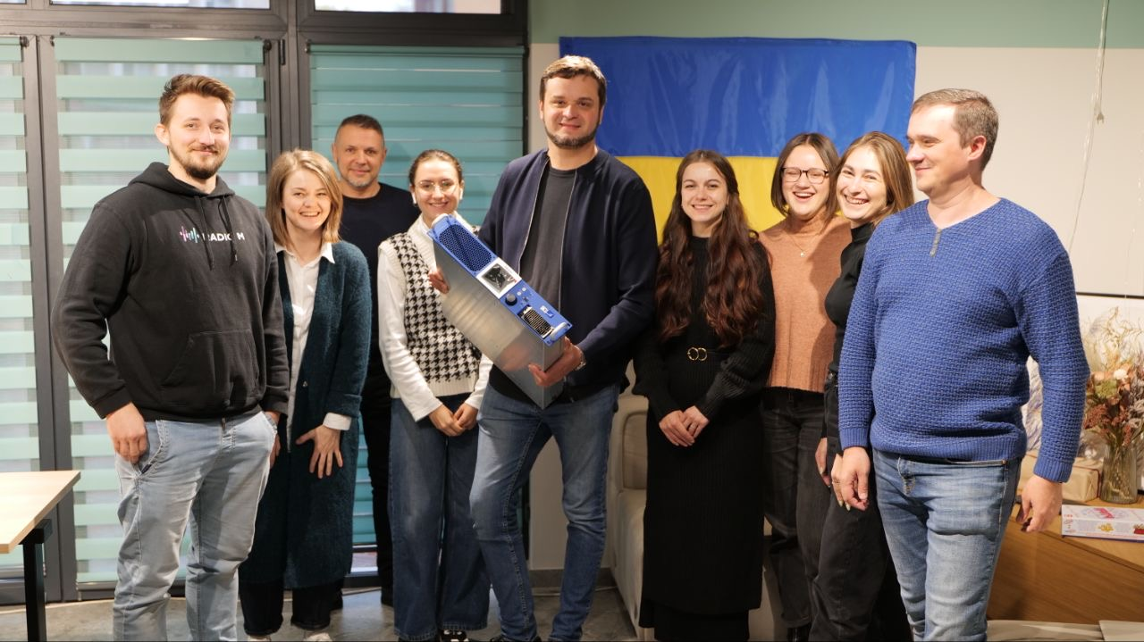

Saturday – 3
Please pray for listeners like Ella, who was divorced and was living with a married man. Things were complicated, and she was confused, so she called FEBC-Ukraine to ask for help. Ella was open to hearing God’s Biblical standards for family, and she prayed with FEBC’s follow up counselor, repenting of her sins and recognizing Jesus as Lord. “Thank you for sharing this with me…I never knew.” Many listeners come to know the Lord because of relationship issues.

Sunday – 4
Please pray for the FEBC-Ukraine’s follow-up counselors, who are speaking with many listeners who are dealing with death, divorce, hopelessness, and suicide on a daily basis. They are interacting with many listeners who are going through very intense situations. Please pray for spiritual and emotional strength for the broadcasters, and for Iryna Nesterenko, who is leading the team.

Monday – 5
Please pray for listeners like Maria, from Ukraine, who was crippled by the negative things her mother had said to her. “How can I live with this?” she said. FEBC-Ukraine’s follow up counselor shared the Gospel with Maria and told her what Jesus said about us. Maria put her faith in Jesus and prayed with the counselor. “Thank you so much. I didn’t realize what God thought about me. Please, pray for my son. He’s fighting in the war. I want him to be safe, and to know Jesus like I do now.”

Tuesday – 6
Please pray for Ilya Bodnari (on the right), who is managing the team in Moldova. He has been traveling across the country, meeting with churches and counselors who are partnering with the ministry. Please also pray for his wife Alina, who is also supporting the ministry, and his young son.
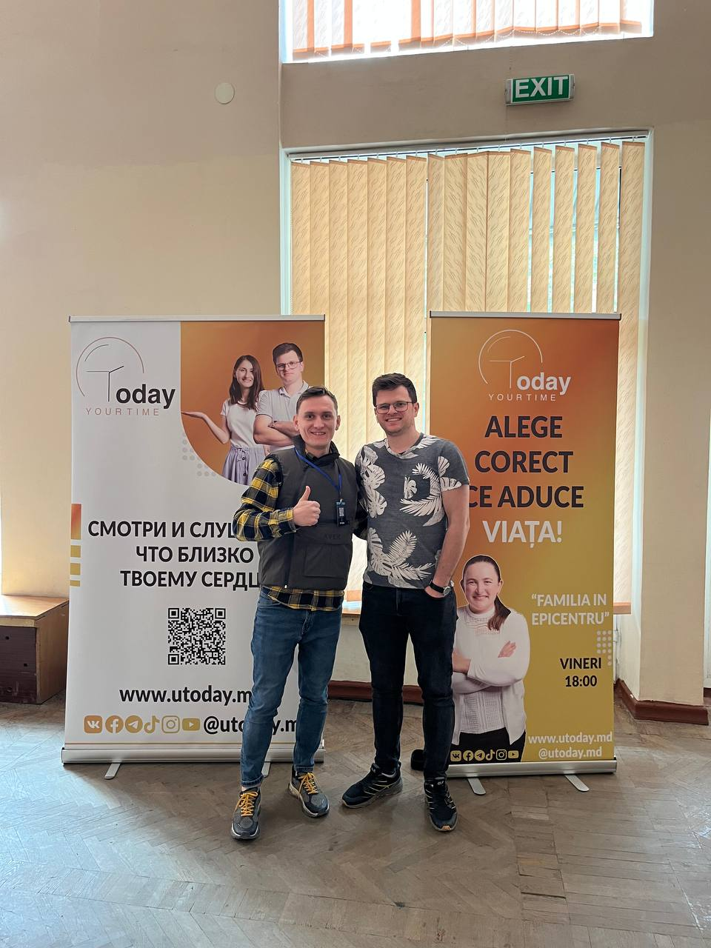

Wednesday – 7
Please pray for listeners like Olga, from Russia, who says, “I’ve started thanking God for the good things in my life, though I don’t know if I believe in Him yet. I had been hurt by others so many times, but I learned from your program that I need to open my heart to God first, then I can understand how to open up to others. My family has seen the change in me and they’re amazed.” Please pray for Olga as she is beginning her journey towards Christ.

Thursday – 8
Please pray for protection for FEBC-Russia’s broadcasters, who are facing great risk at the moment. Please pray for God’s favor and wisdom.

Friday – 9
A listener named Anna was feeling very discouraged when she called FEBC. “It feels like everyone is against me, my neighbors, even my own body—I keep getting sick. I need to know what God says.” FEBC’s follow up counselor told Anna about Jesus, about His sacrifice, and how to become a child of God through Him. Anna was captivated, listening carefully to every word. She prayed with the counselor, giving her life to Jesus and asking Him to rule in her life. Anna was then connected with a local pastor. Please pray for her as she begins her walk with Christ, and for the many other listeners who are searching for answers.

Saturday – 10
Please pray for Elya, FEBC-Russia’s office manager as she helps the team stay as productive as possible as the situation in Russia gets more perilous.


Sunday – 11
Please pray for listeners like Olesia, from Ukraine, who was in despair over her relationship problems. “My husband is leaving me. He has some mental health issues, but I love him so much. I don’t want him to go!” When FEBC-Ukraine’s follow-up counselor shared the Gospel with her, Olesia was moved. “I didn’t know God loved me so much!” She prayed with the counselor, putting her faith in Jesus as her Lord and Savior and asking Him for help. “Thank you! I didn’t think it was possible for me to feel this happy in this kind of situation!”

Monday – 12
Please pray for new believers in Kyrgyzstan who often have nowhere they can go to learn and grow in their faith. Many listeners have no churches in their small villages. The FEBC-Kyrgyzstan team is ministering to these listeners, encouraging them and sharing teachings of the faith with them.

Tuesday – 13
Please pray for Lesia, from Ukraine, a young lady who had a tumultuous home life. “I live with my aunt, and her boyfriend is constantly yelling at me and cursing me. I don’t know what to do.” Lesia was also searching for meaning, and for God, but didn’t know where to look. She had been approached by some followers of another religion and was confused. FEBC-Ukraine’s follow up counselor shared the Gospel with her and encouraged her to read the Bible. She was also excited to come to church when she found out there was one near her. “Thank you! I can’t wait to go!”
Wednesday – 14
Please press for Inna as she works one on one with listeners after programs, sharing her testimony and telling them further about the Lord. Many are coming to know the Lord through these deeper conversations.
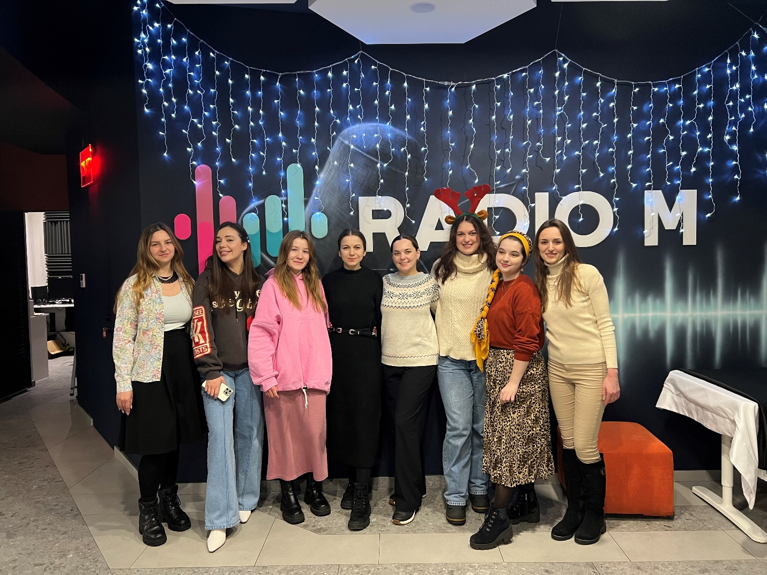

Thursday – 15
Please pray for listeners like Irina, from Russia, who believed in the power of the forces of nature. “Your program helped me in many ways. Your advice helped me look at my life in new ways and handle my problems better. But what I really needed was your faith in God. My life was a mess, but when you prayed for me, I knew things were going to change. I’m afraid to turn to God just yet…For now, I’ll keep watching you and learn what it means to believe in God!”

Friday – 16
Please pray for the ministry in the Buryat Republic, in Russia, which is heavily Buddhist. Please pray for the young people who are coming to faith in Christ.

Saturday – 17
“Today, after we had an argument, my son attempted suicide,” said Lyudmila, a listener from Ukraine. “Thank God he is alive. He is now in the hospital. My son has a drug problem, and he started stealing from our family members. That’s why we argued. But I still feel guilty.” FEBC-Ukraine’s follow up counselor shared with her about God’s Love and strengthening. Lyudmila prayed with the counselor and asked God to reveal His love for her and to strengthen her. “Thank you for reminding me that I can rely on God.” Please pray for Lyudmila to be encouraged and for her son to come to know the Lord.

Sunday – 18
Please pray for the technicians and leaders of FEBC-Ukraine as they manage the restructuring of the antennas for the station in Kyiv, as well as installing the new Canadian made transmitter, which will help us to reach tens of thousands more listeners in Kyiv and surrounding areas.

Monday – 19
Please pray for listeners like Lena, from Russia, who had lost hope after seeing the evil around her. “Watching your program has revived hope in my heart…hope that God is actually good, and is, in fact, stronger than the devil. Thank you for bringing to life my faith in God!”

Tuesday – 20
Please pray for Natasha, who is leading FEBC-Russia’s follow up counselors. Please pray for the follow up team, for Natasha’s family, and for God’s protection, wisdom, and strength.
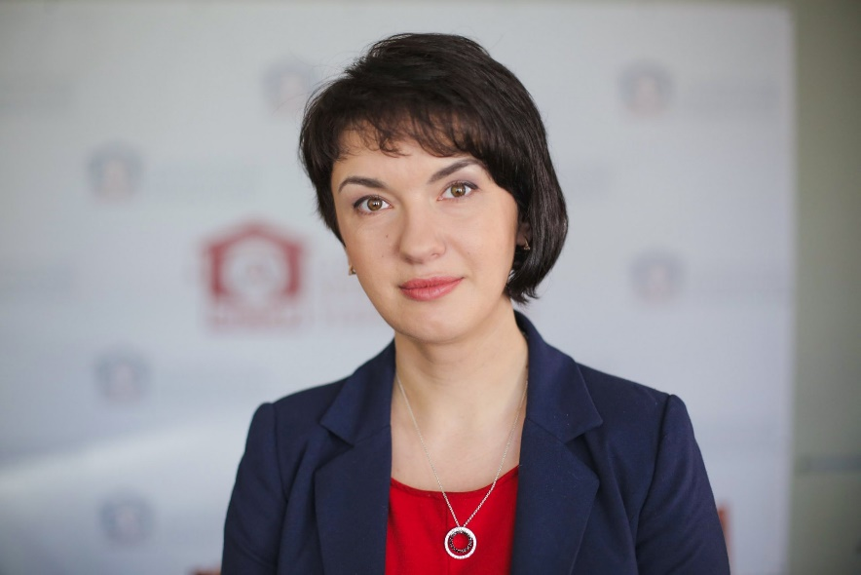

Wednesday – 21
Please pray for listeners like Yulia, who found out she was pregnant after breaking up with her boyfriend, and was considering getting an abortion. FEBC-Ukraine’s follow up counselor talked to Yulia about God’s perspective on abortion and they prayed together. They also gave her the contact information to an organization that offered shelter and support to pregnant women. Please pray for Yulia to come to know the Lord, and for the many other women in Ukraine in a similar situation.

Thursday – 22
Please pray for Dima and Darina, as they are living in a dangerous city of Ukraine where they minister to the people in need. Donna is also one of FEBC-Ukraine’s videographers and reaches many people through his videos. Please pray for protection for their family and for God to continue to bless their work with FEBC and with those in need in Mykolaiv.

Friday – 23
Please pray for the ministry in FEBC-Kazakhstan, especially the young team members who have such a passion for God and are reaching many young people with the Good News. Please pray for Aizhan, Ulan, and Aruzhan, among others.

Saturday – 24
Today is the two-year anniversary of the war in Ukraine. Countless lives have been lost. Marriages have ended. People have been brought to the end of themselves. Please join us in praying for the Lord to bring an end to the war in Ukraine, and to bring the healing that can only come through His Son, Jesus Christ.

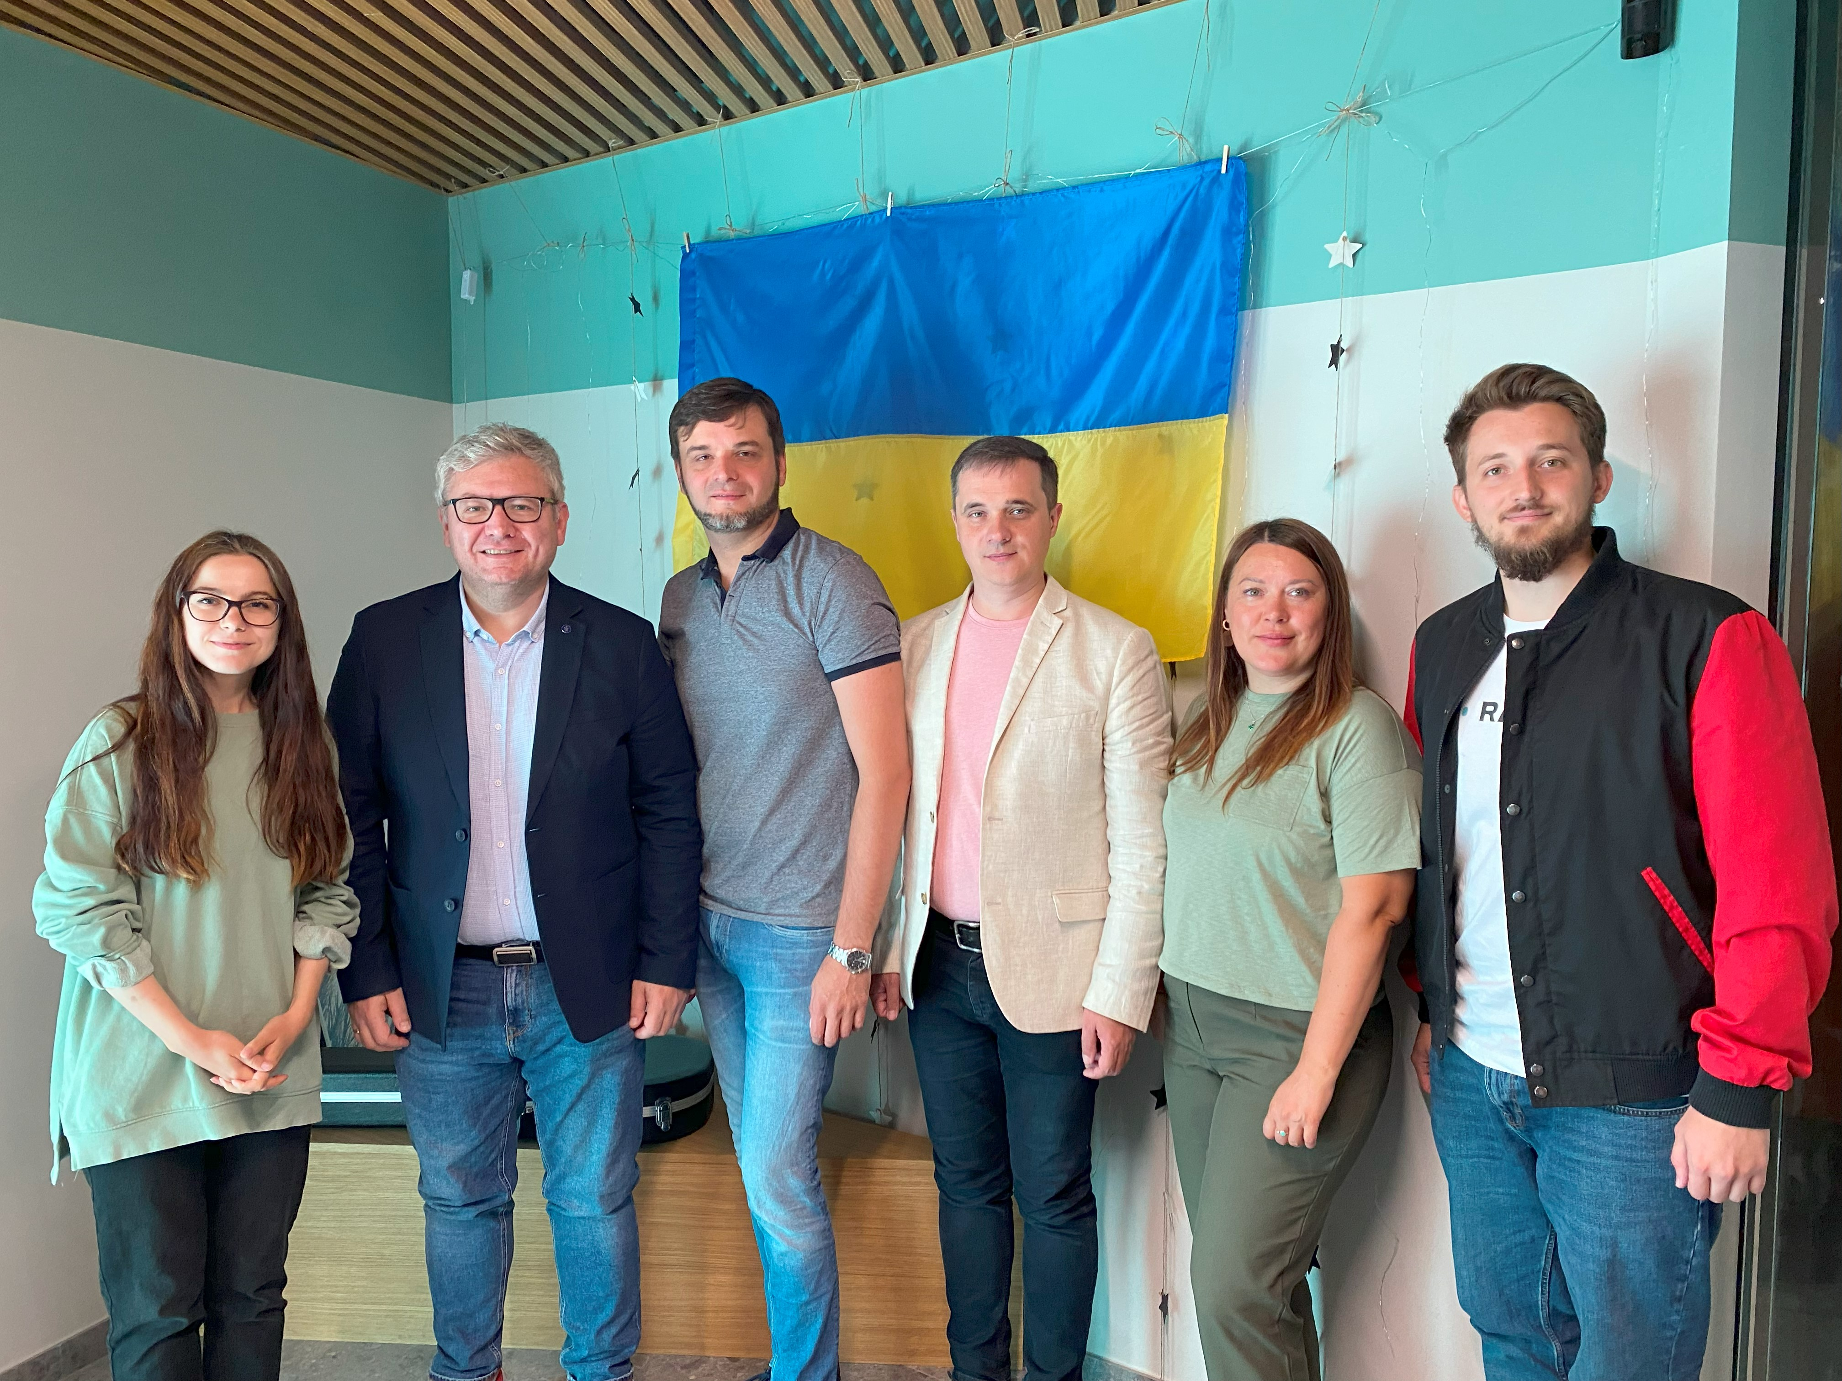

Sunday – 25
Please pray for women who are struggling on their own while their husbands are away at war, like Milena. “I have a lot of children and my husband is away, fighting in the war. It’s been so long, and money is getting tight. Sometimes I drink to deal with the pain.” FEBC-Ukraine’s follow up counselor told Milena about God’s Love and care for people, and they prayed together. Please pray for Milena to come to know the Lord, and for her husband’s safety and salvation.

Monday – 26
Please pray for the new follow up team in Moldova, who are ministering to listeners in response to the large number of messages they have been receiving. The first day they invited listeners to write to them, they had more than 60 conversations with listeners.

Tuesday – 27
Please pray for listeners like Alexey, from Russia, who was experiencing mental anguish over a loved one’s fatal illness. “I was doing everything I could to help them. I started going to church, lighting candles, praying as well as I could. I felt a little better, but the pain was still there. I was in despair. A friend recommended your program to me. As I listened, I learned that it was Jesus who did it all, and that my “good works” didn’t earn anything. Now I’m relying on Him, not on myself!”

Wednesday – 28
“I listened to your program, but I didn’t really believe in God. Not until my mother died. She believed, and when she died, I felt it. I could feel that no one was praying for me anymore…I felt a deep loneliness. I started listening to what you said about God differently after that. I started to really trust you and what you were saying about God. One day, I turned to God—to the God that my mother believed in and that you believe in.” Please pray for Andrey, from Russia, who recently put his faith in Christ. Please pray that he continues to grow in his faith.

Thursday – 29
Please pray for the soldiers who are listening to FEBC-Ukraine on the frontline of the war. Many soldiers listen to the programs, call the broadcasters and follow up workers for prayer, and write in to thank the broadcasters for giving them hope in the midst of such darkness.

