FEBC-Russia & Ukraine January Prayer Focus

Monday – 1
FEBC-Ukraine received a permanent license to broadcast in Kyiv, the capital of Ukraine, for 10 years, praise God! Please pray for this station to continue reaching more and more listeners with the Good News of Jesus Christ! The Kyiv station has generated the most response from listeners of any of our stations, and reaches the most people with the Gospel.

Tuesday – 2
Please pray for listeners like Sergey, from Russia, who was offended by the message of Christ until he heard two different suffering women receive help. “On your broadcast, you helped a woman who lost her son in the war in Ukraine. She was from Russia. And on the same broadcast, you helped another woman whose relatives were killed in Ukraine, and she was from Ukraine. It shocked me that you helped both. And you said that every person needs Christ, because He died for everyone. I realized that I needed to learn more about Jesus, to figure out who He was.”

Wednesday – 3
Please pray for Natalia, the host of the FEBC-Russia program for prisoners. This program gives those in prison, and their families, the hope of transformation and life in Christ. Many prisoners give their lives to Christ and many families are saved through these programs.
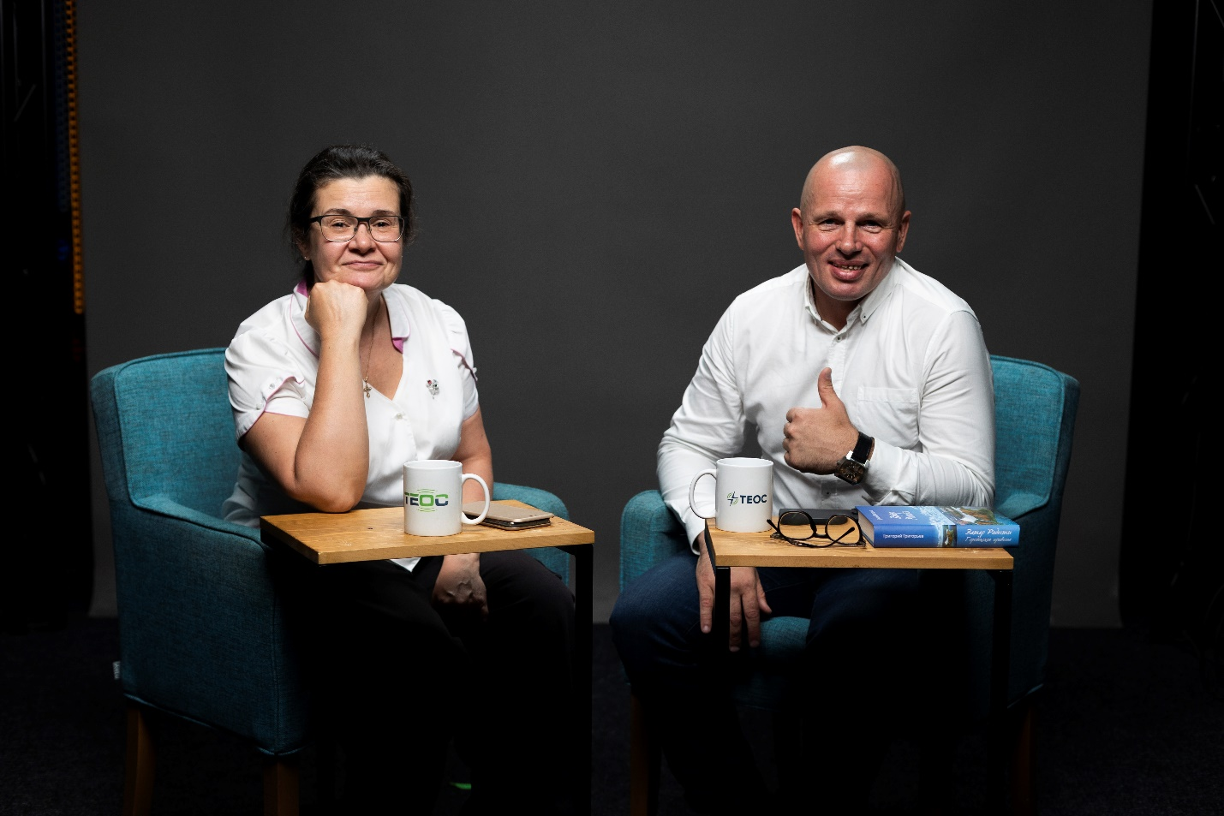

Thursday – 4
Please pray for the many families that are breaking up during this time of war. “My wife is leaving me,” said Ivan. “She’s right. I’ve treated her badly, but I don’t know what I can do.” Ivan felt hopeless because he didn’t know how he could change, but as he heard about Jesus, he wanted to know more. Ivan put his faith in Jesus and prayed with one of FEBC’s follow up workers. “I didn’t know I could feel this way. I didn’t know it was possible to change!” Please pray for Ivan in his new walk with God and for his marriage to be transformed.

Friday – 5
Please pray for FEBC-Moldova’s new team members who are reaching many listeners through short videos. Many listeners are responding and having conversations about their struggles and are getting to hear the Gospel. Please pray for the reach of this ministry to continue to grow, as tens of thousands, and sometimes millions, are hearing the Gospel message.

Saturday – 6
Please pray for listeners like Rebecca from Ukraine, who lost her brother in the war a year ago. “Thank you for being there for me as I was going through a really difficult time. I was looking for answers, and you helped me find them. And now I’m in church!”

Sunday – 7
Please pray for Sergey, FEBC’s senior broadcaster who is now serving as a chaplain in Ukraine. He recently came from a dangerous part of the war, where he is supporting the soldiers, praying with them, and sharing the Gospel with them. He will soon be returning there. Please pray for God’s hand of protection to be on him and for many soldiers to come to the Lord.
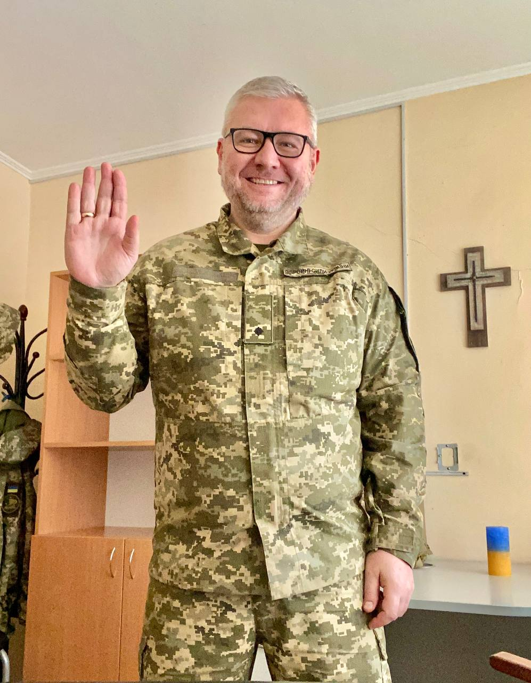

Monday – 8
Please pray for listeners like Alina, from Ukraine, who was having panic attacks and was thinking about ending her life. “I don’t understand it. Everything seems to be going okay, but I don’t see any meaning in life.” As FEBC’s follow up worker shared with Alina how meaning can come only from God, Alina had many questions. Soon, she was praying with the follow up worker. “Thank you. I was in such a panic, in so much stress, but that’s gone now.” Please pray for Alina to continue turning towards God and to be connected with a church.

Tuesday – 9
Please pray for FEBC-Moldova’s follow up team, as they are reaching many listeners in a deeper, more meaningful way agree listeners respond to a program. These dialogues are leading to salvations and real life changes.

Wednesday – 10
Please pray for listeners like Tatyana, in Russia, who are beginning to open their hearts to the Gospel. “I don’t know if there is a God or not. You constantly mention Him in your broadcasts. You became the first believer whose words about God made me seriously think about the existence of God. I used to consider religious people to be fanatics or weird, but now…”

Thursday – 11
Please pray for Oleg, who hosts a Bible program for FEBC-Russia to which many listeners respond, from within and without Russia. Many have come to know the Lord through this program.
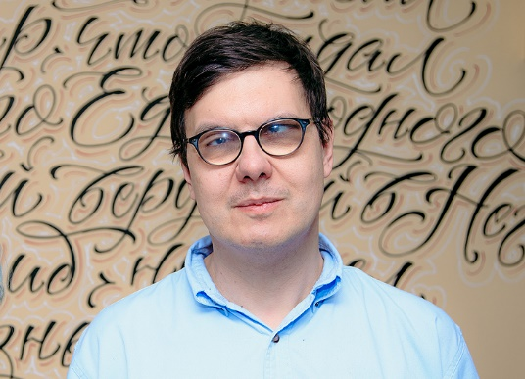

Friday – 12
“My relationships are falling apart,” said a listener named Mariya. “My husband and I keep fighting. My daughter doesn’t want to be close to me. I just don’t understand why this is happening to me.” As an FEBC follow up worker prayed with her, Mariya was very moved. “I didn’t know you could talk to God like that. Like you know Him personally.” Mariya prayed to accept Jesus, put her problems into His hands, and decided to join a Bible study. Please pray that Mariya grows in her newfound faith.

Saturday – 13
Please pray for Ukrainian soldiers who are suffering greatly, as winter sets in and the brutal fight continues. Many tune in to FEBC radio while they are on the frontlines, and many are coming to know the Lord in the midst of great struggle and loss.

Sunday – 14
Please pray for listeners like Antonina from Russia, who was watched one of FEBC-Russia’s programs about painful relationships with people. “Thank you so much!” she said. “My soul was sick with pain and grief over broken relationships, but when I listened to you, my soul began to heal. For the first time in my life I decided to go to church! And I prayed for you! You have no idea how much you have helped me!”
Monday – 15
Please pray for listeners like Nikolai, who was watching as everything around him seemed to collapse. “My wife is leaving me, my children want nothing to do with me…I was looking for a support group when I found your programs. I started watching them, and now, some new reality is opening up for me. Something I had known nothing about before. Your programs are helping me build a new foundation for my life.”

Tuesday – 16
Please pray for the women’s meetings taking place across Ukraine, where listeners with little or no exposure to Jesus are coming together to study the Bible and hear about Jesus. Several have begun attending church and some have even been baptized. Please pray for the Lord to use this part of the ministry to reach many women who are struggling in this time of war with the Good News.

Wednesday – 17
Please pray for listeners like Ludmila, who called FEBC because her son had been diagnosed with an illness. “I can barely talk about it. It feels so helpless.” After praying with one of FEBC’s follow-up workers, she said, “Thank you. I’ve never felt so moved.” Ludmila put her faith in Jesus, was given resources, and was connected with a pastor. Please pray for her and for the salvation and health of her son as they go through this difficult time.

Thursday – 18
Please pray for Igor, the host of several programs for FEBC-Russia, including a Bible program and a program for parents of special needs children; many listeners respond and are connected to churches. Igor and several of his family members are currently experiencing health issues. Please keep them in your prayers.


Friday – 19
Please pray for listeners like Artem, whose entire lives are being destroyed by alcoholism. “I can’t get any peace. I’m constantly arguing with my mother. She wants me to stop drinking, but I can’t. I want to stop. I want to have a family.” Artem responded to the Gospel and put his faith in Jesus, and he was connected with a local pastor. Please pray for his freedom from alcoholism as he begins his journey with Christ.

Saturday – 20
Please pray for listeners like Leonid, who left Russia because of what was happening with the war. “I had tried going to church before, but never really joined. But now, I watch your programs and I am learning so much about Christianity. I’m looking for a local church to attend.” Many listeners who are being shaken by what is happening in their country are beginning to take faith in Christ seriously. Please pray for Leonid’s salvation and for him to be connected with local believers.

Sunday – 21
Please pray for listeners like Pavel, many of whom are dealing with depression, aggravated by the current situation in Ukraine. “Everything is grey…I don’t see a way out.” As Pavel learned about the Word of God and about having a personal relationship with Jesus, he made the decision to put his faith in Jesus and was connected with a local church.

Monday – 22
Please pray for Evgeny, the host of FEBC-Russia’s most popular program, who is receiving many comments like this one, “I didn’t believe in God, but as I kept listening to your program, and putting your advice into practice, I started to see my life transform. Now I know that God is helping me through you.” Many are interacting with Evgeny’s programs and are coming to know the Lord.
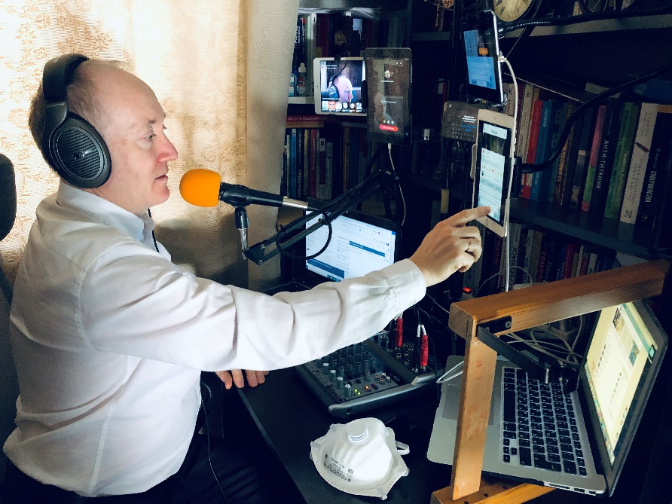

Tuesday – 23
Please pray for listeners like Elizabeta, who felt like she had lost everything in her life. “Something is wrong with me. I stopped eating. I don’t go outside. This war…I lost my job, and the man I was living with left. I have no friends or relatives to confide in.” As she heard about the Love of God who is always there, she wanted to pray. “Somehow, I never considered God. I was always strong, intelligent, but I no longer had the strength to do anything…You showed me that I could turn to the only one who could truly support me, God.” Please pray for Elizabeta as she begins her journey towards the Lord.

Wednesday – 24
Please pray for listeners like Maxim, who first heard about Jesus when he accidentally walked into a church after wandering the streets in despair. “When I first heard about Christ, I started to cry. I was afraid to stay in the church then, but I wanted to read the Bible. Then, on the Internet, I found your programs. A lot of things are beginning to fall into place.” Please pray for his salvation as he seeks the Lord.

Thursday – 25
Please pray for listeners like Igor, who was born disabled, and was dealing with pain every day of his life. “For a long time, I could not believe in God, because I did not believe that God could allow me to go through such suffering. But then I met some Christians who began to help me, talked with me, and brought me to church. I was baptized, although I still have many questions about my faith in God. Your programs help me understand what is happening inside of me. It’s still difficult for me to trust God, but thanks to your broadcasts, I’m learning how.” Please pray for Igor to be built up in his faith, to be built up in God’s Love.

Friday – 26
Please pray for listeners like Dmitry, from Russia, who was being overwhelmed by the darkness he was seeing around him. “I started watching your programs, and I started to have hope again. Thank you for being there for us.” Please pray for listeners to turn to Jesus as they see the darkness spreading around them.

Saturday – 27
Please pray for Mila, a young woman who believed in God but hadn’t ever read the Bible. “I’m learning so much from your programs! It’s amazing to hear about God’s love and mercy! I want to carefully read through the Gospels now so that I can get to know Jesus better.” Please pray for Mila, and the many young people like her, to come to faith in Christ.

Sunday – 28
Please pray for listeners like Pyotr, whose wife went to see a shaman and came back changed. “It’s as if she’s not herself. I can’t get through to her.” Pyotr agreed that there was a God, but was afraid to pray himself. Please pray for listeners who are experiencing spiritual attacks and bondage to find the freedom only found in Christ.

Monday – 29
Please pray for Ivan, who started to feel that the way he was living was leaving him empty and depressed. “After I moved to the big city, I spent my free time partying and drinking. But this just left me depressed and considering suicide. I started looking at how I could change, and then I found your programs. I’ve tried praying, and your programs are really helping me understand the Bible better.” Please pray for Ivan as he begins his journey towards the Lord.

Tuesday – 30
Please pray for listeners like Vitaliy, who wrote to an FEBC-Russia program because he was confused. “I’ve been talking to Christians online for a long time,” he said. “But I’m afraid of coming to church because of some of the things I hear Christians say.” As he spoke to the broadcaster, he began to understand that the fact that there were imperfect people at church didn’t mean that he shouldn’t go, but that he could come as he was and could learn and grow in his faith there. Vitaliy decided to try coming to a church service. Please pray for him to come to the saving knowledge of Jesus Christ.

Wednesday – 31
Please pray for listeners like Alina, who was having serious problems at home. “My life is in shambles. We’re constantly arguing. I just got out of an ambulance. My blood pressure rose as we argued, and I fainted. I just want to end my life.” Alina was desperate for a change. When an FEBC follow up worker discussed God, at first, Alina was offended. “Why would He let my life be like this?” But as she heard about God’s love and salvation, she chose to put her faith in Jesus. “Thank you so much! I feel a calm in my soul that I’ve never felt before!”

