FEBC-Eurasia December Prayer Needs

Sunday – 1
“I almost became a drug addict after my mother died. She was my best friend. I didn’t have any friends, no family I could talk to. Just work. I felt like a robot. Except when I watched your broadcasts…through them, God breathes life and strength into my soul.” Please pray for listeners like Artem who are coming to faith through FEBC’s programs in Russia.

Monday – 2
Please pray for the members of FEBC-Ukraine’s team who have been drafted into service and for those who are waiting for their loved ones to return from the war. The husband of one of FEBC-Ukraine’s helpline evangelists, Natalie, was injured on the frontlines. Another is waiting for her husband to return from the war.

Tuesday – 3
Please pray for FEBC-Moldova’s children’s programs, which are reaching many young listeners. We are seeing a great response, and are praying for many children to be introduced to Jesus through these programs. Please pray for the Lord to bring more broadcasters to participate in this ministry.
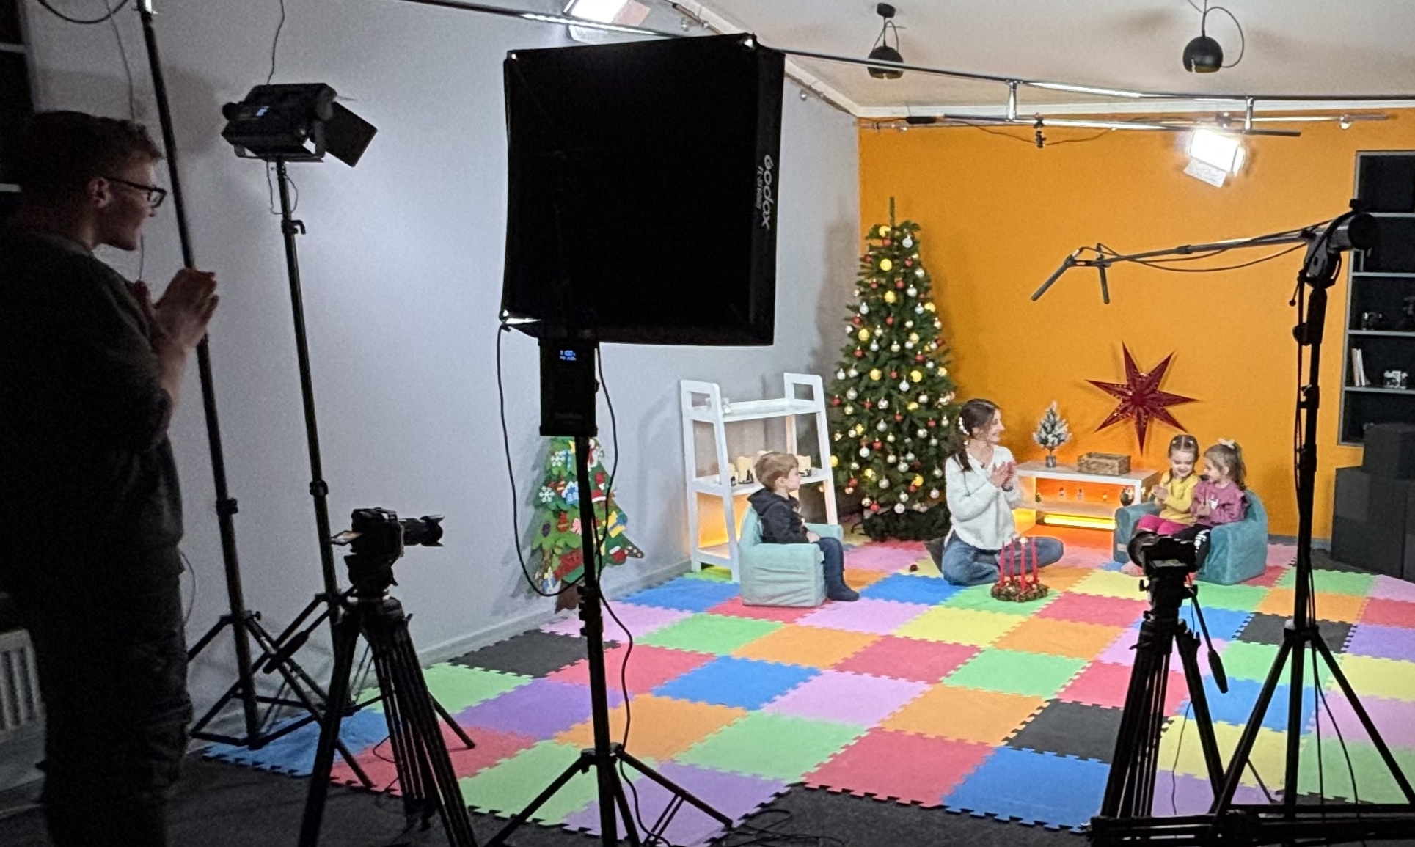

Wednesday – 4
“I’ve been depressed for such a long time now,” said Olena. “My mother died. Then it was just one thing after another: I got robbed, had difficult times at work…” Olena wanted to understand more about prayer. FEBC’s evangelists told her about God’s love and His desire to be with her and to help her. Then they prayed with Olena, and she put her faith in Jesus. Please pray for listeners like Olena who are finding true hope in Christ through FEBC’s ministry.

Thursday – 5
Please pray for FEBC-Russia’s Christmas lineup of programs. This is a time where listeners are particularly open to hearing the message of Christ. Please pray for the Lord to reach listeners through these programs and that many turn to Him and reach out to the FEBC team.
Friday – 6
A new, more restrictive, law on religious freedom has been introduced in Kyrgyzstan. It is currently in the approval stages, and there is a rush to adopt it. Please pray for God’s mercy and protection over FEBC-Kyrgyzstan’s ministry and the churches of Kyrgyzstan.

Saturday – 7
“I was so trapped by my fears,” said Vera. “I was so afraid that my loved ones would die. I tried not to think about this, I even tried praying, but nothing helped. As I’ve watched your program, I’ve learned how to deal with my fears, and I realized why my prayers didn’t give me any comfort—I wasn’t sure I actually believed in God. Since then, I’ve been thinking about God a lot. Listening to your conversations, and asking questions while you’re on the air, has been so helpful. I am learning to believe in God with your help!” Please pray for listeners like Vera, who are coming to know the Lord despite difficult situations.

Sunday – 8
Russian attacks have been targeting Ukraine’s energy infrastructure, and there have been large power outages. While the FEBC-Ukraine studio has a power generator, please pray for these power outages to be managed and to stop entirely. And for FEBC-Ukraine’s Gospel proclamation to continue without interruption.
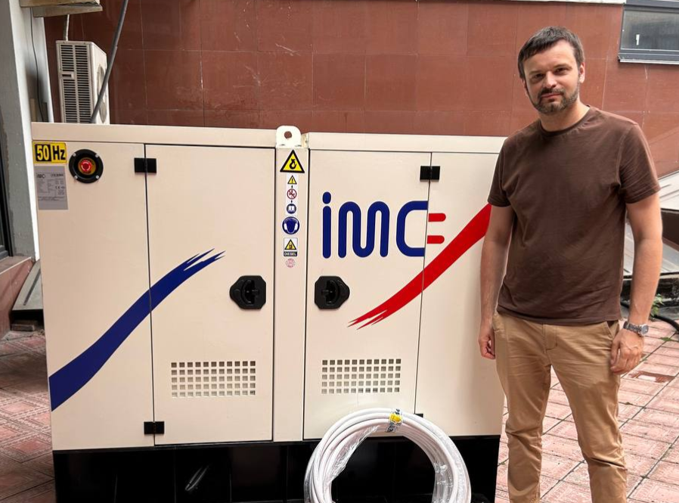

Monday – 9
Please pray for FEBC-Moldova’s vloggers, who are reaching many young people with their videos. Many viewers will respond in the comments and have conversations about Jesus with the vloggers. Please pray for the Lord to bring the right people to join the team as this ministry continues to grow.

Tuesday – 10
“My husband cheated on me…Whenever we have fights, I remember his infidelities. And, every day, the feeling that something inside me was dying continued to grow. It became impossible to live like this—the meaning of life was gone, there was no hope. Your broadcasts literally began to save me, because sometimes, thoughts of suicide and other negative thoughts would rise up. Your broadcasts inspired me. The things you teach help me survive. You say God is Love. It’s hard for me to believe this, but I feel that you’re right. I want to believe it. Thank you!” Please pray for listeners like Svetlana, so many families are falling apart during the uproar in this part of the world.

Wednesday – 11
Please pray for new children’s programming being created by the FEBC-Russia team for the Christmas season. Children’s programs are often requested by parents, and even airlines in Russia. The need is great. It is not uncommon for parents to come to church because their children put their faith in Christ through our programs.

Thursday – 12
Please pray for FEBC-Kyrgyzstan’s partnerships with local churches. This partnership is vital to the ministry, helping with broadcasting and ministering to listeners once they come to Christ. Many people lose everything when they put their faith in Christ and need the support of the body of Christ.
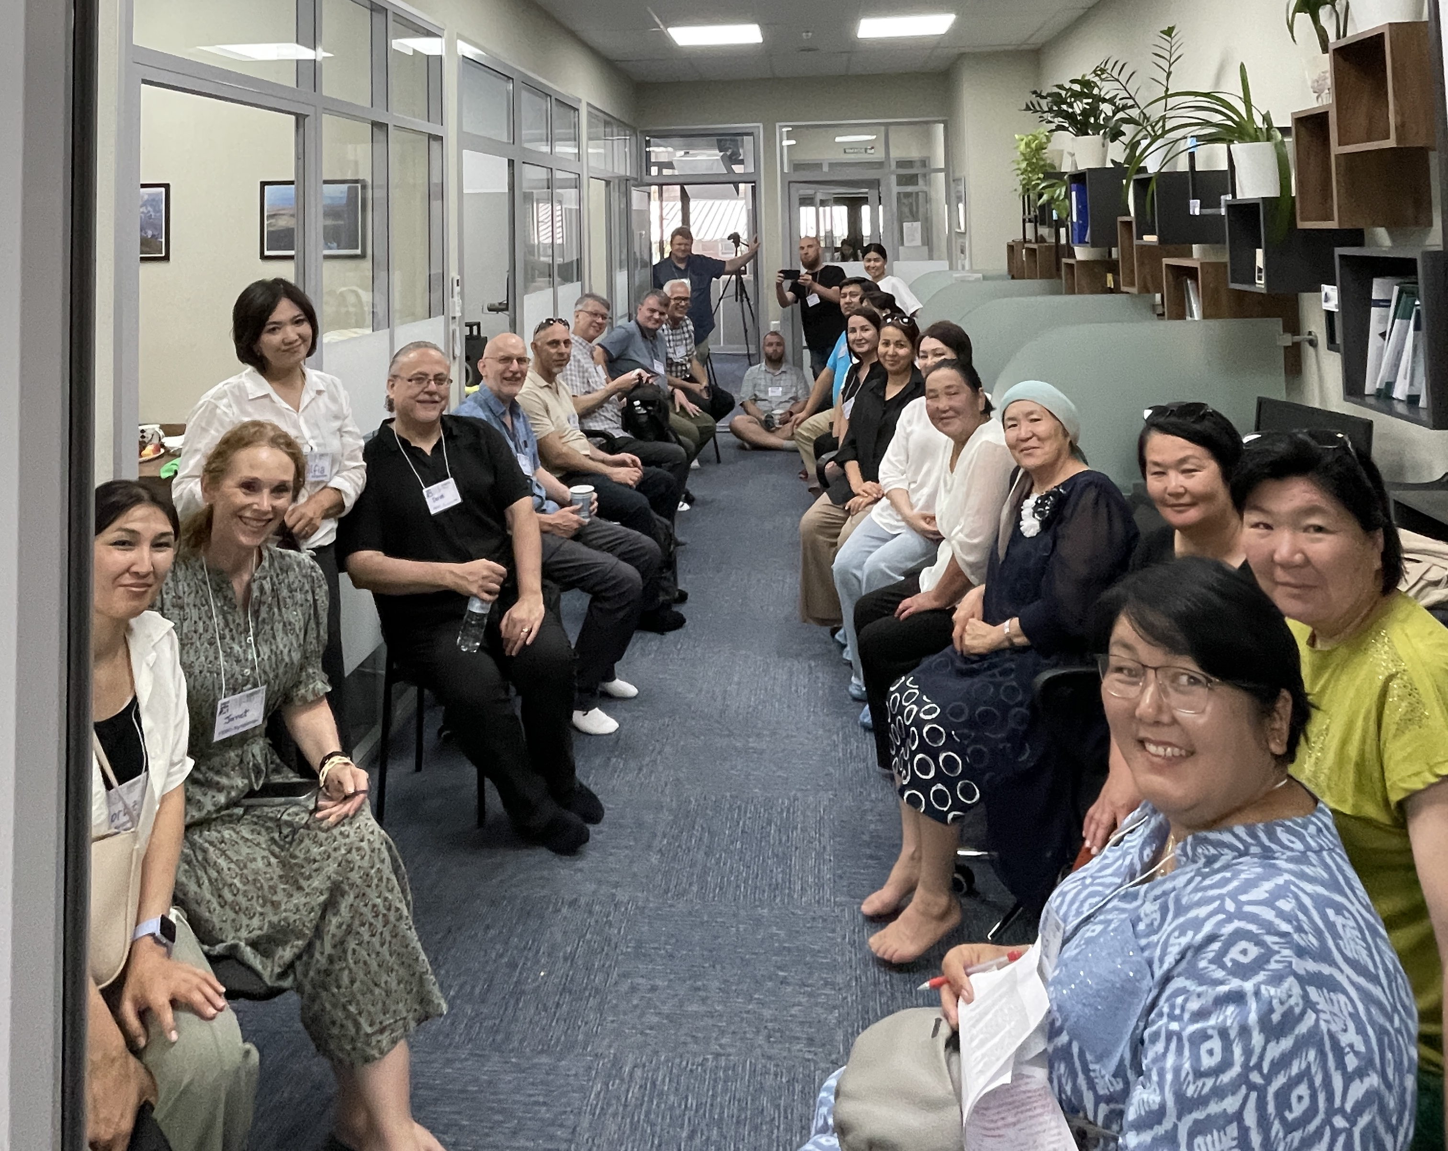

Friday – 13
“I didn’t think that I deserved love,” said Olga. “I had been depressed for a very long time, and I felt myself seeking back into that depression, and I was terrified. And that’s when I heard from you about God’s love and salvation. I learned that my value comes from God. And that the Bible shows me how much God loves me. Now I’m planning to come to the church you recommended!” Please pray for listeners like Olga who are finding value and meaning in Christ.

Saturday – 14
Please pray for the in-person women’s meetings that are being held at FEBC-Ukraine’s studio by Inna and Emma. These meetings are being held with female listeners of all ages, most of whom have no experience with or understanding of Christianity. They come together to hear from broadcasters like Inna, read the Bible, and pray together. Several have given their lives to Christ and are now in church.
Sunday – 15
Please pray for FEBC-Moldova’s teenage ministry, where dozens of teens meet regularly with broadcasters to talk about their lives and struggles, hear about Jesus, and read the Bible together. Most of these teens have no background in Christianity. Please pray for this ministry to expand across Moldova.

Monday – 16
“How do I keep myself from falling apart? I’m going through the most difficult period of my life. I’m struggling at work, with friends, and, on top of all that, my wife just left me. I don’t know what to do.” Vadim prayed with FEBC’s prayer evangelist, putting his faith in Jesus. “I want to have a real relationship with Him,” said Vadim. Please pray for Vadim as he begins his journey with Christ.

Tuesday – 17
Please pray for those ministering in Russia as they are dealing with increasing political restrictions and dealing with the effects of rising inflation. Thank you for your prayers and spiritual support!

Wednesday – 18
FEBC-Kazakhstan has been seeing great results at reaching young people through TikTok videos. They recently held a 2-day meeting in the city of Shymkent, where they met with people from their audience. They were able to hand out Bibles and tell them more about Jesus in person. Many young people are looking for spiritual life. Please pray for them to find it in Jesus Christ!

Thursday – 19
“It's been just over a month since my dad died,” said a teen girl named Lena. “Life at home was difficult. Dad was an addict. I can’t really talk to my mom about my feelings because she has always been cold and distant. Thank you for telling me about my Heavenly Father. That He cares about me, and that I can talk with Him. Thank you for showing me the love He has for me!” Please pray for the many teens like Lena, who are living in difficult circumstances throughout Eurasia. They need to hear the hope of the Gospel.

Friday – 20
Please pray for protection for the FEBC-Ukraine team in the midst of daily attacks. By God’s blessing, no lives have been lost among the team. But every day, people die and are injured in the attacks—everyone on the team has lost someone.

Saturday – 21
Please pray for the leadership of FEBC-Moldova, Ilia, Alina, Arsenie, Vanya, and Andrei as they help build the ministry in Moldova. Many people are being reached with the Gospel, both atheists and people who are nominally religious. Those who are religious are often more opposed to the Gospel than atheists at first. But people’s hearts are opening to the Gospel in surprising ways. Please pray for the Lord to continue growing the FEBC-Moldova team.

Sunday – 22
“My husband and I have been living apart for over half a year now,” said a listener named Lyubov. “We both love each other, but we can’t seem to work things out. Things just keep getting worse. It’s been such a blessing to learn about relationships from your programs. I’ve started applying what I am learning to my own marriage.” Lyubov put her faith in Jesus as she spoke with FEBC’s prayer evangelists. “Thank you for helping me in one of the most painful times of my life. Now I have a relationship with God, and I know that He is with me!”

Monday – 23
Please pray for FEBC-Ukraine’s follow-up helpline. Calls about suicidal thoughts and intentions are frequent, many of them from teenagers. Please pray for wisdom for the follow-up workers and that God will reveal the meaning of life to those who have lost it.
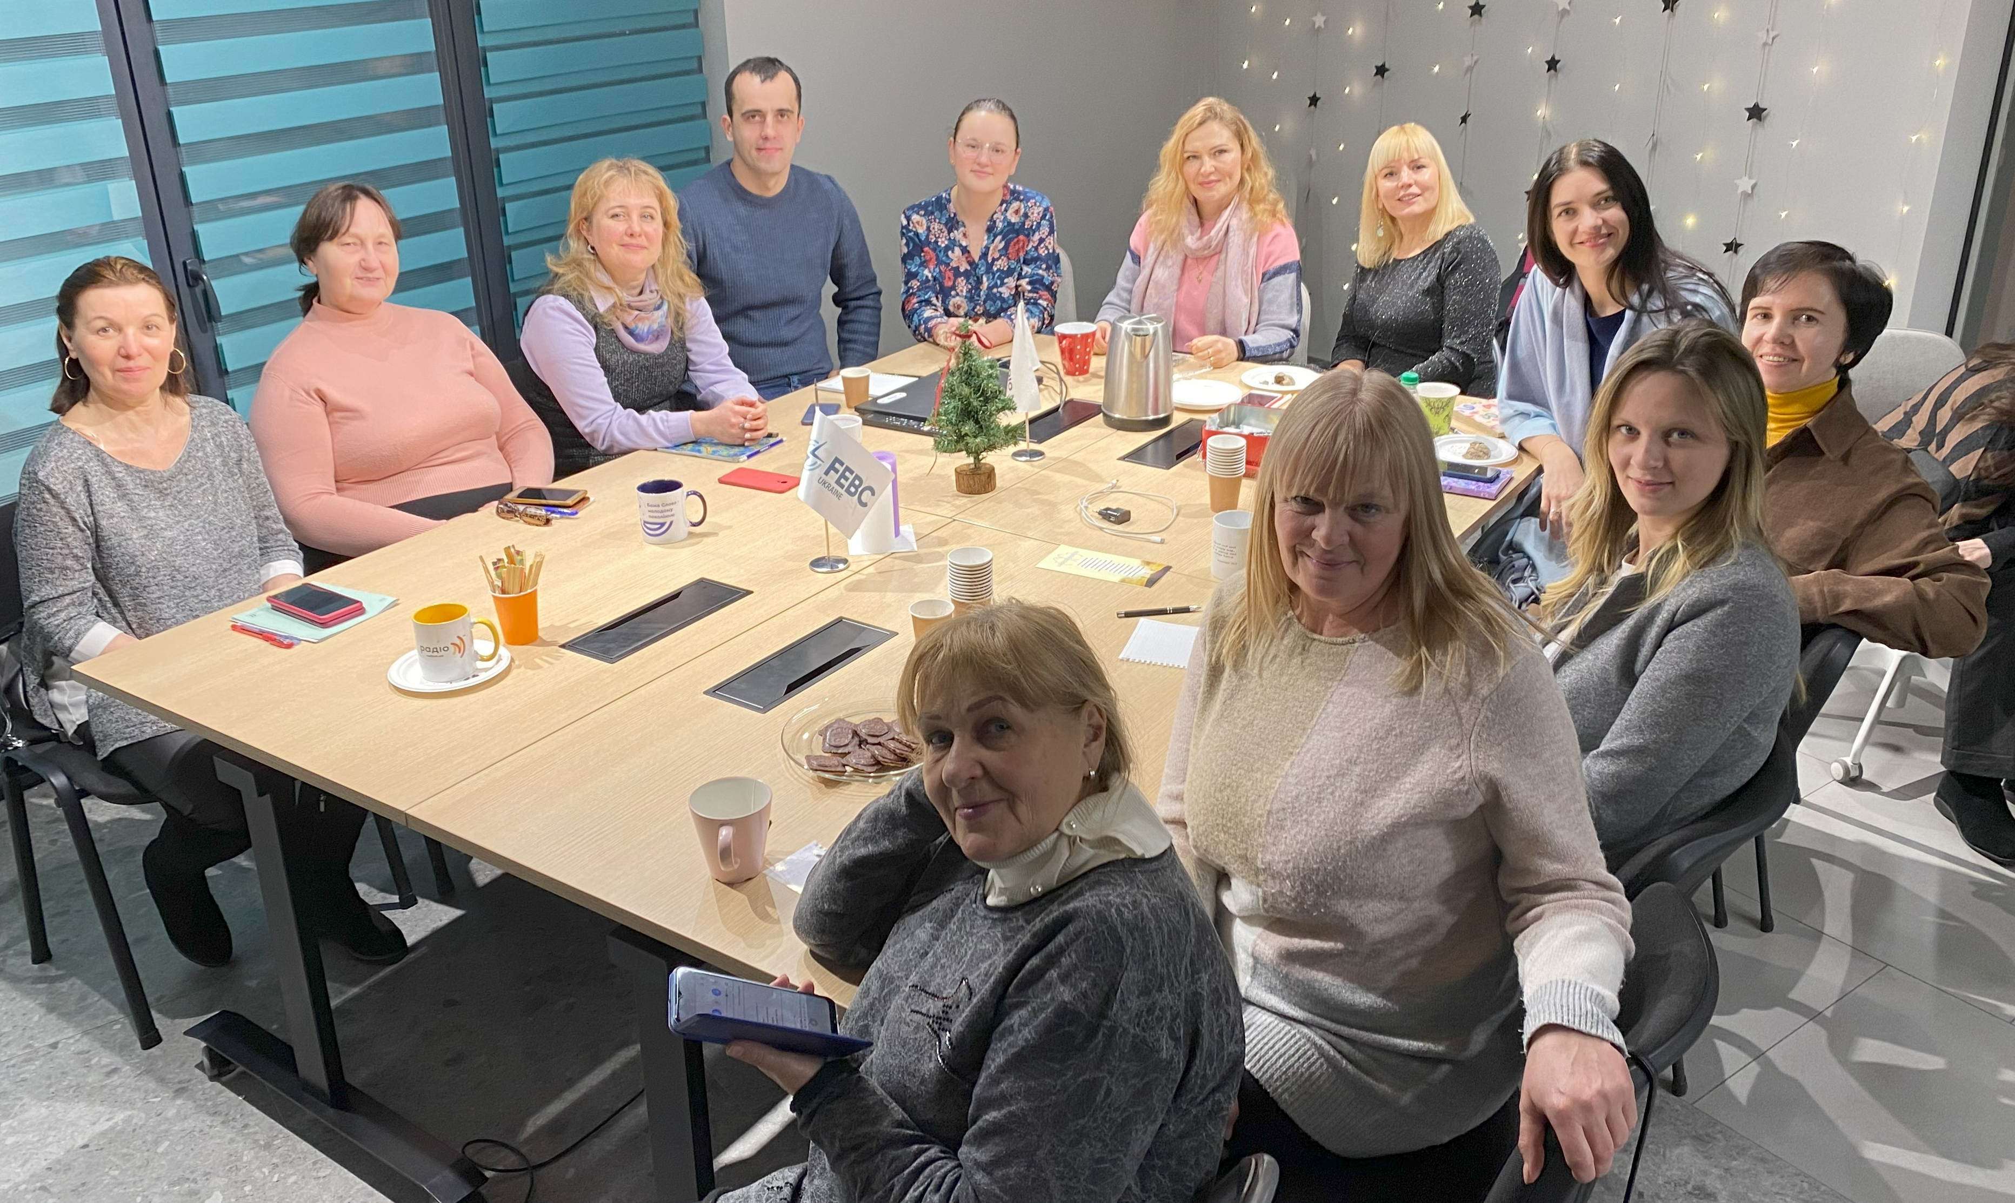

Tuesday – 24
Please pray for a new series of videos about the Bible being prepared in Kazakhstan with a local pastor. It can be difficult to find people who are willing to talk about Christ publicly, and these types of videos can be very powerful. While Muslims do not fully trust the Bible, they still listen carefully to what it says. And this can lead to life-changing conversations between broadcasters and the Muslim audience.

Wednesday – 25
“I am paralyzed by my fear. I’m afraid of the future, of losing everything in this war and ending up on the street, of my husband being drafted into the war. You have been such a support to me. I’m beginning to understand how to find peace as I learn more about the love of God. Thank you for encouraging me to read the Bible and reminding me about God’s love.” Please pray for listeners of FEBC’s Bible programs whose lives are being transformed by the Word of God.

Thursday – 26
Please continue to pray for the health of FEBC-Russia’s employees and their families. Several team members are facing serious illnesses. Please pray for healing and strength.

Friday – 27
Please pray for FEBC-Kazakhstan’s prayer counseling team. Listeners are calling with problems like domestic violence, abuse, addictions, family and relationship problems. The problems listeners are facing in Kazakhstan are often severe and heart-wrenching. Please pray for spiritual and emotional strength for the team of evangelists who are praying with these listeners.

Saturday – 28
“I was completely lost. I didn’t know how to keep living, how to make a decision,” said Yelena, a young woman who was having second thoughts about leaving her husband…As I listened to you, I started to understand my situation more clearly. Yelena called to ask for some specific advice for her situation. We prayed with her, and Yelena put her faith in Jesus. “Please send me the address of a church near me! I will definitely start reading the Bible, like you said!” Please pray for Yelena as she begins her journey with Christ, and for her relationship with her husband to receive healing with God’s help.

Sunday – 29
Please pray for Evgeny Goltsov, FEBC-Ukraine’s volunteer chaplain, who regularly travels to war zones to speak with soldiers and record their stories. He hosts a program that ministers to people serving in the military. Evgeny recently fractured his leg, please pray for quick healing.
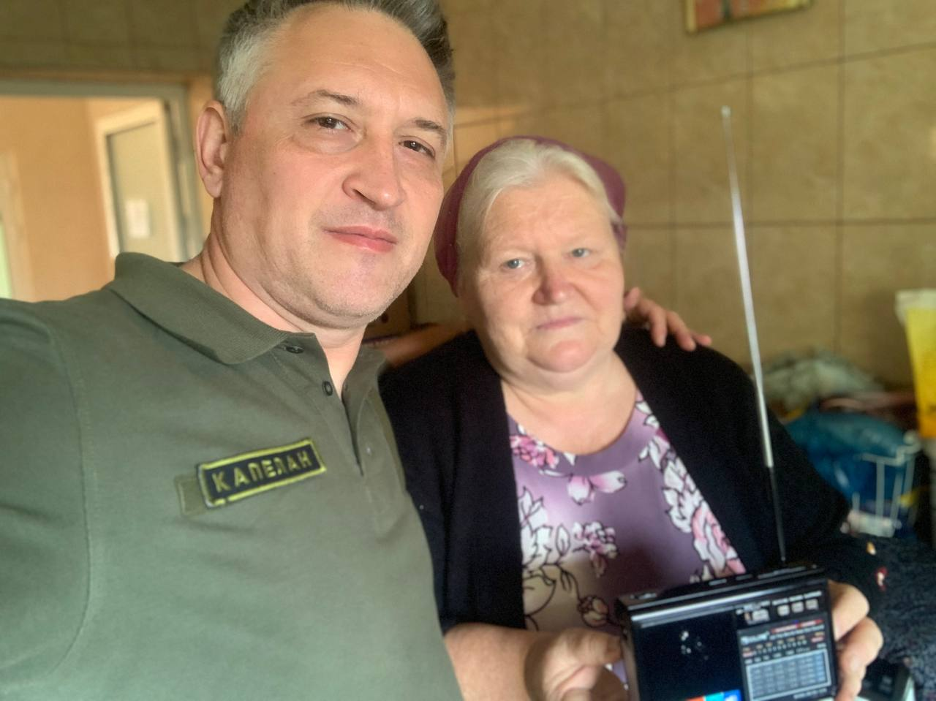

Monday – 30
Please pray for men like Dmitry, from Ukraine, who volunteered to join the army. “I’m exhausted, hurt, disappointed, angry. I want to end my life. Why did this war happen? Even my dreams are about war. There’s not enough time in the day to bury all the men who are dying.” Dmitry prayed with FEBC’s prayer evangelist. The number of men who are dying in the battlefield is overwhelming. Many feel alone and are struggling with their mental health. FEBC’s programs are reaching these men on the frontlines through our FM stations and online ministry. Please pray for this war to come to an end, for the loss of life to stop.

Tuesday – 31
Please pray for the health of FEBC-Ukraine’s staff. Galina, one of FEBC’s helpline evangelists, is awaiting the results of a medical test, it is suspected to be cancer. Please pray for healing and peace for her in this trying time. And please pray for the healing of Sarah, the daughter of one of our broadcasters.

