FEBC-Eurasia November Prayer Needs

Friday – 1
“My health is ruined. No one can help me,” said Margaret. FEBC’s prayer evangelists shared the hope of Christ with her, and Margaret began to feel the weight of her sin. “I regret so many things from my past.” Margaret wept as FEBC’s evangelist led her to Christ on the call. Please pray for her as she begins her walk with God.

Saturday – 2
Please pray for Irina, FEBC-Russia’s sound engineer, who is about to undergo surgery. Please pray for God’s healing and protection as she goes through the operation. And please pray for the health of the entire team.

Sunday – 3
Please pray for FEBC-Ukraine’s Iryna Korolenko, whose mother passed away recently. Please pray for God’s strength and comfort as she goes through these difficult times.
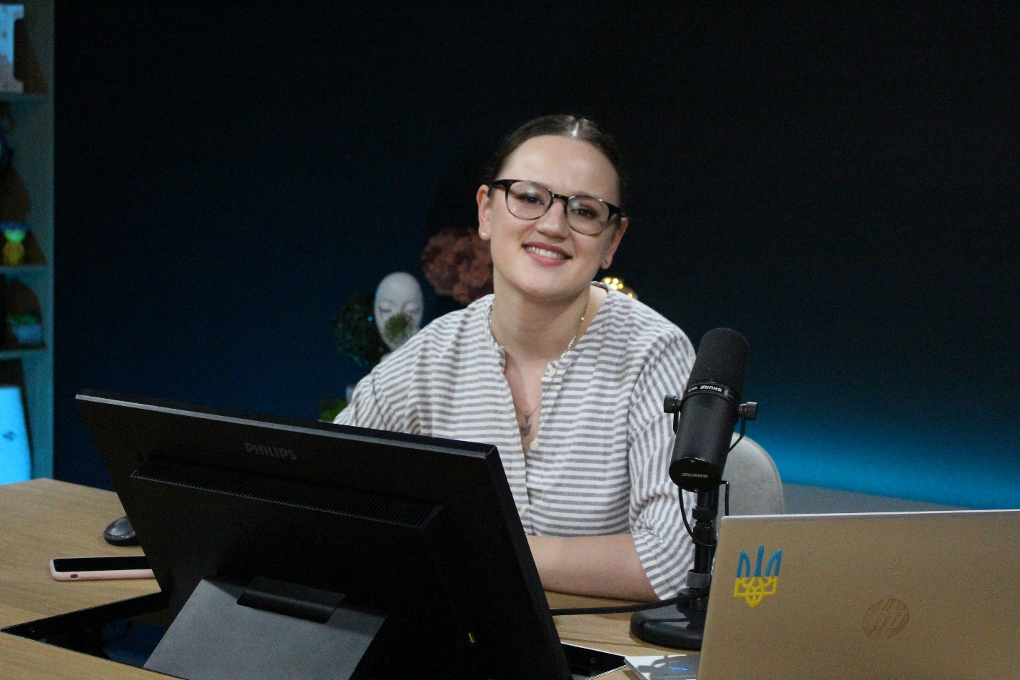

Monday – 4
Please pray for the FEBC-Kyrgyzstan team as they minister in a growingly Islamic country. The number of schools offering Islamic religious education have increased greatly. Many of these schools do not focus on educating people, but on teaching them to recite the Koran and teaching them Islamic traditions. Now is an especially important time to reach young people with the light of the Gospel, as they are being more and more encouraged to dive deeper into Islam. Please pray for God to use FEBC-Kyrgyzstan’s ministry to reach many young people for Christ.

Tuesday – 5
Please pray for soldiers like Maxim, who are coming home from the war damaged, having seen terrible destruction. “It feels like everything is against me,” said Maxim. “I know I need help. I’m about to fall apart.” FEBC’s evangelists shared the Gospel with Maxim and Maxim asked if they could pray together. “I cried while we were praying. I felt such relief…such peace.”
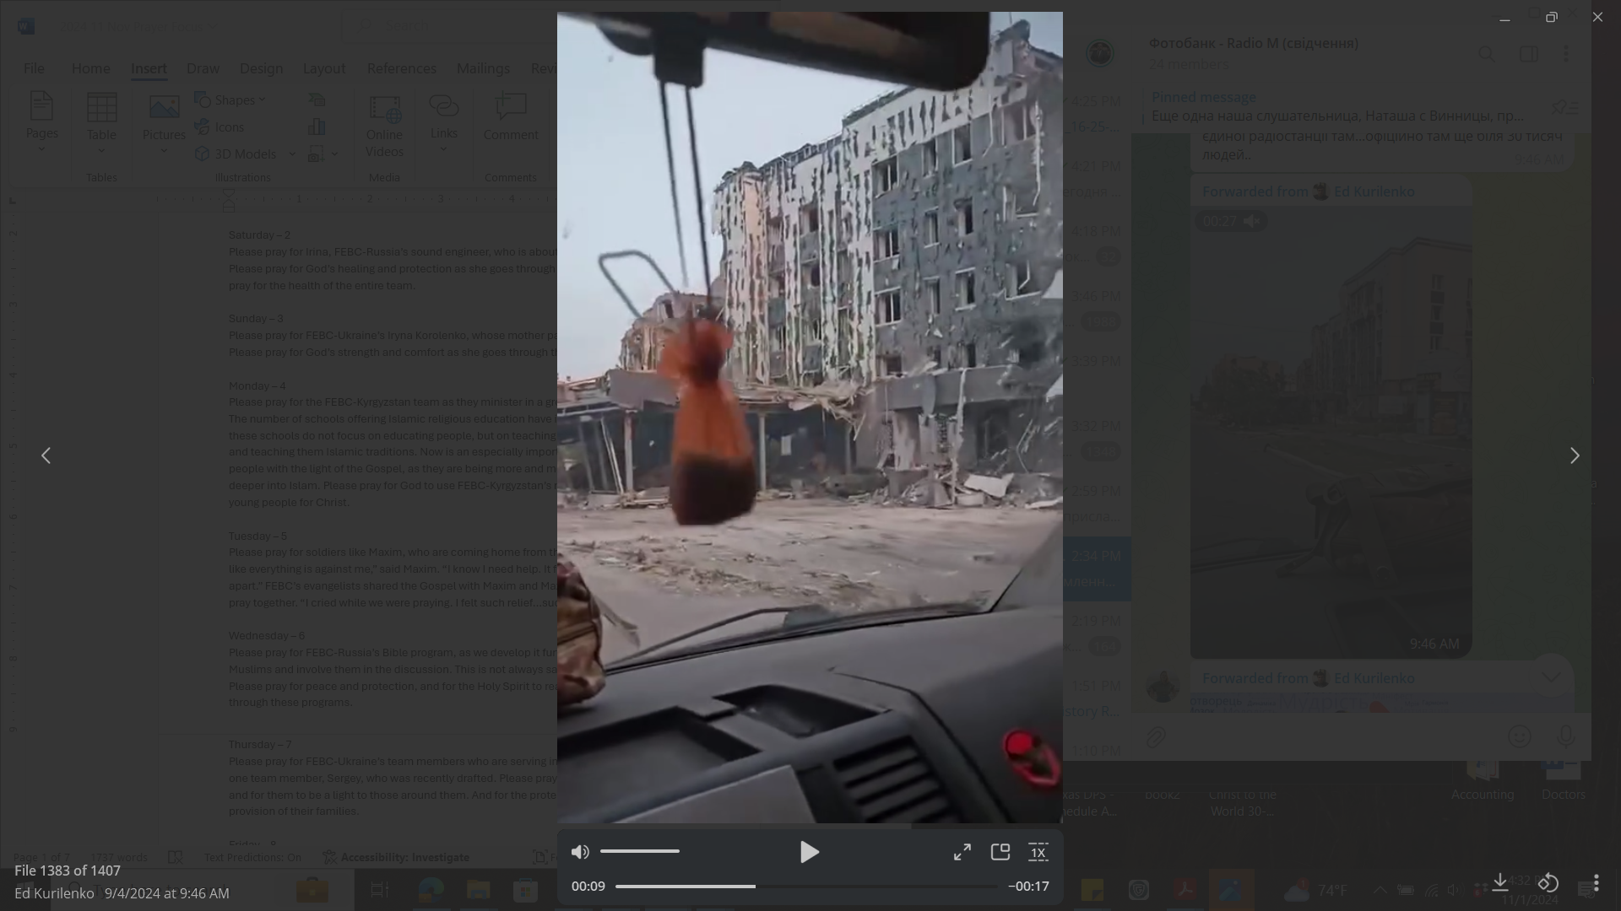

Wednesday – 6
Please pray for FEBC-Russia’s Bible program, as we develop it further to try to reach more Muslims and involve them in the discussion. This is not always safe for them or for us. Please pray for peace and protection, and for the Holy Spirit to reach many Muslim hearts through these programs.

Thursday – 7
Please pray for FEBC-Ukraine’s team members who are serving in the military, including one team member, Sergey, who was recently drafted. Please pray for protection, provision, and for them to be a light to those around them. And for the protection, comfort, and provision of their families.

Friday – 8
Please pray for a training session that will be held soon in Kazakhstan. The team has recently grown, as has the outreach to both younger and older Muslim listeners. Please pray for this training to help the team grow together and learn to reach these listeners as effectively as possible.


Saturday – 9
“I just lost my mother,” said Ekaterina. “I’m heartbroken, and so is my son. She lived with us…my life is completely different now.” FEBC’s evangelists shared Christ with Ekaterina and they prayed together. Please pray for her walk towards Christ.

Sunday – 10
FEBC-Russia has been facing difficulties because of the rapidly changing situation with social networks. These changes, a result of outside sanctions and Russia’s own internal restrictions, require us to constantly adapt. Please pray for God’s favor and help as we deal with this situation.

Monday – 11
Please pray for an end to the war in Ukraine, for an end to the death of civilians—every member of the team has lost someone close to them. Please also pray for our listeners who are currently prisoners of war or are living in occupied territories. Please pray for them to come to know the Lord, for their safety, and for their freedom.

Tuesday – 12
Please pray for the remodeling of the studio in Kazakhstan to be finished soon and for the ability to meet with listeners and put on events to increase. These in-person meetings with listeners are very important for Muslim listeners to take the next step in their faith journey.

Wednesday – 13
Please pray for listeners like Olga, who prays to the many icons she has on her walls. “My prayers aren’t being answered. It doesn’t seem like God is strong enough to defeat Satan in my life.” FEBC’s evangelists shared more of Christ’s truth with Olga, telling her about God’s love, and prayed with her. Please pray for her to come to a fuller understanding of God’s love and grace.

Thursday – 14
Please pray for FEBC-Moldova’s new children’s program that is being developed. Please pray for wisdom and direction, and that the program reaches many children with the love of God.
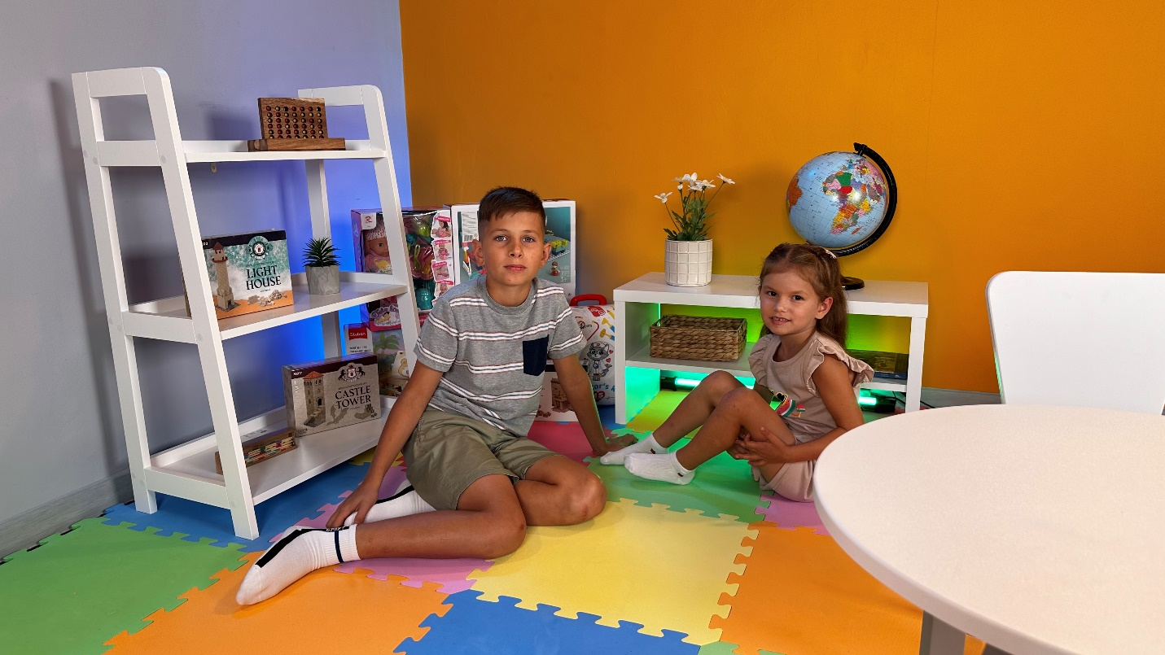

Friday – 15
Please pray for the healing of the daughter of one of FEBC-Ukraine’s broadcasters, who was born with some underdevelopment. Please pray for full healing and restoration, and a long, healthy life. Please also pray for the parents as they go through this difficult time.

Saturday – 16
Please pray for listeners like Marusya, an older woman who called FEBC’s prayer helpline. “I want to find out more about Christianity. I go to Orthodox church, but I don’t understand what’s taught there. I know that Jesus died for us, but that’s all.” FEBC’s evangelists shared the Gospel with Marusya and prayed with her. Marusya put her faith in Jesus and was connected with a minister from a church.

Sunday – 17
Please pray for FEBC-Moldova’s Teen Project, which makes programs for teenagers and sets up meetings where teens can gather and learn more about Christ and the Bible, pray together, and get to know FEBC-Moldova’s broadcasters.
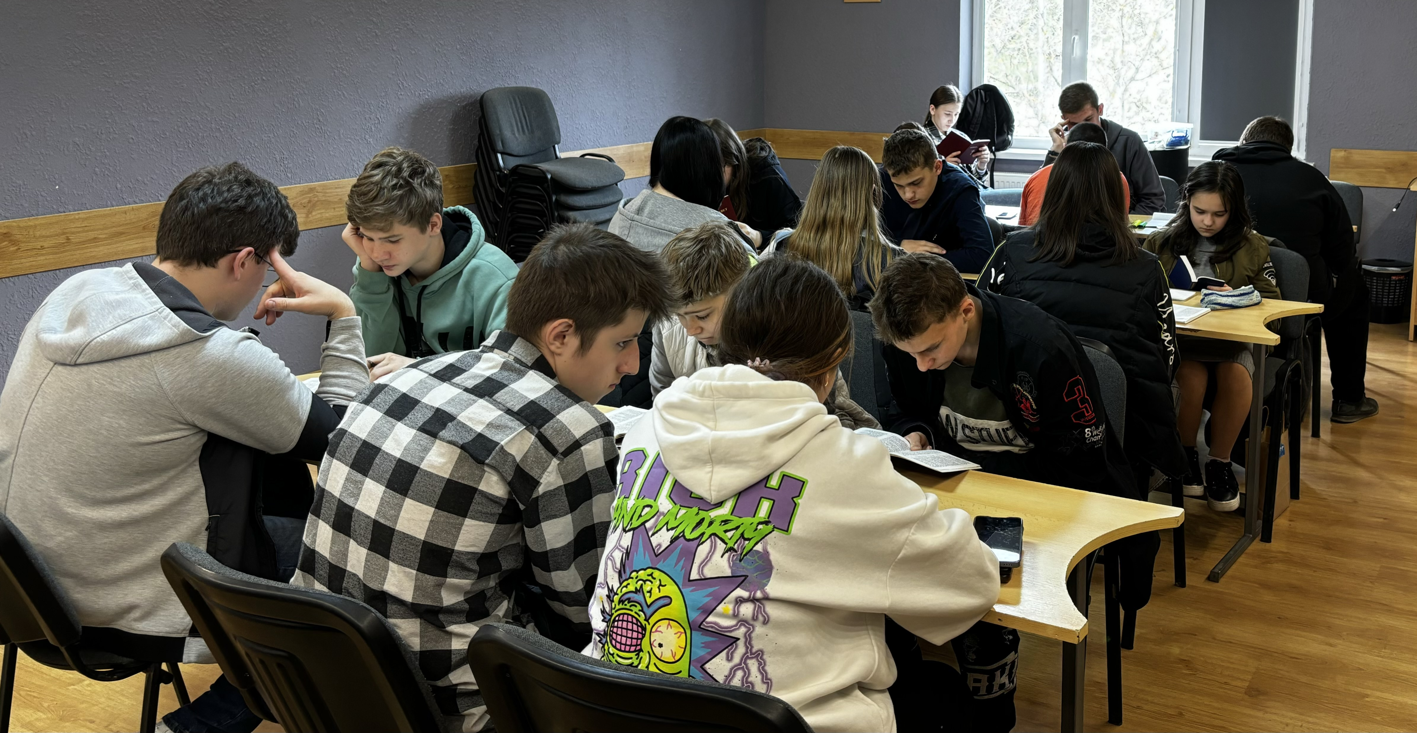

Monday – 18
Please pray for strength—emotional, spiritual, and physical—for FEBC-Ukraine’s follow-up helpline, who are praying with and counseling people who are going through incredible hardships. Soldiers who are coming home from the war damaged and hurt, widows, orphans; people who are scared, anxious, depressed, suicidal. Please pray for God to use this ministry to bring His hope into the lives of Ukrainians.

Tuesday – 19
Diana called FEBC in tears when her husband left her with a 1-year-old child. “I haven’t eaten in days. I so want my child to have a father.” FEBC’s evangelist comforted Diana in her situation and shared the Gospel with her. She was moved by what she heard and wrote down some books of the Bible to read and agreed to visit a church to pray. “I feel so guilty, so unworthy. I want God’s forgiveness.” Diana prayed with FEBC’s evangelist and put her faith in Jesus. Please pray for Diana as she begins her journey with Christ.

Wednesday – 20
Please pray for Ivan, FEBC-Moldova’s broadcaster who is reaching a great many young people with the Gospel. Please pray for growth, inspiration, and for God to work mightily among the young people of Moldova through his videos and dialogues.

Thursday – 21
The FEBC-Ukraine team has been blessed to participate in media conferences, which helps FEBC-Ukraine’s team partner with other local churches. Please pray for these meetings to produce great results as listeners are connected with believers.
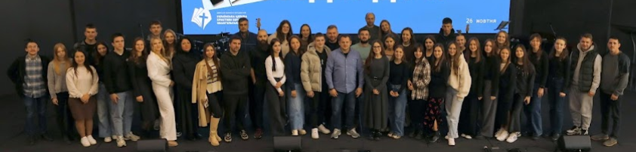

Friday – 22
“I lost my beloved husband,” said Viktoria, from Ukraine. “We had his ‘funeral’ three weeks ago, but we just received what was left of his body. He died on the frontlines. Where do I get the strength to live on?” Please pray for listeners like Viktoria, who are losing their loved ones in the war. Many people are turning to the Lord after experiencing loss. Please pray for God’s comfort, and for these people to be reached with the Gospel through the ministry.

Saturday – 23
Please pray for FEBC-Kazakhstan’s new youth project aimed at evangelizing the younger generation. They are being pulled in many directions, the popularity of Islam is growing rapidly. Please pray for the Lord to bring the right people to help with this project; this person needs to be able and ready to put their face on camera, something that can be dangerous.

Sunday – 24
FEBC-Ukraine was able to participate in a medical training course, so that team members know what to do in case of injury from explosion. Please pray for the ministry to continue to grow and spread the Good News across the country, and please pray for the safety of everyone on the team and their families.

Monday – 25
“A bomb went off right by our house,” said Ihor. “The windows and doors were blown off. I tell my wife that I’m okay, but I’m not. I can’t tell her that I’m hurt and scared. I feel like I’m coming apart. I lash out in anger and I don’t know why.” FEBC’s evangelist shared Christ with Ihor, about the hope found in God. Ihor prayed with the evangelist and accepted Christ. Please pray for him as he begins his journey with Christ.

Tuesday – 26
Please pray for a new project on TikTok reaching older Kazakh Muslims. These listeners are willing to talk for hours about Jesus and the Bible. Please pray for this project to reach many Muslims with the light of the Gospel.

Wednesday – 27
Please pray for FEBC-Moldova’s Bible program to reach many listeners with the Good News. This program teaches the Bible in simple to understand language so that it is accessible to anyone. Please also pray for new Bible programs being developed to reach teens.
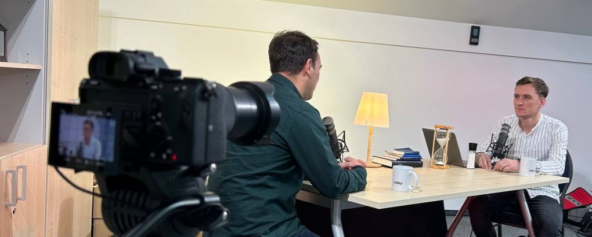

Thursday – 28
Please pray for listeners who have spouses on the frontlines of the war; families are seriously struggling with the long separation and fear. Alina and her husband have three children, two 8-month-old twins and a 17-year old. “I love my husband very much. Every time he goes on a mission, he says goodbye to me, because he doesn’t know if he’s coming back.” She called FEBC’s helpline crying, asking for support and prayer. “I haven’t heard from him in two days. I’m scared that something has happened to him.” They prayed together, and Alina remembered God’s faithfulness in keeping her and her children alive during a recent bout of heavy shelling. Please pray for families of soldiers who are separated. They are experiencing a great deal of pain and suffering.

Friday – 29
Please pray for FEBC-Kyrgyzstan’s counselors, who are leading many listeners to Christ through one-on-one conversations and in-person meetings. These counselors are helping listeners take the next step which can be very dangerous, especially to women who are married to radical Muslim men.

Saturday – 30
Please pray for the leadership of the FEBC-Moldova team, that the Lord grows the ministry, bringing the right people to the team, and strengthens the leaders as they guide and grow the team.

