FEBC-Eurasia October Prayer Needs

Tuesday – 1

Praise God for protecting the lives of the FEBC-Ukraine team through this war. While everyone on the team knows someone who has died, the Lord has shown great mercy in protecting the lives of the team. Recently, the team was able to participate in a media conference where they could share about their ministry.

Wednesday – 2

Please pray for FEBC-Russia’s leadership team, Alexey, Oleg, and Victor, among others. Please pray for wisdom, strength, and favor as they deal with the growing restrictions. And please pray for peace to come to this region.

Thursday – 3

“I’m afraid of death,” said Olga, an older woman living in Ukraine. “Not just that I will die—though I worry about that too. I am worried about my son-in-law, who is fighting in the war. My daughter lives far away from me… I’m all alone. And I’m sick.” As Olga heard the Gospel, heard about God’s love for her as a daughter, she began to silently cry. Olga put her faith in Jesus and promised to read the Bible. “Thank you…I thought I was alone…thank you for being with me—for introducing me to my Father.”

Friday – 4

According to forecasts, Ukraine’s autumn and winter will be very challenging due to regular attacks on the energy infrastructure. It is predicted that electricity will only be available for 2 hours a day. Please pray for the people of Ukraine as they endure this time, and for the FEBC-Ukraine team. We are preparing to be able to continue broadcasting during power outages.

Saturday – 5

Please pray for the young people of Kazakhstan, many are searching for the truth. Some have closed their hearts to God after being disappointed by religion. Others consider themselves Muslims, but still feel that something is missing. And there are some who are very antagonistic towards Christianity. Please pray that God reaches them where they are and ministers to them through FEBC-Kazakhstan’s programs.

Sunday – 6

“I want to jump,” said Elena, to FEBC’s follow-up evangelist. “I kissed another man…my husband found out. It was only a kiss, but he doesn’t believe me! What do I do? He wants to leave me, but I love him! I can’t imagine life without him! If he leaves me, I’ll…” Elena’s husband was a soldier, a situation that has become sadly common, with countless families falling apart. Elena put her faith in Jesus as she spoke to FEBC’s follow-up evangelist. “Please save me, Jesus.”

Monday – 7

Please pray for the members of FEBC-Ukraine’s team who are serving as chaplains in the Ukrainian military. Maxim, Serhiy, Oleksandra, Ruslan, Dmytro, Roman, and Sviatoslav. May the Lord protect their lives, and their mental and emotional health, as they serve the soldiers around them in incredible difficulties.

Tuesday – 8

Please pray for a training retreat that will be held in for the FEBC-Kyrgyzstan team on October 10-11. As the country becomes more and more Islamic, the need for the Gospel only increases, as does opposition. Please pray for this to be an encouraging and edifying time for the team.

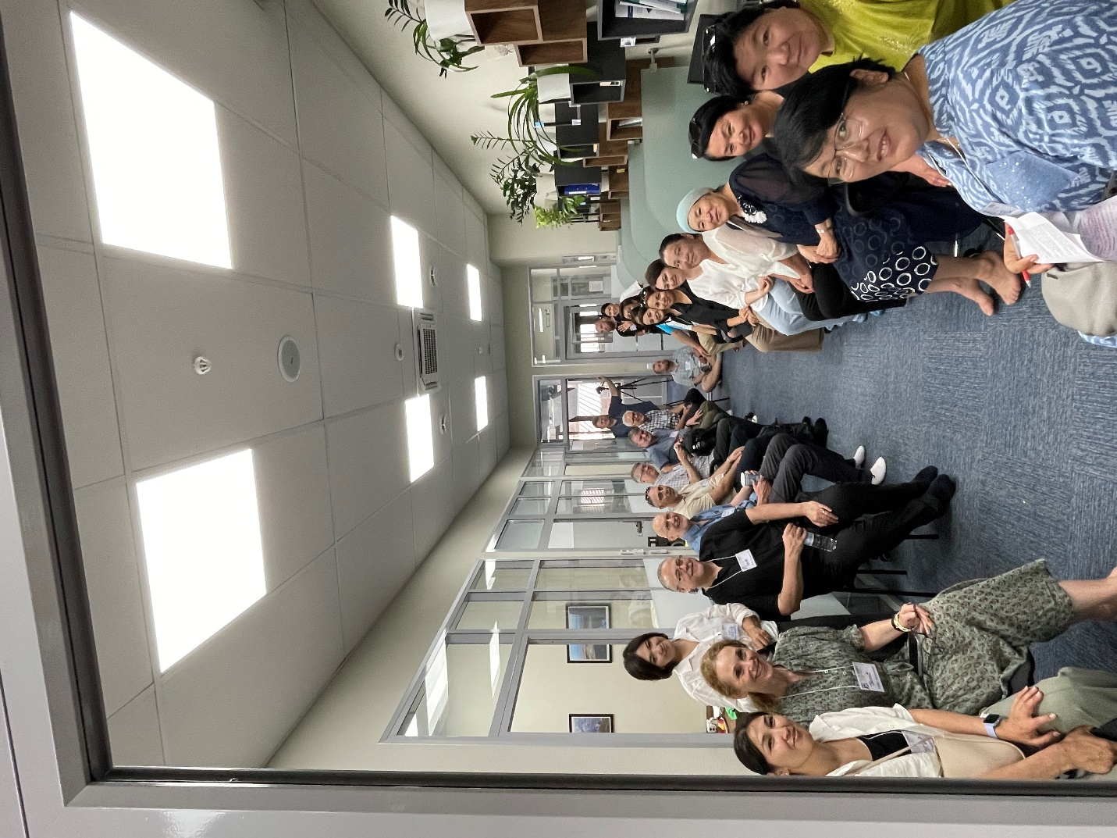

Wednesday – 9

Please pray for the father of one of FEBC’s team members in Uzbekistan, who is undergoing treatment in the hospital. This team member was radically saved by Jesus while seeking a closer relationship with Allah, and is passionate to help share Jesus with her people.

Thursday – 10

“I’m going to the frontlines the day after tomorrow,” said Dmitry. “There’s not much chance of surviving, but I’ll fight to the end.” Fatalities among soldiers have been very high. “I’ve done and seen so much in this war. I don’t know what will be left of me, even if I come back alive.” Please pray for Dmitry to come to a saving knowledge of Jesus Christ, to surrender to Him, and to find freedom and peace in Him—no matter what happens in the war.

Friday – 11

Please pray for Maxim, FEBC-Ukraine’s former program director, who is currently on the frontlines in a dangerous area. Please pray for his protection, and for physical, emotional, and spiritual strength.

Saturday – 12

Please pray for one of FEBC-Moldova’s broadcasters who is going through a very difficult time in her family. This passionate young broadcaster faced a lot of opposition to preaching the Gospel from her family and community, but she couldn’t stay silent any longer. Please pray for God’s comfort and provision.

Sunday – 13

I’m terrified every day,” said Sveta. “I’ve been afraid of dying—afraid of everything—for two years, since the war began.” FEBC’s follow-up evangelist prayed with Sveta, inviting her into relationship with her Father. They prayed together, and FEBC’s follow-up evangelist explained to read the Bible and how she can pray to her Father at any time. “Thank you, you really helped me. I was falling apart!” Please pray for listeners like Sveta, who are living with constant fear of death.

Monday – 14

Please pray for FEBC-Ukraine’s project to reach out to the wives of soldiers. There will be an upcoming meeting on October 5th. May God grant us wisdom in sharing the Gospel with the wives, mothers, and daughters of these servicemen.

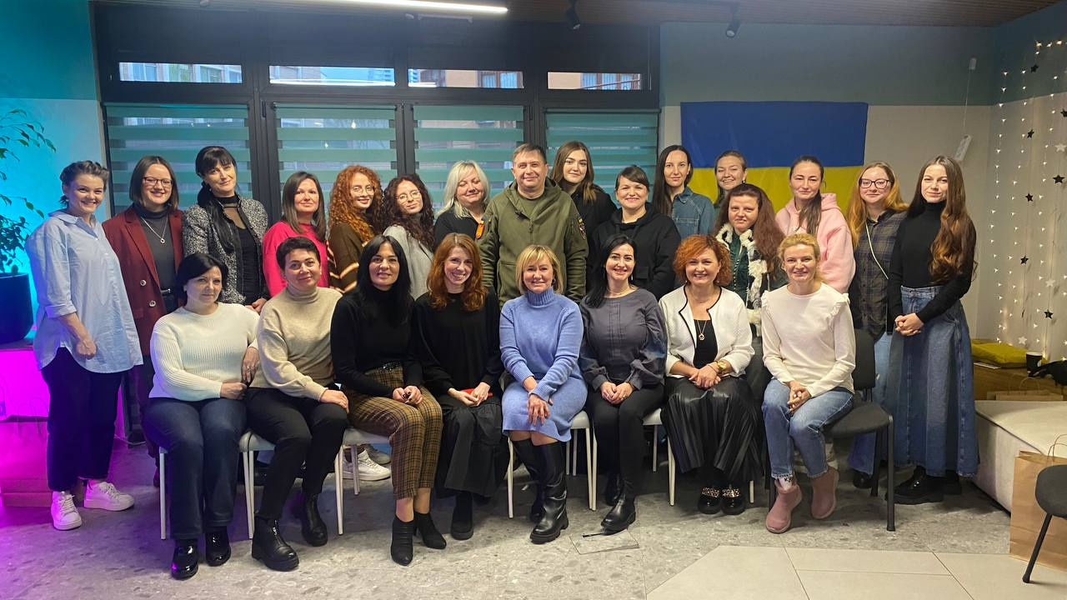

Tuesday – 15

Please pray for FEBC-Kazakhstan’s upcoming meeting with pastors from churches across the capital city of Almaty. We will be sharing about our ministry and building relationships with churches who can further serve our listeners. Please pray for God’s blessing over this time, for us to be able to build good relationships, and for the possibility of partnering on other programs and projects.

Wednesday – 16

“I haven’t slept for three days,” said one listener, who had just lost her husband in the war. “My heart is an open wound. I can’t sleep, can’t eat. I just cry all the time. I can’t accept it. I haven’t told anyone yet. They told me they can send back some of his body parts…to bury.” Please pray for listeners who are in great grief, having lost husbands and fathers and sons. Please pray for an end to the war in Ukraine.

Thursday – 17

Please pray for upcoming training sessions and workshops that the FEBC-Ukraine team will be attending. Please pray that the team grows and is equipped during this time to continue the great work they are doing in the midst of very difficult circumstances.

Friday – 18

Please pray for the safety of one of FEBC-Russia’s team, who is returning to the country after leaving after some threats were made. Please pray for God’s hand of protection and favor.

Saturday – 19

“I thought this was love,” said Marina. “But he just left me—after five years!” Relationship problems are one of the most common types of calls we receive. People often feel hopeless in these situations. But when people are at their lowest, sometimes they are more open to the call of God. FEBC’s follow-up evangelist shared the Gospel with Marina, telling her that God can turn any situation for good. Marina prayed, putting her faith in Jesus. “Thank you!” Marina said. “This is the first time I’ve stopped crying since he left.”

Sunday – 20

Please pray for Irina, whose mother has a terminal illness. Please pray for God’s peace and presence to be with them as they go through this difficult journey.

Monday – 21

Please pray for FEBC-Kyrgyzstan’s Bible program, which receives many negative and angry comments from listeners. Ministering to Muslim listeners is a process, and it can take some time for hearts to begin to soften to the Gospel. Please pray for the Lord to open their hearts to Jesus and to the Word of God.

Tuesday – 22

Please pray for FEBC-Moldova’s leadership as they build and expand the ministry. There have been powerful results, and as the ministry grows, the needs increase. Please pray for God’s vision, strength, and wisdom as they prepare the ministry to reach their people with the Good News.

Wednesday – 23

Please pray for listeners like Alyona, who was taking care of a child with special needs. “Thank you so much for your program. I sometimes get very tired, and there is no one I can talk to. If I go to my relatives, they just tell me to give her up. Thank you for being there! Thank you for listening to me, responding to me. Thank you for your prayers! Your programs are such a great resource for me. I’ve learned so much about my relationships with my children.” Please pray for FEBC-Russia’s family programs which are addressing a great need in Russian society.

Thursday – 24

Please pray for FEBC’s ministry to Ukraine’s teens, who are going through a very difficult time. The suicide rate is on the rise, as teens are dealing with fear, stress, and hopelessness. Please pray that our videos reach them with the hope of Christ, and lead many to visit a church.

Friday – 25

Please pray for FEBC-Kazakhstan’s follow-up ministry—this is where much evangelism takes place. There are many listeners who are living in very difficult circumstances, especially women, and it can be difficult for them to reach out to Christians for help. Please pray for God to give us the wisdom to serve these women and lead them to the One who can make them whole.

Saturday – 26

Please pray for Alexandr and Nadia, FEBC-Ukraine’s broadcasters and follow-up helpline evangelists. They are pregnant and are asking for prayers for a healthy baby and delivery.

Sunday – 27

“Thank you for your program!” wrote Pyotr, from Russia. “I turned to God when my addiction became too much, and He gave me strength. Soon, I will have been sober for a year and a half—a year and a half of joy!” Please pray for FEBC-Russia’s programs that talk to listeners about addiction and freedom in Christ. We hear many stories of freedom like this one.

Monday – 28

Please pray for those on the FEBC-Russia team who are dealing with sickness, including Oleg, Irina, Lyuda, and Daniil. Please pray for God’s healing and wisdom for the doctors who are treating them.

Tuesday – 29

Please pray for the Lord to bring the right people to join FEBC-Moldova’s team. The needs are great, especially for families. There are many broken families in Moldova, filled with abuse, neglect, addiction, and abortion. Please pray for the right people to join the team and help minister to this issue.

Wednesday – 30

Please pray for the Lord to bring the right people to FEBC-Ukraine’s team. With the war, people’s situations can change quickly, and several people have had to leave the team. Please pray that the Lord fills the different positions with the right people.

Thursday – 31

Please pray for FEBC’s new ministry in the country of Uzbekistan, an officially secular country, with over 90% of the people identifying as Muslims. Recently, people who watch FEBC’s videos there have started receiving messages warning them to unsubscribe. Please pray for the Gospel to reach the people of Uzbekistan despite any opposition.