FEBC-Russia & Ukraine December Prayer Focus
Friday – 1
Please pray for favor as we wait to hear whether we receive a permanent license to broadcast on FM in Kyiv. We are currently broadcasting from a war-time license. Receiving a permanent license would be a great blessing, as 25% of our listener responses now come from the Kyiv region.
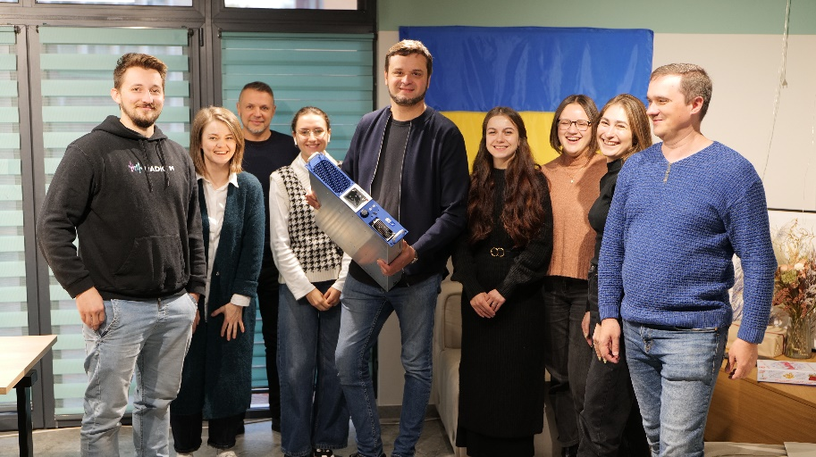

Saturday – 2
Please pray for listeners in Ukraine who are exhausted with the war and other crises they are facing in their lives. A listener named Ludmila called FEBC-Ukraine, “They are taking my husband to the war.” Her voice was hopeless and sad. When prayer was suggested, she said, “I don’t pray, and I’m not sure that God exists. I’ve been so disappointed…” Ludmila allowed the FEBC evangelist to pray for her, however, and afterwards she was shocked. “I’ve never felt anything like that! Thank you so much!” Please pray for Ludmila to put her faith in Christ.

Sunday – 3
Please pray for Rudy Wiens, one of FEBC-Eurasia’s senior members. He was influential in the starting of much of the ministry in Eurasia and is currently helping coordinate the work in Kyrgyzstan.
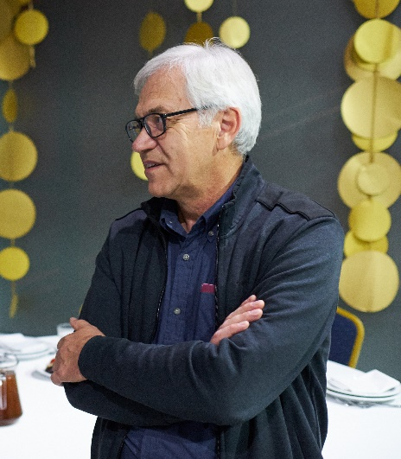

Monday – 4
“I know that God is calling me to live a more spiritual life,” said a listener named Pavel, “and I’ve been praying to the Icons, but nothing seems to be changing.” For many listeners, having a relationship with God means following rituals. FEBC’s counselors talked with Pavel, telling him about God, and leading him in a prayer to accept Christ as his Lord. “I read the prayer out loud three times!” he said. Please pray for listeners like Pavel, who are seeking a real relationship with God.

Tuesday – 5
Please pray for FEBC’s ministry to military wives, many of whom are living as single parents, with little to no support from others. The FEBC-Ukraine team puts on regular meetings and events throughout the country, where they are able to hear about the Lord, receive encouragement and support, and get connected to local believers.

Wednesday – 6
Please pray for listeners like Paul, whose negative view of Christians changed as he watched one of FEBC’s programs. “Seeing Christians who are ready to listen and talk, not just preach, is very attractive. I’ve never seen this before. I want to find out more about you.” Paul asked to be connected to a church.

Thursday – 7
FEBC-Moldova’s short videos are receiving millions of views and starting many conversations about the Lord. Please pray for a new set of videos being filmed to reach many more Moldovans with the Good News and for travelling mercies for the team as they film these videos.

Friday – 8
Please pray for listeners like Yelena, who had experienced the most difficult year of her life, with the war in Ukraine, losing her father, her husband leaving, and her mother being in the hospital. “I no longer have faith in people or in God,” she said. When Yelena heard the Gospel, heard that God was near to her and loved her no matter what she was experiencing, she was cut to the heart and she prayed with FEBC’s team member, putting her faith in Jesus.

Saturday – 9
Please pray for Eduard, FEBC-Ukraine’s Director, who is regularly travelling across Ukraine. It is winter right now, with icy conditions on the road. Please pray for protection on his travels as he works to
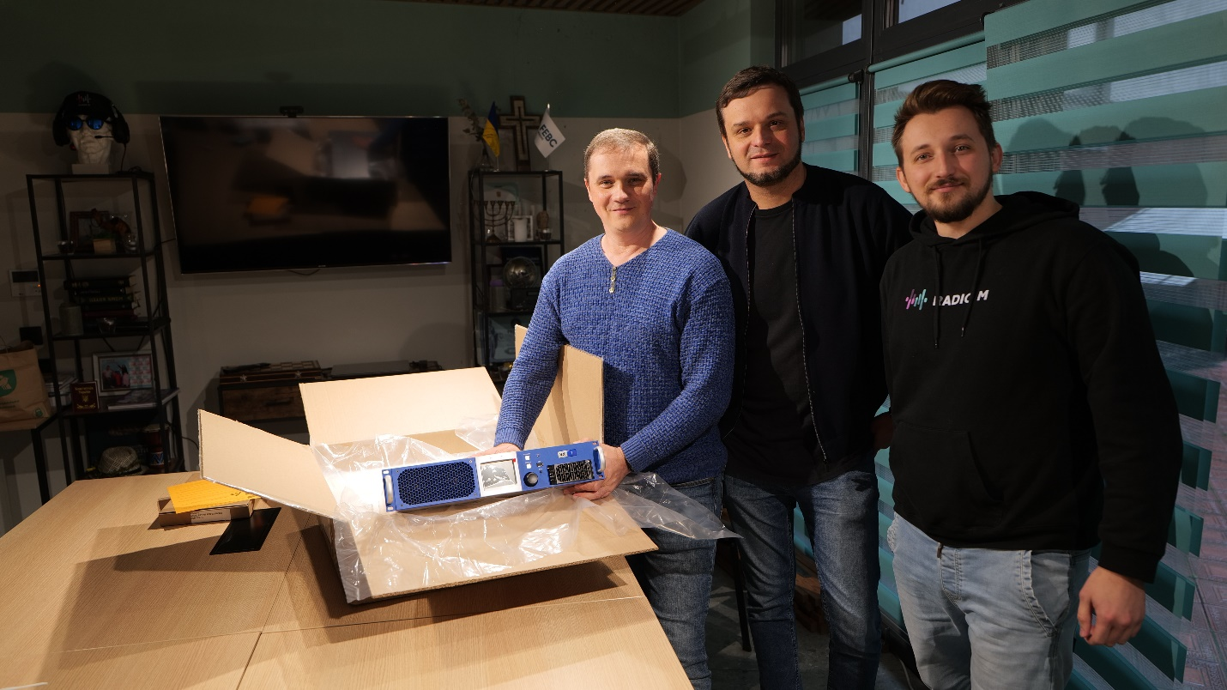

Sunday – 10
Please pray for listeners like Evgeniy, who responded to FEBC’s program about forgiveness. “Your broadcast helped me start thinking about forgiving someone who brought a lot of pain into my life. I grew up in a small town and lived in an ordinary working-class family. No one ever spoke about faith in God, and no one ever brought up repentance and forgiveness… Your broadcast helped me think about the fact that forgiveness could heal my emotional wounds. I was deeply touched by the story you told during the broadcast, about how your father asked you for forgiveness. I couldn’t even stand it and started crying. Please pray for me.”

Monday – 11
Please pray for FEBC-Kazakhstan team, especially Ulan, Aizhan, and Aruzhan, as they reach many young people with the Good News. “We are connecting with all of the young people who reach out to us through our videos and through the online counseling,” said Ulan, the young man who supports the online counseling team. “We share with them about Jesus in a way we cannot do on the air, and we help get them connected to churches in their area.
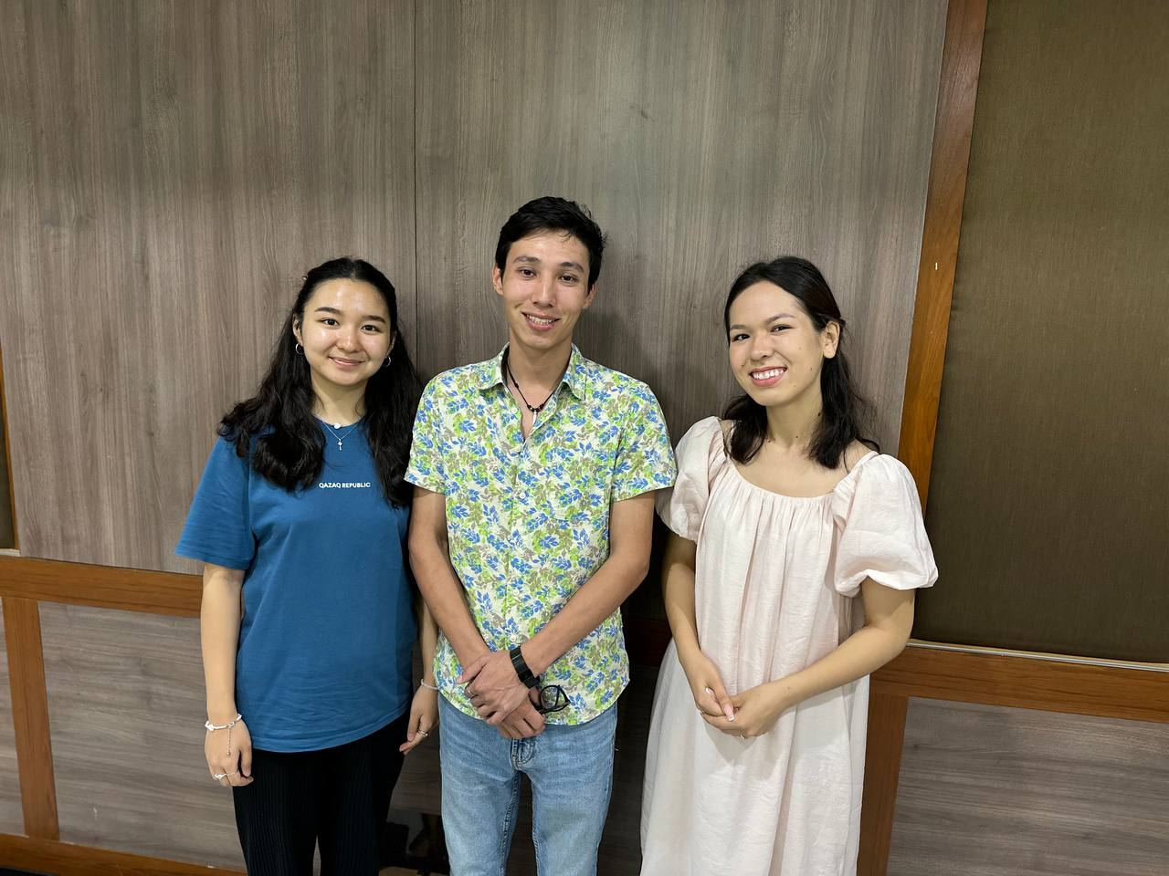

Tuesday – 12
“I’ve been trapped by my fears,” says a listener named Vera. “As I’ve watched your programs, I’ve been learning how to solve my problems, and how faith in God helps with this. Then it became clear to me why my prayers couldn’t give me confidence—I didn’t know whether I really believed in God or not. I began to think about it, asking questions on the air, listening to your conversations with others on spiritual issues. I am learning to believe in God with your help. Thank you so much!” Please pray for Vera as she is learning to put her faith in Christ.

Wednesday – 13
Please pray for Emma (second from the left), from Ukraine, as she puts together listener groups and meetups for the young women who listen to FEBC-Ukraine’s programs. Many of these young women are unchurched, but they are very responsive to the Gospel, the support, and the prayer they are able to participate in.
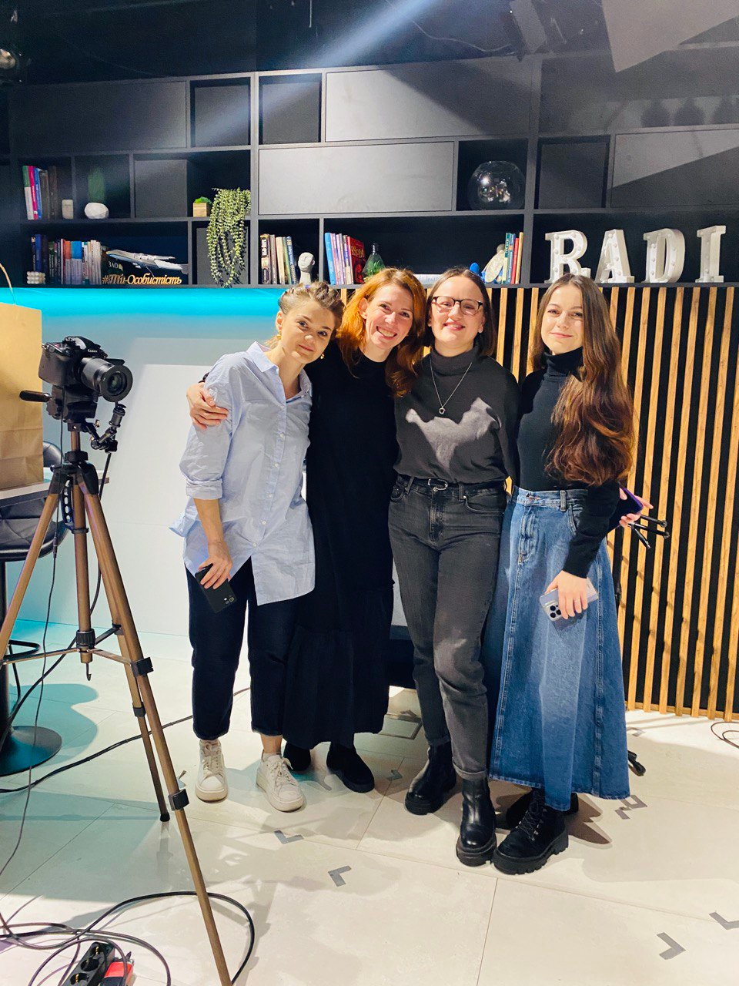

Thursday – 14
Please pray for listeners like this one, who said: “I was all alone in life, I thought. My mother died, and my brother, and his wife. I was so depressed. I was having panic attacks and felt exhausted. My doctors did not understand me. I was on medication, but my soul still hurt.” As this listener spoke to an FEBC team member, she turned to the Lord, putting her faith in Christ and asking Him to heal her soul from her pain and fear.

Friday – 15
Please pray for Victor as he coordinates the ministry in Eurasia. This is a complicated and challenging time, but it is also a time of opportunity. As persecution and limitations increase, so do responses and opportunities for change and growth. Please pray for God’s favor over Victor as he coordinates the ministry.
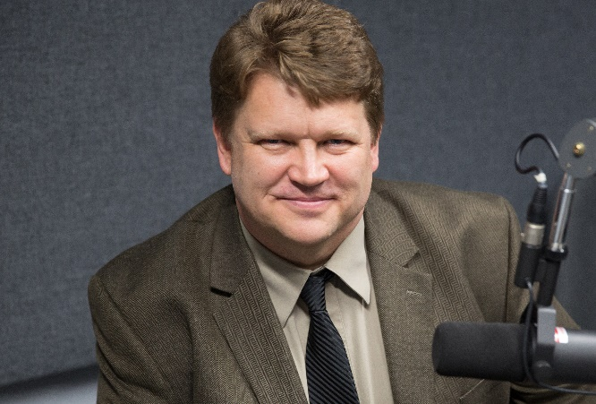

Saturday – 16
Please pray for listeners like Olga, as she takes her first steps towards Christ. And please pray that she agrees to visit a local church. “As I was listening to your program, I realized that I simply did not believe that God could forgive me. What a change your broadcast made! You answered the questions that have been tormenting me for so long! All my life, I’ve been blaming myself for my parents’ divorce…Your broadcast helped me understand that God really loves me! And he wants to heal my heart!”

Sunday – 17
Please pray for Iryna Nesterenko and for FEBC-Ukraine’s evangelistic prayer counseling team as they are dealing with some of the most difficult situations, including suicide, divorce, PTSD… They are leading listeners through these situations and are introducing them to the love and Grace of Christ. Many are coming to know the Lord and are being connected with local churches.
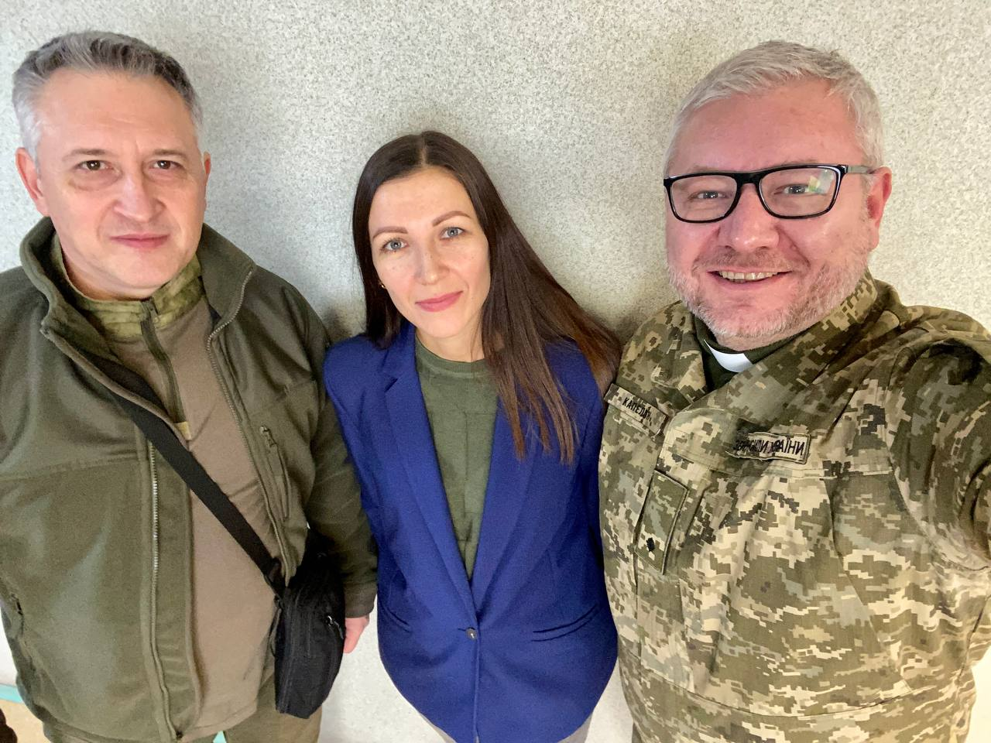
Monday – 18
Please pray for our listeners who are going through some very difficult things, and are in desperate need of the hope of Christ. Like Zhenya, who spoke with one of FEBC-Ukraine’s broadcasters. She was a single mother in this time of war, and witnessed someone committing suicide. “I called the ambulance,” she said. “But now, I’m afraid of even approaching a balcony, because I’ve had similar thoughts of suicide.” The previous day, she had been praying to all of the saints, but found no relief. Then, exhausted, she cried out to God. “And today, you’re here! You were my answer from God!”

Tuesday – 19
Please pray for Arseniy, a new member of the FEBC-Moldova team, who broadcasts in Romanian (the primary language spoken in Moldova) and in Russian. Arseniy is hosting one of FEBC-Moldova’s Bible programs.
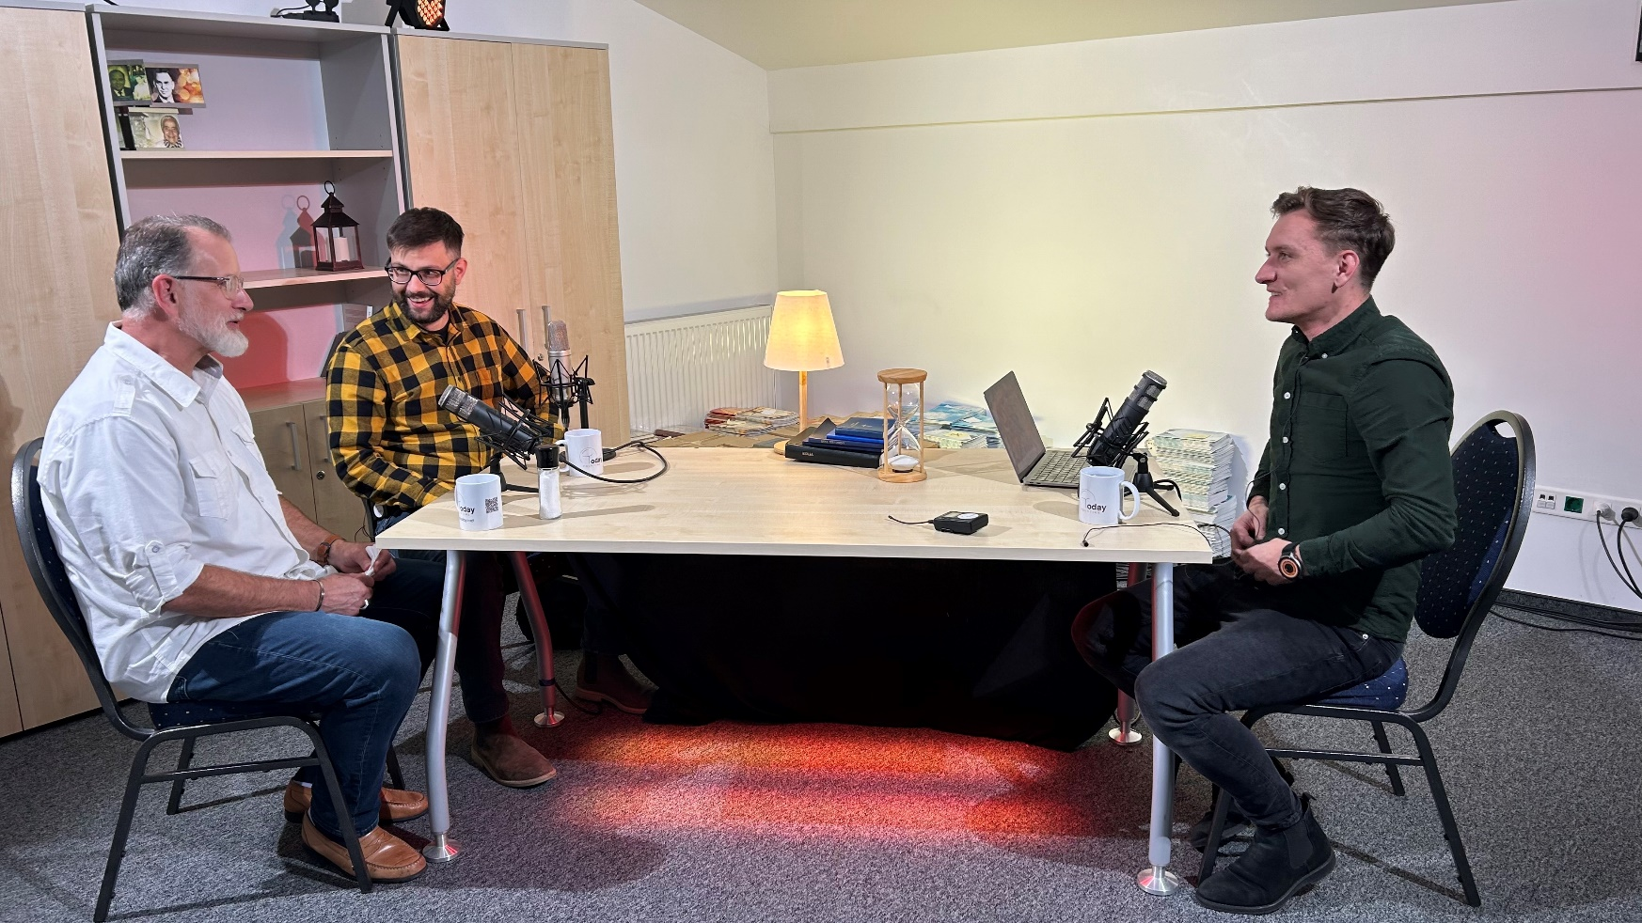

Wednesday – 20
Please pray for listeners like Svetlana, who was in despair because she found out her husband cheated on her. “We stayed together, but, whenever we have fights, I remember his infidelities. And, every day, the feeling that something inside me was dying continued to grow.” But as she continued watching FEBC’s programs, things began to change. “Your broadcasts began to literally save me, because sometimes, thoughts of suicide and other negative thoughts would rise up. Your broadcasts inspired me. The things you teach helped me survive. You say God is Love. It’s hard for me to believe this, but I feel that you’re right. I want to believe it. Thank you!”

Thursday – 21
Please pray for new believers in Kyrgyzstan who regularly face heavy persecution, especially those who live in small cities. FEBC-Kyrgyzstan meets with and supports the new believers who come to faith through their programs, often helping them relocate to different areas of the country where persecution may not be as heavy.

Friday – 22
Please pray for listeners like Katya, an FEBC-Ukraine listener who recently visited the studio in Kyiv. “Your programs appeared in my life at just the right time,” she said. “I’m going through a difficult time in my life, and all of my friends have left me.” She agreed to go with an FEBC-Ukraine broadcaster who invited her to come to church.

Saturday – 23
Please pray for Oleg, one of the key leaders of FEBC-Russia. He is a brilliant engineer, and supports all of the Eurasian region with technical issues and questions. He has been instrumental in building up and maintaining the ministry in the region. Please pray for him and his family as he continues to serve in this complicated time.
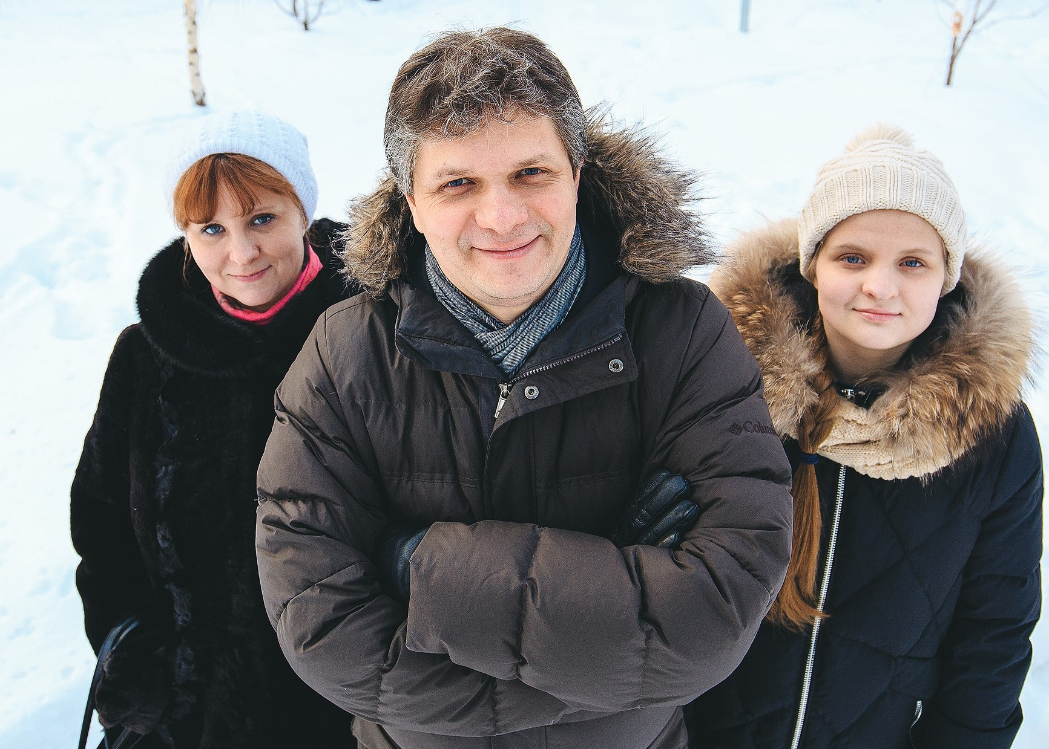

Sunday – 24
Please pray for listeners like Yelena, whose entire life seemed to have fallen apart, in addition to the war in her country. She had been in the hospital, her father had died, her husband left her, and her mother had recently had a stroke. She was at the end of her rope. But as she heard the Gospel from an FEBC-Ukraine team member, and understood that God never left her on her own, she put her faith in Jesus and was connected with a local church.

Monday – 25
Please pray for Evgeniy Goltsov as he travels to areas near the front lines, ministering to soldiers, gathering their stories, and encouraging their families. Please pray for protection as he travels and for his family.
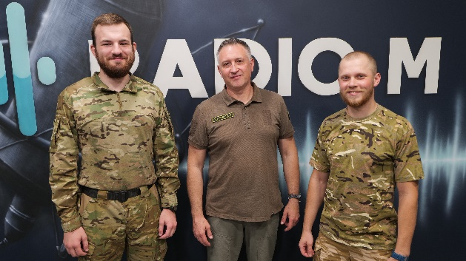
Tuesday – 26
“I admit it, your program made me jealous—in a good way,” said Alexey a listener of FEBC-Russia’s program for prisoners. “I can see how God works in your lives. One day, I caught myself thinking that I wanted that too. I started asking God to help me. I prayed simply, from my heart. I didn’t want to go back to prison, I wanted to improve my relationships…And I started to see results…I also started reading the Bible. Before I couldn’t understand anything that was written there. Now I find it fascinating.” Please pray for Alexey as he starts his journey with the Lord, and for other prisoners and ex-prisoners to come to the Lord through FEBC’s programs.

Wednesday – 27
Please pray for Russian listeners who are reaching out to FEBC-Russia’s prayer counselors. “In a moment of confusion and anger, I decided to write to you for help. I work a lot. I got tired, burned out, and I felt like I was totally unnecessary to anyone. I felt like God didn’t care about me, about my suffering. But after talking with counselors, I began to understand what I was feeling, and, most importantly, I could feel that God loves me. After that, I decided to visit a church.”
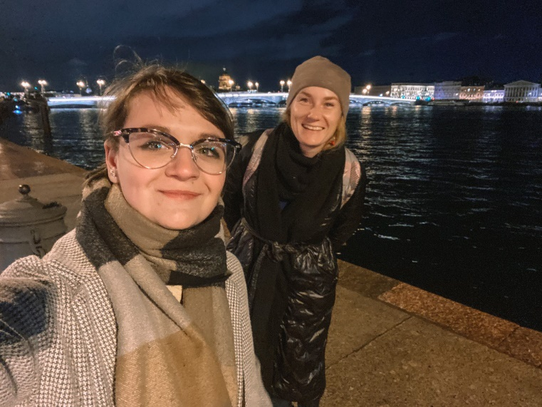

Thursday – 28
“I prayed once, and, believe it or not, God answered my prayer! It was amazing! But I never did it again, and soon, I forgot about it. Then, I was listening to your program, and I started thinking about God—what kind of relationship did I have with Him? I know God is real. Please pray for me and my husband; I don’t want this desire to know God to go away.” Please pray for listeners like Elena, who are being awakened to spiritual life through FEBC. Please pray that she continues on her journey towards Christ.

Friday – 29
“Your broadcast really inspired me,” said a listener named Nastya. “For a long time, I lived as an addict. I was even living on the street. Then some Christians helped me, taking me to a Christian rehab. Soon, I was baptized. But I was still ashamed. I couldn’t talk about my faith like other Christians. So I just stayed at the rehab center, working there. But as I listened to your program, I realized that I had wasted so much time—all this time, I could have been telling people what Jesus had done for me! Thank you!”

Saturday – 30
Please pray for soldiers like Max, who are returning from the war seriously damaged. “I’m deciding whether I’ll see the morning or not,” he said to an FEBC-Ukraine team member. “All my friends died in the war. I was the only one to survive. And now, all I can think about is death.” After hearing the Gospel, Max decided to keep living. “I know it can’t end like this,” he said. Please pray for Max as he takes his first steps towards faith in Jesus.

Sunday – 31
Please pray for Ulanbek, the director of FEBC-Kyrgyzstan, as he leads the team in Kyrgyzstan, including Nurayim and Nooruz. Though the country was once very closed to Christianity, and is once again seeing more radicalization, people are coming to know the Lord despite all the risks. Please pray for Ulanbek as he travels, for his family, and for protection for the staff as they continue ministering to the people of Kyrgyzstan.
