Wednesday – 1
Please pray for Dima and his wife Darina, who are producing video content for FEBC-Ukraine and are currently still living in Mykolaiv, which is under regular attack. They believe it is their calling to serve the people of this city as they are going through this very difficult time. Please pray for their protection and for them to continue to reach many listeners with the Gospel through their videos.

Thursday – 2
“I turned on your program while I was on vacation,” said Inna, an FEBC-Russia listener. “There were many tourists around, and soon, around 15 people were gathered around me, listening and asking questions. I sent you around 7 questions, and you answered all of them! It was so great when you explained why God forgives, because of Jesus.”

Friday – 3
Please pray for FEBC-Russia’s programs for Jewish listeners, especially as antisemitism is on the rise in Russia. “My grandmother used to tell me about our faith,” said one Jewish listener, “but I had never heard that all the holidays related to the Messiah, and that the Messiah is Jesus! I was introduced to Jesus through your program…now, I believe and accept Him as Messiah.”

Saturday – 4
Please pray for Pastor Sergey, as he has been drafted into the Ukrainian military as a chaplain. Please pray for the Lord to place him where he can have the most impact on the military and for his protection. Please also pray for his family during this difficult time.
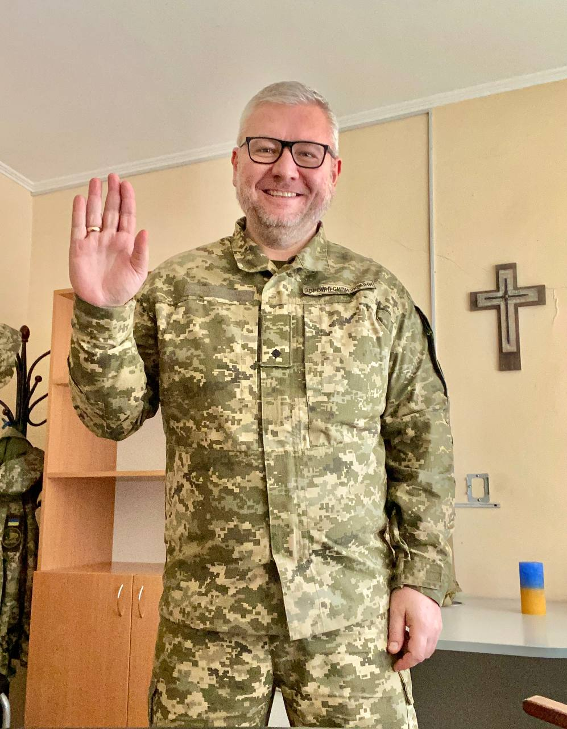

Sunday – 5
“I started watching your broadcasts a year ago, when my faith in God was very weak,” said an FEBC-Russia listener, “but through your broadcasts, my faith in God was strengthened—and so was my courage to tell other people about the Savior.”
Monday – 6
Please keep Andrey, a popular broadcaster in Moldova, in your prayers. He is reaching a surprising number of listeners in Moldova and in the surrounding regions. Please pray that God continues to bless his programs and his conversations with listeners.

Tuesday – 7
Please pray for Nooruz, from Kyrgyzstan, who is taking on a more administrative role, including more leadership tasks. Please pray for God’s wisdom and favor over her in her new duties.

Wednesday – 8
Please pray for FEBC-Ukraine’s children’s programs. We are currently searching for new producers—there is a great need to create programs that can encourage and share the Gospel with children.

Thursday – 9
“Through your broadcasts, God healed my heart, and I changed!” said Svetlana, from Russia. “I had a terrible relationship with my parents. And because they were religious, I hated even thinking about God. But through your programs, I learned to forgive my parents, and, even though they haven’t changed, I have! Now I have a great relationship with God, and I am moving forward in my life!”

Friday – 10
Please pray for Vlad Iurtov, who is coordinating FEBC-Russia’s counselors. Please pray for support for him and his family.

Saturday – 11
Please pray for FEBC-Ukraine’s prayer counselors who are helping the many children who are calling for help. The children of Ukraine are under a great deal of stress during this time of war; many have experienced trauma.

Sunday – 12
“I was an atheist for many years,” wrote one listener. “I was a teacher. So when I heard you openly talking about your faith in God during your broadcast, I was surprised. It really helped me when you talked about how you overcame your own struggle with cancer. It felt like I had hope. I started to believe that there really is a God. Thank you for sharing Jesus with us!”

Monday – 13
Please pray for Ulan, who has a difficult family situation. He is leading Kazakhstan’s prayer helpline and several youth movements. Please pray for God’s hand to be on him and his family.

Tuesday – 14
There is rising persecution in Russia. We have multiple channels reaching people as we try to stay under the radar, but it continues to grow more challenging. We are continuing to look for new ways forward. Please pray for God to continue to make a way for FEBC-Russia to continue broadcasting the Good news in Russia in dark times.

Wednesday – 15
Please pray for the children in Ukraine who are growing up as orphans. Many new orphans have been created by this war. Please pray for FEBC’s broadcasters and prayer counselors who are creating programs for children, speaking and praying with them, and visiting orphanages, where they put on events. Please pray for many children to “become friends” with Jesus.

Thursday – 16
“I’ve told many of the people around me about your programs, and quite a few are watching them. I watch as they gradually become kinder, softer…I want you to know that you are making a difference. A couple of my friends opened up to me and told me they had stopped wanting to live. I knew they were going through such difficult times, but I had no idea they were so close to the edge. Thank you for helping change hearts! Watching your programs sometimes feels like having a real conversation with God.”

Friday – 17
Please pray for FEBC’s new ministries reaching the countries of Uzbekistan, Tajikistan, and Turkmenistan. Please pray for God to open doors and to draw more local people to join the ministry.

Saturday – 18
Please pray for FEBC-Ukraine’s outreach to Jewish listeners, many of whom are coming to know the Lord. Like Sophia, who first put her faith in Jesus through FEBC’s programs when the war began. “The first time I heard about Jesus as my Savior was from you,” she said. Now, Sophia wants to help reach other Jewish listeners with the Good News.

Sunday – 19
“I once asked you on the air, ‘Is magic a sin?’,” said a listener named Katyusha, “and you told me that, yes, it was. Some people in my family are involved in the occult and magic. Whenever I heard you talk about Jesus Christ, I felt some kind of resistance…After talking with you, it was like I saw the light! I asked God for forgiveness for the first time in my life. My soul felt so light!”

Monday – 20
Please pray for the many children who are listening to FEBC-Kyrgyzstan to put their faith in Jesus. This is a time when they are surrounded by many other influences, but there is still an openness to the Gospel. Please pray that many have the opportunity to hear the Good news.

Tuesday – 21
Praise God for the new transmitter that was received in Kyiv! Please pray that many additional people will hear the Gospel in Kyiv and the surrounding region. Many people who have been displaced are going to big cities, especially to Kyiv.

Wednesday – 22
Please pray for young people who write in to FEBC-Ukraine’s evangelistic prayer counseling chatline. Many are being helped, and many are coming to know the Lord. “ One listener, Eva, a teenage girl living with her single-parent mom and taking care of her younger sibling, was feeling overwhelmed. The counselor advised her and prayed with her, sharing Psalm 91 with her. “Thank you so much! I will definitely be reading this Psalm!” said Eva. “Thank you for calming me down. I would like to hug you from the bottom of my heart!”

Thursday – 23
Please pray for Nurayim, who is contacting many listeners in Kyrgyzstan. Many of these listeners live in villages, which are heavily Islamic; the situation there is very difficult for new believers.

Friday – 24
Please pray that FEBC-Ukraine would receive a permanent license in Kyiv. We have been operating with a temporary war-time license, and the reach has been great.

Saturday – 25
One young man wrote in to FEBC-Ukraine’s chat helpline to ask for help with his gambling addiction. When the counselor suggested they pray, he was hesitant. “I haven’t been to church for a long time.” They decided to pray together anyways, and the young man responded, “Thank you! I feel such a relief. I will try to overcome my pride and go to church again. Thank you for helping me!”

Sunday – 26
There is a growing movement in Kazakhstan where many young Muslims are becoming Christian. Please pray that this movement continues to grow and that many in Kazakhstan come to know the Lord.

Monday – 27
Please pray for Max, FEBC-Ukraine’s former program director, who was drafted into the Ukrainian military as a chaplain. Please pray for his protection, as he has been transferred to a more dangerous area. Please also pray for his family.
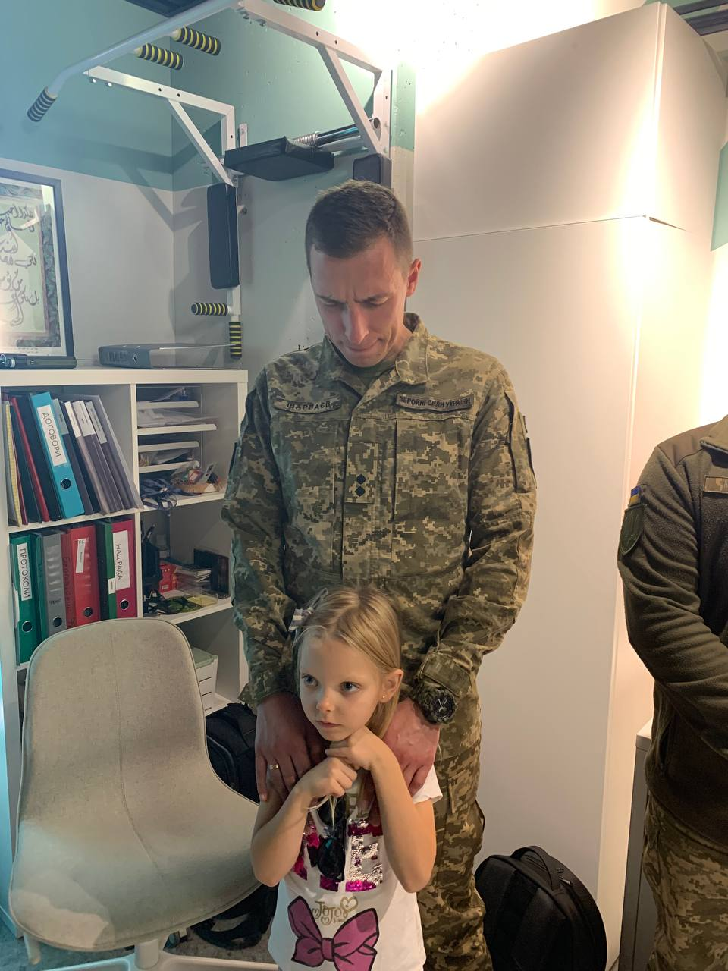

Tuesday – 28
One young listener wrote in to FEBC because of a heartbreak. “When I told her that God loves her and wanted to support her,” said the prayer counselor, “She told me that she was so sinful that God would not listen to her or forgive her. She told me about her life, and it’s true that she was living in sin, but I told her that now was the best time to talk to Jesus about what she had gone through, and to trust that He has set her free. She chose to pray and give her life to the Lord!” Please pray for FEBC’s younger listeners who are being transformed and changed.

Wednesday – 29
Please pray for the prayer counseling helpline that is starting in Moldova. May God bless it so that it reaches many listeners and may He bring the right prayer counselors to join the new team.

Thursday – 30
Please pray for the many Russian-speaking Jewish people in Israel. There is a growing FEBC audience in Israel. Please pray that many hear the Good News and for the peace of Israel.

