Russia & Ukraine September Prayer Focus

Friday – 1

Recently, a soldier visited FEBC-Ukraine’s studio and spoke and prayed with broadcasters. “I listen to your programs regularly,” he said, “even on the frontlines.” He thanked the team for sharing the truth of Jesus in their programs, and he took some radios and prayer pamphlets so the other soldiers could listen as well. Please pray for protection for this soldier and for the many other soldiers who are putting their lives at risk. Pray that many come to know the Lord through FEBC’s programs.

Saturday – 2

Please pray for young listeners like Maria, whose parents are alcoholics. She and her siblings have been struggling. FEBC’s counselors prayed for her, her siblings, and her parents. “Thank you for listening to me and praying for me,” said Maria.

Sunday – 3

Please pray for the leadership of FEBC Russia, Ukraine, Kyrgyzstan, Kazakhstan, and Moldova, who will be meeting to plan new projects. Please pray for God’s wisdom and guidance as they make plans, and safety for them as they travel.

Monday – 4

Please pray for listeners like Masha, who responded to a broadcaster who was talking about the prayer of salvation on her program. Masha was going through a difficult time and asked for prayer. She and the broadcaster continue to talk. Please pray for Masha to come to know the Lord.

Tuesday – 5

Please pray for Sergey Nakul, FEBC-Ukraine’s Bible program host, who is in the process of being drafted as a chaplain. Please pray for God’s hand to be on him, guiding and protecting him. Please also pray for his family.

Wednesday – 6

One FEBC-Russia broadcaster recently sent a Bible to a listener who requested one. She has been reading the Bible daily, and writes to the broadcaster with any questions she has. Please pray that this listener puts her faith in the Lord and agrees to be connected with a church in her city.

Thursday – 7

Please pray for the prayer counselors in FEBC-Russia as they pray with listeners and share the Gospel with them. Please pray for God to bring the right people to the counseling team.

Friday – 8

Please pray for listeners like Mikhail, who put his faith in Christ through FEBC-Ukraine’s programs a year before the war began. “I still remember moments from the broadcasts that touched my heart and started me thinking about God” he said. He is now serving as a soldier in the Ukrainian military. “Many of the men in my unit were wounded, many lost their lives. I thank God for keeping me safe.” Please pray for Mikhail and for other soldiers who have put their faith in Jesus through FEBC’s program.

Saturday – 9

We thank God for protecting our team members in Ukraine! On August 30, there was an explosion 50 yards from the home of our broadcaster Ihor. More than half of the windows in his house were broken. Ihor and his family are okay. On the same morning, 300 yards from our FEBC-Ukraine team member Iryna, fragments of a rocket fell on the shopping center. They were unharmed. We are grateful to God for His goodness. We ask that the Lord preserve the souls and bodies of our team members and our loved ones in the night shelling.

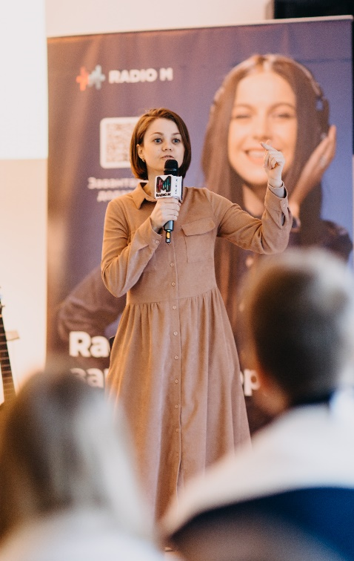

Sunday – 10

“I was having problems with my kids, and I was listening to your program. You addressed my problem directly! And then you talked about how our relationship with God works in the same way. You talked about how God is our Heavenly Father, our Lord, our Teacher, and our Savior. I shared your program with my children, and they were so surprised to learn this! They even wanted to go to church afterwards!” Please pray for listeners like Daryna whose families are hearing the Gospel through FEBC-Russia’s programs.

Monday – 11

Please pray for FEBC-Ukraine’s Lyoshi, whose father is being drafted. Please pray that the Lord protects him, and supports and protects his family.

Tuesday – 12

There is a growing atheistic worldview appearing in Russia. One way we reach people with this mindset is by talking about popular topics from a Christian perspective. One listener, Alexey, responded to a recent broadcast saying, “I really appreciated the way you discussed this new scientific development. I thought Christians just tried to stop scientific progress any way they could because of superstitious fears. But after your broadcast, I had to really think about my own perceptions.” Please pray for Alexey to put his faith in Jesus as he continues hearing the Gospel on FEBC.

Wednesday – 13

Please pray for God's guidance and favor as we reach out to members of the military and their families. We receive many messages from soldiers and have met with them in our studio. Many members of the military are listening to FEBC-Ukraine.

Thursday – 14

“Your program helped me start to think about what restores my damaged soul,” said Yelena, a new FEBC-Russia listener. “Can you tell me more about Jesus’s sacrifice on the cross?” Yelena went to church when she was younger, but she had been on a spiritual search since she was fifteen. She had lived through a very difficult time, losing her job and living in poverty, but she had never stopped praying. “Please, pray for me to grow spiritually,” she said. “And for my husband to put his faith in Jesus.”

Friday – 15

“My husband and I started considering adoption when our children left home,” wrote one listener of FEBC-Russia’s program on adoption. “Everyone around us was very supportive, and we even met with a psychologist. But still, I had my doubts. It was while we were watching your program that I realized I could do this. You had a guest who had adopted a young girl with mental disabilities, and after hearing her talk, my heart responded! I want to give myself away!” Please pray for listeners like Maria, who are making the decision to take children who are in need into their families through FEBC’s programs.

Saturday – 16

Please pray for listeners like Milena, who called FEBC after losing her life’s savings. “My children would have been able to use that money one day,” she said. “Now what are they going to do?” Milena was despairing and didn’t want to go on living. FEBC’s counselors shared about the grace of God with Milena and invited her to pray. As they prayed, Milena put her faith in Jesus and made Him her support rather than her money. “I feel so much relief,” she said.

Sunday – 17

Please pray for our Ukrainian prayer helpline counselors, Iryna, Nina, Anna, Maria, Lyuba, Alex, and Nadia. They are receiving many difficult calls and need God’s strength emotionally and spiritually.

Monday – 18

Please pray for listeners like Natalia, who is a regular listener of FEBC-Ukraine’s morning program. Early in the war, she met with one of our broadcasters, Inna, when Inna visited her city. “Meeting with you, your program, and meeting the Christian girls you introduced me to has changed my life,” said Natalia. They recently met again when Inna visited her city and Inna was able to share the Gospel with Natalia again. Please pray for Natalia to come to know the Lord.

Tuesday – 19

Please pray for FEBC’s broadcasters who visit rehabilitation centers to spend time with the people there and share the Gospel with them. One such center recently contacted an FEBC broadcaster and requested some New Testaments. He has agreed to begin visiting them to help the people there and to share Christ with them.

Wednesday – 20

“I feel wonderful, so much calmer,” said a teenage girl after putting her faith in Jesus. When she first called FEBC-Ukraine’s helpline, she was severely depressed, she had been cutting her arms with a blade. “I’m scared of telling my parents,” she said. “Please help me.” Prayer counselors helped her make a plan to talk to her parents and offered to pray for her. As she prayed, she opened her heart to God and put her faith in Jesus. She gave her burdens to God and asked Him for help. Please pray for the many young people who are struggling to hear the Good News and turn to the Lord.

Thursday – 21

Please pray for the FEBC-Ukraine staff as they prepare for winter by insulating the office, servicing the generator, and gathering the necessary supplies.

Friday – 22

Please pray for listeners like Ivan, who put his faith in Jesus through FEBC-Russia’s program for prisoners. “I recently went to an event where many people knew me from before. They were surprised to find out I wasn’t drinking or smoking, and even more surprised that I was a believer. One woman said to me, ‘I’ve been watching you all this time, and I’ve decided to stop drinking. You have so much energy and light. That’s how I want to live too.’ Thank God that I found your program and that God changed me and my life in one day. But I know that this is only the beginning!”

Saturday – 23

Please pray for God’s favor as FEBC-Ukraine attempts to obtain a permanent license in Kyiv. We are currently broadcasting on a temporary war-license. Please pray for God’s favor and for His will to be done.

Sunday – 24

Please pray for listeners like Eugene, who stayed in communication with one of FEBC-Russia’s broadcasters for 6 years before putting his faith in Jesus. When Eugene went through a difficult time in his life recently, he asked the broadcaster to connect him with a local church. A few weeks later, he and his wife were baptized.

Monday – 25

Please pray for listeners like Bogdan, who received one FEBC-Ukraine’s prayer booklets. Bogdan called FEBC-Ukraine after receiving a prayer booklet with FEBC’s phone number inside. “This prayer booklet was a great support for me. I accepted Jesus! I prayed the prayer for forgiveness of sins I found there, and made Jesus my Lord and Savior. My wife died a few months ago—it’s been difficult, I’m so lonely, but I read prayers from the prayer booklet every day and God’s grace surrounds me. Thank you for helping comfort me in this terrible grief.”

Tuesday – 26

Please pray for listeners like David, whose life changed after beginning to listen to FEBC, and who is now helping others come to know Christ through FEBC’s programs. “I started watching your programs about a year ago. I even turn them on at work sometimes, where I had problems. Since I’ve been watching, the entire environment has changed at work. It’s great!! My wife and children also noticed that I’ve become a softer, kinder person. I tell everyone about your program now. And I think some of my employees have started to believe in God since I started playing your programs here!”

Wednesday – 27

Please pray for FEBC-Ukraine’s partnership with churches to continue to grow. Churches will sometimes reach out to FEBC’s team for help with different evangelistic projects. Please pray for partnerships like this to lead to more listeners coming to church.

Thursday – 28

Please pray for listeners like Darina, who have been overwhelmed by the struggles they have faced in the last year and a half. Darina had experienced many troubles in addition to the war, including problems in her family and her husband’s life being in danger. At first, she handled it, “I was an iron woman,” she said. “But in the last six months, something happened to me. I can’t bring myself to do anything, I’m depressed, any minor problem that I used to be able to solve easily now overwhelms me.” FEBC-Ukraine’s counselors offered Darina advice and other resources. When they prayed for her, Darina began praying as well and repented of her sins. “Thank you so much for helping me!”

Friday – 29

Please pray for the leadership of FEBC-Ukraine - Viktor Akhterov, Eduard Kurylenko, Ihor, Sergey and the entire leadership team. Please pray for God's guidance in making decisions and for God's protection as they travel.

Saturday – 30

“I can’t decide whether I should keep living with my husband or get a divorce,” said a listener named Elena, from Ukraine. “We’re constantly arguing. I tried to get him to work on our relationship, but all the initiative comes from me.” FEBC’s counselors shared the Gospel with Elena and, as they prayed with her, Elena put her faith in Jesus. “God Himself sent you to me,” she said. Please pray for listeners like Elena who are facing serious marital trouble. May many more come to learn that Jesus is the only solution to their troubles.