Russia & Ukraine July Prayer Focus

Saturday – 1
Please pray for the city of Kramatorsk, where 12 people were killed, and over 60 were injured, after a restaurant was struck by a missile. One of FEBC-Ukraine’s stations covers the city.

Sunday – 2
“You helped me so much in my relationship with my husband, but I always kind of ignored your stories about God, salvation, and Christ. Now I absolutely believe in God, and even though I know things will probably only get worse in Russia, I believe that I will survive all these trials with faith in God in my heart. Thank you!” Please pray for listeners like Svetlana, who are turning to God through FEBC’s programs in the midst of a darkening world.

Monday – 3
Some members broadcasters from Moldova recently visited the FEBC-Ukraine team to go through training. Please pray for this time to continue to produce fruit in the ministry in Moldova as the team continues to reach many Moldovans through their videos and programs.


Tuesday – 4
Please pray for listeners like Boris, an atheist, who started watching FEBC “as a joke.” “At first, I didn’t understand your good character. I thought you were faking it. But now I’m beginning to understand. You were following Christ, and I started following you without realizing it. A few months ago, I started reading the New Testament and met with Christ myself.” Please pray for the salvation of many such listeners.

Wednesday – 5
Please pray for the many Muslims being reached by FEBC’s ministry. Please pray for FEBC-Russia’s partnerships with ministers from various Muslim countries to create evangelistic videos and recorded testimonies.

Thursday – 6
“I was addicted to alcohol and my loved ones already thought that I was lost. I listened to your broadcasts both when I was very drunk and when I was not very drunk. Your program seemed to treat me – my soul. I began to notice that when I listen to your broadcasts, I don’t feel like drinking…I stopped drinking a month ago. My family is in shock.” Please pray for listeners like Yelena, who have been struggling with addiction for much of their lives, and are being freed through Jesus Christ.

Friday – 7
Please pray for spiritual and emotional strength for FEBC-Ukraine’s broadcasters, team members, and families. The ongoing war, constant sirens and attacks, often seeming to be aimed at civilians, are leaving people exhausted. Many people are sleep-deprived because of the night attacks. Some days, all of Ukraine is under alert for risk of missile attack.
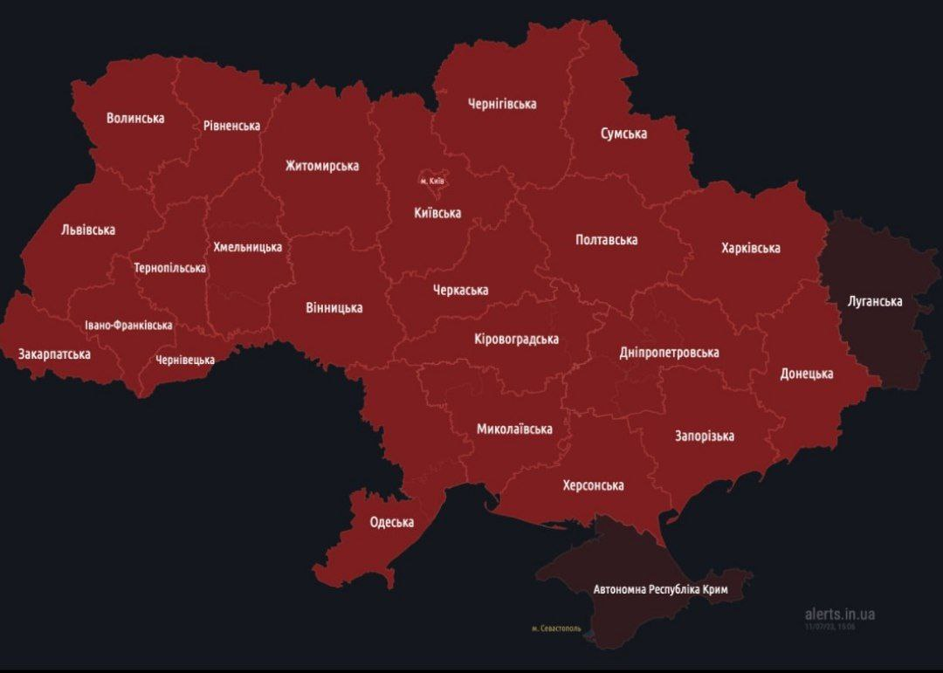

Saturday – 8
“Your programs saved me from depression,” said a listener named Evgenia. “You came in at just the right time and helped me get through a time of struggle with discouragement. I left church a long time ago, but I started watching your broadcasts a few months ago and decided to start going to church again. You helped me regain my faith in God!” Please pray for listeners like Evgenia to come back to God through FEBC’s programs.

Sunday – 9
Please pray for the leadership of FEBC-Russia. While they are facing national instability and government restrictions, they are also seeing a much higher number of deeper conversations and conversions from listeners. Please pray for emotional and spiritual strength for our leaders and their families.

Monday – 10
Please pray for listeners like Natasha, who originally watched FEBC to get help with her problems, but came to faith through them over time. “Through your broadcasts, faith in God grew in my heart. I don’t think anyone could have helped me out of my difficult situation if God wasn’t helping them. That’s how I came to faith. Thank you so much!”

Tuesday – 11
Please pray for Arseniy, the new broadcaster joining the Moldova team. He will be hosting a Bible program in the Romanian language. Please pray for his program to reach many Romanian speaking people with the Good News.

Wednesday – 12
“I have been so lonely and unhappy,” said one Russian listener. “Thank you so much for talking about Jesus. Now I’ve started to really understand the meaning of life.” Please pray for listeners like Ella, who heard the Gospel and turned to God when her life was it its lowest.

Thursday – 13
Please pray for FEBC’s listeners in Lviv, a city in western Ukraine, where seven people were killed after a missile struck a residential building. Several FEBC-Ukraine broadcasters were in Lviv just a few days before the attack holding a seminar on evangelistic broadcasting. Please pray for the people of the city and for protection for our broadcasters.
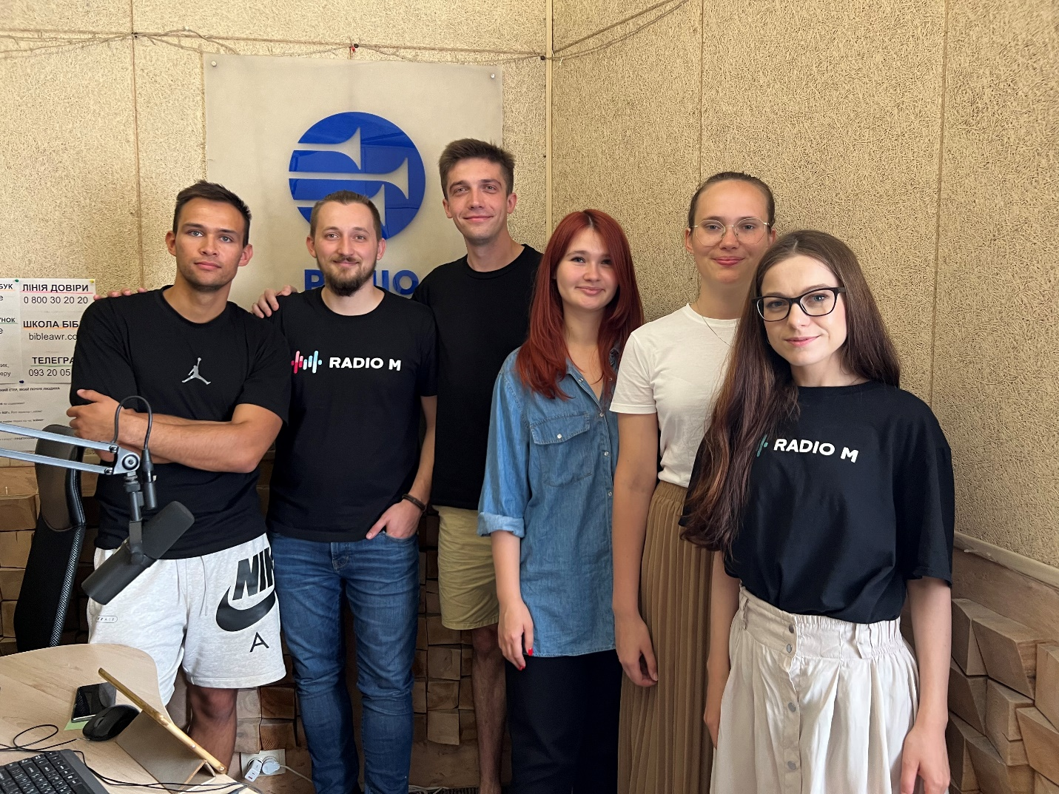

Friday – 14
Please pray for those who are in very difficult situations in Ukraine. In the middle of a war, one woman was taking care of her mother, and needed to make serious, life-altering decisions about her health. When calling FEBC, she put her faith in Jesus and prayed with the counselor. “Oh, I thought it was all over,” she said. “But I feel hopeful again. This has really helped me. Thank you!”

Saturday – 15
Please pray for the ministry in Russia, where millions of people are listening, despite all the difficulties the ministry is facing. We are receiving more responses, and deeper responses, from people who are more open to the Gospel.
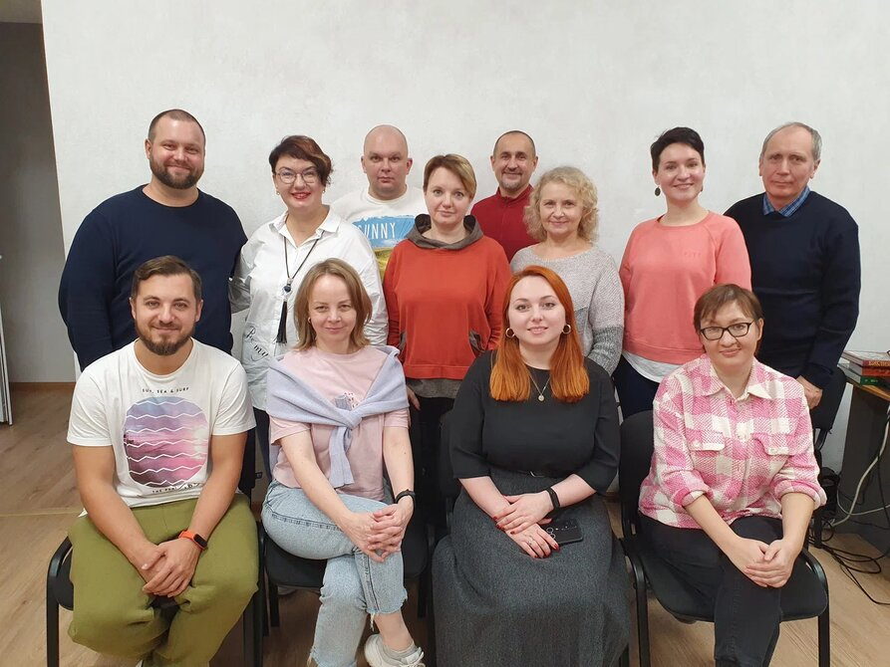

Sunday – 16
Please pray for listeners like Vlad, who lived difficult, dangerous lives and are coming to know the Lord. “I had never been afraid of death,” said Vlad. “Ever since I was young, I knew that I could be killed in the street at any moment. But through your broadcasts I found out about something worse than death, the death of your soul. And you told me about Christ, who gives us the strength to overcome the death of our souls. Now I don’t have to be afraid. I don’t believe yet, not like you, but I am on the way.

Monday – 17
Please pray for the many young people who call FEBC-Ukraine’s prayer helpline. Many are dealing with depression or trauma, and many suicides have been averted. Please pray for the young people of Ukraine, whose lives have been turned upside down, and for the counselors who are supporting and praying for them.

Tuesday – 18
Please pray for listeners like Tamara, who had to leave their friends and homes behind to move to another part of Ukraine for safety. “I feel all alone,” said Tamara. “I don’t fit in here, we are living in a small one-room apartment with not enough space for our children, and my relatives are still in our city, which is occupied.” Please pray for God’s encouragement and provision for listeners like Tamara, who cried after praying with FEBC’s prayer counselor.

Wednesday – 19
Please pray for FEBC-Ukraine’s prayer counselors, who are hearing many heartbreaking stories every day. The team has had to grow to over 35 counselors to keep up with the number of people calling in. Many people are coming to know the Lord through their ministry. Please pray for spiritual and emotional strength.
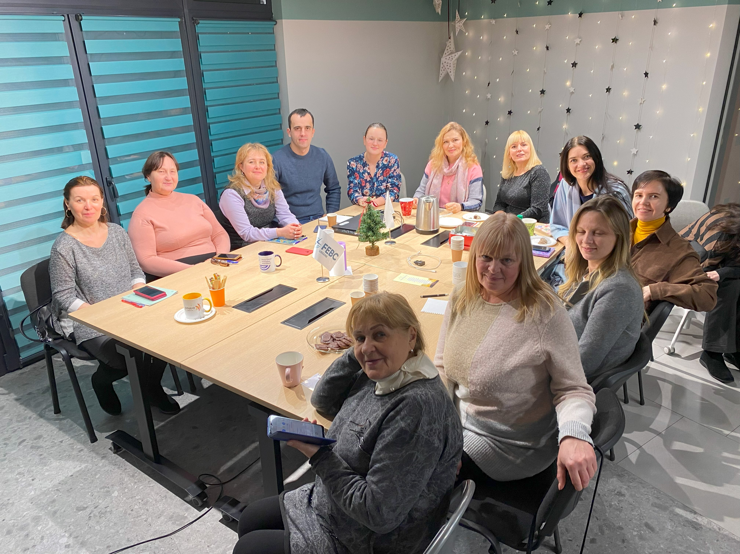

Thursday – 20
Please pray for listeners like Alina, who was terrified as she was waiting for the night shelling to begin. “I can’t get to a bomb shelter,” she said. “Every time the shelling starts, I read Psalm 91, but I get so worried that the fear overcome me.” Many Ukrainians are struggling to sleep with the increased night shelling. Please pray for protection and rest for the people, and for healing to come to Ukraine.

Friday – 21
Please pray for remodeling happening in the studio in Moscow, creating more studio space for creating videos. People have been very responsive to short and some longer form videos, leading to deeper conversations with FEBC’s broadcasters and counselors.

Saturday – 22
Please pray for listeners like Margarita, who was feeling totally hopeless in her life. “My family had fallen apart, things at work were bad, and none of my relatives lived near me. But your broadcasts have saved me. Thank you so much for talking about Jesus. Now I’ve started to really understand the meaning of life—to repent and turn to God while I am still on the earth and have the chance.”

Sunday – 23
Please pray for the FEBC-Ukraine team. Attacks have become more frequent across Ukraine, with cities like Lviv, far from the frontlines, being targeted. Many FEBC-Ukraine team members are struggling with exhaustion, not sleeping at night because of regular air-raid sirens. Please pray for emotional and spiritual strength as FEBC-Ukraine leaders lead their team members through these trying circumstances.
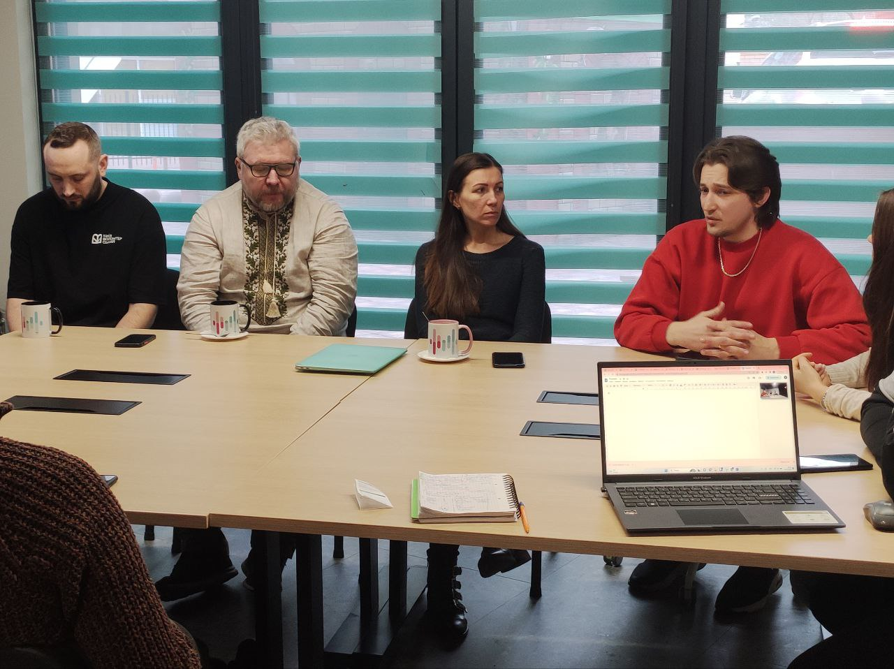

Monday – 24
“My friends and I were very far from believing in God,” said a listener named Yulia, who wrote in to FEBC. “After watching your program, for the first time I believed that Christ was a real person, that there is salvation of the soul, and that if Jesus was resurrected, so will I be…You have opened my heart to faith in God, but it was a long road. I started listening to you 7 years ago. Thank you for having patience with me!” Please pray for listeners like Yulia, who come to Christ after a long road and for the FEBC broadcasters who build relationships with listeners.

Tuesday – 25
Please pray for the children who are becoming “friends of Jesus” through FEBC’s phone prayer helpline. Many children are living without one of their parents, some even having lost them to the war. They are dealing with fear, loneliness, and trauma. Please pray that they experience healing through a relationship with Jesus Christ.

Wednesday – 26
Please pray for listeners like Irina, who was baptized last month after putting her faith in Jesus. Irina started watching FEBC-Ukraine’s programs 3 years ago. She visited FEBC-Ukraine’s studio, getting to know the broadcasters, and was ministered to over the next three years. Many listeners’ path to faith takes some time. Now Irina is attending church with her family and is asking for prayers for her husband to come to know the Lord. Please pray for listeners who are on the path to faith in Jesus.

Thursday – 27
Please pray for FEBC-Ukraine’s partnership with local churches to continue to produce positive results. Churches are being equipped in media evangelism and are becoming resources for local listeners who hear the Good News and want to visit a church.

Friday – 28
“I’ll never go to church, they’re all frauds. And anyways, there is no God,” said a man who called FEBC’s prayer helpline. He had been struggling with alcoholism for many years, despite trying many methods to overcome it. After the counselor prayed for him, however, he grew emotional and started to ask questions about God. He even asked to be connected to a local church. Please pray for God to continue working on this man’s heart and to draw more people to Himself through FEBC’s counselors.

Saturday – 29
“Your videos are great! I’ve been looking for something like this for a long time! You gave me answers to questions that no one else could answer. God is supporting me through you, though you are a Christian and I am a Muslim. And now I’ve started secretly reading the Bible.” Please pray for Muslim listeners who are listening to FEBC’s programs and are beginning to turn to Jesus.

Sunday – 30
Please pray for listeners like Daria, who recently started watching FEBC-Ukraine’s programs. She lived in Kharkov in the early months of the war, when it was experiencing heavy warfare. “The war really affected me,” she said. “For the last year, I’ve been in a state of fear and apathy. It’s hard to do anything because I have no real hope for the future.” An FEBC broadcaster met with her and told her about God. Daria was interested to hear what it is like to have a relationship with God. Please pray for her to come to know the Lord.

Monday – 31
Please pray for those listeners who have lost loved ones in the war in Ukraine. People have lost spouses, parents, children, and friends. Everyone on the FEBC-Ukraine team has lost someone. Please pray for healing of the emotional wounds, and for the war to end in Ukraine.

v

