Russia & Ukraine June Prayer Focus

Thursday – 1
Please pray for Pastor Sergey, one of FEBC-Russia’s lead counselors, who has been able to influence hundreds of people for Christ in the last few months. Pray that many more will be touched.

Friday – 2
Please pray for the group of young people in the city of Kremenchuk who are serving as volunteers of FEBC radio in that city. They are promoting FEBC radio to their friends and other young people who live in that industrial city. Many of them are living in fear of the war.
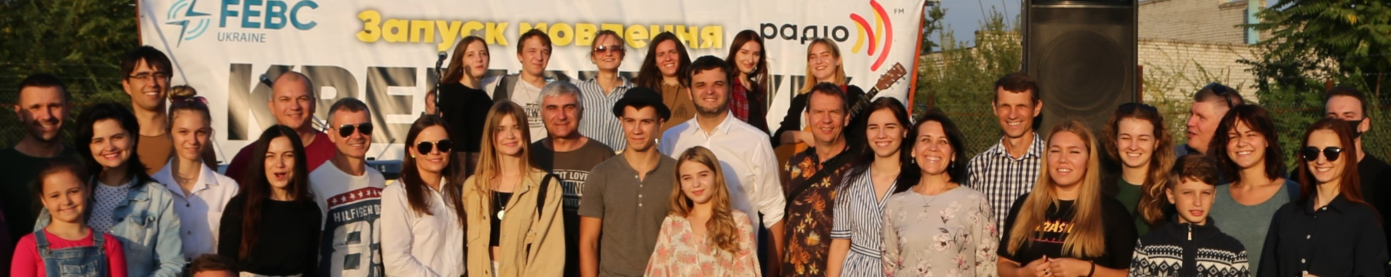

Saturday – 3
Please pray for the young people in Buryat who are working on recording video testimonies for the people of Buryatia, and for Russia as well. Pray that many lives will be touched.

Sunday – 4
Please pray for the safety of our FEBC-Ukraine broadcasters. Recently, 54 drones attacked Ukraine in one night, 52 of which were shot down. The apartment complex where one of our broadcasters lives was hit by a rocket, damaging several apartments.

Monday – 5
Please pray for a project in Kyrgyzstan geared towards evangelizing influential people in the country. The project involves in-person and on the air ministry. Many have already come to know Christ.

Tuesday – 6
Please pray for Aglaya, Margarita, Oleg and Igor, listeners of FEBC-Russia’s program for parents of children with special needs, to come to know the Lord and be connected to a church. Please pray for many parents and families to come to God through this program.

Wednesday – 7
Please pray for listeners like Marta, who called FEBC after her husband left her. “We had our entire future planned out. Now that’s all over.” During the call, Marta heard the Gospel and gave her life to Jesus. “I didn’t have a father,” she said, “but now I have experienced the care of my Heavenly Father.”

Thursday – 8
Please pray for FEBC-Ukraine’s eight working radio stations and the two that were captured or destroyed. May they reach listeners going through some of the most difficult times in their lives with the Gospel of God’s grace. And may the two stations that were destroyed or captured be returned and rebuilt in God’s timing.

Friday – 9
Pray for the team of young broadcasters in Kazakhstan managed by Aizhan. There are several young people who have come to know Christ and have joined churches because of their ministry.


Saturday – 10
Please pray for an influential FEBC-Russia broadcaster who is going a trying time. God’s intervention is desperately needed.

Sunday – 11
Praise God for several successful training sessions that FEBC-Eurasia broadcasters participated in. As a result, we have more than 2 million new listeners.

Monday – 12
Please pray for God to bring more people to join FEBC-Ukraine’s prayer counseling teams. Both the prayer helpline and online text counseling teams need more counselors who can share God’s heart with broken people whose families are broken, who have lost loved ones, and who are filled with fear.

Tuesday – 13
Please pray for FEBC’s program concentrating on people living in the villages in Moldova, where there is a lot of drinking and many orphans. Pray for Lena, the project manager, and her family.

Wednesday – 14
Please pray for FEBC-Ukraine programs that are being prepared for children. The programs will be dealing with how to protect children in a time of war and how to help children who have been through trauma. Please pray for broadcasters and guests who will be handling very sensitive topics, and for the parents and families who have experienced trauma and loss.
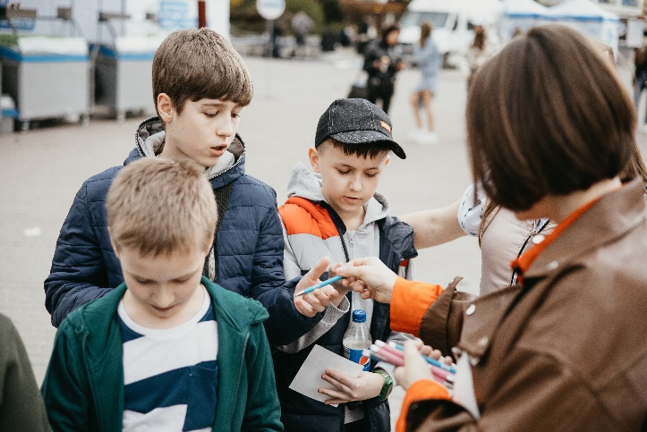

Thursday – 15
Please pray for the work that needs to be done at the FEBC office in Moscow. The office needs some repairs, and the studios need to be remodeled. Please pray for this to be done smoothly and with no issues.

Friday – 16
Please pray Iryna, FEBC-Ukraine’s administrator, who is the heart of the Kyiv studio. She has just started leading a new program called “Workroom,” where she talks to people with different professions that involve service, about their lives and about faith.

Saturday – 17
Please pray for listeners like Igor, a communist who recently started watching one of FEBC-Russia’s programs. “I was hooked,” he said, “which surprised me, because I’m an atheist. I wanted to thank you for not just arguing and debating with me, but actually sharing your experience of believing in God. You drew me in, and you really made me think.”

Sunday – 18
Please pray for the possibility to open new stations in several cities across Ukraine. Please pray for God to open the right doors in the right cities, so that people can be reached with the Gospel.

Monday – 19
Please pray for Vlad, FEBC-Russia’s broadcaster and one-on-one evangelist. Please pray for his family, for health, and for the new church he is pastoring. Please pray for God to bless his family and ministry.
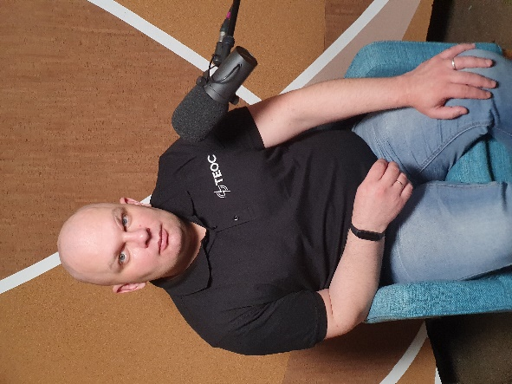

Tuesday – 20
Please pray for the FEBC-Ukraine team as they are in the process of finding more broadcasters. Please especially pray for one morning show broadcaster, Misha, who joined the team recently, but whose programs have already touched many people. Misha is receiving huge feedback from listeners, especially through social media. He has a particular gift for working with young people.

Wednesday – 21
Please pray that we will be able to personally visit 25 of our listeners in Kyrgyzstan in the next 3 months. Many of them are women who are abused by their husbands and are seeking spiritual help.

Thursday – 22
Several of our volunteer broadcasters have been drafted into the Ukrainian army, some as soldiers, and some as chaplains. Please pray for their safety and their influence as they serve their country.

Friday – 23
Please pray for listeners like Marina, from Russia, who wrote in to FEBC’s program for prisoners and their families. “I was tired of my husband’s lies and drunkenness,” she said of her husband who was in prison. “But now I understand that I can pray for him and love him without accepting the evil that he has done. After your broadcast, I talked to him, and he confessed his lie. We’ve both been praying every day, and I can see now that God can actually change things through prayer.”

Saturday – 24
Please pray for the listeners who visit FEBC-Ukraine’s studio. Many of them are not believers, but felt a connection with the broadcasters and decided to visit (there is an open invitation for listeners to visit the studio). They have coffee, talk about their experiences, hear the Gospel, and get connected with churches. Please pray for these listeners and the broadcasters who open their lives and hearts to them.
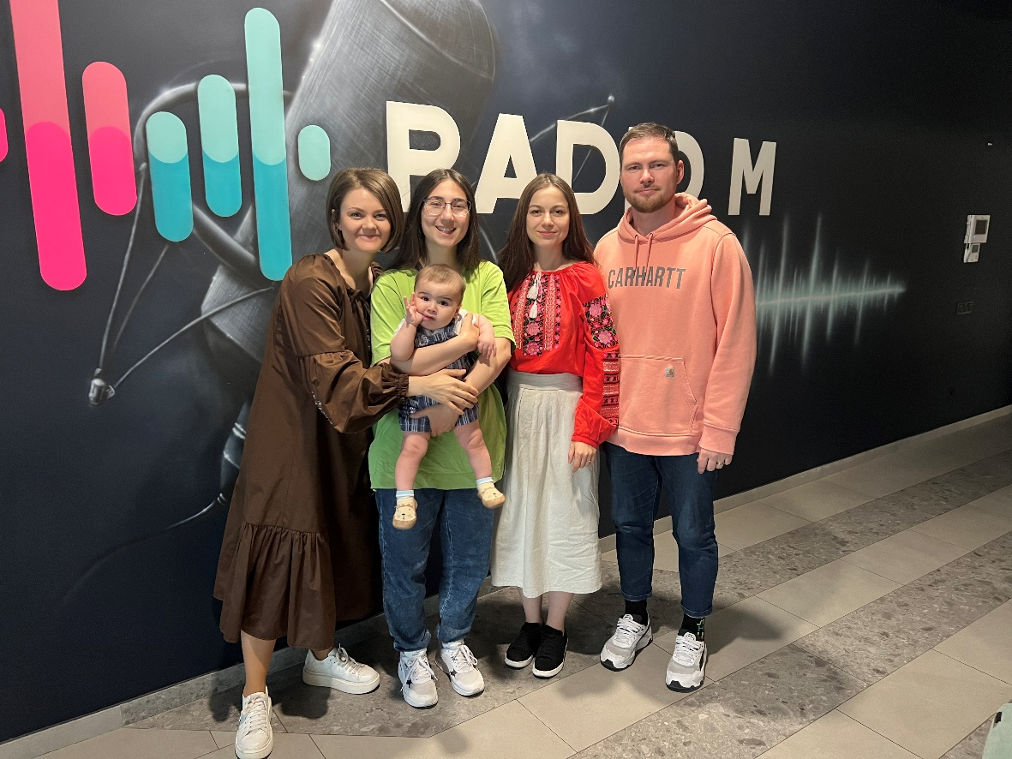

Sunday – 25
“I left a book in the backseat of a taxi that I took,” said one FEBC broadcaster. “The taxi driver who brought it back asked me what was so important about this book. I told him it was about the Trinity. The driver was a Muslim and was very interested. We ended up talking for forty minutes. I invited him to church, and he agreed to come.” Please pray for FEBC-Russia’s broadcasters who regularly have conversations like this. And please pray for our Muslim listeners to come to know Jesus.

Monday – 26
Please pray for listeners like Liana, who reached out to FEBC for help finding a church. A few weeks later, she wrote: “I’ve been to that church three times now! Thank you for answering me, without your help, I wouldn’t have been able to find a church!” Please pray for FEBC’s relationship with local churches to continue to grow—many listeners are being connected with churches.

Tuesday – 27
Please pray for Ivan, FEBC-Russia’s videographer, and his family. They are going through a difficult time and are facing some health battles.

Wednesday – 28
A pastor in Ivano-Frankivsk, where FEBC-Ukraine opened its newest radio station, said, “We are grateful that from the time they came to our city, FEBC has been working with the churches in Ivano-Frankivsk. Because their end-goal is to help evangelize our city and lead people to our churches.” Please pray for many to come.
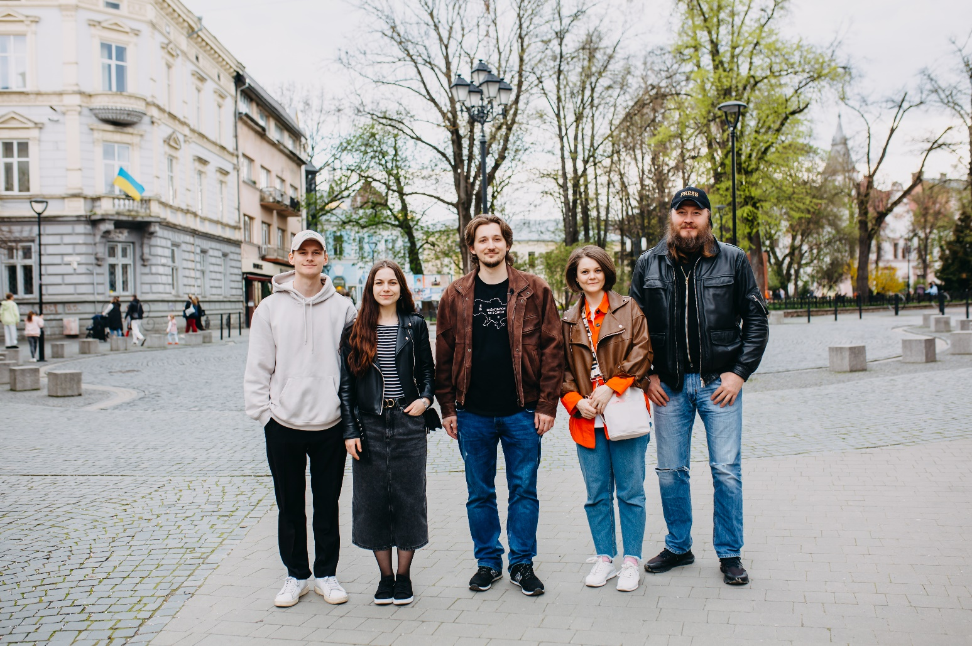

Thursday – 29
Please pray for listeners like Alyona, from Russia, who are beginning to look to God for answers as things grow more difficult. She writes: “This is such a great program! In peaceful times, I didn’t see the need for religion. But now that bad times are here, I’ve been wanting to turn to God. Sometimes it can be hard to tell what’s good and what’s evil, but it seems like there are real answers.”

Friday – 30
Many Muslim viewers respond to our videos. Please pray that God would send experienced evangelists who are called to evangelize Muslims.

