Russia & Ukraine April Prayer Focus
Monday – 1
The new station in Ivano-Frankivsk, in western Ukraine, is now open and broadcasting on 102.0 FM! Please pray for the 750,000 people in the region to come to know the power of the Gospel through FEBC’s programs and evangelistic conversations with Christian counselors.

Tuesday – 2
Please pray for listeners like Yeva, who called FEBC-Ukraine after receiving a prayer book that had the prayer helpline’s phone number. “Is it true that prayers can really help?” Yeva asked. The counselors told Yeva about prayer and faith in Jesus, and Yeva prayed the prayer of salvation. Please pray for many more Ukrainians to reach out to FEBC for prayer and to hear the Gospel through FEBC-Ukraine’s prayer books.

Wednesday – 3
Please pray for the people of Uman, Ukraine, where an apartment building was shelled at night. The attack killed 23 people, including 4 children.

Thursday – 4
Please pray for the soldiers who are struggling to adapt after coming home from the war. They have often lost many friends. “I’m afraid,” said one soldier. “I can’t control my emotions, and I can see that I’m not acting right. My wife asked me to seek help, so I called you.” Please also pray for the counselors who are supporting these soldiers and their families. They are hearing many traumatic stories.

Friday – 5
Please pray for the FEBC-Ukraine team, including Maxim, Eduard, Ruslan, Alexander, Yulia, Sofia, and Dmitri. Please pray for God to strengthen them and give them wisdom.

Saturday – 6
Please pray for the many listeners whose marriages are breaking apart, in large part because of the strain of the war. One woman was left alone with a six year old daughter when her husband left her. Another man tried to commit suicide when his wife left him, but the doctors saved his life. After praying with counselors, the man said, “The prayer was the best part of the entire consultation! I can feel joy in my heart! I’m even smiling!”

Sunday – 7
Please pray for the FEBC-Russia team, including Oleg, Alexey, Igor, Vlad, Ella, Oleg, Eugene, and Irina, for wisdom and strength as they manage governmental restrictions.
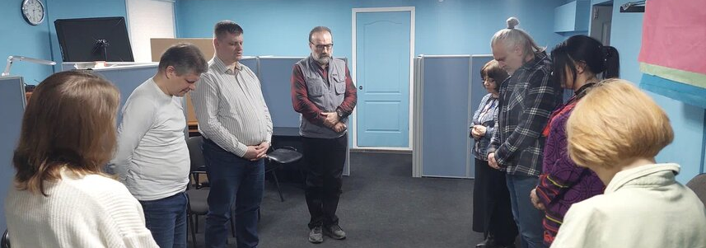

Monday – 8
Please pray for listeners like Pyotr, who are struggling with addiction. Pyotr called FEBC because he couldn’t stop drinking after his girlfriend left him. “She meant so much to me.” At first, when FEBC’s Christian counselors spoke to him about God’s love, Pyotr was not interested. But as they continued to speak, he softened and asked the counselors to pray for him. “I want to meet some other Christians,” he said, and was connected with a church.

Tuesday – 9
Please pray for FEBC-Russia’s programs for ethnic minorities living in Russia. Please pray for partnerships with church leaders and evangelists who can reach these groups with the Gospel.

Wednesday – 10
Please pray for listeners like Vasyl, who called FEBC for relationship advice. He was having an affair with a married woman, and wanted to understand why the relationship was not working. FEBC’s Christian counselors helped him look at his relationship more clearly and discussed how God looks at adultery. “I can see that I am sinning,” the man said, and prayed with the counselor, giving his life to the Lord and asking for His help. “My heart is so much lighter! I feel so much joy! Thank you!”

Thursday – 11
Please pray for FEBC-Ukraine’s online Christian counselors, who are counseling and praying with many young people. Please pray for Victoria, Karina, Lesia, Galina, Natalia, Anna-Katerina, and Irina.
Friday – 12
A listener named Marta was deeply distressed after a betrayal. So much so, that she had started getting sick. “I’m married now,” she said, “but I’ve never been able to forgive the man who betrayed me.” Counselors prayed with Marta and led her to the Lord. She was able to forgive the person who betrayed her and began to feel peace for the first time since the relationship ended. “Thank you so much!” Please pray for listeners like Marta to find freedom from their pasts in the Lord.

Saturday – 13
Please pray for Evgeny, FEBC-Ukraine’s broadcaster and chaplain. He recently spent several days getting to know a new unit of soldiers. “I prayed with them, told them the Gospel, and left some Christian literature for them. As I was leaving, one soldier said, ‘For some reason, your voice seems so familiar to me.’ I asked him if he knew FEBC, and he said, ‘That’s where I know you from!’” Please pray for Evgeny as he ministers to soldiers and their families through his program and in person.
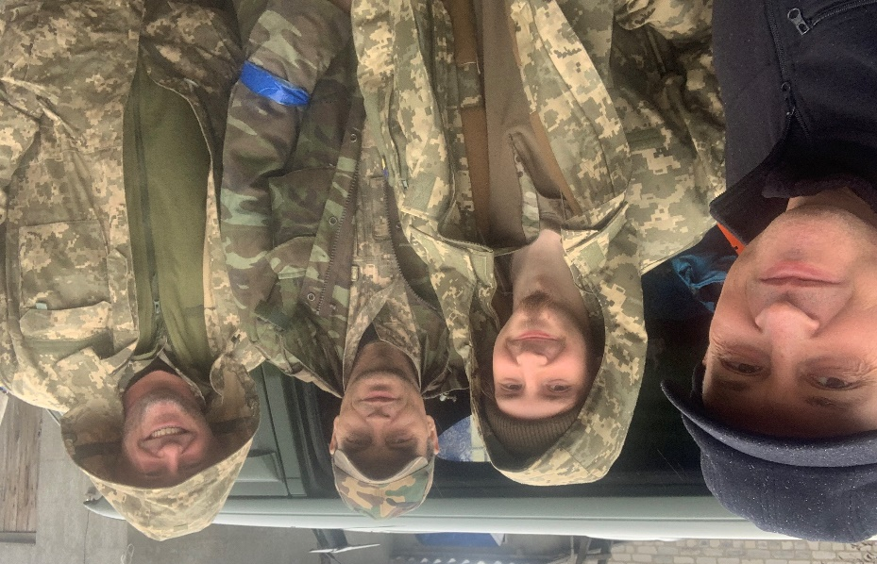

Sunday – 14
Please pray for listeners like Anya, who called FEBC after losing her mother. “No one understands what I am going through,” she said. “My mother died so suddenly. We laughed together early that day, but when I came home, she was gone. Where do you think my mother is now?” Anya had never heard that Jesus died to provide salvation. After the counselors told Anya about God’s love and care, Anya prayed to accept Jesus and was connected with a local church.

Monday – 15
Please pray for the people of Sloviansk, where FEBC-Ukraine has a studio. At least 11 people died after a missile attack, including children.

Tuesday – 16
Please pray for listeners like Natalia, who has been suffering from panic attacks since the beginning of the war. Many listeners are having strong reactions to the anxiety and fear they experienced in the war. Please pray that many find freedom in Christ through FEBC’s programs and through prayer and counseling with FEBC-Ukraine’s trained Christian counselors.

Wednesday – 17
Please pray for the search for young people who can work as social media evangelists in Moldova. They will connect with listeners who leave comments under videos, developing deeper conversations where they can share the Gospel.
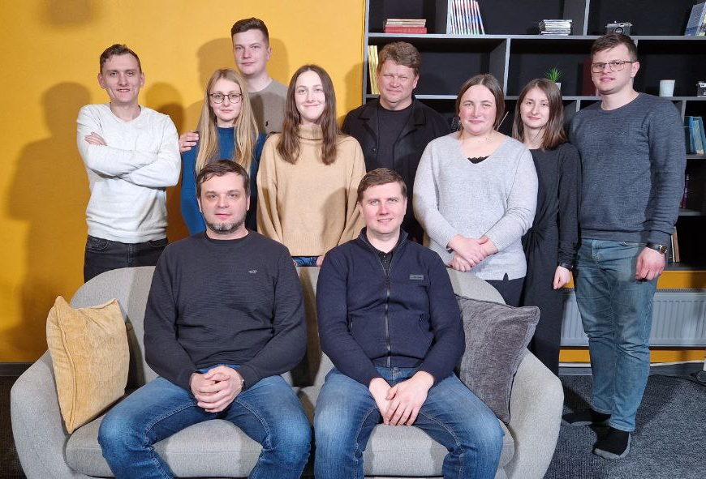

Thursday – 18
A Ukrainian listener named Ella called FEBC-Ukraine because she was anxious and panicked about the war, and she was planning to end her life. “What if this war never ends, and we all die?” She was also afraid of losing her father, who was a soldier. FEBC-Ukraine’s evangelistic counselors shared the Gospel with her and prayed with her. “Thank you so much!” she said. “I don’t want my life to end, I want to live!” Please pray for the salvation of Ella and her family.

Friday – 19
Please pray for the health of FEBC-Russia’s broadcasters and their families. Several team members have been dealing with extended times of sickness. Please pray for God’s healing and for His strength to be given to them.

Saturday – 20
Please pray for listeners in Ukraine who have lost all they have, like Lena, who came home to her home in Irpin after fleeing shelling. “I looked out one of our windows and saw our destroyed car. I looked out another and saw a demolished house. It’s all too much!” FEBC’s counselors helped her connect with local Christians who could support her.

Sunday – 21
Please pray for FEBC-Ukraine’s helpline Christian counselors, including Nina, Anna, Maria, Lyuba, Alex, and Nadia, among others.

Monday – 22
Please pray for listeners like Helena, who lost loved ones in the war. Helena called FEBC sobbing uncontrollably. "I don't want to live! I can't live! how can I continue to live?" Two of her grandchildren had died. After a long conversation with FEBC’s Christian counselors, Helena said, “Thank you for helping me get through the most difficult day of my life.” Please pray for listeners who are experiencing this kind of intense loss and grief.

Tuesday – 23
Please pray for listeners who are coming to know the Lord as they interact with broadcasters and counselors after programs. One Muslim listener recently became a Christian and was baptized. When his family rejected him, his relationship with one of FEBC’s broadcasters was a great support to him.
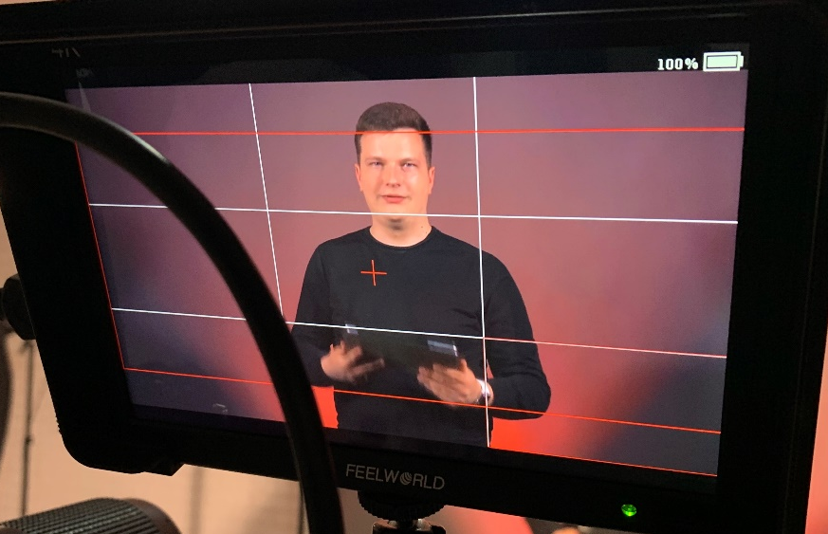

Wednesday – 24
Please pray for the soldiers who are experiencing a great deal of trauma. “This has been so hard, I’m so angry,” said one soldier when talking with FEBC’s Christian counselors. “I just came from the frontlines. I lost everyone. There were 28 of us, and only me and another friend are still here.” The losses soldiers are facing are staggering, and the trauma is very serious. Please pray for the soldiers on the frontlines. We receive many comments and calls from soldiers on the frontlines who listen to FEBC.

Thursday – 25
Please pray for FEBC-Russia’s programs for Jewish listeners. Please pray that many come to know the Lord through FEBC’s programs and personal interactions with broadcasters and Christian counselors.

Friday – 26
Please pray for listeners like Tanya, who are experiencing extreme circumstances due to the war. “I am a medic, and I don’t believe in the supernatural—it is the 21st century after all. But lately, so many things have happened to me that I can’t help but think about it.” She and her son, her only family, had to flee their home because of the war, and she had been sick for a long time, draining their finances. “I’m at the end of my rope,” she said. FEBC-Ukraine’s Christian counselors shared the Gospel with Tanya and prayed with her. Please pray for the salvation of Tanya and her son, and for peace in Ukraine.
Saturday – 27
Please pray for the ongoing work of FEBC- Ukraine to support local churches, teaching them how to use FEBC-Ukraine’s programs and helpline as an evangelistic tool to draw people in their region to their churches.

Sunday – 28
One listener called FEBC’s prayer line because she was struggling with living in the house of her deceased father. “I loved him, but he was cruel to us,” she said. FEBC’s counselor’s shared the Gospel with her, and offered to pray with her. “Oh yes, please!” she said. “My grandmother was a believer and used to pray all the time, but my dad would mock her for it.” Please pray for more listeners like this to turn to the Lord in these difficult times.

Monday – 29
Please pray for video testimonies being recorded in Kazakhstan. These types of videos regularly receive many views and create a lot of discussion in the comments, where further evangelistic conversations can happen.

Tuesday – 30
Please pray for listeners like Myroslav, who experienced God while talking with FEBC’s Christian counselors. He was very depressed after an accident, even feeling suicidal. After counselors prayed with him, Myroslav said, “I can see now that I’ve been holding on to bitterness toward someone who hurt me a long time ago. Please, can we pray again?” This time, Myroslav prayed more passionately, for a long time, and with tears. He accepted Jesus and asked for His forgiveness. “I can see that I have new life now,” he said, “now that I’ve turned to God. Thank you so much!”

Wednesday – 31
Please pray for FEBC-Russia’s network of church partnerships to grow, helping more listeners to be connected with churches and ministers in their local communities.

