Russia & Ukraine April Prayer Focus
Saturday – 1
Please continue praying for Max, from FEBC-Ukraine, who is working as a chaplain, and for the soldiers in his battalion. Please pray that many are encouraged and turn to the Lord through his ministry to them.
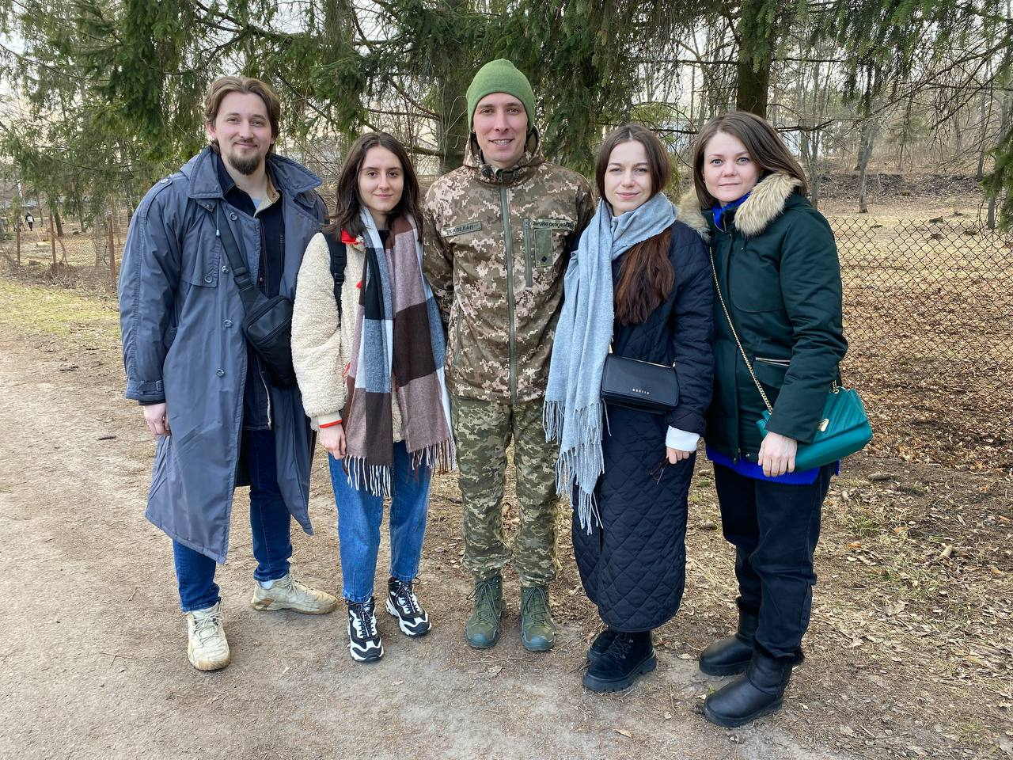

Sunday – 2
Please pray for listeners like Ulyana, who was introduced to believers in her city and started watching FEBC-Ukraine when a friend reached out to one of FEBC’s broadcasters. Today, she is regularly attending church. “It was a wonderful surprise to see her at a Christian conference and to hear how God has changed her life!” said the broadcaster.

Monday – 3
Praise God! FEBC-Ukraine has received temporary permission to broadcast in Ivano-Frankvisk on 102 FM. Please pray for the team as they prepare to begin broadcasting.

Tuesday – 4
Please pray for the many listeners who have had to flee their homes when the war reached them, like Maria, who was struggling after having to flee to western Ukraine. She called FEBC’s helpline because of problems she was having with work, and during the call, Maria prayed to accept Jesus as her Lord and Savior. “I had nowhere else to turn to,” said Maria. “Thank you!”

Wednesday – 5
Please pray for FEBC’s ministry in Kazakhstan, where tens of thousands are being reached every month. Please pray for their partnerships with local churches, where pastors are often having to work several jobs and do not always have the time to minister to new believers.

Thursday – 6
Please pray for listeners like Vika, whose lives are being transformed through FEBC’s programs. “I really liked the feeling of strength and freedom that emanated from you, and some special kind of kindness. I remember commenting once that I wanted to be more like you. Your response was that if that was the case, then I needed to learn to believe in and love God. Since I’ve been learning from you, I don’t know exactly when, but at some point, I realized that my resentment against people was gone. I had forgiven them and had even begun helping them!”

Friday – 7
Despite dozens of media outlets being shut down in Russia, God is continuing to provide avenues for FEBC-Russia’s programs to reach millions of Russians. Please pray for God’s continued provision and blessing in the midst of tightening controls and sanctions.
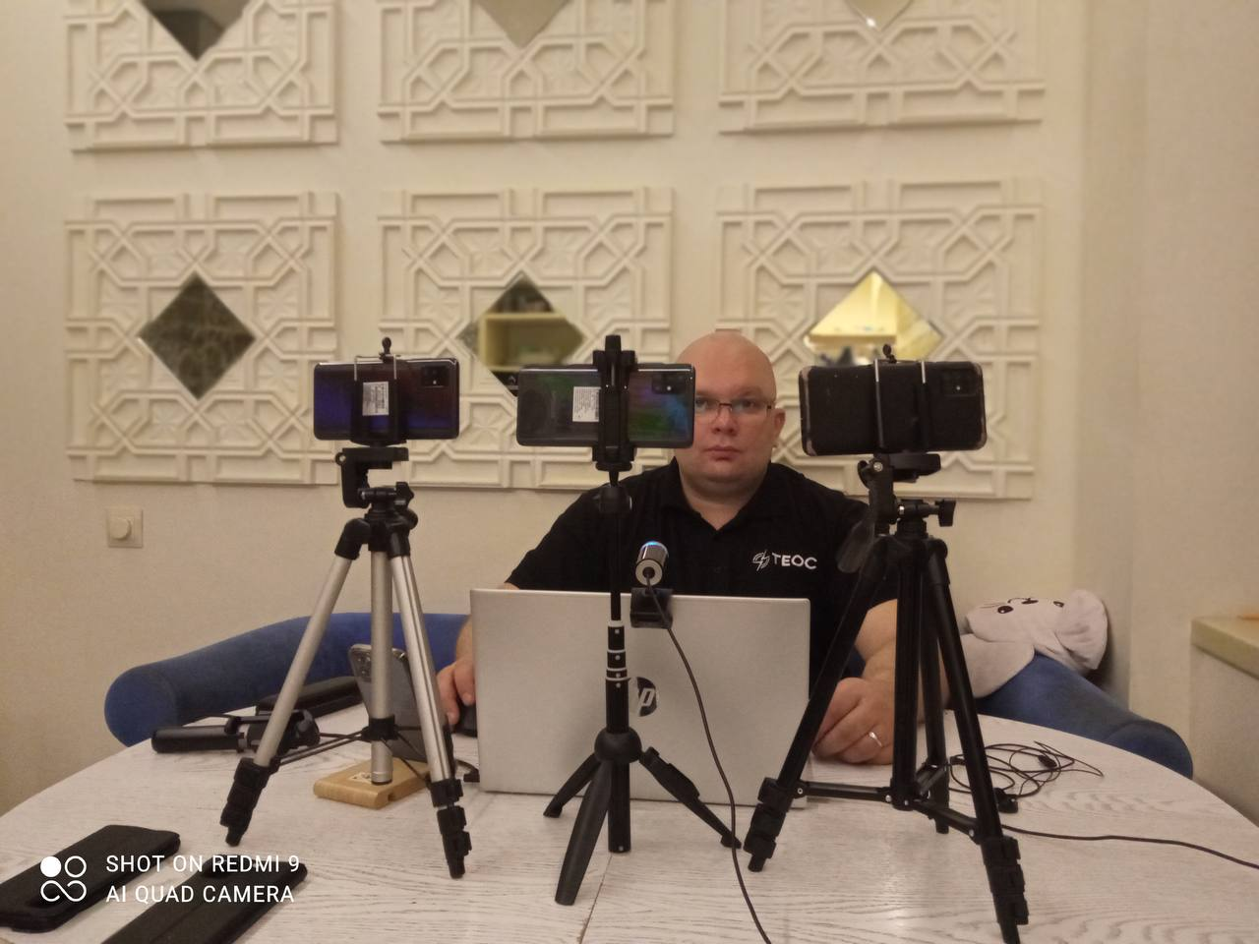

Saturday – 8
“Wisdom comes from you,” writes a listener named Marta. “I started watching you to help manage my difficult character. I didn’t believe in God, in fact, I thought those who did were crazy fanatics. But you were different. I want to believe in the God you believe in.” Please pray for the salvation of listeners like Marta.

Sunday – 9
Please pray for strength and wisdom for the leadership of FEBC-Ukraine as they deal with many new challenges along with many new opportunities.
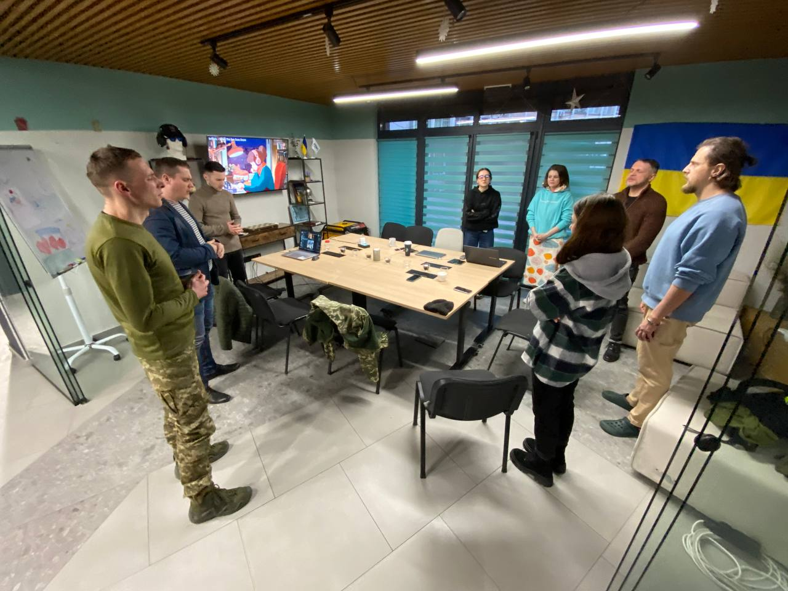
Monday – 10
Please pray for listeners like Sonya, from Russia, whose faith in a good future let her down after looking at what was happening in the world around her. “I was having problems in my family, with my husband, at work, COVID19, and now this war in Ukraine. I no longer had this faith in the future. When I started watching your broadcasts, at first, I didn’t like what you were saying about God. But over time, I saw how it helps you, and it helped me. I started praying to God, and I asked Jesus for forgiveness, just like you said to do. I’ve started to believe again in goodness, and in a better future, but in a different way – I began to believe in God!”

Tuesday – 11
Please pray for new ministry opportunities in Muslim countries in Central Asia. Some are more closed than others, but all of them have serious persecution. Please pray for God to open doors and provide connections with local evangelists.

Wednesday – 12
Please pray for the millions of Ukrainians who are out of work, either from having to flee their homes, from businesses shutting down, or because of injuries. One FEBC-Ukraine listener, Pavel, was unable to work after being shell-shocked during the war.

Thursday – 13
Please pray for the people of Sloviansk, which were recently hit by shelling that killed two people and injured dozens more.

Friday – 14
Please pray for listeners like Svetlana, who turned to Jesus while seeking family advice. “You told me about how Jesus reconciled us with the Heavenly Father,” she wrote. “This made a big impression on me. I realized how important it was that I had a personal relationship with Jesus. Also, because of your advice, the relationship between my son and his stepfather actually improved! Thank you!”

Saturday – 15
Please pray for strength and protection for the FEBC-Russia staff. Please pray that God protects them from the draft and from government persecution.
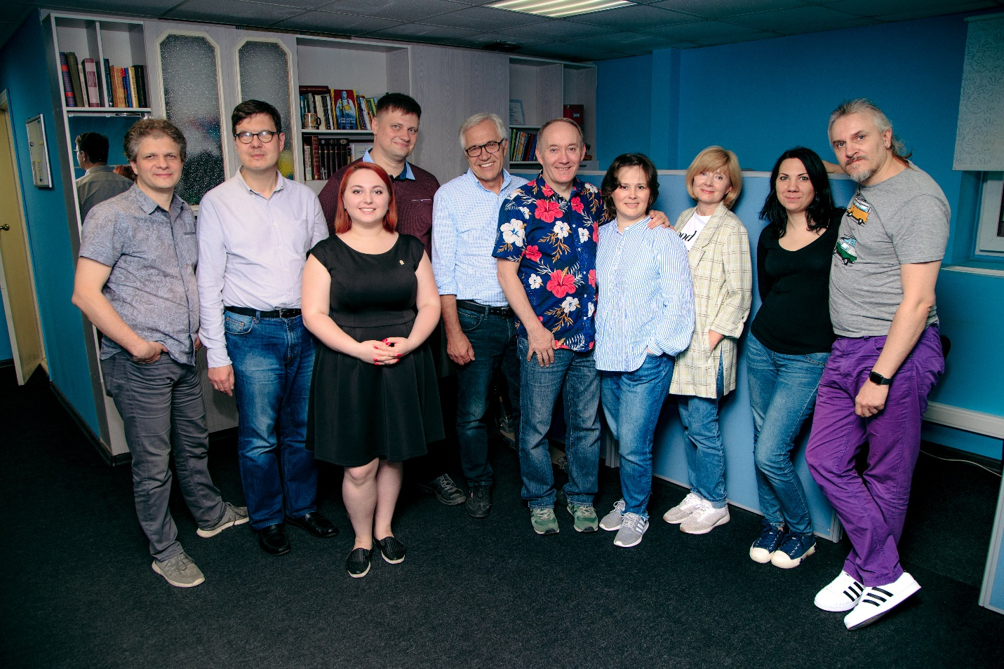
Sunday – 16
Please pray for listeners who are coming to know the Lord during difficult trials, like Mila, who writes, “I have stage 4 cancer. You have really helped me get through these incredibly difficult days. I had tried to turn to God before, but it was like I was performing a ritual. I had no faith in my heart. But you helped me to believe in God, and now my prayers have become different. I think that God sent you to me to prepare me to leave this world in peace.”

Monday – 17
Please pray for FEBC’s ministry in Kyrgyzstan, which has six FM stations covering most of the territory of the country. Please pray for the new team members who are ministering to young people.

Tuesday – 18
Please pray for listeners like Volodymyr, who was living in eastern Ukraine and regularly hiding in the basement during shelling. “There is no other radio like yours! It calms me down and supports me during difficult times. And I tell everyone I know to listen to it.” Please pray for listeners who are living under heavy attack in eastern parts of Ukraine.
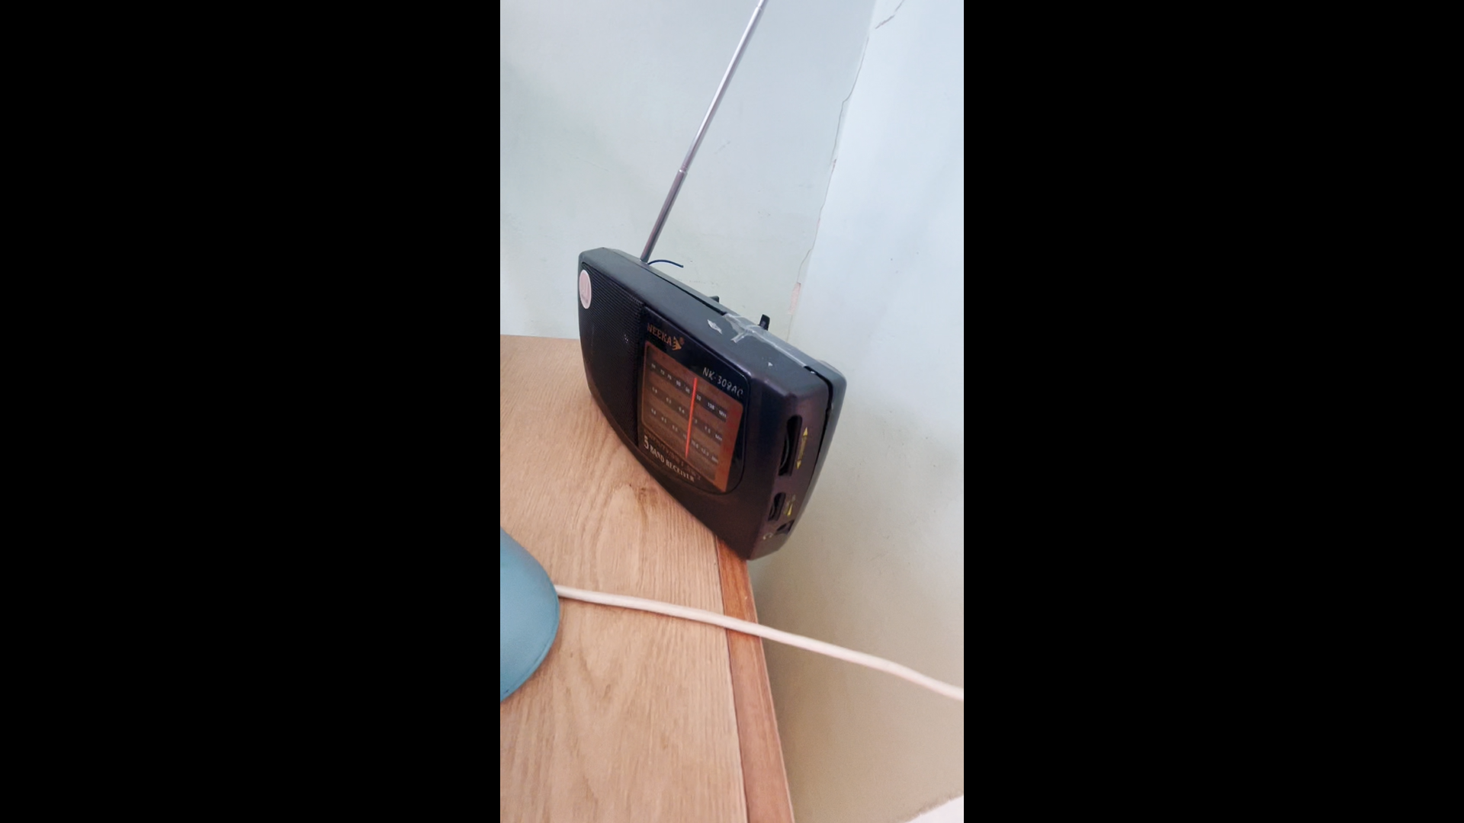

Wednesday – 19
Please pray for wisdom and peace for the FEBC-Russia leadership, especially Oleg and Alexey, as they as they navigate this increasingly complicated and tense situation.

Thursday – 20
Please pray for Muslim listeners like Asya, who called FEBC-Russia because she had lost a child. She was tormented by a fear of death. The counselor prayed with her and shared with her that the weary and heavy laden could find rest in Jesus. Please pray for her salvation and for many more Muslims to be reached with the Good News.

Friday – 21
Please pray for children who call FEBC-Ukraine’s helpline. Often, they are calling to ask for prayer for their parents who are in the war, or to ask for prayer about their fears of death.

Saturday – 22
Please pray for listeners like Lena, from Russia, who was terrified of death. “I am literally going crazy with fear,” she said. “I don’t want to die. How do I come to terms with the fact that I will have to die?” As she started listening to FEBC’s broadcasts, she says that she began to feel peace in her soul. “I began to turn to Jesus, like you said, and after that, I finally began to sleep peacefully.” Please pray for many listeners of FEBC-Russia who are dealing with fear to also turn to the Lord.

Sunday – 23
Please pray for the ministry in Moldova, as they are in the process of building the team, especially as they are looking for an experienced and well educated Bible teacher.
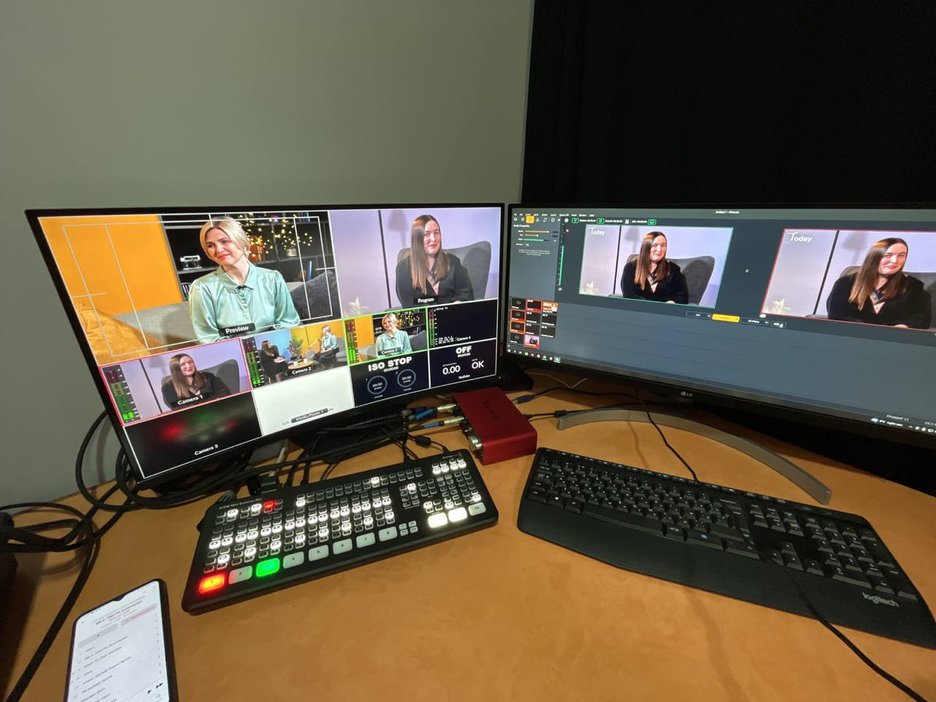

Monday – 24
Please pray for listeners like Konstantin, from Ukraine, who lost his brother, girlfriend, and father at one time. He was isolated from the rest of his family and was considering taking his own life. He called FEBC-Ukraine, who helped him begin to calm down. Christian counselors shared the gospel with him and taught him how to pray.

Tuesday – 25
Please pray for the short videos of testimonies being released by FEBC-Russia that are receiving tens of thousands of views, some of which are receiving millions of views. Please pray for
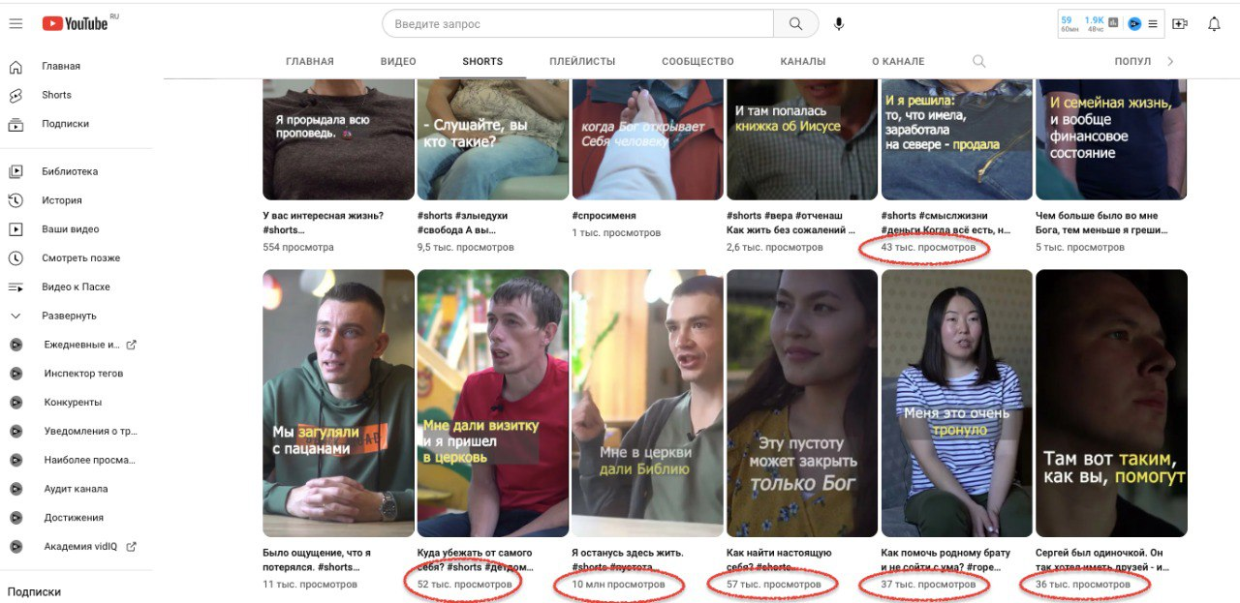
Wednesday – 26
Please pray for listeners like Eva, from Russia, who began really seeking the truth when her son was forced to go to the war in Ukraine. “I am personally against this war, but how can I say this today when I can be imprisoned for such a view. I watched your program for many years, it made a nice atmosphere in my home. But when my son was taken, I began to really watch your broadcasts in a different way, especially when you talked about God. I am a Muslim, though I didn’t follow the traditions, but I started constantly praying in my mind to your God, the Christian one.”

Thursday – 27
Please pray for FEBC’s ministry on TikTok, where much of the audience is young and many are nonbelievers. “I found your videos in the most difficult moment of my life. I had lost all meaning, but you helped me find it again. I started believing in God after hearing you talk about Him in your videos.”
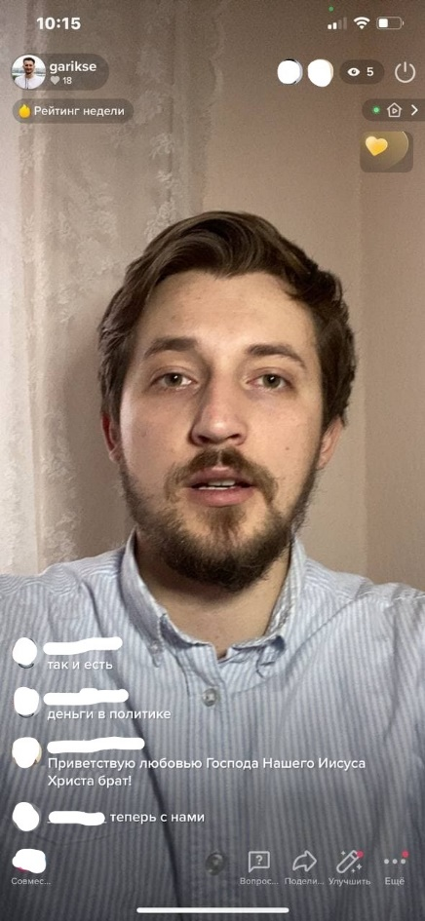

Friday – 28
Please pray for the many Ukrainians who are taking care of elderly, ill, and injured relatives. One listener was taking care of a mother who had experienced a stroke; he had also been injured during the war. Another listener was separated from his family, and was the only one who could take care of his father, who had dementia. These types of situations are becoming more common in Ukraine as the war drags on.
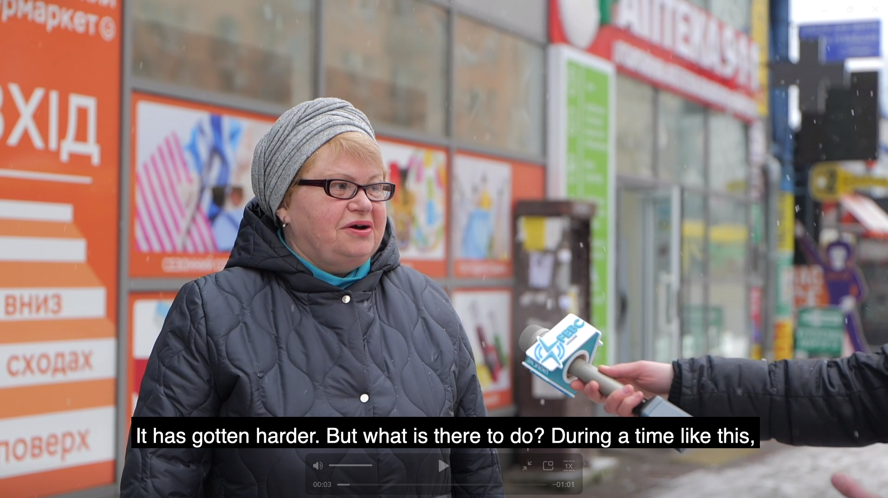

Saturday – 29
Please pray for the Christian counselors ministering to people on FEBC-Ukraine’s helpline. They are answering some of the most difficult calls. One listener, who had attempted suicide, said that he had called several other numbers first. “You’re the only ones who answered my call.” Counselors shared the Gospel with him and prayed with him.

Sunday – 30
Please pray for Jewish listeners like Alina, who came to know the Lord through FEBC-Ukraine’s programs. After a personal meeting with one of FEBC-Ukraine’s hosts, Alina put her faith in Jesus and began attending church. Please pray for the rest of her family to also come to know the Lord.

