Russia & Ukraine March Prayer Focus

Wednesday – 1
Please pray for FEBC-Ukraine’s program director Max, who has been drafted into the military as a chaplain. Please pray for his family and for wisdom and protection for Max.

Thursday – 2
Please pray for listeners like Ivan, a young man with disabilities who contacted one of FEBC-Russia’s broadcasters. The broadcaster agreed to come to Ivan’s house, to talk with him and pray for his mother, who was ill. Please pray for listeners with disabilities and broadcasters who minister to them.

Friday – 3
Please pray for the weekly evangelistic meeting for women being held by FEBC-Ukraine broadcaster Inna. “We talk about the Lord, we pray, we read the Bible. Some of the girls are going to church for the first time, are changing their lives, and are regularly writing to me asking questions about Jesus,” said Inna.

Saturday – 4
Please pray for FEBC-Ukraine director Eduard his family as they make plans in this complicated time. Please pray for God’s wisdom and guidance.
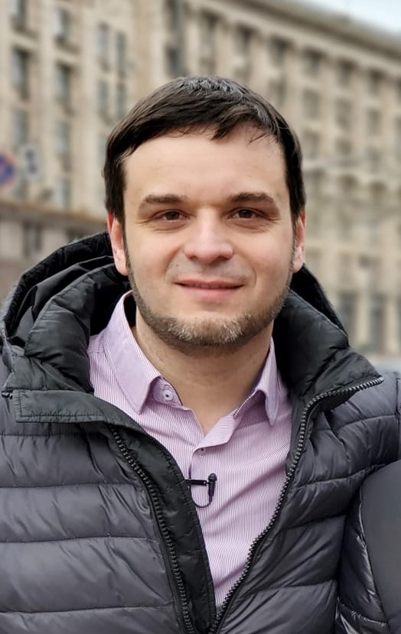

Sunday – 5
Please pray for the ministry in Kyrgyzstan as the government is becoming more radicalized. Please pray for God to continue to provide more opportunities for sharing the Gospel.

Monday – 6
“When the war in Ukraine began, my heart became so hardened,” said one FEBC-Russia listener. “Even you annoyed me when I watched you. But while my mind was irritated, by heart was drawing me to your programs. Apparently, the God you talk about on your programs is real.” Please pray for listeners who are having to cope through situations outside of their control, and for them to turn to the God who can heal them.

Tuesday – 7
Please pray for FEBC-Russia’s Christian counselors as they are counseling many listeners online. Many listeners are writing in with problems like suicide and abuse, are receiving help, and are hearing the Gospel. Please pray for wisdom and emotional strength for the counselors.

Wednesday – 8
“I was in a really terrible place when I found your broadcasts,” said one FEBC-Russia listener. “But they transformed my life. Without them, I think that I would have really hurt myself and the people around me—I felt so terrible. You saved me and my family!” Please pray for the salvation of listeners in Russia.
Thursday – 9
There are millions of Ukrainians that are living in poverty. It is projected that the number of people living in poverty will actually increase after the war. But even in these conditions, people are experiencing so much joy when they come to know Jesus. Many are being connected with churches, and many are being helped. Please pray for those who are truly struggling in these times to experience the love of Christ and come to know Jesus.

Friday – 10
“I got very sick recently, and was in the hospital for almost two months. It was really terrible,” said one FEBC listener in Russia. “As I was in the hospital, I started turning to the God that you talked about in your broadcasts, praying and repenting of my sins. This helped me survive! When I was able, I asked the nurses to turn on your program.” Please pray for listeners who are turning to the Lord through FEBC’s programs in difficult situations.

Saturday – 11
Please pray for the ministry in Moldova, which continues to grow. On the left is a listener that came to visit the studio to meet with Lena, the host of a family program in the Romanian language.

Sunday – 12
Please pray for listeners like Natalia, who is a Russian teenager who felt alone and hopeless when she contacted FEBC-Russia’s helpline. The Christian counselor prayed for her and connected her with one of FEBC’s evangelists. After speaking with the counselor, Natalia began to feel hope again. Please pray for Natalia to put her faith in Jesus.

Monday – 13
Millions of Ukrainian families are separated because of the war. So many people are calling FEBC-Ukraine for help. “My husband just left. I don’t know why. What do I do?” So many are coming to the saving knowledge of Jesus Christ. Please pray for these families to come to know Jesus and to be healed.

Tuesday – 14
Please pray for the salvation of listeners like Sveta, who said, “I have never heard such open and honest opinions on how to deal with hatred. I couldn’t tear myself away from your program. It really made me think. I really want to visit a church like this!”

Wednesday – 15
Please pray for FEBC’s broadcasters who are communicating with listeners after programs. One listener had questions about praying and reading the Bible. Broadcasters communicated with her online, sharing their personal testimony with her. The next morning, during the program, she shared in the comments that she had prayed to accept Jesus. These one-on-one interactions help many listeners take the next step.

Thursday – 16
“I was an evil man,” said one listener. “But you taught me to start fighting against the evil, and I did. Some of my friends told my wife, who left me because I was dangerous—I had already beaten her and would probably have killed her one day. When she saw me, she said that I was a different man. ‘God has saved you,’ she said.” Please pray for listeners like this who are destroying their marriages through abuse. Please pray that God changes their hearts and they come to know Jesus.

Friday – 17
Please pray for Evgeny as he ministers to soldiers in eastern Ukraine, bringing hope to soldiers who are experiencing a great deal of suffering.
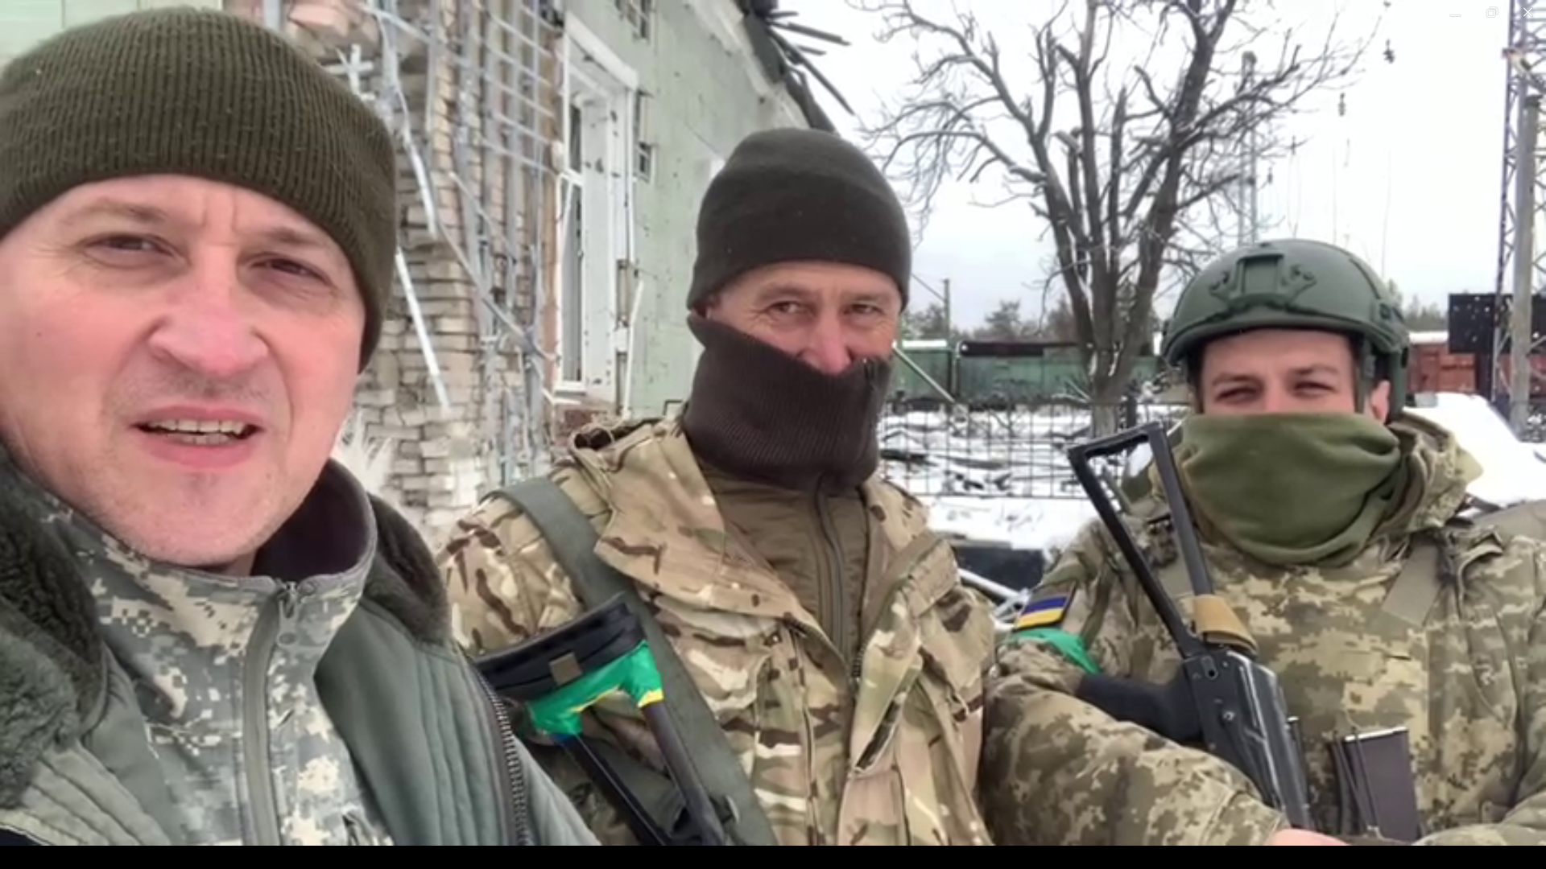
Saturday – 18
“When I started watching your programs,” said one listener, “I would write insulting comments on your broadcasts. But as I listened to your advice, my life continued to improve. My work situation got better, and so did my relationship with my children. I realized that God had been helping me through your broadcasts.” Please pray for listeners whose lives are being transformed through FEBC’s programs, that they come to the saving knowledge of Jesus Christ.

Sunday – 19
Please pray for Alexey, as he helps lead the FEBC-Russia team in this difficult time, as some broadcasters are travelling and government restrictions are increasing.

Monday – 20
Please pray for listeners in Russia who are nominal Christians, like Pavel. Pavel was in a serious depression, as was even having thoughts of ending his life, and this scared him, so he called FEBC-Russia’s helpline. After helping him think work through his troubles, the Christian counselor shared the Gospel with Pavel. Though Pavel believed in God, had never given his life to Jesus. Please pray for the salvation of Pavel and other listeners like him.

Tuesday – 21
Please pray for the prayer helpline counselors serving in Ukraine. For spiritual and emotional energy as they support struggling Ukrainians a year into the war.

Wednesday – 22
Please pray for the ministry in Kazakhstan, especially the new TikTok channel, where many listeners are being given the opportunity to see and learn about Christianity for the first time. “I heard all kinds of things about Christianity when I was a girl. But when I saw how you acted, and how you worship God, I had to write to you.”

Thursday – 23
Please pray for FEBC-Russia broadcaster Igor and his family, who hosts a Bible program and family programs. His daughter is having some health issues.

Friday – 24
“My friend recommended your program to me, and I found it so interesting,” said one FEBC-Russia listener. “Christian content is so interesting to me right now—I actually sat there with a notebook taking notes.” Please pray for listeners like this one who are on the pathway to God.

Saturday – 25
Please pray for a club that is being hosted by FEBC-Ukraine broadcaster Nadia for teenage girls. As she ministers to the girls, she lets them know that they are special and important, while sharing the Gospel with them.

Sunday – 26
Please pray for listeners like Rayana, from Kazakhstan, who reached out to an FEBC broadcaster because of relationship problems, and had Jesus shared with her. “Though I am a Muslim, I’m going to listen to all of your programs,” said Rayana. Please pray for Rayana’s salvation and for the salvation of the many Muslims who listen to FEBC.
Monday – 27
FEBC-Ukraine team members are handing out prayer booklets with prayers written in Ukrainian and the number to FEBC’s prayer helpline. Many listeners are praying the prayers and are turning to the helpline, are being connected to churches, putting their faith in Jesus, and receiving prayer.
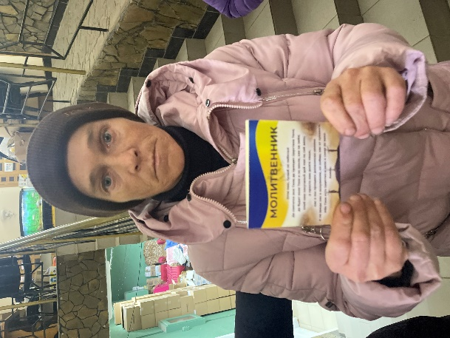

Tuesday – 28
One FEBC listener who had just lost her son wrote, “You revived my faith in God today. The songs you sang about God brought me to tears, and I repented before Him. I was so hopeless after the death of my son that I had stopped believing. Now, even though it still hurts, God gave me the strength I needed to go on living.” Please pray for listeners who are experiencing the love of God in the midst of tragedy.

Wednesday – 29
Please pray for the FEBC-Russia broadcasts helping listeners consider adopting a child. Many listeners write in to say they never thought it was possible for them to adopt until they heard the program.

Thursday – 30
There are many listeners like Sergey, who believes that Jesus was just a spiritual leader. When an FEBC-Russia broadcaster shared the Gospel with Sergey, he responded, “That’s impossible. Christ could not have died for everyone.” At the end of the broadcast, Sergey said that he was now considering believing. Please pray for Sergey as he begins to understand who Jesus really is and for other listeners like him.

Friday – 31
There are hundreds of thousands of refugees in Ukraine. People left their homes, everything the own, and fled the war. Please pray for FEBC-Ukraine’s programs made specifically to help refugees. Many are being helped, connected with local churches, and are hearing the Good News.

