Russia & Ukraine February Prayer Focus
Wednesday – 1
FEBC-Russia broadcaster, Oleg, has just finished production of the Russian version of Dr. McGee’s Thru the Bible program. This program produces many deep responses. Please pray for Oleg’s health and for his family.
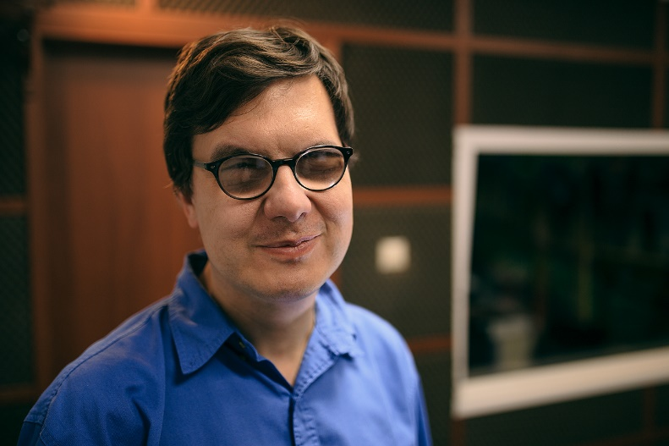

Thursday – 2
Please pray for children like Asya, Vera, Yulia, and Sasha, who call FEBC-Ukraine’s helpline. Many children call the helpline to ask questions about Jesus, the war, and how to deal with their fears. They are learning how to pray, are asking for prayer for their parents, and sometimes just need someone to talk to. One young girl, Yulia, was afraid to leave her building. “What do I do if a drone or plane flies by?” she asked. Please pray for the children who are growing up under extreme stress, that they experience the love of the Father and come to know Jesus.

Friday – 3
Please pray for the growing ministry in Moldova. Please pray for the new programs being developed and for God’s blessing and His guidance for the future. Many listeners are responding.

Saturday – 4
Please pray for young adult listeners in Russia, like Sergey, who wrote, “I didn’t know that Christians could speak so passionately on such important topics. You really made me think about the questions you raised. Thank you for showing me a new side of Christianity!” Please pray that the programs made for young adult audiences reach many people with the Good News of Christ.

Sunday – 5
Please pray for those in the FEBC-Ukraine team who are often traveling for the ministry, including Eduard, FEBC-Ukraine’s director. This is dangerous during wartime, with drones and missiles flying overhead. Please pray for their safety.
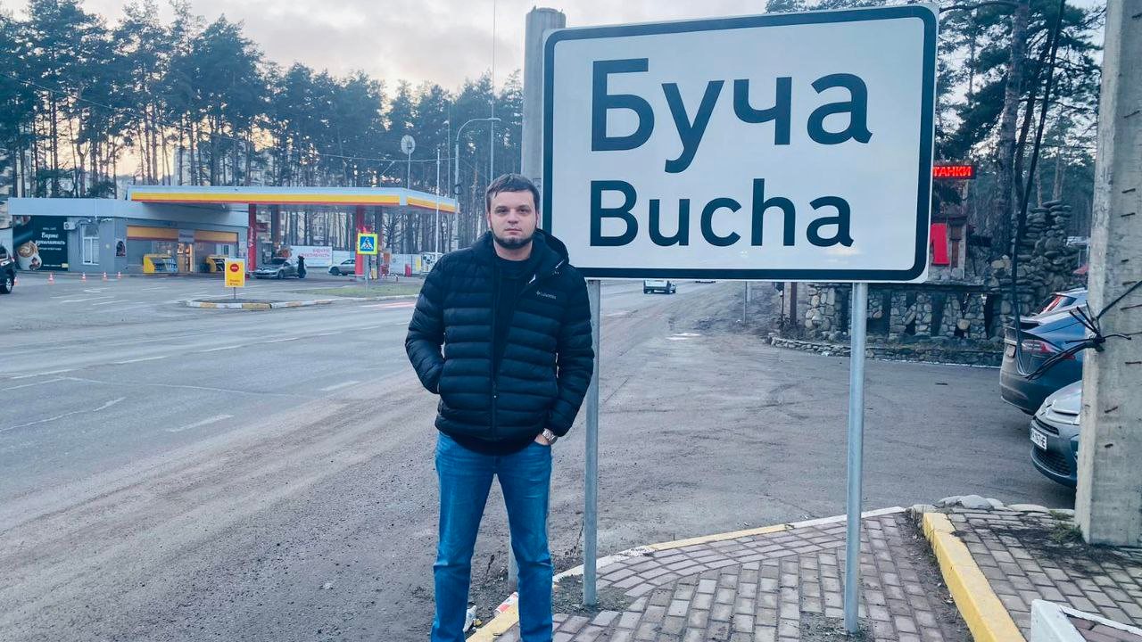

Monday – 6
Please pray for the family of Eugene from FEBC-Russia as his children are going through trying times. One of his daughters needs special prayer.

Tuesday – 7
Please pray for the FEBC-Ukraine team to be spiritually strengthened and refueled. With the war continuing for a year now, including regular power outages that leave people without heat, water, and Internet, the toll has been heavy. Please pray for God’s encouragement, peace, and healing.

Wednesday – 8
Please pray for families who are being introduced to Christianity through FEBC-Russia’s programs. Natasha writes: “I loved watching your program! I learned so much. And you gave me some great resources so that I can share what I’m learning with my kids.”

Thursday – 9
There are new volunteers joining FEBC-Ukraine’s prayer helpline from a nearby seminary. Please pray for these students as they go through training and begin taking calls. Please pray for wisdom and emotional strength as they will be dealing with many callers who are going through very serious emotional, relational, and even physical pain.

Friday – 10
Please pray for Nadia, who is coordinating the work in Buryat, Russia, who will be attending a training seminar in new media. Many Buryat people are being reached through new media.

Saturday – 11
Many Ukrainian refugees pass through Moldova, and the ministry in Moldova has been evangelizing and helping those who are coming through, especially teens and young people. Please pray for the Ukrainian refugees who are escaping the war and those helping them.

Sunday – 12
“With all the craziness going on in our country,” said a listener from Russia, “I thought I was all alone. I was having arguments with my family, and even had to leave my job. But when I found your program, I realized I wasn’t alone. I was surprised when you quoted the Bible, how many wise words it had. I decided to follow your example and start reading through the Bible.” Please pray for listeners who are looking for truth as their worlds are falling apart. Please pray for the people of Russia to turn to Jesus in these difficult times.

Monday – 13
Please pray for Nina, from FEBC-Ukraine’s counseling team, as she transitions to a roll involving taking more calls from listeners. Please pray for wisdom, and emotional and spiritual strength.

Tuesday – 14
Although broadcasting FEBC programs into Uzbekistan from Kyrgyzstan, we are planning to begin broadcasting from within Uzbekistan, working with local partners and broadcasting in the local language. Please pray for God’s leading and for His favor.

Wednesday – 15
Please pray for safety and strength for Victor Akhterov as he travels to Ukraine to meet with the team. Pray that they are able to have productive and encouraging meetings. Please also pray for his wife and children.

Thursday – 16
Please pray for younger listeners who are writing into FEBC-Ukraine’s text prayer counseling ministry about their struggles and fears and are learning about Christ. One listener wrote in for help with anxiety. When counselors asked her if she ever prayed, the girl said that she read from a prayer that she had found. She was surprised to learn that she could talk to God in her own words. Please pray for this girl as she continues in her first steps towards Christ.

Friday – 17
Please pray for a leadership meeting for the FEBC-Ukraine team that will be taking place on the 18th. This will be an opportunity for the team to recharge and to refocus on the vision of the ministry.

Saturday – 18
“I always found the Bible to be frightening,” said one listener, “especially the book of Revelation. But now, looking around, I see that we can make life a horror all on our own. As I listened to your programs going through the book of Revelation, I was able to see God’s mercy for the first time. Thank you so much!” Please pray for listeners who are listening to FEBC-Russia’s Bible programs. Please pray for many to come to know Christ through His Word.

Sunday – 19
Please pray for Sergey, FEBC-Ukraine’s senior broadcaster, as he continues his education in Biblical counseling. This knowledge and ability is extremely needed in these difficult times.

Monday – 20
“Please pray for me and my friends,” said a teenage girl who was hiding in the subway while the air raid siren was blaring. “Pray that the rockets pass us by and don’t explode.” Many young listeners are looking for answers as they are facing life’s challenges. This young woman asked many questions about prayer, baptism, and God. Please pray for the young people growing up in Ukraine today, that many of them hear and accept the Gospel, placing their faith in Jesus.

Tuesday – 21
Please pray for the students from a Biblical counseling program in a Christian university in Russia who are volunteering with FEBC-Russia’s phone counseling ministry.

Wednesday – 22
Please pray for broadcasters in Kyrgyzstan as they regularly make personal visits with listeners who respond to programs. This is where much more open evangelization can take place and how many people put their faith in Christ.

Thursday – 23
Moldova has become a hub for the FEBC-Eurasia ministry, helping FEBC-Russia as the situation in the country continues to grow more restrictive. Please pray that God continues to bless the team in Moldova and that they continue being able to provide support to FEBC-Russia.
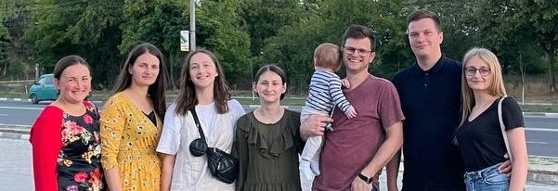

Friday – 24
Many young people in Ukraine are being forced to take on adult responsibility because of the war. One 16-year-old girl who called FEBC-Ukraine’s helpline was left to take care of her house when her mother had to leave the country to find work. “After I finish with the housework, I still have to finish my homework,” she said. She had a difficult relationship with her mother, and was very critical of herself. Counselors shared Christ’s love with her, and helped her see God as a Father. Please pray that she puts her faith in Jesus.

Saturday – 25
Despite increasing restrictions, the ministry is continuing in Russia. A new person, Katya, was recently brought on board. She hosts programs and makes short videos to reach young people. Please pray for her as she grows in this position.

Sunday – 26
Please pray for listeners like Bogdan, who called FEBC’s prayer helpline because he was having relationship problems. During the conversation, Bogdan prayed for the first time. Praying with the counselor, he accepted Jesus as Lord and Savior. “It’s amazing, I have so much peace! I was actually able to experience God!”

Monday – 27
We are currently reorganizing the counseling ministry in Ukraine as it is growing. Please pray for everybody involved, and specifically for Iryna, who is leading the counseling teams.
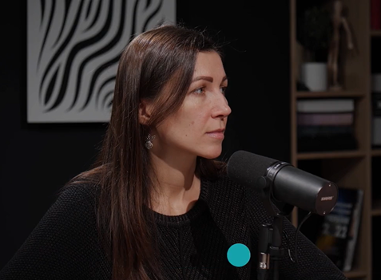

Tuesday – 28
Please pray for Eugene, a part of the FEBC-Ukraine team, who is expecting his 7th child in March. Please pray for his wife and his family.

