Russia & Ukraine January Prayer Focus
Sunday – 1
Please pray for the ministries of FEBC-Russia & Ukraine in the new year of 2023. Please pray that many hearts to be opened to the Gospel and for opportunities for sharing the Gospel to continue and grow. And please pray for an end to the war in Ukraine and a change in the direction of the Russian government.

Monday – 2
Please pray for listeners like Lyubov, who lives in the Donetsk region, where there is constant shelling. Many listeners who are living under heavy attack are calling FEBC-Ukraine’s helpline for spiritual support and are being connected with local believers.

Tuesday – 3
Please pray for the young leadership in FEBC-Eurasia, from Ukraine, Russia, Kazakhstan, and Kyrgyzstan. The team was able to meet together for a conference, receiving training to invest in the future leaders of FEBC-Eurasia.
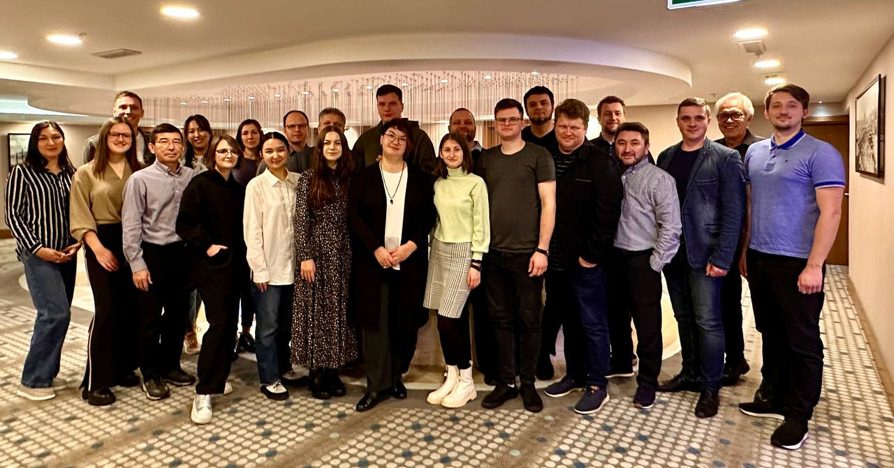

Wednesday – 4
Please pray for Russian listeners like Eugene, who are awakening to their spiritual needs because of what is happening in Russia. He was an FEBC listener who fled Russia because of the draft. He had never been to church before, but after he left Russia, he began having panic attacks and he contacted one of FEBC-Russia’s broadcasters. Now Eugene has been connected with a local church. Please pray for Eugene’s salvation and the salvation of many Russians like him.

Thursday – 5
Please pray for Oleg, who leads one of FEBC-Russia’s most popular Bible programs. Please pray for his health and his family.
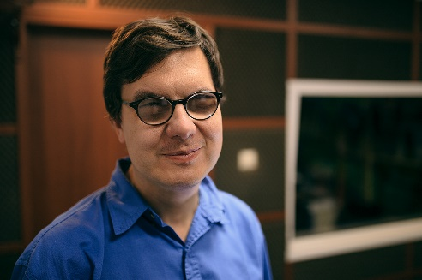
Friday – 6
Please pray for Maria, a new broadcaster with FEBC-Russia. Please pray that God blesses her programs for young people and inspires her with new

Saturday – 7
Please pray for listeners like Alena, who was reconnected to God through one of FEBC’s Bible programs. “I want to thank you for your program. I found it when I was in despair. And God, through your program, breathed a new breath in me, a new love for Him.”

Sunday – 8
Please pray for protection for Eduard, FEBC-Ukraine’s director, who is currently travelling. Please also pray for his family.
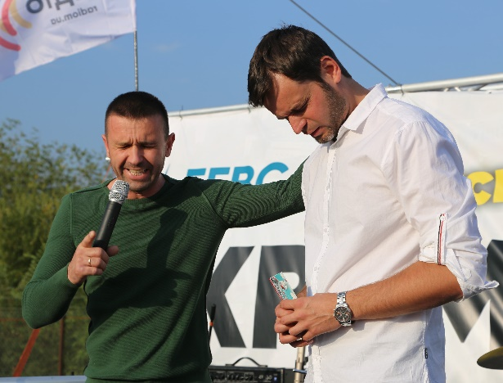

Monday – 9
“When you talked about ‘Why God allows evil’ on your program, at first, I was very critical. But your questions and the answers you gave were so real. You made me think very seriously about God.” Please pray for the salvation of listeners like Oleg, who are beginning to think about God through FEBC’s programs.

Tuesday – 10
Please pray for Inna from FEBC-Ukraine, who is working on a new platform. Many non-believers are responding, some of them aggressively. However, many are also hearing the Gospel for the first time. Please pray for strength for Inna and for the hearts of the listeners to be opened to the Gospel.

Wednesday – 11
Please pray for listeners like Natalia, who lost her son in the war and was planning to commit suicide. She called FEBC-Ukraine’s helpline and prayed with the counselors to abandon her negative thoughts and giver her life to the Lord. “Thank you! Now I’m thinking about how I will live on.”

Thursday – 12
Please pray for Sergei, FEBC-Ukraine’s senior broadcaster, who is hosting one of FEBC’s Bible programs. Please also pray for his family.


Friday – 13
Please pray for listeners like Olesia, who are isolated due to the war in Ukraine. “My husband is fighting at the front, and my child is stuck in an occupied zone with my parents. I’m living here alone, under constant shelling.” Please pray for the salvation of listeners like Olesia and for their isolation to end.

Saturday – 14
Please pray for FEBC-Russia’s Christian counselors who are leading many listeners to Christ and helping them with their problems, Yulia, Ruslan, Evgeny, Vera, Tatyana, Irina, Sergey, Kristina, Alexey, and Igor. These Christian counselors are helping listeners with some very serious issues, so please pray for spiritual and emotional strength, and for wisdom.

Sunday – 15
Please pray for listeners like Alexander, whose marriage was breaking up. “I want to change, but I don’t think that my wife will come back,” he said to a counselor. As he prayed with a counselor, Alexander put his faith in the Lord and asked to be connected with a church.

Monday – 16
Please pray for FEBC-Ukraine’s technical workers, who are dealing with many issues including regular power outages. Please pray for God to continue to provide the equipment and opportunities to stay on the air.

Tuesday – 17
Please pray for listeners like Valentine, who knew nothing about God, but called FEBC’s helpline because of a desperate situation. After FEBC’s counselors explained the Gospel to her, Valentina put her faith in Christ and prayed with the counselor, crying. Many listeners who are experiencing difficult situations because of the war are turning to God for the first time.

Wednesday – 18
Please pray for Alexey, the director of FEBC-Russia, as he is leading the ministry through complicated and difficult times. Please pray for the situation in Russia to improve in 2023 and for the number of listeners who are being reached with the Good News to continue to increase.
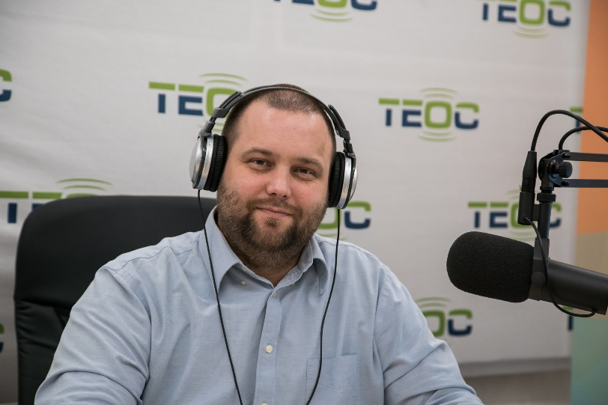

Thursday – 19
Please pray for listeners who are under extreme stress, like Sergei. Sergei lives in an area where there is constant shelling. “My wife and child left to a safer area, and I visit them, but the closeness is gone, and it’s my fault.” Sergei was dealing with PTSD from the violence around him, and was taking care of elderly parents, one of which also had cancer. Please pray for listeners who are burnt out from constant stress and heavy responsibilities.

Friday – 20
Please pray for the ministry in Buryat, and for Nadezhda, who is working with new volunteers to create short videos and testimonies. One video reached over 8 million views.

Saturday – 21
Please pray for Vlad, who is leading the volunteers in FEBC-Russia. He is also regularly meeting with listeners, sharing the Gospel with them in person, helping get them Bibles, and connecting them with churches.
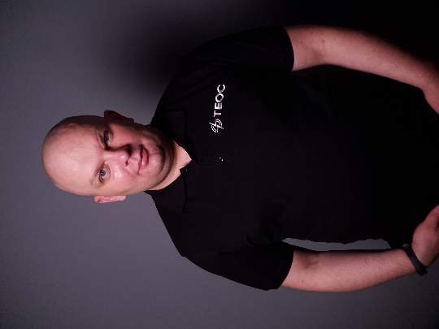

Sunday – 22
Please pray for children like Andrey, Misha, Sasha, and Pasha, four boys who called FEBC-Ukraine’s helpline. “Can we pray that the war ends?” they asked the prayer counselor. They prayed with the counselor and asked him some questions about Jesus. Many children call FEBC’s helpline and ‘become friends’ with Jesus.

Monday – 23
Please pray for Igor from FEBC-Ukraine, who is working on projects to reach young people who are non-believers. Please also pray for his family.


Tuesday – 24
Please pray for listeners like Sergey, from Ukraine, who said, “My life is falling apart, and now I’ve been called in to the enlistment office and I can be called to the front at any time.” As counselors prayed with him, Sergey put his faith in the Lord.

Wednesday – 25
Please pray for Oleg from FEBC-Russia, who is handling government licenses. Please pray for favor with the government, and please also pray for his family.
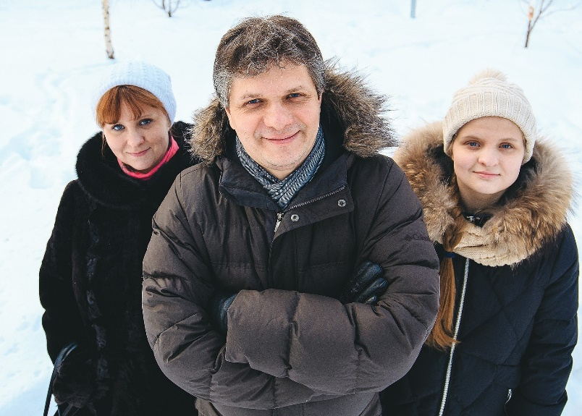

Thursday – 26
Please pray for listeners like Maria, who was pregnant and was considering ending her baby’s life because her husband was serving in the military. FEBC counselors talked to her about God’s view of this, encouraged her about the future, and prayed with her. Please pray for listeners like Maria who are without hope.

Friday – 27
Please pray for the technical workers in Russia who are experiencing a shortage of equipment because of sanctions. At the same time, many of our broadcasters are scattered and are in need of equipment for mobile studios, while the number of listeners is growing like never before.

Saturday – 28
Please pray for listeners like Olga, who was living in addiction. Olga was numbing herself from her problems through these addictions, and felt she could tell no one until she heard about FEBC’s helpline. Please pray for the salvation of these listeners and for their freedom from their addictions.

Sunday – 29
Please pray for Natasha, who is training and leading FEBC-Russia’s Christian counselors. These are trained Christian counselors who are passionate to share the Gospel with the listeners. Many are giving their lives to Jesus through the ministry.
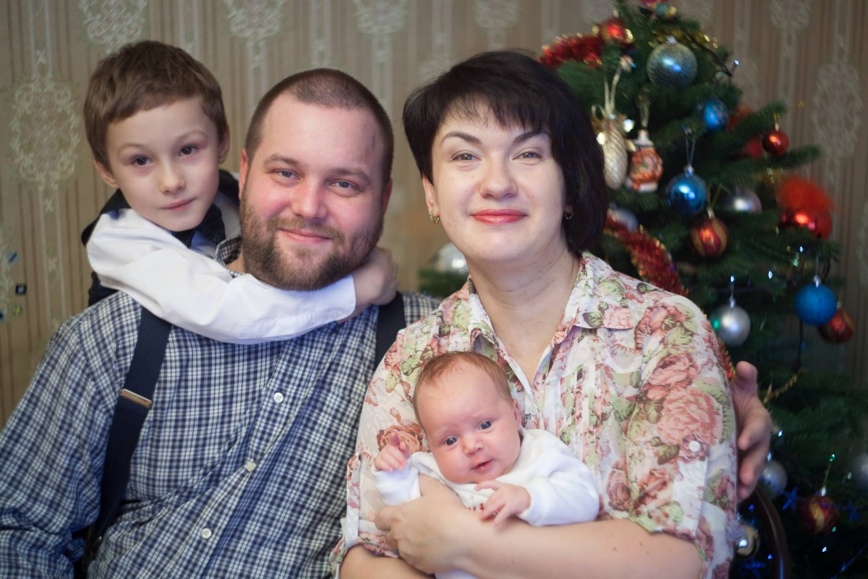

Monday – 30
Please pray for listeners like Oksana, who are experiencing a great deal of stress right now. She called FEBC’s helpline because this year she lost members of her family, had serious health problems, and was now having relationship problems. As counselors began to speak to her about God and His forgiveness, Oksana accepted Christ and asked if the counselors could help her find a church. “Thank you!” she said. “I know that everything will be alright now, as long as I hold on to God.”

Tuesday – 31
Please pray for FEBC-Russia’s volunteers, who help respond to listener’s comments and help them get connected with FEBC’s Christian counselors when they have more serious issues. Please pray for Anastasia, Zhanna, Sasha, Alexey, Andrey, Tatyana, Yuri, Olga, Sergey, Evgeny, Olga, Irina Dmitri, Olga, and Alevtina.

