Wednesday – 1
Please pray for the development of more programming for refugees. This programming is evangelistic in nature, but also focuses on helping them deal with their struggles, fears, and anxieties about the future; many refugees who will soon be returning to Ukraine have no jobs or homes to return to.

Thursday – 2
Please pray for children who call the helpline, like sisters Ilona and Valia, who had a lot of questions about God. She had heard that after death, God weighs our good deeds versus our bad deeds to see if we get into heaven. “What will happen to me if I have more bad deeds?” Ilona asked. When the counselor shared the Good News with them, the sisters were ecstatic. “Do you mean Jesus loves us no matter what?” The girls were crying as they accepted the love of God and became “friends with Jesus.”
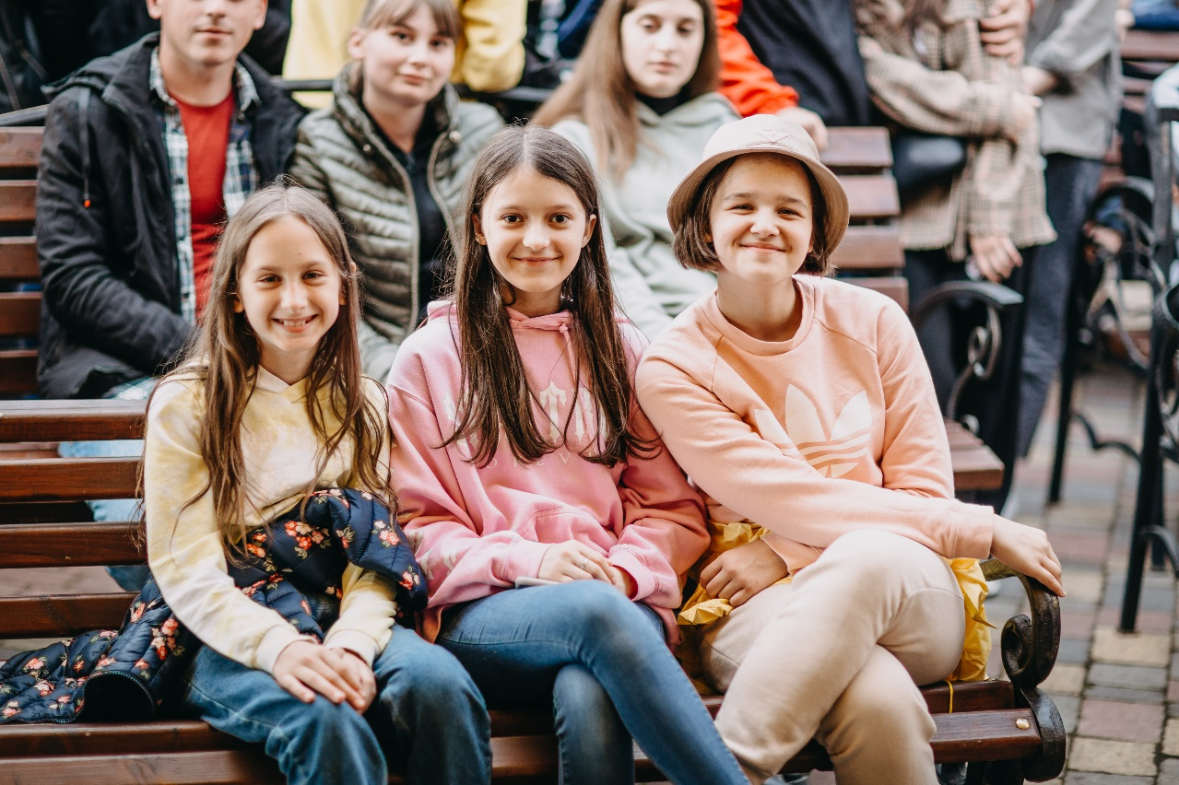

Friday – 3
Please pray for God to provide solutions to technical difficulties in Ukraine, such as Internet connectivity issues and electricity problems.

Saturday – 4
Please pray for FEBC-Ukraine broadcasters who are currently living abroad. Pray that God protects, provides, and gives them wisdom on what to do and when to return.

Sunday – 5
“After talking with you, I really want to pray!” Please pray for listeners like Katya in Ukraine, who had heard about God, but after speaking to an FEBC broadcaster is learning who God is and how to pray to Him for the first time.

Monday – 6
“I have been growing up without my mom, and I learn a lot from your broadcasts!” Please pray for younger listeners like the two sisters who recently met with an FEBC broadcaster. FEBC broadcasters often build long-term relationships with their listeners through their programs, through online chats, and even in person.

Tuesday – 7
Please pray for Max, FEBC-Ukraine’s program director, and his wife, Yulia, and young daughter, Karina. They are under a great deal of stress. Please pray for peace, health, and wisdom as they decide when to move to Kyiv.
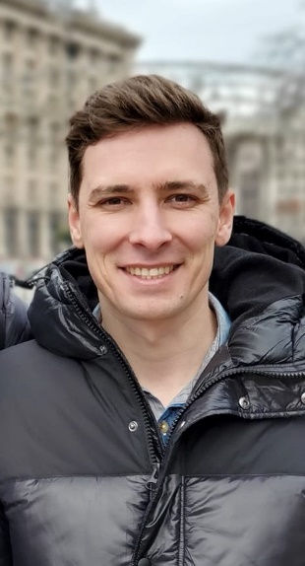

Wednesday – 8
Please pray for Evgeny, from FEBC-Ukraine, who is ministering to people in the most heavily war-affected areas. He was recently in the city of Kramatorsk, “Very few people are left. Mostly those who were unable to leave.” Evgeny was brought to a bedridden man by some of his neighbors. “We prayed with him, left him some medicine, and put him in contact with some local believers so that they could support him. Several days ago, I found out that he had put his faith in Jesus!”

Thursday – 9
Please pray for the people in the twin cities of Sloviansk and Kramatorsk, Ukraine, as the intensity of the fighting increases and more Russian troops move in the direction.

Friday – 10
Please pray for the young people who are new FEBC-Ukraine team members in the city of Zaporizhzhia, who are making TikTok videos to reach other young people with the Gospel.

Saturday – 11
Please pray for the ministry in Buryat, which is operating in difficult circumstances. They are facing several cultural and spiritual challenges.
Sunday – 12
Please pray for those FEBC-Ukraine broadcasters who are planning to return to Kyiv. There was recently a rocket attack after things had been quiet for some time. Please pray for God’s wisdom, provision, and protection.
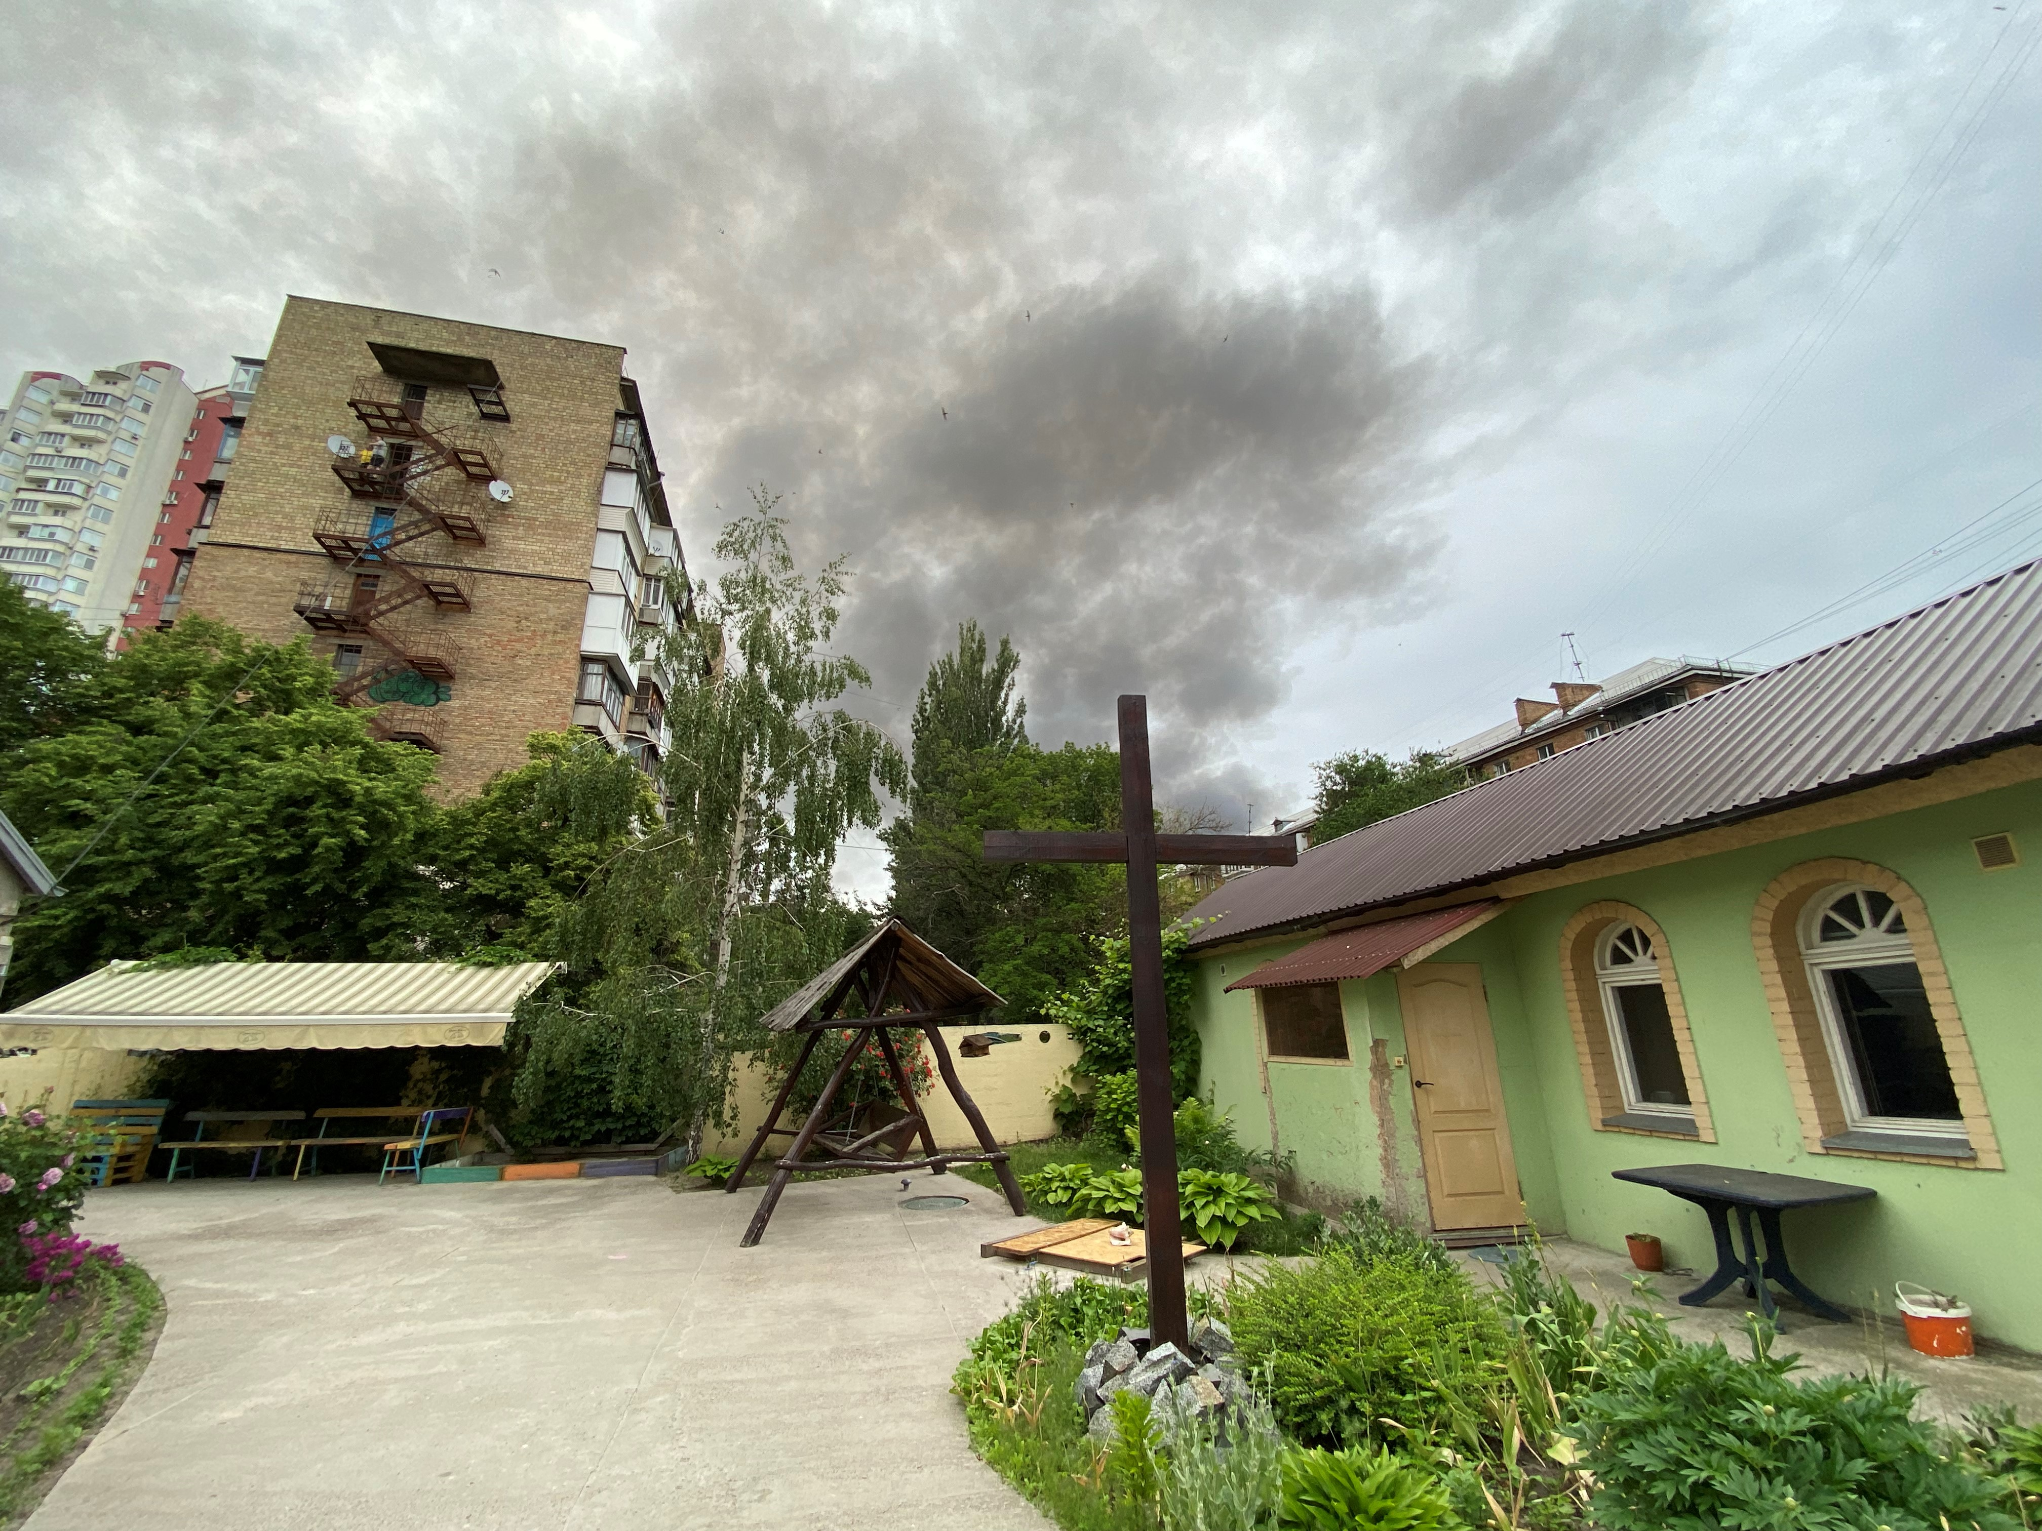

Monday – 13
Please pray for Masha, a new coworker in St. Petersburg, who is making short videos for young people. Please pray that she succeeds in reaching many young people with the Gospel.

Tuesday – 14
Please pray for the FEBC teams as they further develop the online text counseling in addition to the prayer helpline. This would make prayer and counseling accessible to many more people.

Wednesday – 15
Please pray for FEBC-Ukraine team members who are scattered across the country. As Ukrainian broadcasters were on the road to visit Kyiv, planning their return to the city, they met with some FEBC broadcasters from Sloviansk who travel across the country helping people and preaching the Gospel. (The two travelling broadcasters are wearing hats).
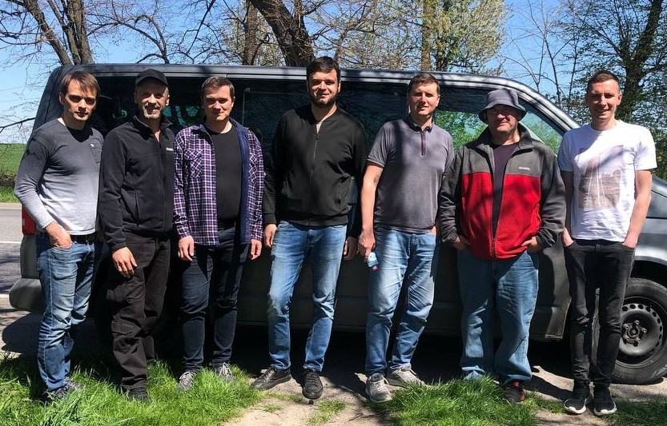

Thursday – 16
Please pray for FEBC-Russia broadcasters who are concerned for their future freedom and safety. Some have had to leave the country and are broadcasting from abroad. Pray for God’s protection and for the freedom to proclaim the Gospel to continue in Russia.

Friday – 17
“I took communion with a group of soldiers,” said Evgeny. “They feel a great need for Christian fellowship and spiritual support, and they asked for prayer. They were also excited to get several radios where they can listen to FEBC-Ukraine.” Please pray for the Ukrainian soldiers and for Evgeny, as he ministers to them.

Saturday – 18
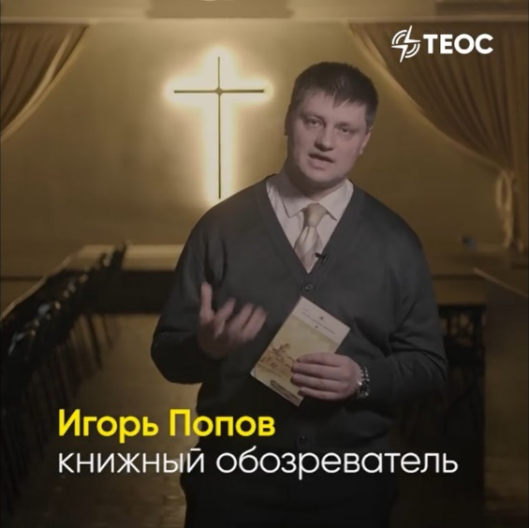
Please pray for a new program that FEBC-Russia broadcasters, Igor and Vlad, are cohosting. Many non-Christians respond to this program with deeper questions about God.

Sunday – 19
Please pray as FEBC-Russia technicians work to find solutions to technical issues they are now facing and expect to face in the future, to ensure FEBC’s programs remain accessible as laws continue to change.

Monday – 20
Please pray for FEBC-Ukraine broadcasters who have lost their homes and are now looking for new places to live. Many have been living with other Christian families for extended periods of time.

Tuesday – 21
Please pray for the salvation of the father of FEBC-Russia’s Alexey. Alexey’s mother became a believer after much prayer. Please pray that his father, who was a former KGB agent, also puts his faith in Christ.

Wednesday – 22
Please pray for the Pastushak family in Chernivtsi, Ukraine. Alexandr and Nadia host a program on FEBC-Ukraine and are ministering on the prayer helpline. They have been opening their homes to many refugees and this has left them with little time to rest.
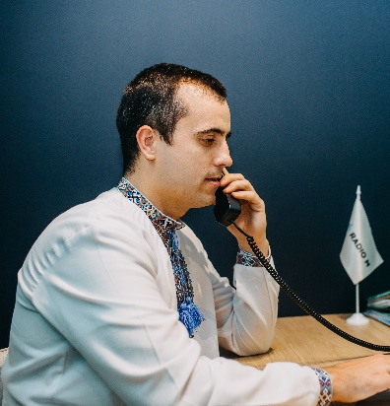

Thursday – 23
Please pray for Evgeny, from FEBC-Russia, who has been broadcasting from abroad because of the many death threats he has received. He and his family had to leave the country, and he fears for their safety as well as his own.

Friday – 24
Please pray for the reach of FEBC’s ministry to continue to increase in both Russia and Ukraine. In Russia, through social platforms, to reach as many people as possible where they are. And in Ukraine, please pray for opportunities for expansion both online and through FM stations.

Saturday – 25
Please pray for listeners like Natalia, who was evacuated from her city when the war started and became a refugee. “Since the beginning of the war, I have often felt confused, oppressed, and even defeated. Several times, I heard a word of encouragement on your programs right when I needed it. Thank you for not stopping your work!”

Sunday – 26
Please pray for FEBC-Ukraine’s prayer counselors who are scattered across the country. When someone calls the helpline, any of the 35 counselors are able to answer the call, wherever they are, using their mobile phones.

Monday – 27
Please pray for FEBC-Ukraine broadcasters who are meeting with listeners in person to help them by sharing about Jesus, answering their questions, and helping connect them to local believers.

Tuesday – 28
“How can I cope with my emotions? I want to be able to call on the Lord like you do,” said one listener when he called the prayer helpline. After the counselors shared how to pray, Denis immediately began praying out loud. After the prayer, he breathed a sigh of relief and blessed the counselors. Please pray for listeners like Denis who are learning to turn to God in times of need.

Wednesday – 29
Please pray for young people in Ukraine who have recently become Christians to get connected to churches and other believers, to become members of a community of believers, so that their faith continues to grow after the war.
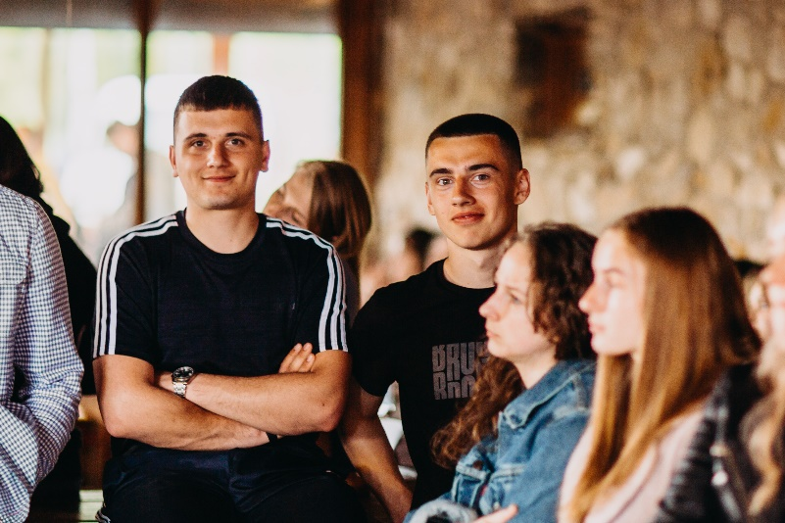

Thursday – 30
Please pray for listeners who are experiencing new closeness with God through prayer on FEBC’s programs. In response to a prayer program, one listener wrote, “This is the first time I’ve done something like this. Thank you for allowing me to experience this!”

