December Prayer Focus – Russia & Ukraine
Wednesday – 1
Please pray for Russian and Ukrainian broadcasters and their family members who have health issues. Pray for healing for them and their families.

Thursday – 2
Please pray for listeners like Nastya, who wrote in three years after reaching out to FEBC for help. “Three years ago, I was a completely normal person from a normal family, until, out of the blue, I was hit with such a strong depression that I felt totally lost. My mom had a prayer book with your phone number in it, so I called… on that call, I turned to the Lord. Now, three years later, I am still walking with God and I am in church.”

Friday – 3
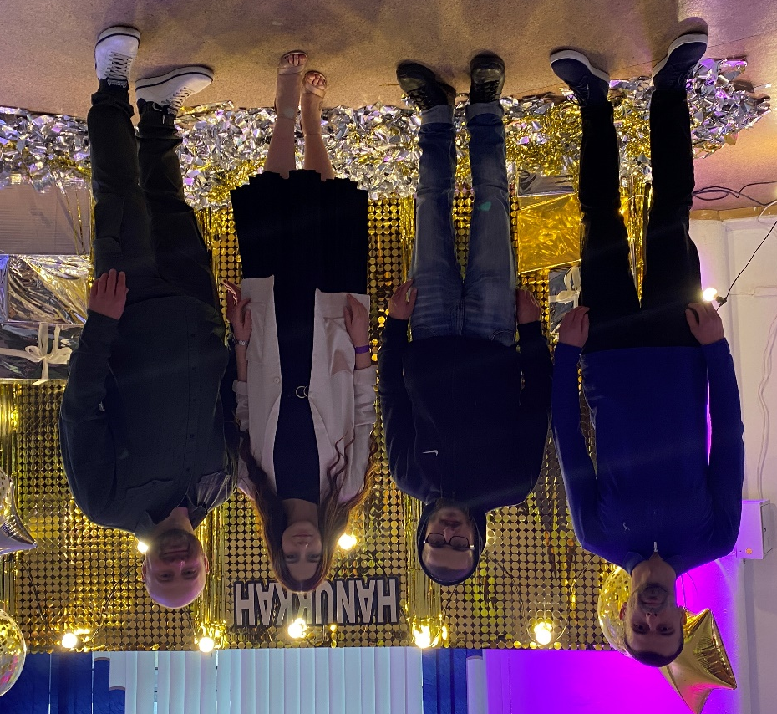
Inna, a broadcaster in Ukraine, shared this story. “These are three of our listeners. Nikolai, on the far left, started walking with God, in large part, because of our programs. Recently, while I was speaking at an evangelistic event put on by our church, Nikolai kept the other two listeners company, making sure they felt comfortable. Because of that, these listeners really enjoyed the event and are now looking at joining a home group.” Please pray for listeners like Nikolai who began their walks with God through FEBC and are now partnering with us to help lead others to God.

Saturday – 4
Please pray for governmental and financial stability and freedom to continue in Russia. And for wisdom and grace to operate in these difficult times.
Sunday – 5
“I feel so great after I listen to your programs! I am from a Muslim family, but secretly believe in Isa. Your programs are my daily spiritual bread, my lifeline,” wrote a listener from Uzbekistan. Please pray for our Muslim listeners who are hearing the Good News about Jesus Christ.

Monday – 6
Please pray for the Ukrainians in eastern Ukraine, who are under the constant threat of a new outbreak of war with Russia. Please pray for the peaceful resolution of this long-lasting conflict.

Tuesday – 7
“My sister said I should call you,” said one listener who called the prayer helpline. After praying with her, the counselor asked her if she had ever given her life to Jesus. “I have wanted to for years,” she said, “but because of my disease I haven’t been able to go to church.” She repented with joy, and became a believer. Please pray that this listener, and others like her, finds a church where she can grow in her faith.

Wednesday – 8
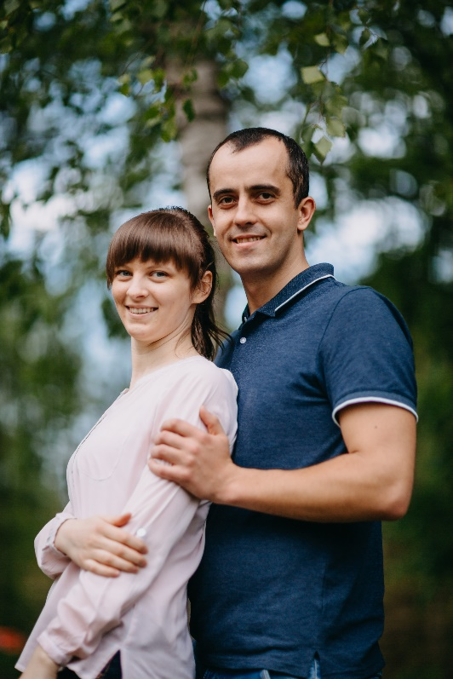
Please pray for Alexander and Nadia Pastushak, who host a program on FEBC-Ukraine and work as prayer counselors in the prayer helpline, working often with the poorest listeners in the most need, helping them get connected with local churches and ministries that can help.

Thursday – 9
FEBC-Ukraine just received permission to broadcast in Zaporizhzhia, a large city in southern Ukraine. We will be reaching a potential audience of more than 1 million people including the city and surrounding areas. FM 88.8. Praise God!

Friday – 10
Please pray listeners like Valery, who found hope when he lost everything. Valery drank, smoked, and stole, until one day his friends beat him badly, leaving him blind. Eventually, even his family didn’t want anything to do with him. Then Valery started listening to sermons on the radio and recording them on a tape recorder. Today, Valery has turned to Jesus, is free from his bad habits, and is asking for prayer for the salvation of his family and for his healing.

Saturday – 11
Please pray for God’s blessings on the families of FEBC’s broadcasters. Many lives are being reached for Christ through their work, but the job can be demanding. Please pray for energy and wisdom for broadcasters.

Sunday – 12
Please pray for young listeners like Zabar, who called FEBC to discuss a Bible story he had heard. After the conversation with the counselor, as they prayed, Zabar invited Jesus into his life. Zabar’s older brother called the line the next day to talk, and he shared that their family had 18 adopted children. Please pray for Zabar and his family, and other families with children who need to hear the Good News.

Monday – 13
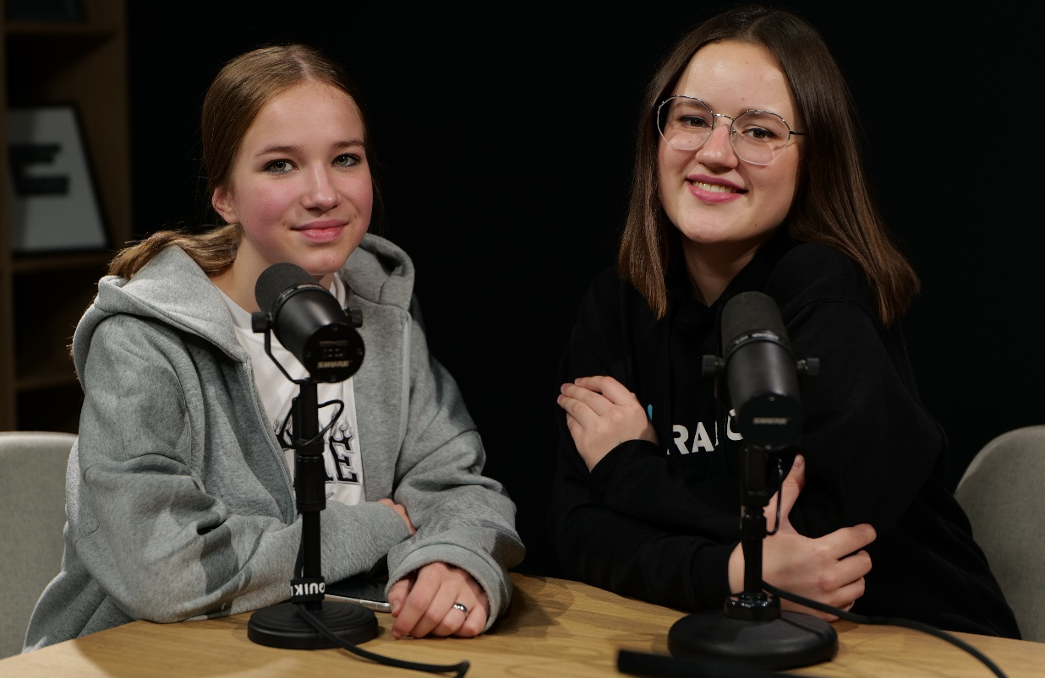
Please pray for the new program TeensTok, which has been bearing fruit. Below is a picture of Karina, who came to church after listening to FEBC-Ukraine. “She has been there twice now,” said Irina, the host of the program, on the right. “The FEBC-Ukraine team is scheduled to be at a teenage event at a church in Kyiv. Please pray for the youth to experience a personal encounter with Jesus!”

Tuesday – 14
Please pray about the record number of COVID related deaths occurring in Russia right now. People are desperate and are looking for hope, and many are turning to God through FEBC. Please pray for the broadcasters and counselors who are helping people find hope in Christ.

Wednesday – 15
“I was so tired of always worrying about my children and my parents. You helped me look at the situation differently. Thank you so much! I didn’t believe in God, but I believe that He exists now, because no one was able to help me like you were. I believe that God sent you to me.” Please pray for listeners like Lyudmila who are finding God through the wisdom and support of Christian ministers and broadcasters on FEBC.

Thursday – 16
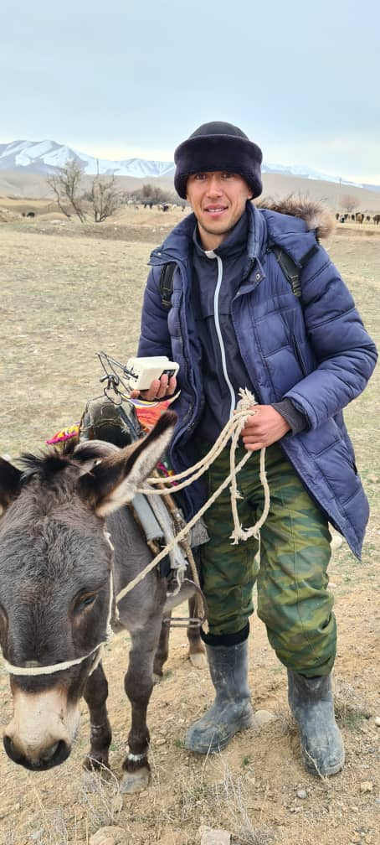
Please pray for the ministry in Kyrgyzstan. Recently, the equipment in Kyrgyzstan was updated, improving the broadcasting quality of the stations throughout the country, and FEBC Kyrgyzstan broadcasters also had the chance to travel across the country, distributing solar radios and speaking with listeners.
Friday – 17
Please pray for the increasing work in Siberia and the Russian far east. A group of FEBC-Russia leaders will be travelling there in January.

Saturday – 18
“I saw your program for the first time eight months ago. I really liked it—you speak carefully and honestly, with professionalism. I also like how you relate what you are saying to God’s laws. Thanks to this, I started reading the Bible for the first time.” Please pray for listeners like Marianna, who are being introduced to God through His Word.

Sunday – 19
Please pray for the FEBC broadcasters who are doing personal outreach to nonbelievers, speaking with them online and meeting with them in person.

Monday – 20
Please pray for FEBC-Kazakhstan’s partnership with local churches to help orphans adapt to life outside of the orphanage. Like Ayaulym, a young woman who was abandoned at an orphanage as a baby. “I love listening to stories about God’s love, about Jesus,” she said.

Tuesday – 21
Please pray for listeners like Vera, who says, “My brother has an addiction, and I am afraid for him.” Please pray for listeners who have family members trapped in addiction, for comfort for the families and deliverance for those who are addicted.

Wednesday – 22
Please pray for the work going on with Muslim listeners. Many videos are being recorded – testimonies and sermons for Muslim listeners in Russia and surrounding countries. We plan to reach an unprecedented number of Muslim listeners in the next six months.

Thursday – 23
Please pray for FEBC-Ukraine’s collaboration with dozens of churches, helping them use media for evangelistic efforts. God is blessing this collaboration with churches.

Friday – 24
We are working tirelessly to help the listeners who are calling us in distress in Russia. With 1,200 people dying daily, on average, from COVID, (unofficial numbers are twice as large), many are scared, disoriented, and many are looking for spiritual answers. Please pray especially for two counselors, Sveta in Moscow and Vlad in St. Petersburg.

Saturday – 25
Please pray for the many volunteers who help make the ministry in Ukraine prosper. With more space available for them to work, more volunteers are joining in the effort.

Sunday – 26
Please pray for a project to help women in eastern Ukraine, in the war-affected area, that is currently underway. May many women receive healing and comfort in the Lord.

Monday – 27
Please pray for people like Olga, who turned to the Lord after an almost fatal illness. “I thought that I would die. I was in bed for two months—I don’t remember anything, my children have been telling me what happened. My whole family thought that I would die. For 3 weeks, I didn’t eat anything, I just had some juice. My husband also became very ill—throat cancer—after the murder of our son. I know that the Lord saved me. Some people told me about you, and I’m calling you because I want to repent for my sins. Can you pray with my husband and me?”

Tuesday – 28
Please pray for new programs being released for children. Short, animated videos of Bible stories are being released in Russian and Ukrainian.

Wednesday – 29
Please pray for the evangelistic meetings that are planned in partnership with local churches in Ukraine this Spring.

Thursday – 30
FEBC-Ukraine's counseling center is leading hundreds of listeners to the saving knowledge of Jesus Christ. Please pray for FEBC’s prayer counselors, Nina, Maria, Alex, Nadezhda, and Anna, among many others.

Friday – 31
Please pray for the ministry in Belarus and Moldova, which are growing despite severe economic and political challenges.

