Wednesday – 1
Please pray for the freedom to preach the Gospel in Russia. The government has just given the status of “unwanted organizations” to several Evangelical churches and have begun demolishing a Presbyterian church. 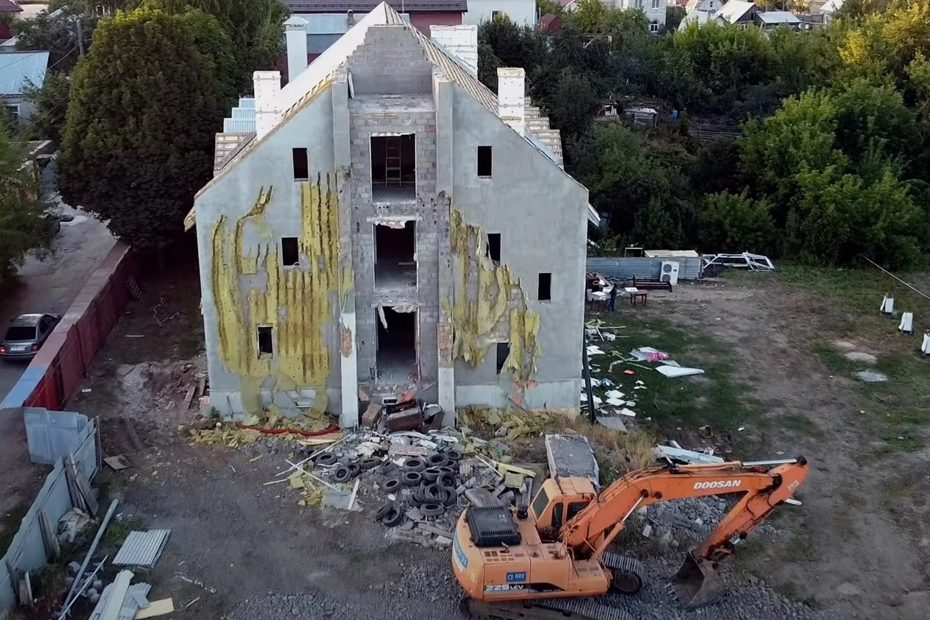

Thursday – 2
Please pray for our broadcaster, Igor, and his daughter, who are dealing with complications after having COVID. Please pray that God provides the finances needed for treatment.

Friday – 3
As we were analyzing our listener response, we found that Bible programs are becoming more popular. We are seeing a lot of deeper responses coming from these programs. Please pray for health and strength for the broadcasters of the Bible programs and for God to continue blessing this work.
Saturday – 4
Please pray for listeners like Peter, who was able evangelize a terminally ill man in the hospital with the help of FEBC. He called FEBC’s prayer helpline so that they could pray with him, and the man eventually accepted Christ. Two days later he passed away.

Sunday – 5
Please pray for listeners like Victoria, who are seeing transformation through ongoing communication with FEBC prayer counselors. Victoria called the helpline for the first time a year ago. She had been on antidepressants for 12 years, and she was dealing with suicidal thoughts. Today, Victoria has completely stopped her medication, is working, and has returned to church.

Monday – 6
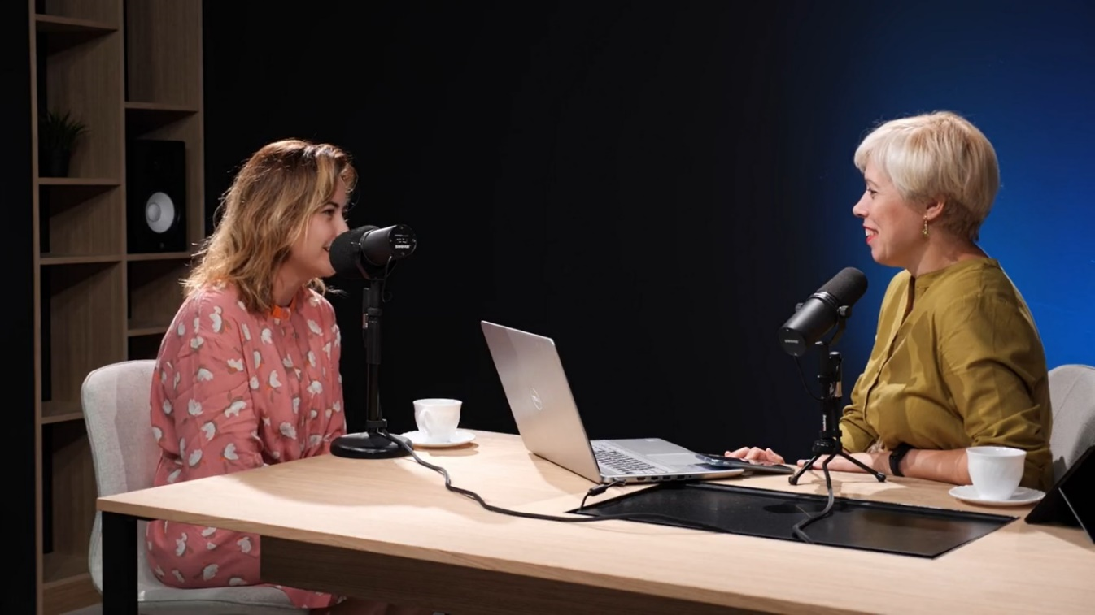
Please pray for the growing ministry to Russian women. More programs are being developed for women, and many female broadcasters are doing one-on-one counseling online.

Tuesday – 7
Lydia wanted prayer after having a stroke, so she contacted FEBC Ukraine. After praying, the prayer counselor asked Lydia if she knew Jesus personally. Lydia wasn’t sure, she had doubts about whether she was saved, though she was religious. The prayer counselor explained how to be saved and Lydia accepted Jesus. Please pray for listeners like Lydia who are religious, but do not have personal relationships with Christ.

Wednesday – 8
Please pray for kids like Angelina, who was given the FEBC phone helpline number by someone at school. Angelina became ‘friends’ with Jesus and the counselor talked with her how to develop a relationship with Jesus as a friend.
Thursday – 9
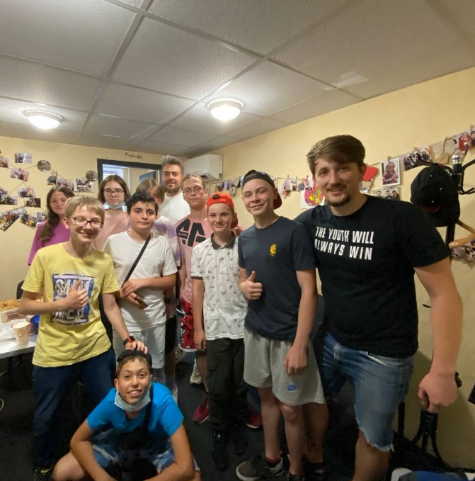
Please pray for the success and growth of the ministry to young people in Russia. Russia is leading the world in teen suicide. We have several projects that are helping young people in Russia find true meaning, and many of them are being reached with the Good News and connected with local churches.

Friday – 10
“I curse people, but I don’t want to be cursed myself. I understand that I am behaving badly. How can I calm my demons?” Elena called the FEBC prayer helpline with this question. She didn’t know any other way to deal with difficult people. The prayer counselor told her about God’s ways of solving problems. Please pray for listeners like Elena, who prayed to accept Jesus and was connected with a church.

Saturday – 11
Please pray for the upcoming women’s conference being held for broadcasters in FEBC Russia, Ukraine, and Central Asia. May it encourage the broadcasters and further equip them to do God’s work.
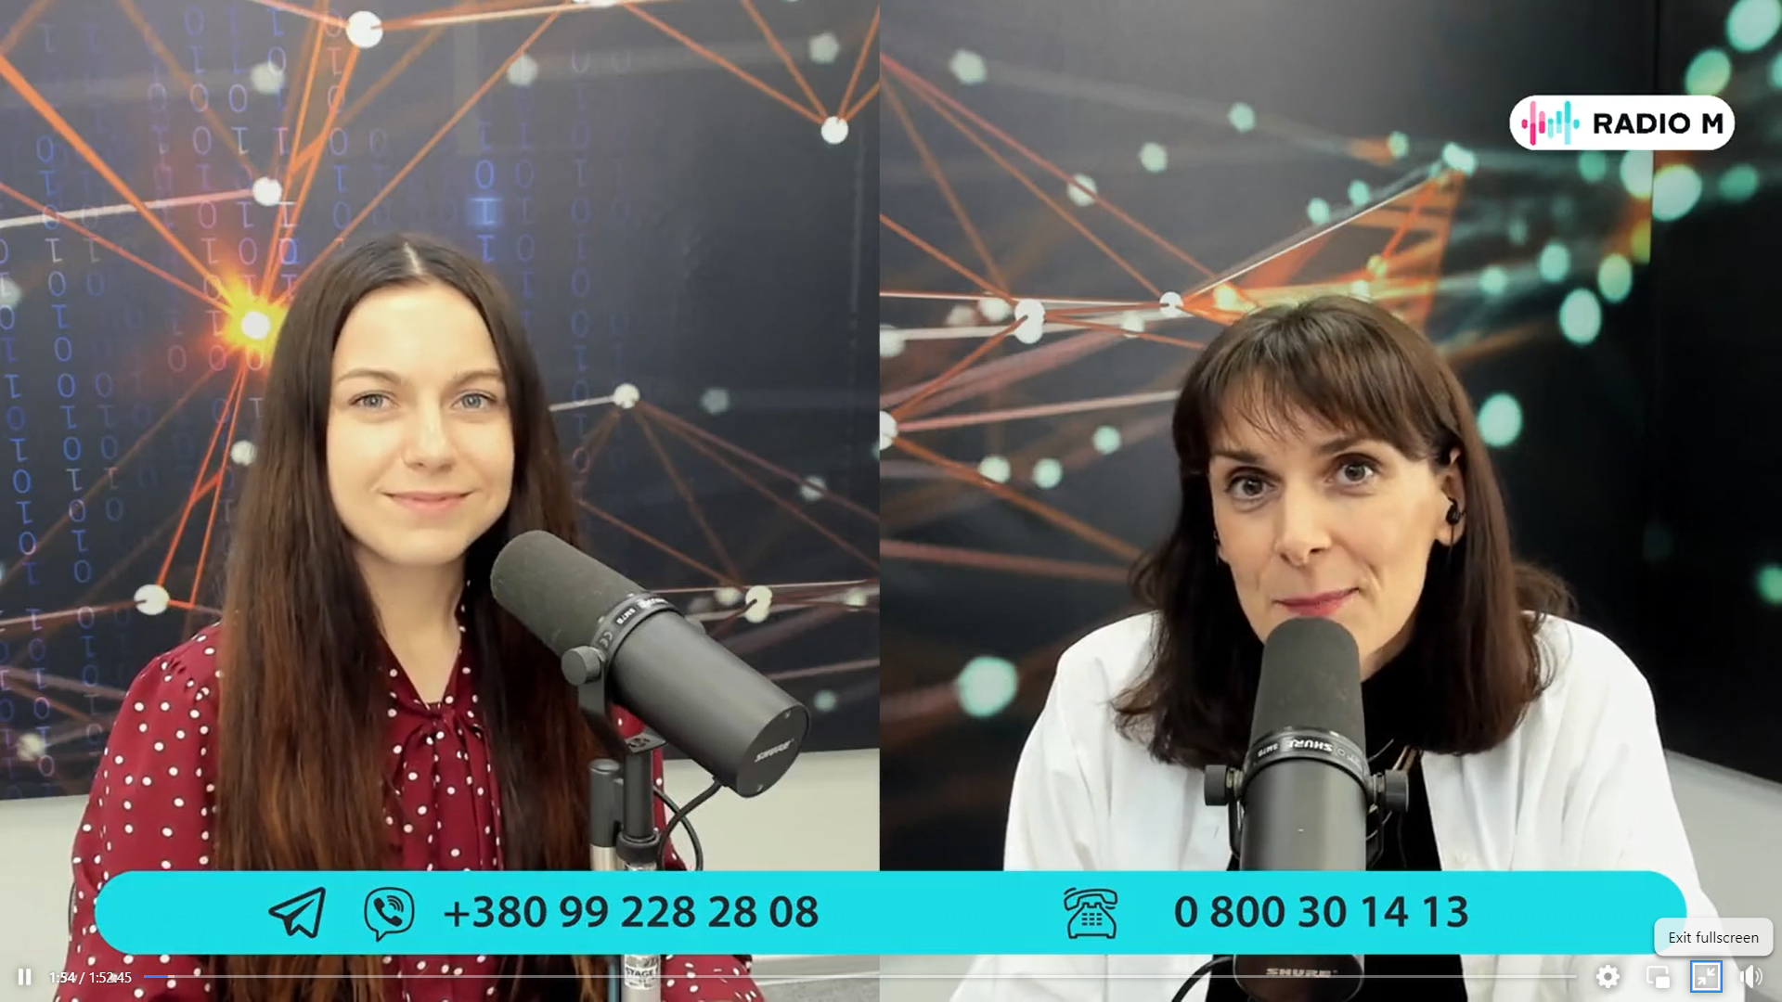
Sunday – 12
Please pray for listeners like Vera, who are finding freedom from alcohol through the support of FEBC in Russia and Ukraine. Vera began drinking after some old friends came to visit her during a difficult time and convinced her to drink. She called the prayer helpline while she was drunk, and with their help, prayer, and God, she was able to come out of her alcoholism and is seeing God’s blessings in her life.

Monday – 13
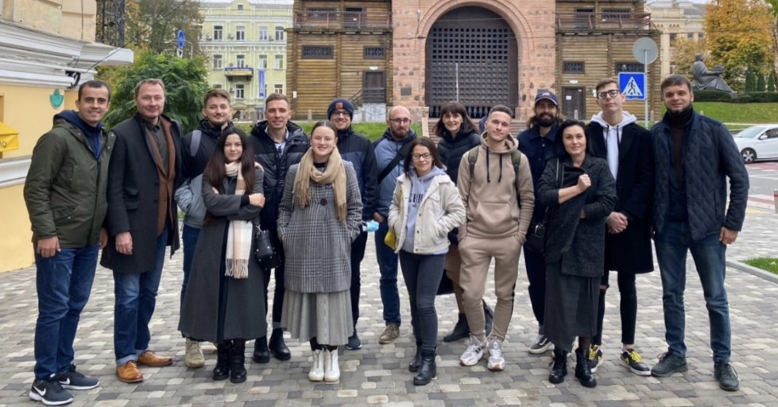
Please pray for FEBC Russia and Ukraine staff that are facing health issues, including Alexey, Evgeny, Natalia, and Tatiana.

Tuesday – 14
A listener named Elena recently accepted Jesus on a call with prayer phone line counselors. She is disabled and cannot travel far, so she asked if some Christians could visit her. “I don’t have a Bible or any other Christian writings.” Please pray for listeners like Elena, who are being connected with local churches who can minister to them.

Wednesday – 15
Please pray for the opening of the Kyiv Media Evangelism Center on September 25th. Some programs have begun to be streamed from there already, but the full opening will be later this month. Please pray that the transition and the opening go smoothly.

Thursday – 16
Please pray for children like Diana, who are being learning about God by talking with FEBC counselors and are drawing their parents to God as well. After becoming a believer, Diana started calling FEBC’s helpline to ask questions about Jesus and for prayer. Recently, she gave her mother the phone, and now her mother is a listener of FEBC Ukraine.

Friday – 17
We are experimenting with new broadcasting techniques, including long, uninterrupted streams, some lasting 24-hours. Please pray that God guides and inspires broadcasters and blesses their efforts.
Saturday – 18
Please pray for listeners like Sergey who are being connected to rehabilitation centers to get help for their addictions. Sergey reached out to FEBC for help many times, but would not take any steps to get help, until recently, when God led him there. Sergey met the head of a rehabilitation center by chance at a bus stop. Later, he was being harassed by some criminals, and the only place he felt he could hide was in this rehabilitation center. Now he is getting treatment and has committed to learn about the Lord.

Sunday – 19
FEBC Russia is starting a project to work with Kyrgyz people in St. Petersburg. They will be making evangelistic videos with them. Please pray for wisdom as we make and share those videos with the Kyrgyz Muslim audience.

Monday – 20
Please pray for listeners like Eduard, who are living in increasing poverty in Ukraine. All his family relationships are strained because of the debt, and they are living worldly lives. Please pray for the salvation of his family and for God’s blessing on Eduard. Many listeners are facing severe financial hardship, and with international travel being limited, they are having trouble finding work. Please pray for God’s provision.

Tuesday – 21
Please pray for Elia, the project manager in FEBC Russia. She has a chronic illness that causes dizziness and can cause hearing loss in one ear.

Wednesday – 22
Please pray for listeners like Galina, whose husband was in the fighting in eastern Ukraine and is now dealing with PTSD and occasionally drinks. “I want to help him, but I know that sympathy and support isn’t enough.” Galina accepted Jesus during her call with an FEBC prayer counselor and cried as she prayed. “Hope appeared in my heart that the Lord will help.” The counselor connected Galina with a phone line that specializes in working with veterans and connected Galina with a church.
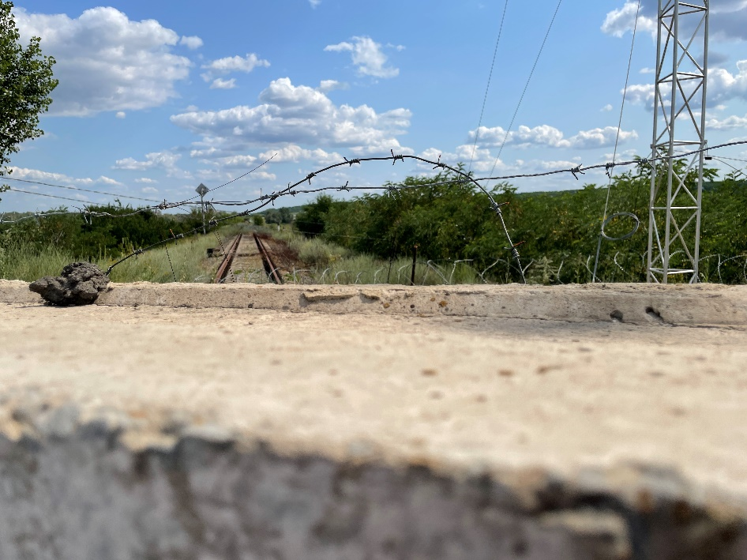
Thursday – 23
Please pray for Sergey, an FEBC Russia volunteer, who is asking for prayer support for his daughter. She was born recently, and doctors discovered a cerebral hemorrhage.

Friday – 24
Please pray for listeners like Sophia. “I felt God’s presence,” said Sophia, after praying to accept Jesus. She had been ill for a long time and was reliant on her parents, though her father could be abusive. She started off the conversation depressed but ended it smiling.
Saturday – 25
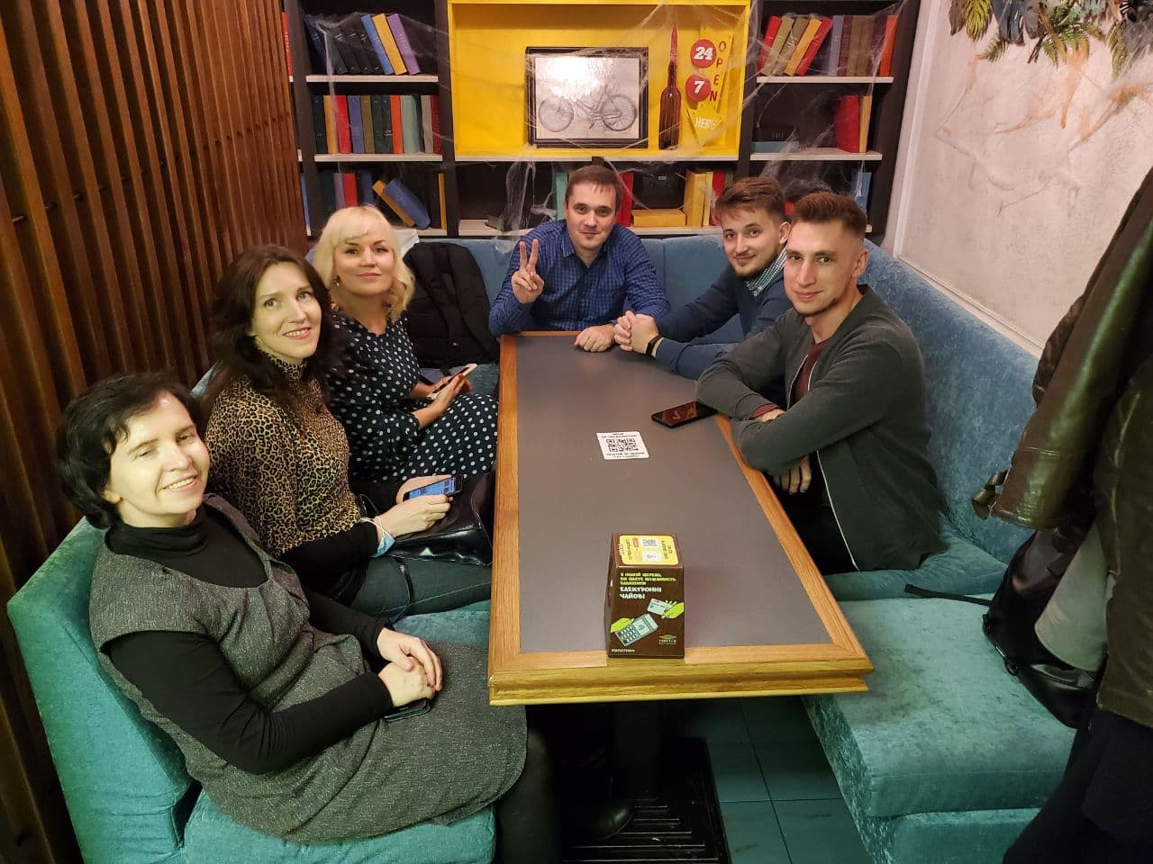
Please pray for the development of a free helpline project from Russia for other nearby countries, such as Moldova and Belarus. There are a lot of potential technical difficulties, both in redirecting calls to consultants and in organizing multilingual support. Some helpline workers are pictured below.

Sunday – 26
Please pray for listeners like Sergey, who became a believer in prison, but once he was released, his life began to fall apart. Sergey called the phone helpline for help, and the counselor encouraged him and connected him to a church.

Monday – 27
Please pray for the training of employees in new methods for working on social media. Techniques and tools evolve very quickly, and new media continues to change, so the need for this kind of training is constant.

Tuesday – 28
The Ukrainian police gave the phone number of FEBC Ukraine’s helpline to a woman whose husband had just died in front of her. He fell while he was drunk and hit his head. She was grief-stricken, though he had sometimes been abusive towards her, and was crying. The counselor prayed for her and she was able to calm down. Please pray for Ludmila, and praise God that the police knew enough about FEBC Ukraine to give her the phone number of the prayer helpline.

Wednesday – 29
Please pray for listeners like Sergey and Igor, from Russia, whose families are in crisis due to infidelity. The divorce rate is increasing due to the ongoing strain of the war and the poverty that is being made worse because of COVID. Please pray for the family programs and prayer helpline workers, where many people are finding help and support.

Thursday – 30
Please pray for the new outreach to Russians in the far east of Russia. The far east can be very different culturally, so please pray that these programs are effective and connect with listeners.

