July Prayer Focus – Russia & Ukraine
Thursday – 1
Please pray for FEBC Ukraine’s ministry to churches throughout Ukraine. FEBC employees have been meeting with churches, in person and over zoom, to train them in how to use media effectively to reach their neighbors for Christ.

Friday – 2
Please pray for listeners like Galina. “My son is addicted to drugs and he doesn’t want to change his lifestyle. I know I can’t change him, and I’m tired of trying. I am putting my faith in God. Please agree with me in prayer.”

Saturday – 3
Please pray for listeners like Oksana. She had been listening to FEBC Ukraine for some time and was able to meet with Nadia, one of the broadcasters, several times. Recently, Nadia was able to tell her about God’s work in her life. “She listened to me, and she cried,” said Nadia. “She told me that she always felt restless after talking to me. That she was beginning to believe that there was a God because our conversations were different from those that she has with her friends. When I told her that I would pray for her, she cried again. None of her friends had ever told her that before.”
Sunday – 4
FEBC Russia is dealing with multiple new laws and regulations every month. Some are just bureaucratic, and others are restrictive, like a recent law regulating educational projects online. Please pray for God’s wisdom and favor in navigating these new laws.

Monday – 5
Please pray for FEBC broadcasters Eugene and Eduard, who have been visiting the military zone in Ukraine, as well as neighboring towns and cities, meeting with soldiers and their families, and others who have been affected by the fighting.
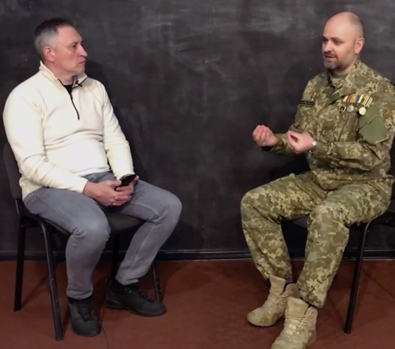

Tuesday – 6
Please pray for listeners like Vika, who are dealing with domestic violence and addiction in a spouse. “My husband was in rehab, but he got in a fight with someone and left. Now he wants my daughter and I to come get him. I am afraid of a repetition of the past.” This is a growing issue in Russia and Ukraine. Many listeners are calling in for prayer and are being connected with churches and supporting organizations to get help.

Wednesday – 7
Please pray for the hosts of the weekly special family programs in Russia. These programs are dedicated to specific issues such as teen depression and suicidal issues, old age, evangelism, and family counseling. The hosts include Vladimir, Tatiana, Tatyana, Natalia, and some new broadcasters, including Pastor Evgeny, pictured below.
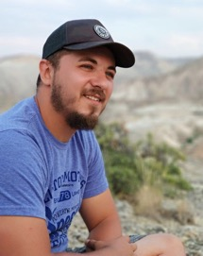
Thursday – 8
“You saved my family, and then, you saved my soul…well, God did, but He did it through you. I am forever grateful.” Please pray for FEBC Russia’s daily family programs, where people learn from and be helped by leading Christian experts on family issues. These experts all have theological and psychological degrees.

Friday – 9
Please pray for travel blessings and protection for FEBC staff this July.

Saturday – 10
Please pray for the new listeners who receive pre-tuned radios so that they can listen to FEBC’s programs, like this listener from the Odessa region of Ukraine, who received a radio during a Family Festival.
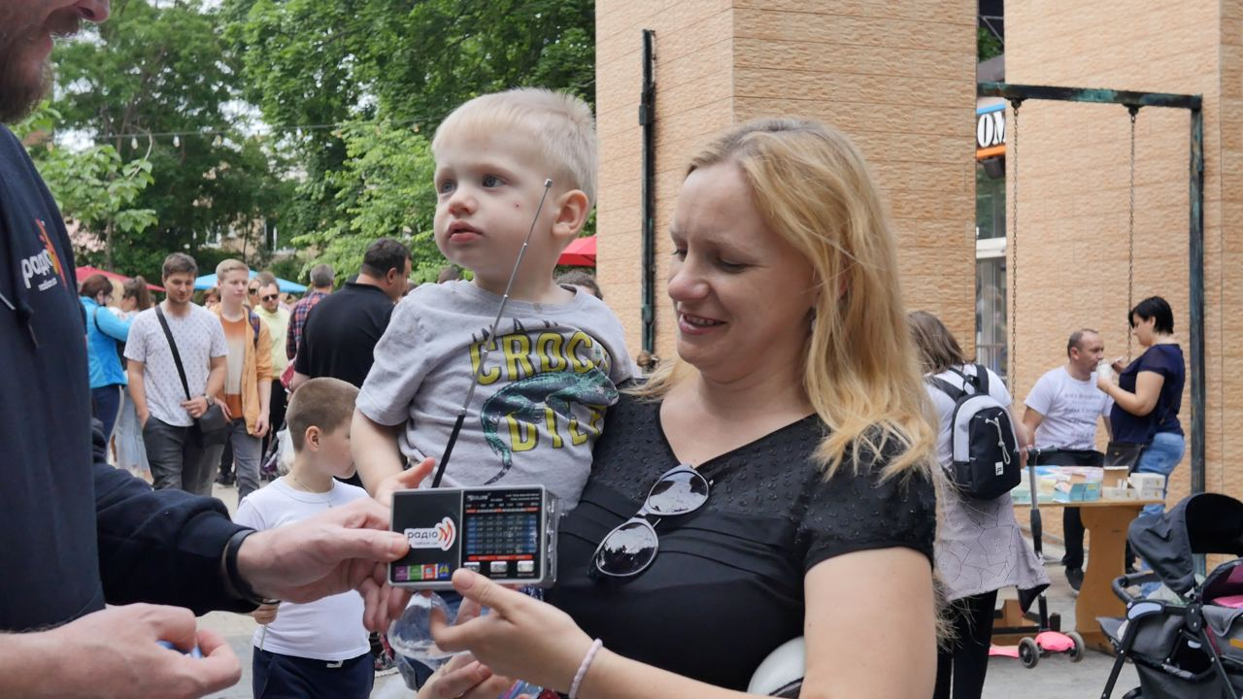

Sunday – 11
Please pray for the series of church and youth events where we are sharing with people how they can use media, including FEBC’s media, to reach non-Christians.

Monday – 12
Please pray for the continued growth and development of online/social media activity. FEBC Russia’s programming is almost exclusively online because of legal restrictions, and we estimate that about 50% of listeners of FEBC Ukraine are online as well. This is a growing and ever-changing environment that has provided many opportunities for expansion. Please pray for God’s favor with regards to Internet freedom laws in Russia and for His guidance and blessing in reaching listeners on social media in both countries.
Tuesday – 13
Please pray for listeners like Tatiana, who was disabled and had no one to help her through rehab, so she called the prayer helpline. During the call, Tatiana gave her life to the Lord, and she was connected with a local minister named Anatoly. This minister was excited to get the call, saying, “God must have sent you to me, because my ministry is mainly to the disabled and sick. I’ll gladly visit Tatiana tomorrow.” Many listeners are connected to local churches and believers through the prayer helpline.

Wednesday – 14
Please pray for programs being made to reach children. Tatyana and Yulia are two presenters who produce programs where they talk with their young daughters on the air. Below is one of their daughters, Maria, participating in the program.
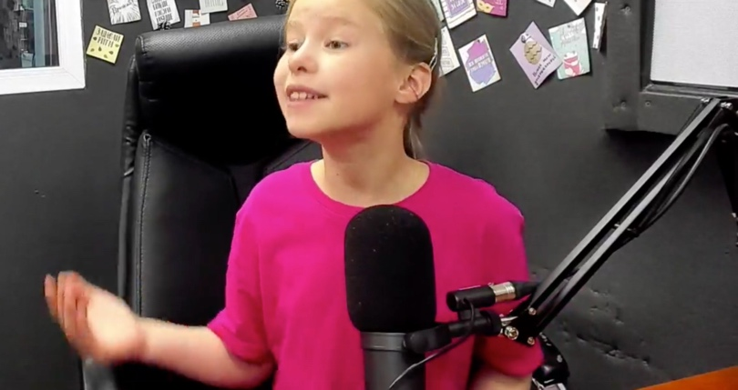

Thursday – 15
“On your show, for the first time, I heard from a Jewish person who believed in Jesus Christ. I was very much intrigued to hear about Jesus… Thank you for this program!” Please pray for Jewish listeners like Izolda, who are hearing the good news of Jesus from other Jewish believers.

Friday – 16
Please pray for the FEBC Ukraine team, including Alex, Valentin, Igor, Max, Eugene, Eduard, Inna, Ira, Olesia, and Nadia, to name a few. Please pray for God’s blessing on their work in the ministry and on their families.
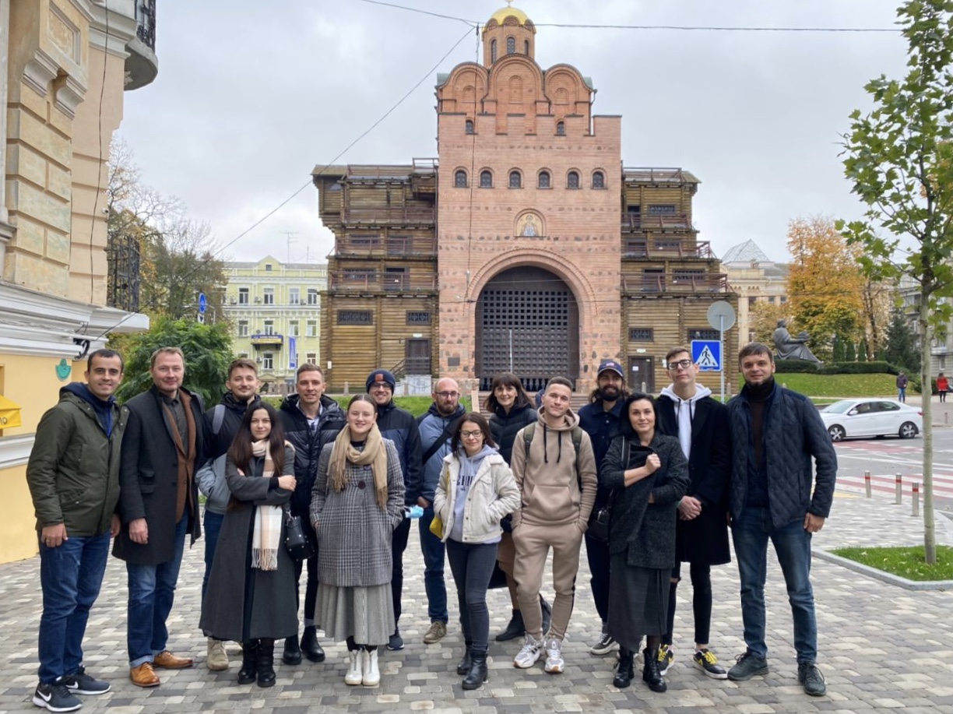

Saturday – 17
Please pray for the visits made to listeners, possibly including small listener rallies that will be taking place in eastern Ukraine. This also includes radio distribution, visiting soldiers, and visiting refugees.

Sunday – 18
Please pray for FEBC Russia’s increasing ministry to Muslim listeners in Russia and neighboring countries. Recording listener testimonies from former Muslims has proven to be effective. Many listener responses have been coming in that have led to positive results, whether the responses were initially positive or negative.

Monday – 19
Please pray for the FEBC Russia team, including Oleg, Igor, Alexey, Elya, Natalia, Irina, and many others. Please pray that God continues to bless their work and for health, healing, and restoration for those who have been struggling with various complications.
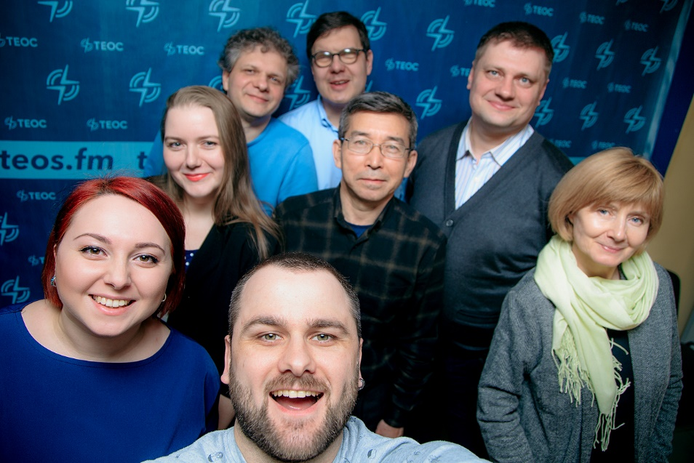

Tuesday – 20
“Thank you for giving us a radio. My sister and I are now your listeners, and so is our mom.” Please pray for FEBC Ukraine’s ministry to disadvantaged children. 15 presentations were held in camps, churches, and orphanages and over 750 children had the Good News shared with them and received counseling. Many children accepted Jesus as their Savior. Please pray for Vladimir, who is overseeing this effort.

Wednesday – 21
Please pray for FEBC Russia and Ukraine broadcasters who spend a lot of time dealing directly with listeners, both during and after programs. “I want to thank you for your morning broadcast. It was so unexpected and touching when you responded to me personally and supported me during the broadcast. So many thousands of people were listening and watching, and you responded directly to me. I went to church for the first time in 5 years because of your encouragement.”

Thursday – 22
Please pray for the completion of the Kyiv Media Evangelism Center in Ukraine. It will allow for an expansion of the programming, including studio equipment quality, backgrounds and lighting, and the ability to invite more guests onto the programs.
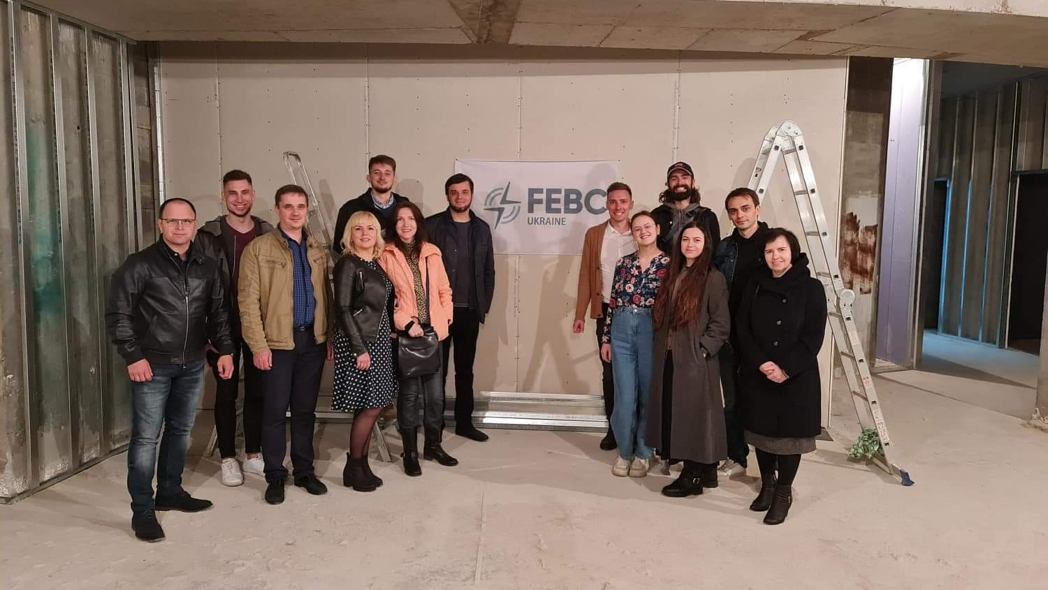

Friday – 23
“The church that you connected me with is my new family. They exemplify Jesus to me personally.” Please pray for God’s blessing as we continue to expand our network of partnerships with local churches throughout Russia and Ukraine. Connecting listeners to local churches helps them continue to grow in their new faith and receive personal attention and help.

Saturday – 24
Please pray for listeners like Antonina, an older woman from Ukraine. “I’m alone in my apartment—the kids went on a trip to the sea—and I can’t stop remembering the war. My granddaughter still isn’t speaking after her experiences.” Please pray for listeners who are dealing with long term consequences from the war, and those still living in the militarized zones.

Sunday – 25
Yulia is a Jewish listener who has been listening to FEBC Ukraine. “I really like your morning broadcasts. I don’t just listen… I delve into them.” One of the broadcasters from the morning program met with Yulia and told her about her faith. “I am praying for her,” said Inna, the broadcaster. Below is a picture of their meeting.
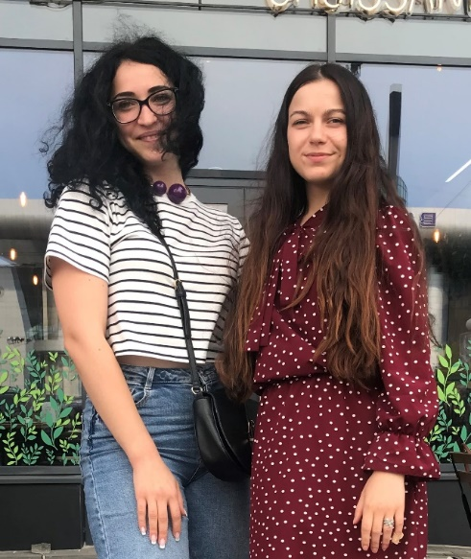

Monday – 26
Please pray for listeners who are asking deeper questions about life after the pandemic. “When I realized that I was mortal after saying good-bye to several of my friends and relatives, I began listening to you and started to think about my eternal future. I hope my newfound faith will be with me for the rest of my life.”

Tuesday – 27
Please pray for the Zoom and in-person training that FEBC broadcasters are going through to continue to improve their programs. Training conferences and seminars include topics like how to involve volunteers, best ways to invoke responses, and how to use short videos within a broadcast. “Despite my eight years in college and graduate programs I never benefited that much from a course; the Leadership Academy helped me grow through some very difficult times.”

Wednesday – 28
Please pray for Vasily, a listener of FEBC Ukraine, who was injured at a construction site and left paralyzed. His wife did not want to take care of him and left him. “I didn’t see the point of going on like this,” said Vasily. “But believers began visiting me and they introduced me to FEBC Ukraine’s radio programs and the prayer phone line. I began listening, and my heart lit up. I started hoping that God had a good plan and a happy future for me.” Please pray for Vasily and other listeners like him who are finding hope in God through FEBC’s programs and interactions with broadcasters and prayer ministers.
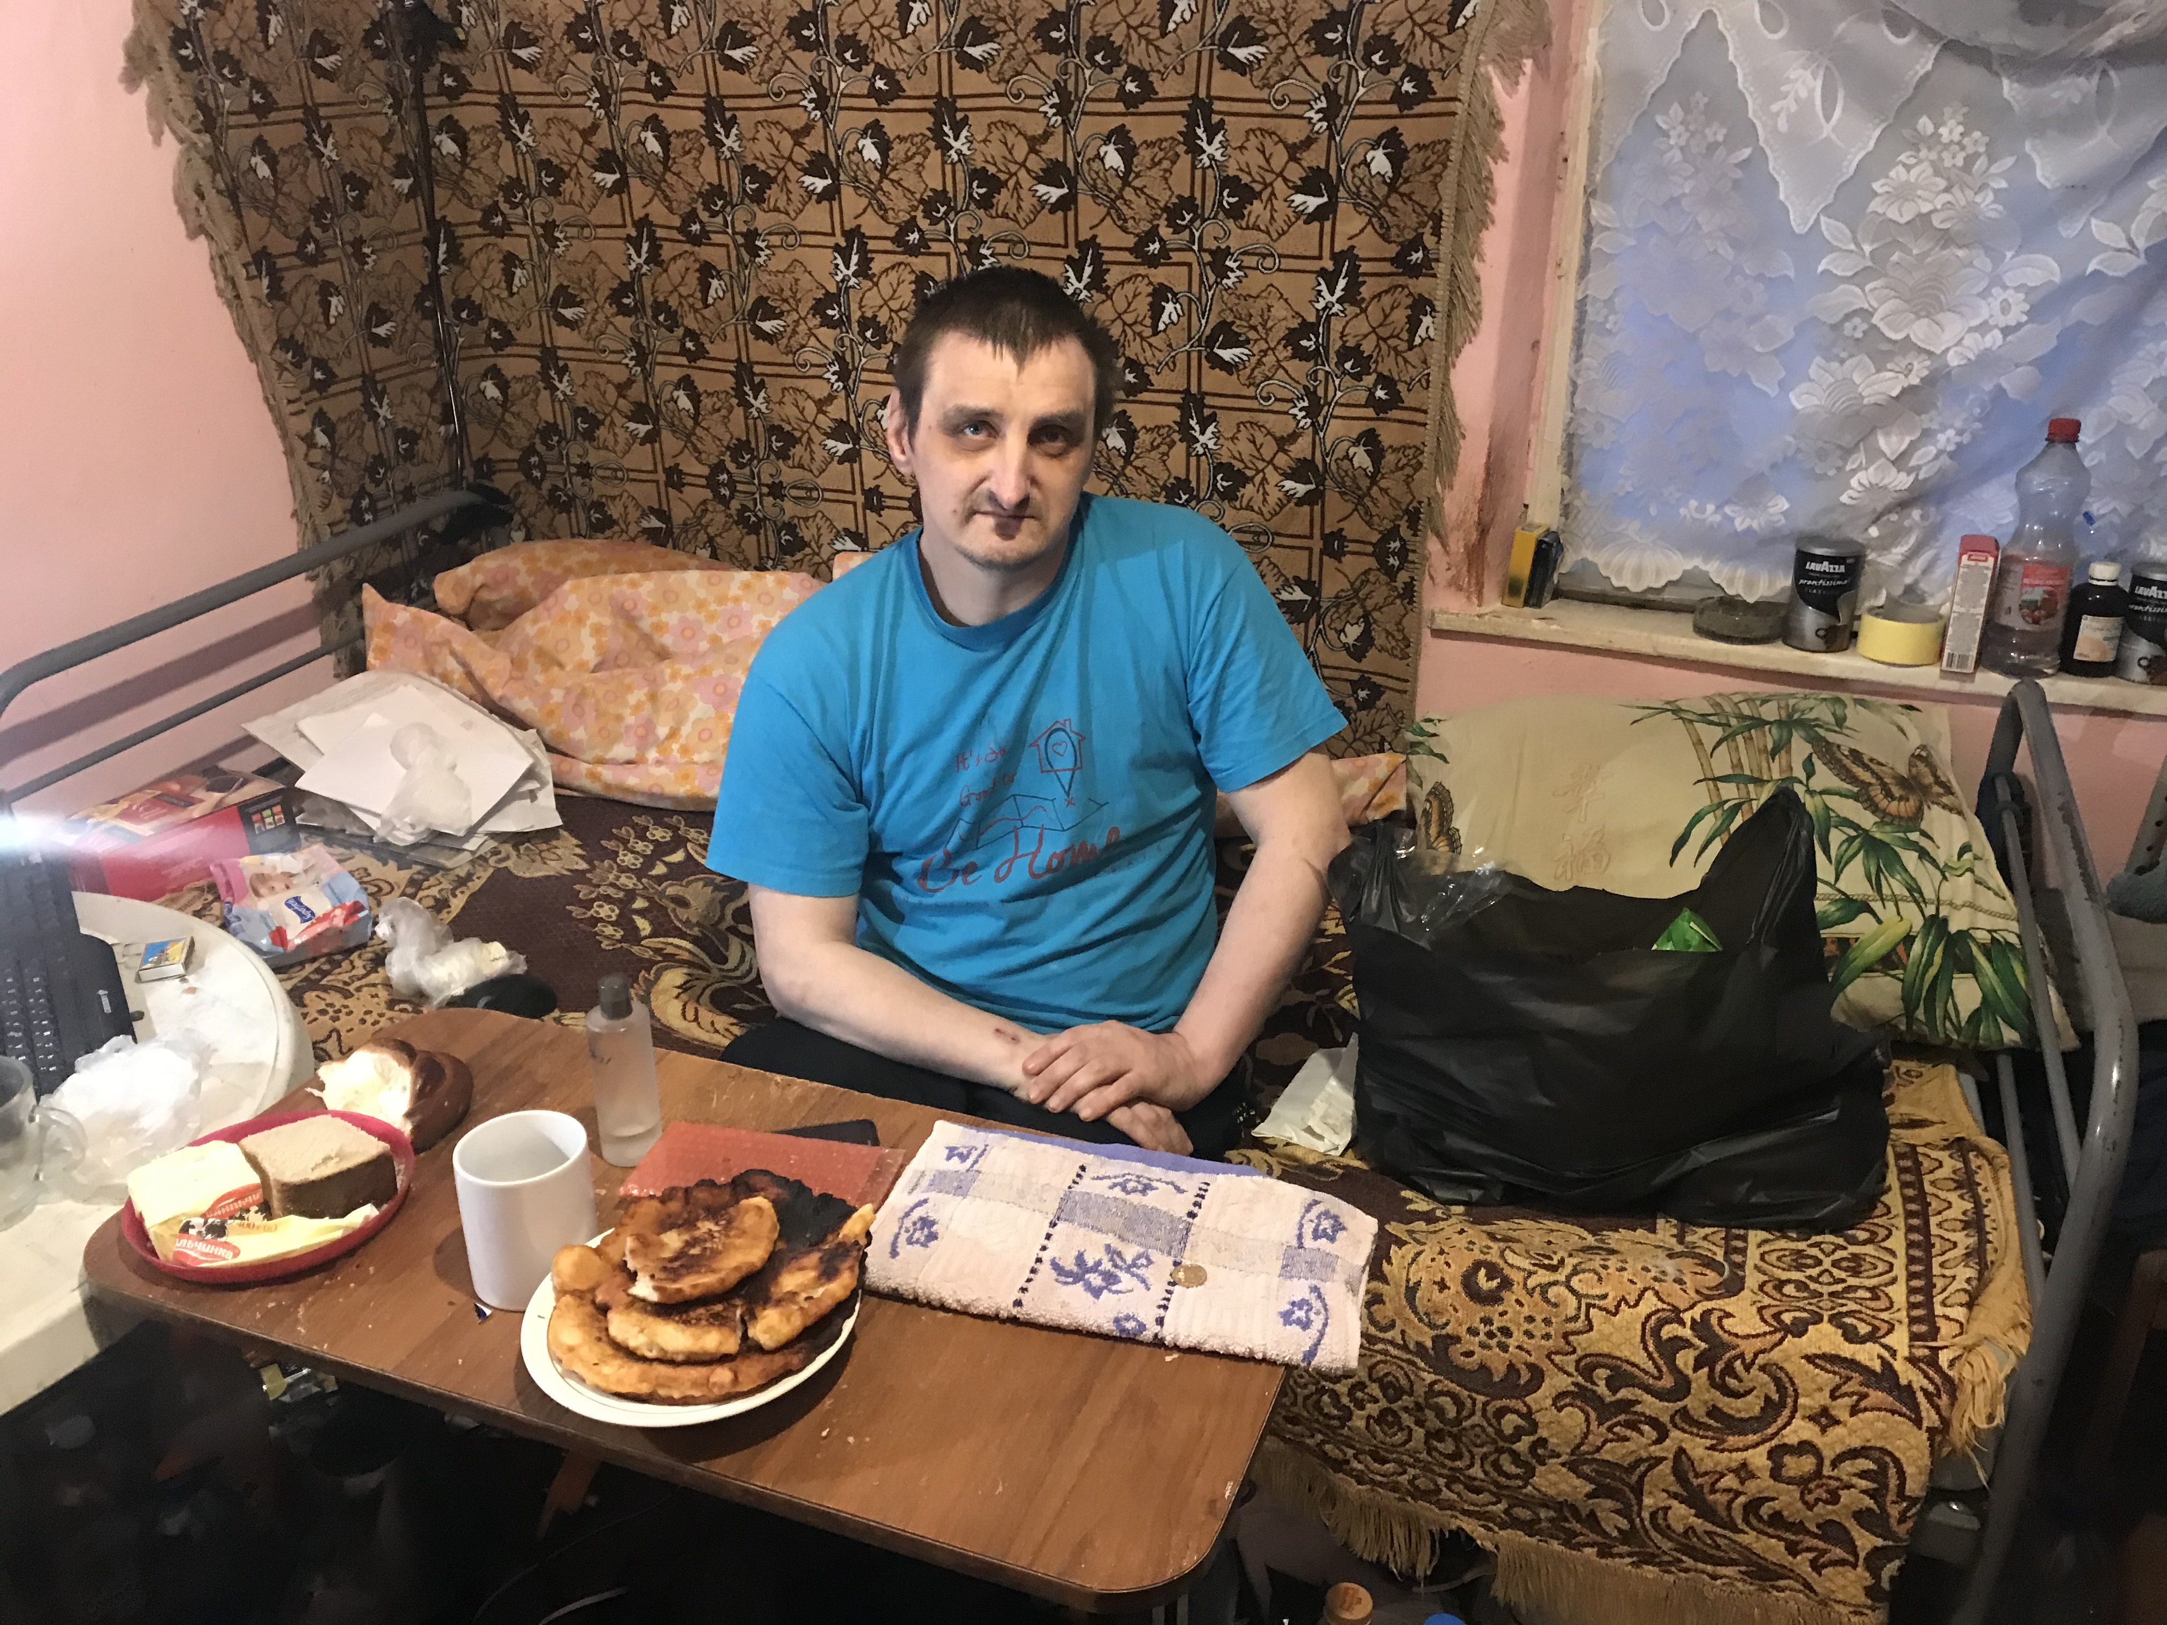

Thursday – 29
Please pray for the counselors and volunteers who are praying with listeners in Russia and Ukraine. They minister to people going through many difficult situations, such as poverty, depression, marriage troubles, PTSD from the war, and people who want to take their own lives. Please pray for God’s strength and peace for our counselors, and that He gives them wisdom as they counsel and pray with listeners.

Friday – 30
Please pray for children who are coming to know the Lord. Brother and sister, Gleb and Christina, called the prayer helpline to find out more about God. When Gleb had to leave the call, his sister, Christina, was happy to become friends with Jesus and wanted to learn more about what it meant to be a Christian.

Saturday – 31

“My husband left home, I’m not sure where he is now.” Please pray for listeners like Ekaterina, with serious marital issues. Divorce, abandonment, and long periods of separation are common. Please pray for listeners to continue listening to FEBC’s programs and to reach out to get help from FEBC’s broadcasters and counselors.

