June Prayer Focus – Russia & Ukraine
Tuesday – 1
Please pray for listeners like Vincent, an atheist who has been listening for FEBC. Pray that these listeners turn to the Lord. “Thanks for your honesty and openness while talking with me. I tried to hurt you with my comments, but you continued to patiently talk about your faith, not about religion. This is what won me over. Thank you for that.”

Wednesday – 2
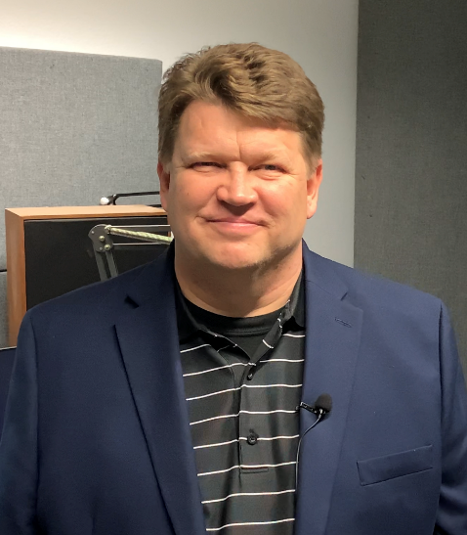
Please pray for Victor Akhterov, who is overseeing FEBC Russia and Ukraine. Please pray for his family, who have experienced a loss and are going through a transition. Please pray for God’s comfort and His presence to be with them in this time.

Thursday – 3
Valentina and her husband are an older couple who decided to adopt. “Almost all of our friends and relatives tried to convince us not to do it, and even the people at the agency asked us why we needed these problems. But we prayed, and we felt in our hearts that we were on the right path. We listen to your broadcasts a lot, and they are a real encouragement. Especially hearing the stories of other people who have adopted.” Please pray for listeners like Valentina who are finding help and encouragement through FEBC’s program on adoption on their journey of adoption.

Friday – 4
FEBC Ukraine is partnering with an organization that puts on Christian summer camps for orphans. These organizers join FEBC programs as guests to encourage people to foster and adopt. Please pray for this ministry to continue influencing the culture.
Saturday – 5
“Where was God? Why did this happen? I didn’t know what to do. I have been on anti-depressants for the last four years after losing my child. Today I listened to your program for the first time. It was amazing! I actually felt better for the first time in years.” Please pray for listeners like Natalia who are finding hope after tragedy.

Sunday – 6
Please pray for the ministry of FEBC Russia as new restrictive ‘religious protection’ laws are being introduced. These are likely to be used against the Protestant churches in Russia, often deemed to be Western.

Monday – 7
Please pray for Alexander, a Jewish listener of FEBC. He has been listening for about six months and regularly hears about Jesus from the broadcasters. He does not yet want to read the New Testament, but he joins in conversation and discussion about Jesus. He is open to talking about God, please pray that his heart is opened to the Lord.
Tuesday – 8
Please pray for Rudi Wiens, the Regional Coordinator for Central Asia, who is currently waiting for a visa. Please pray for God’s favor and provision.

Wednesday – 9
Please pray for listeners like Tatiana and Sergey, who are having serious family issues. Sergey has recently returned from the fighting in eastern Ukraine and is suffering from PTSD and his wife Tatiana has a problem with alcohol. They have 5 children and are having trouble with their housing situation. Tatiana and Sergey both gave their lives to the Lord while talking to FEBC consultants. Please pray for God to do a work in their lives and that they can find spiritual and financial support in the church they are connected with.

Thursday – 10
An FEBC broadcaster held a dinner in her home for non-believers. Four listeners attended and they talked about God and the Bible, and they prayed together. Please pray for FEBC’s broadcasters who are evangelistically minded and seek to introduce people to Jesus on and off the air.
Friday – 11
Please pray for listeners like Natalia, who are learning about the Bible. “This is what I like about your programs, the presenter always draws a simple analogy from life, and everything becomes clear! I heard a lot of useful things for real life today.”

Saturday – 12
Esther started watching an FEBC program about art from a Christian perspective. She wrote to the presenters to thank them for the program. Because of their suggestion, she started reading and meditating on the Psalms. Please pray for listeners like Esther who are being drawn to read the Bible for themselves. Pray that they come to know the Lord through His Word.

Sunday – 13
Please pray for the families of FEBC broadcasters and coworkers in Russia and Ukraine. Please pray for health, wisdom, and protection as they navigate these politically, socially, and economically tumultuous times.
Monday – 14
Please pray for children like Katerina, who can ask the questions they have about God and learn how they can have a relationship with Him. Katerina asked questions like, “Why did Jesus die?” and “Can God hear us?” Counselors told her about Jesus and about eternity, and Katerina became ‘friends’ with Jesus. Praise God for the salvation of many children.

Tuesday – 15
Russia has one of the highest rates of suicide in the world, and the teen suicide rate is particularly high. Please pray for listeners like Olga, who called FEBC to ask for prayer for her granddaughter, who was suicidal. Many suicides have been adverted through one-on-one discussion and prayer with FEBC counselors.

Wednesday – 16
Please pray for listeners like Rimma, who have family in prison and find God’s love and acceptance through FEBC’s program for prisoners. “In some ways, those of us who are close to people who are in prison for serious crimes are even more hated than the prisoners themselves, because we are still around. Your program is like a light in the dark. You don’t humiliate or insult us. Instead, you pray for us and help us. Thank God for your program.”

Thursday – 17
Please pray for the people of Belarus, who are going through a difficult political situation. We are beginning to minister from Russia and have a married couple on the ground who are helping. Please pray for the peace of Belarus and for the Gospel to spread and flourish there in this difficult time.

Friday – 18
A second meeting was recently held by an FEBC broadcaster for non-Christian women. During the meeting the participants pray, talk about their personal issues, and talk about God. Please pray that these meetings continue to bear fruit and that the women in these meetings come to know the Lord personally.

Saturday – 19
Please pray for the leadership team in Russia, including Alexey and Oleg, as they handle changing laws and an expansion of the ministry to nearby Russian-speaking countries.
Sunday – 20
Please pray for listeners like Ekaterina, who are dealing with alcohol addiction. Ekaterina had been an alcoholic for 12 years, was unhappy, and didn’t have any family. She prayed to accept Jesus and asked God for real freedom from all her sins. "Thank you for listening to me. I couldn’t tell anyone all this before. Now my heart is easy."

Monday – 21
Please pray for our ministry in the Buryat region, where we have been releasing programs in the Buryat language. Buddhism, Shamanism, ancestor worship, and animalism are common there. Please pray that the listener audience grows.

Tuesday – 22
Please pray for the broadcasters in Russia and Ukraine who are often doing one-on-one ministry with listeners in addition to their programs, both in-person and online. They talk and pray with listeners, invite them to seminars, and lead Bible studies and give out Bibles. Most conversions happen through one-on-one communication after programs. Please pray that God provides opportunity and works mightily through them.
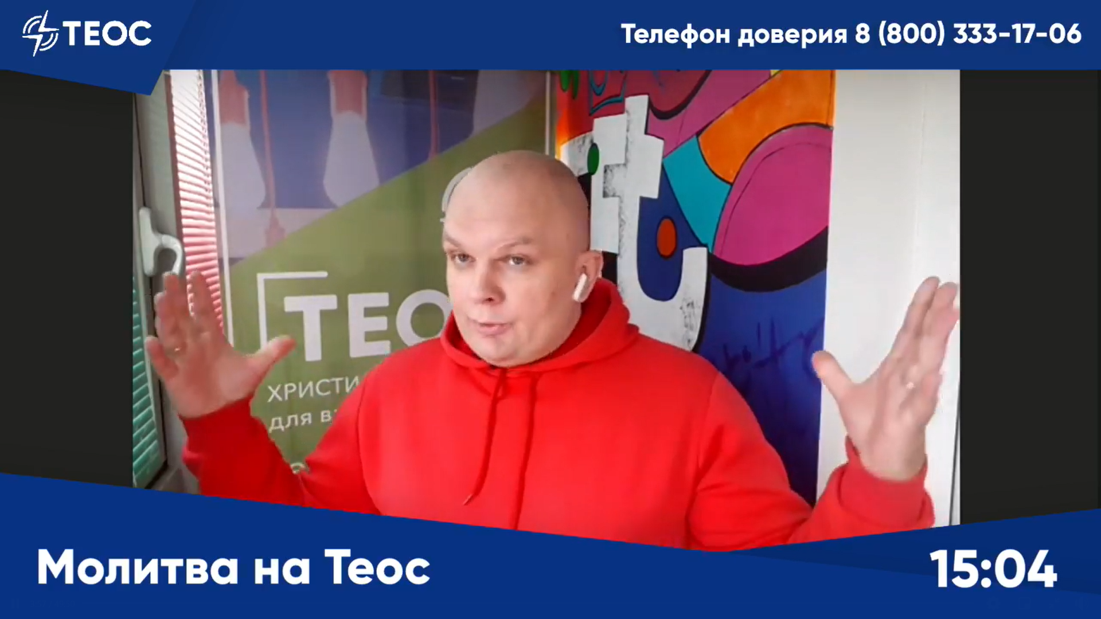

Wednesday – 23
Please pray for the growth in the number and level of training of volunteers in Russia and Ukraine. Volunteers are a huge support to the ministry, especially in follow-up work, and their importance is only increasing.

Thursday – 24
Please pray for listeners like Natasha, who listen to FEBC with their children. “Thanks to your program, I’ve begun to understand the Bible more. Sometimes my 6-year-old son listens with me and tells me he is very interested.”

Friday – 25
Please pray for Eugene in Ukraine who is regularly travelling to the war zone to minister to soldiers and to the affected villages in the area who are in desperate need.
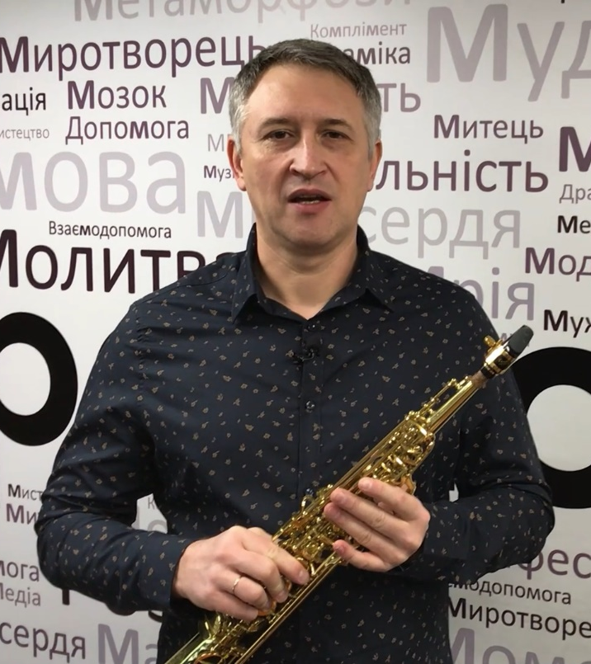
Saturday – 26
Please pray for listeners like Anna, who are hesitant to go to church. Anna had prayed with an FEBC counselor to accept Jesus, but she was afraid to go to church because of what others might think. Counselors continued praying for and communicating with Anna for a year. Recently, Anna called one of the pastors she had been connected with by FEBC. They visited her and had a church service in her home. Anna loved it and now wants to begin attending church with them.
Sunday – 27
Please pray for the new projects aimed at reaching Muslims with Jesus across Russia and Central Asia. Please pray for courage, wisdom, and favor and opportunity. May many people turn to Christ through these projects and one-on-one evangelism and follow-up.

Monday – 28
Please pray for listeners like Galina, who feel alone after the COVID pandemic. “It feels like God has abandoned me,” said Galina, who went on to pray a prayer of repentance and turned to the Lord. She also agreed to reach out to a nearby church.

Tuesday – 29
Please pray for the leadership team in Ukraine, including Eduard and Max, as they oversee a growing and expanding ministry.

Wednesday – 30
Please pray for FEBC Russia’s new partnerships with Christian online personalities who are famous for other reasons, like teaching English, but want to preach the Gospel. We are working together with them, providing support and advice, to help them grow and develop and reach people with the Good News.

