Russia and Ukraine Prayer Focus – May 2021

May 1 – Saturday
Please pray for listeners who will be celebrating Easter on May 2nd. May their hearts be open to hearing the Good News in the easter-themed programs designed to reach new listeners.

May 2 – Sunday
Please pray for the situation between Russia and Ukraine to continue to de-escalate. It appears that the Russian troops are being pulled back. There are several Ukrainian broadcasters who are in the region that would be directly affected by an invasion, as they were in 2014. Please pray for the peace and security of Ukraine.

May 3 – Monday
“I am a Buddhist. At least, that’s what I thought when I started listening to your program about studying other religions. At first, I was skeptical, but the pastor who was a guest on your show intrigued me. I was interested in how a Buddhist could become a Christian. He talked about ‘meeting with God.’ Is it really possible to meet with God?” Please pray for listeners from other religions like Sergei, who are being touched by the Gospel.

May 4 – Tuesday
Praise God for Dr. Evgeny Sarapulov's successful cancer treatment. Please continue to pray for his health and his family. Especially uplift Svetlana, his wife, in your prayers.

May 5 – Wednesday
Please pray for listeners like Nadezhda, Maria, and Tatiana, who learned the story of Jonah through an FEBC program about art from a Biblical perspective. Many listeners who tune in know nothing about the Bible and are becoming familiar with God and the Bible through the program.
May 6 – Thursday
Please pray for the success of some new projects aimed at reaching Jewish listeners for Jesus. Russia and Ukraine each have dedicated programs to Jewish listeners and several other programs have segments reaching out to Jewish listeners.

May 7 – Friday
Please pray for listeners like Inna, who came to an evangelistic seminar for women, hosted by a church. They brought in a broadcaster from FEBC to speak to the women. Inna wasn’t a Christian, but she listened to FEBC and she recognized the speaker, so she came to the seminar. She was very open to talking about God and is interested in visiting a community church.

May 8 – Saturday
Please pray for the freedom of proclaiming the Good News to continue in Russia as the government continues to increase its control over the Internet. People are being imprisoned now for reposting political messages. Pray for God’s wisdom and favor for the FEBC-Russia leadership.

May 9 – Sunday
“My grandma gave me your number,” said a young boy named Vitaly when he called the prayer helpline. “She said that I can call you because there are good people here.” He had seen someone steal from a store and wanted to know what to do. Afterwards they talked about God and Vitaly gave his life to Jesus. Please pray for children who are learning that they can have a relationship with Jesus.

May 10 – Monday
Please pray for the ongoing ministry to the people in the warzone in eastern Ukraine. The outreach is not only to soldiers, but to the affected populations of these towns.

May 11 – Tuesday
“I’m not a Christian, though I can’t call myself an atheist either, but I listen to your programs sometimes. You asked a question that got me thinking, about how one can hear God. I have more questions than answers after the broadcast, but I really want to read the Bible now.” Please pray for listeners who are not yet believers, but are hearing the Good News, like Alexey.

May 12 – Wednesday
Please pray for the completion of the work on the studio in Kyiv, which has faced some delays because of COVID. The studio will allow for more broadcasters to work at once, provide room for guests and visitors, and provide opportunities for outreach, especially among students from the nearby university.

May 13 – Thursday
Please pray for our younger broadcasters who are reaching the youth of Russia and Ukraine, especially through social media and short videos, such as on Tik Tok.

May 14 – Friday
Please pray for FEBC's video maker Evgeny, and his wife Olga. Also pray for Olga's mother. All of them are recovering from a difficult case of COVID-19.

May 15 – Saturday
Please pray for listeners like Vadim, who have experienced tremendous loss. Vadim experienced 4 deaths over the last 4 years: his father, mother, grandfather, and brother. His grandmother is helping take care of him and is asking for prayer for his salvation and his emotional state.

May 16 – Sunday
A broadcaster in FEBC Ukraine invited listeners to come to the studio for her birthday to celebrate with her. Around 25 people showed up. Broadcasters were able to get to know the listeners and tell them about God.

May 17 – Monday
Please pray for listeners like Elena who turn to the occult to solve their life problems. This is not uncommon in Ukraine. Elena phoned the helpline and turned to God. She was connected with local believers and is eager to meet them.

May 18 – Tuesday
Pray for FEBC's ministry to the Buryat people; pray that many young Buryats will join evangelical churches.

May 19 – Wednesday
Please pray for listeners like Svetlana who are finding peace in Jesus. Svetlana had experienced much trauma in her life and was crying as she shared her struggles, from abuse, to depression, to being out of work. But after the counselor prayed with her, she began to calm down and listen to what the counselor was saying. Svetlana began asking questions about Jesus and His sacrifice, and she prayed with the counselor to accept Jesus.

May 20 – Thursday
Please pray for FEBC listeners who lost their relatives to COVID-19. Russia's excess death rate is higher than it is in the US. Pray that people will open their hearts to Christ as they grieve and ask existential questions.

May 21 – Friday
Please pray for listeners like Nikolai, who are dealing with trauma from the war. Nikolai lost both of his legs in the war and was struggling with thoughts of suicide. Through talking with FEBC counselors, Nikolai repented and was connected with a minister.

May 22 – Saturday
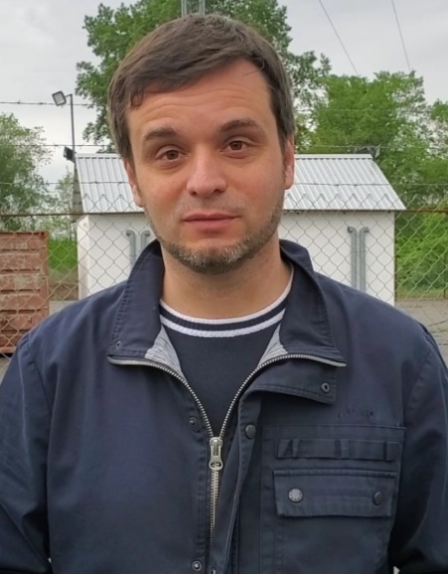
Please pray for Eduard Kurylenko, FEBC-Ukraine's director. Pray that he will continue to grow as a minister under the leadership of more experienced ministers.

May 23 – Sunday
Please pray for listeners like Natalia who have never been in church but are drawn to the person of Jesus. “His personality intrigues me, and I often ask myself what He would do in my place.” Natalia connected with an FEBC counselor, where she was encouraged in her faith and invited to church.

May 24 – Monday
Please pray for listeners dealing with substance abuse issues. This problem is becoming increasingly serious because of the economic situation and the ongoing conflict in Ukraine. Mikhail is a young man who was in the military and is now a drug addict. His grandparents are praying for him day and night and are believing that they will see him free from this addiction.

May 25 – Tuesday
Please pray for FEBC's ministry in Belarus, a country of 10 million people that is going through a difficult political and economic period.

May 26 – Wednesday
“Hello! This is my first time listening to you and I love it! Thank God for you! In our village, no one other than me reads the Bible or wants to know Jesus.” Please pray for listeners like Tatiana, who are isolated Christians.

May 27 – Thursday
Please pray for listeners like Alexander, who are in difficult circumstances. Alexander is disabled, but he is independent and is looking for work. His mother recently died and now he is taking care of his mentally ill sister. During the call, Alexander gave his life to Jesus and was connected with a local church. Please pray for God’s provision and that he finds community and support in the church he was connected with.

May 28 – Friday
Please pray for the project that we are planning and praying for, as we want to evangelize millions of Muslims in Eurasia. Pray for God's leading and guidance.

May 29 – Saturday
Praise God for FEBC's leadership training that our leaders went through. We learned to better use Biblical principles to be Christ-centered, more effective, and more caring, not only for our listeners, but for one another as we minister together.
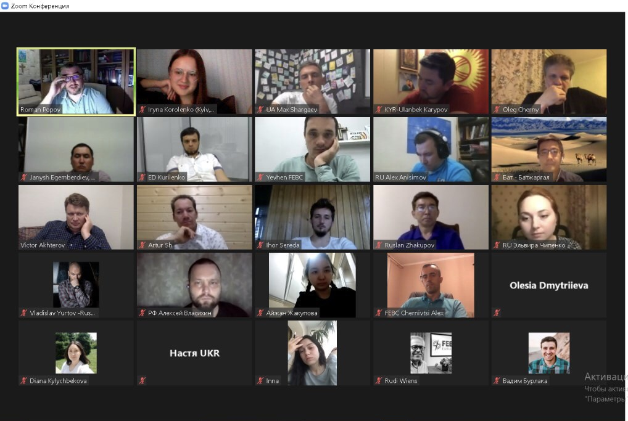
May 30 – Sunday
“Your program gives practical advice on how to live and survive after prison, how to improve and radically change our lives with the help of spiritual principles and by trusting God. Thank you for supporting us and our loved ones in difficult times.” Please pray for listeners who are being helped by our program dedicated to prisoners and their families. Listeners like Alexander, who spent 18 years in prison.

May 31 – Monday
Please pray for the Lord to send more people to help with the counseling center in Ukraine. The volume of calls has been overwhelming, and we have been seeking to add more counselors. We are currently in the process of training new volunteers.

