Russia and Ukraine Prayer Focus – April 2021

Thursday – 1
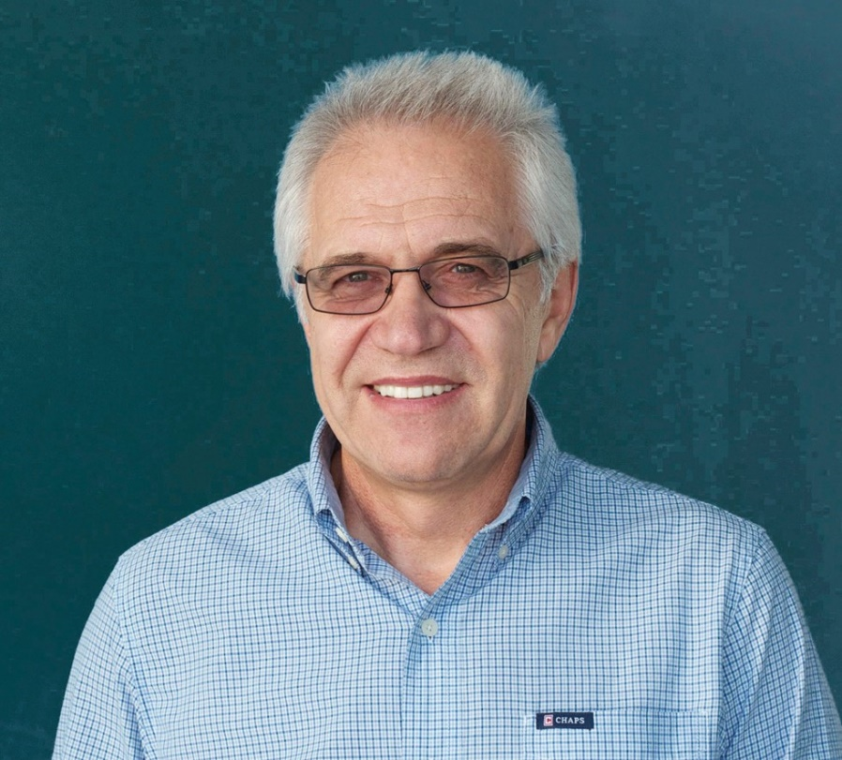
Please keep Rudi Wiens and his family in your prayers after the passing of his wife, Anni. Rudi is the FEBC Coordinator for Central Asia, Kyrgyzstan and Kazakhstan.

Friday – 2
Please pray for the Easter programs being prepared in Russia and Ukraine. Each program is approaching Holy Week and Easter in their own unique ways.

Saturday – 3
Nadezhda writes, “I have been taking care of my daughter’s children for the last six years. My youngest grandson has stopped going to church now and I am worried about him.” Grandparents are often taking care of children whose parents have died, are travelling for work, or are addicted to various substances. Please pray for the many grandparents who are raising their grandchildren in Russia and Ukraine.

Sunday – 4
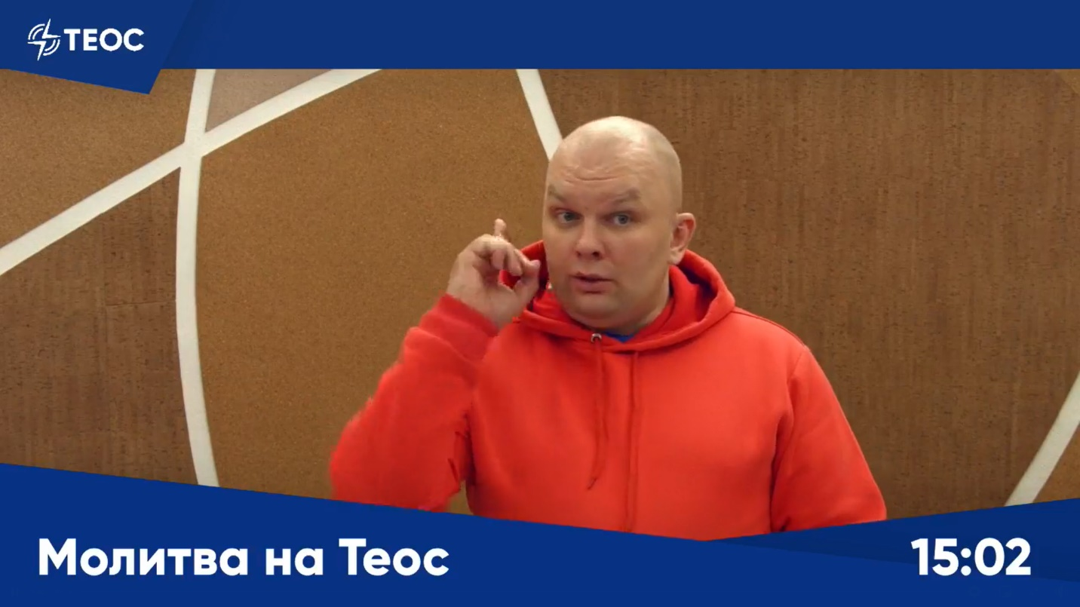
Please pray for the many listeners who reach out for live prayer every week in Russia. FEBC host Vlad prays with listeners live on the air and listeners can submit their prayer requests anonymously as well.

Monday – 5
Please pray for listeners who do not know Jesus. Ivan had a stroke, and he was confined to a bed, unable to get up. He called FEBC to pray for his condition, but it became clear that he was unsure of his salvation. Counselors shared the Gospel with Ivan and he gave himself to Jesus.

Tuesday – 6
Please pray for the women of FEBC Russia and Ukraine. FEBC held a conference for women in ministry in March where women in broadcasting encouraged and built up one another in the Lord.

Wednesday – 7
Please pray for Victor Akhterov, the director of FEBC Russia and Ukraine. Pray for wisdom and favor, and God’s protection for his family.

Thursday – 8
Larisa is a disabled woman who was connected with a church through FEBC and her life began to turn around. “Believers began to visit me, and my son started going to church with them. He loves it and wants to go all the time now! I’m so thankful that he is on the road to salvation!” Please pray for listeners who are being connected with local churches for follow-up work and evangelism.

Friday – 9
Please pray for listeners in desperate situations that are finding living relationships with God. Vitaly was going through a truly difficult time. He had only recently lost his parents and his brother, when his wife cheated on him and they divorced. Then the quarantine began. He could no longer escape through work or by lighting candles in church. All that Vitaly had was a prayer book with FEBC’s phone number in it. When Vitaly finally called the number, he was told how he could have a relationship with Jesus. With tears, Vitaly asked Jesus Christ to fill his soul with His love. Vitaly was eager to be connected to a church and find his new family.

Saturday – 10
Nadezhda had fallen into sin and alcoholism, and called FEBC’s prayer helpline several times. “When you pray, it becomes easier for me.” Nadezhda was afraid to return to church and she felt like she was in bondage. During her most recent call, Nadezhda felt like she was fighting a spiritual battle as she was being prayed for. After the prayer, she felt calm, “I started remembering the times when I used to go to church and how good it was when I was walking with the Lord.” Please pray for listeners like Nadezhda to return to the Lord.

Sunday – 11
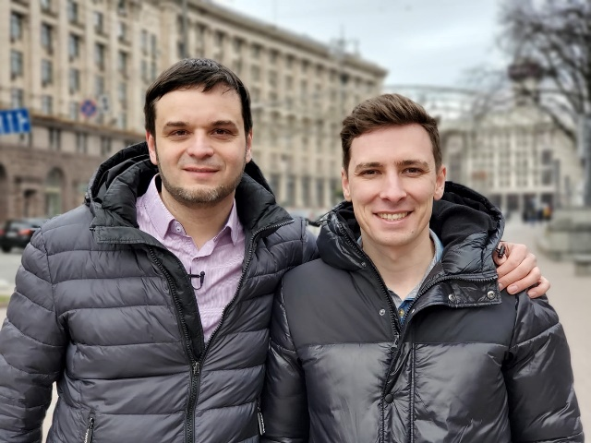
Please pray for Eduard, Maxim, and the rest of the FEBC Ukraine leadership team in this time of transition for the ministry.
Monday – 12
Please pray for listeners who have been impacted by the military conflict. One listener, Nikolai, spoke with counselors for 50 minutes. He had been a company commander in the military and had lost three of his friends. He was being tormented by guilt and thoughts of suicide, despite being a believer. Counselors helped him deal with his harmful thoughts and put his hope in God. “Thank you for being there for me. You have an important ministry.”

Tuesday – 13
“My daughter left the Lord and lived apart from God for 21 years,” writes one man. “I called you and asked for prayer, and now my daughter has returned to the church and we are serving God together!” Please pray for listeners whose families are not walking with God.

Wednesday – 14
Please pray for listeners like Nikolai, who are in prison. Nikolai is in prison for a theft he may have committed while drunk. He heard about Jesus in prison and accepted Him as Lord and Savior. Please pray that God helps Nikolai to get free from his troubles and start a new life.

Thursday – 15
Please pray for the supporting and technical staff in FEBC Russia. The support staff helps keep the broadcasting running smoothly, often while hosting their own shows part-time as well. And the technical staff is always learning and growing to keep up with fast-paced changes in technology and new online platforms.

Friday – 16
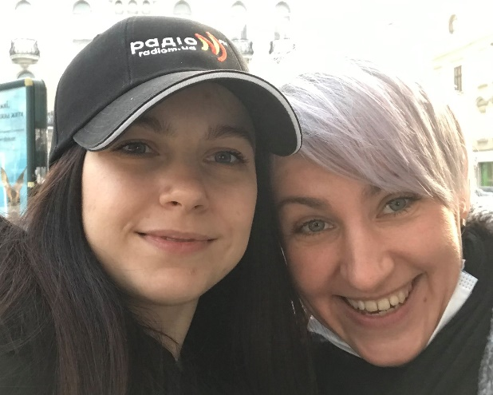
Please pray for listeners like Polina, who know about God, but have not followed Him yet. “I considered myself spiritual but not religious. I used to flirt with things like yoga,” said Polina, “even though I knew that the God of the Bible was real. When I started listening to your programs, I found myself being challenged, but I still felt drawn to listen.” Polina later met with an FEBC Ukraine host, and talked about God. Afterwards Polina wrote, “I experienced God. I saw a light in the host’s eyes, and I know that this can only come from the Lord.”

Saturday – 17
Please pray for efforts to reach new listeners on a new social media platform, Clubhouse. Anton found FEBC on Clubhouse. “I only recently started going to church, and I was so excited to find a radio station that can help me learn and grow in God!”

Sunday – 18
Please pray for listeners like Natalia who are struggling with depression. “At first, I had strong panic attacks, which quickly moved into depression. When I got sick, I started dealing with a fear of death, which actually turned into intrusive thoughts of suicide. But you came to me in this incredibly dark period of my life, and now it is all over. I’m alive and I’m happy! Thank you so much! I didn’t believe in God then, but now I believe!”

Monday – 19
Please pray for listeners like Anatoly who want to find a church they can attend. Anatoly contacted FEBC and said, “I want to go to a service, but I don’t know where to find one.” FEBC counselors connected him with several local churches and offered to talk with him about his experience there. One of the goals of FEBC Russia and Ukraine is to connect listeners with local believers after preaching the Gospel to them, so that they can grow in their faith.

Tuesday – 20
Please pray for the children’s programs that are sharing the Gospel with children in a way that they can understand. Many children are coming to know Jesus as their Savior and God as their Father.

Wednesday – 21
Please pray for listener fan clubs, created by partnership between FEBC Ukraine broadcasters and local churches and believers. FEBC listeners gather to listen to and discuss FEBC programs. These groups help listeners connect to local churches and are a great tool for evangelism, since at least half of the members of the fan club tend to be non-Christians.

Thursday – 22
Please pray for the partnership in evangelizing between churches, small groups, and FEBC broadcasters. One group organized a seminar about personal development and invited a broadcaster from FEBC to come and speak, drawing new people to the group.
Friday – 23
Please pray for listeners like Boris, who do not know the Gospel but think that they are right with God. Boris thought that by watching Christian television and praying, he was saved. FEBC counselors shared about faith in God and salvation through faith in Jesus Christ and Boris believed in Jesus and was connected with a local pastor.

Saturday – 24
Please pray for the technical staff of FEBC Ukraine, which is expanding quickly and moving into new areas, managing both on air and online broadcasts to multiple social network sites simultaneously. New techniques and formats, such as short videos, are also being tested to reach as many people as possible on different platforms.

Sunday – 25
Please pray for Oleg, Alexey, and rest of the leadership team of FEBC Russia as the religious liberty situation in Russia gets more difficult.
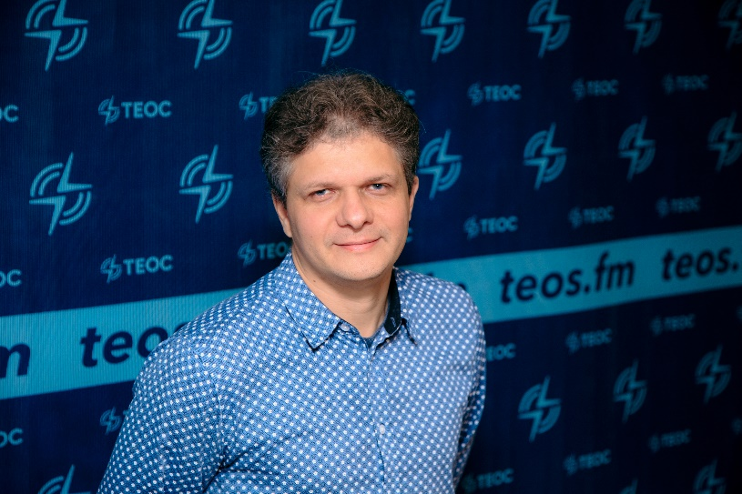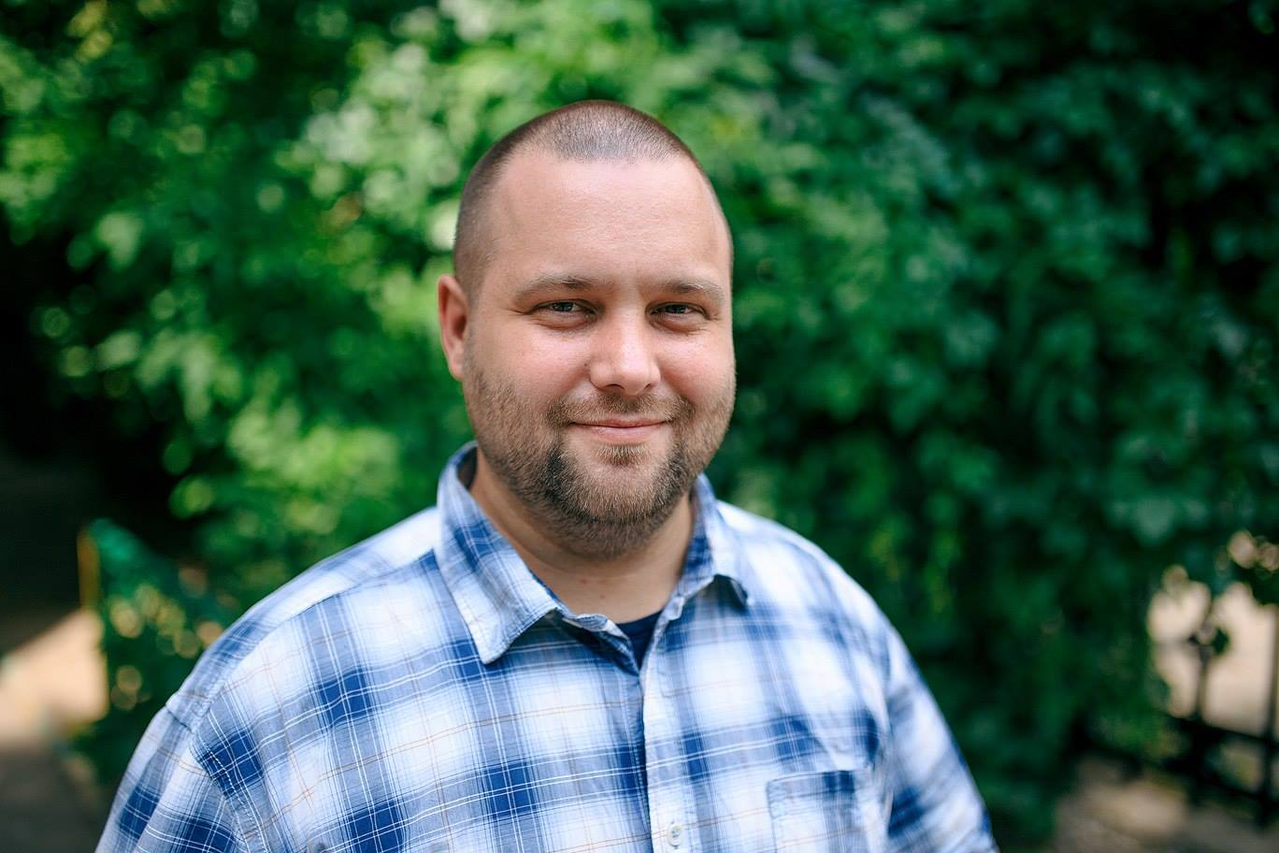

Monday – 26
Please pray from Evgeny, a popular broadcaster in FEBC Russia. He recently went through a surgery and used the experience to broadcast and show people how a believer handles difficulties. His set a new record with a live broadcast that had over a million viewers.

Tuesday – 27
Please pray for listeners like Victoria who are finding community through FEBC radio. “I had no real friends before I started watching you every morning. But then I got to know the hosts of the show and other listeners online and became friends with them.” Victoria is now volunteering for FEBC Ukraine.

Wednesday – 28
Please pray for FEBC Russia presenter Igor’s daughter. She has autism and recently needed a dental surgery for which she was put under anesthesia. The surgery went well and they were able to fund the surgery with some help. Please pray for quick healing for Igor’s daughter and good health for his family.

Thursday – 29
Please pray for the counseling teams in Russia and Ukraine. Our increased focus on follow-up work has produced a great harvest of salvations. Many more people are coming to know God and are being connected to local believers.

Friday – 30
Please pray for listeners who are growing in their walks with God. One such listener, Danilo, just started attending church again and contacted broadcasters to talk. He visited them at the studio and spoke with them for over an hour. “Thank you for strengthening me in my faith. This meeting was very important for me.” Danilo is now regularly attending church services and a small group.

