September Prayer Focus – Russia & Ukraine

Tuesday – 1
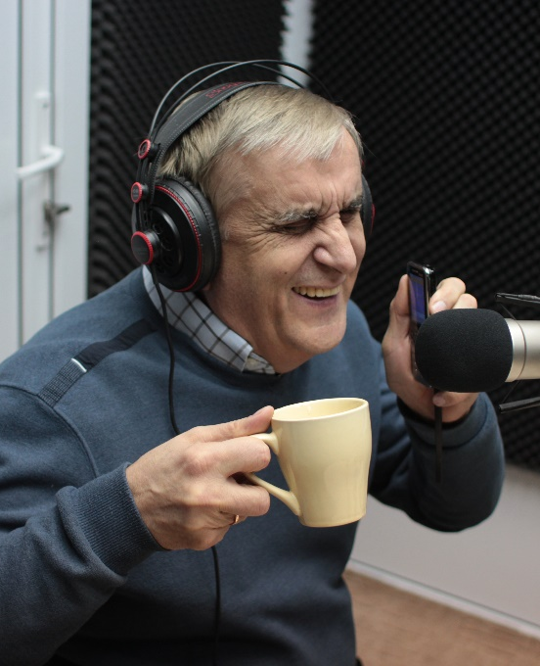
Please pray for the family of Viktor Kurylenko, one of the founding members of FEBC’s ministry in Ukraine. He recently went to be with the Lord, shortly before his 68th birthday, after contracting COVID-19.

Wednesday – 2
“My love for God is getting stronger and stronger, because every day your program reveals a new side of Him to me. I promise to share my love with others and live in His way as best I can. I want to win as many as people as possible into Christ’s new life, I want to show them His path.” Please pray for Zhanna, who was a fearful believer, but is now one of FEBC’s key volunteers.

Thursday – 3
Please pray for Larisa who recently signed up to be a mentor to orphans. “My husband and I wanted to do something, but we weren’t ready to be foster parents yet. But after we watched your program, we learned that wasn’t the only way we could help! Now we’re going through training so that we can help influence and support some children who really need it. Thank you!”

Friday – 4
“When you prayed with me before, God healed me of a bad cough. I know that God answers prayers! Please pray for my sons, Sergei and Arthur, and for their children, that they turn to the Lord.” Please pray for Valentina and that her whole family comes to the Lord.

Saturday – 5
“When you prayed with me, I felt God’s presence so strongly. He even spoke to my heart.” Tatiana’s son has Down syndrome and recently had a stroke, and now he is in a very bad state. Please pray with Tatiana and keep all those looking after the sick and disabled in your prayers.

Sunday – 6
Please pray for Anastasia as she has learned how to read the Bible. “It used to be so strenuous for me. I was filled with doubt about its truthfulness. On the other hand, it seemed all I could see was myself and my sins. I learned through your program to see Jesus Christ in its pages. There is peace in my heart now, like the wound that was there is healing.”

Monday – 7
Please pray for Eduard Kurylenko, FEBC-Ukraine's incoming director, as he is recovering from a moderate case of COVID-19.
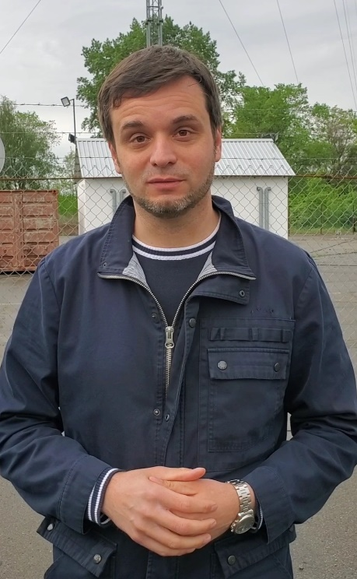

Tuesday – 8
Vitalina was very lonely; two years ago she had lost her legs and now she could not get around, and her family all live too far away to support her. When she was in the hospital recently, she found the number of FEBC’s prayer phone line and called. The counselors prayed with her, and when they offered to pray the prayer of salvation, Vitalina quickly agreed. She was also excited to be connected to a local church minister. Please pray for Vitalina and those who are without support and without Christ. “Thank you so much for praying for me! I really needed it!”

Wednesday – 9
Please pray for Larisa, who is battling fear after the death of her son. “I could not stop thinking that my second son would die as well. The fear was simply paralyzing. At first I could only listen to your program, letting the words wash over me. My soul began to thaw, and I started communicating with you. It took me a long time to begin to trust the Lord again. You understood the Bible in a way I didn’t, and I saw God as He really is. I was finally able to cry, tears of cleansing, like a confession. Thank you!”

Thursday – 10
FEBC-Ukraine's station launch in the city of Kremenchuk is scheduled at the end of September. Pray that the new station will reach thousands of people.

Friday – 11
Please pray for Alexander as he learns to share his faith. “I’ve been in church for over ten years, but I’ve always felt embarrassed to talk about God. I didn’t know how to do it naturally. But I’ve been watching your program for some time now, and I’m inspired by the ease with which you talk about your values and Christian experience while talking with viewers. I think I’m starting to get it right.”

Saturday – 12
“My mother has been an alcoholic for over 25 years. She’s been in and out of prison, and though she stopped drinking for a time while she attended church, she soon went back to drinking. She is so addicted that she will often have alcohol in her house but won’t even have bread.” Please pray for Natalya and her mother Tatiana, that Jesus comes into her life and free her from her addiction.

Sunday – 13
Please pray for the leadership team of FEBC Russia: Victor, Oleg, and Alexey. Also please pray that God would protect and bless their families.

Monday – 14
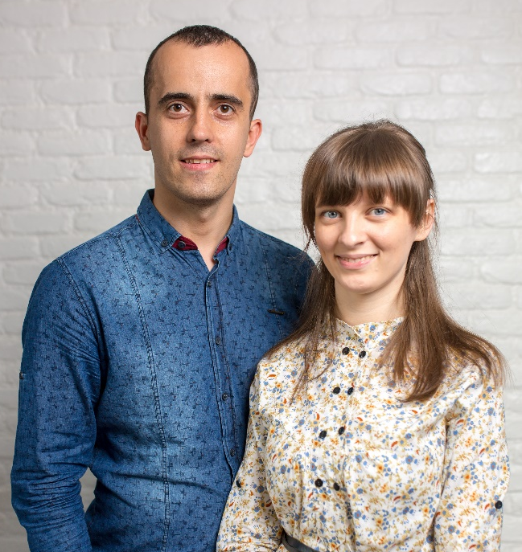
Please pray for FEBC broadcasters and counselors Alex and Nadia Pastushak, a husband-and-wife team in Chernivtsy, Western Ukraine. They minister to dozens of individual listeners every week, leading many to Christ. Also, they are expecting their second child.

Tuesday – 15
Boris and Kathy called the prayer line with a lot of questions about God, ‘How did He create the earth?’ and ‘Can He help you deal with mean classmates?’ Over the course of the call, both Boris and Kathy became ‘friends’ with Jesus and called the prayer line back to talk about what Jesus had done in their lives. Please pray for the children who are coming to know Jesus as Savior and Friend.

Wednesday – 16
Please pray for Natalia, FEBC-Ukraine's phone counselor/evangelist who is hospitalized with COVID-19. Natalia is the widow of Viktor Bradarsky, the FEBC volunteer broadcaster who died for his faith in 2014.

Thursday – 17
Please pray for Valeria, who has been suffering from depression for the last 20 years. She had looked everywhere for help, antidepressants, astrology, psychologists, and psychics. Nothing helped. She has recently repented and turned to the Lord. Please pray for all those like Valeria, who are desperately seeking relief in the world. May they turn to the only one who can actually help, Jesus.

Friday – 18
“It feels like God isn’t listening. Like He can’t hear me.” During a consultation and prayer, Olga understood that it was her own inability to forgive herself that made God feel distant. As she was told about the forgiveness and love of God, Olga found peace and freedom from her guilt. Please pray for those like Olga who feel that God is angry and distant, that they may understand his love and forgiveness.

Saturday – 19
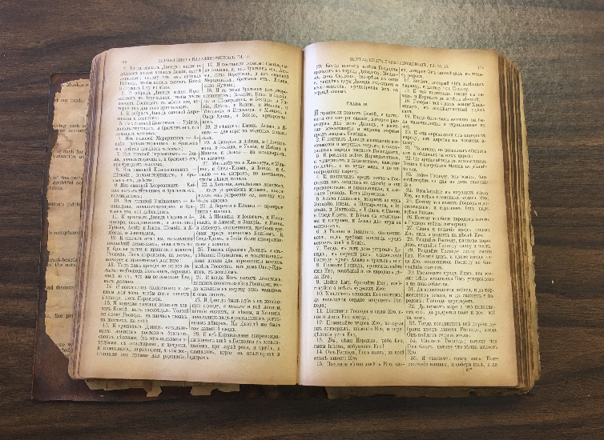
Please pray for the FEBC volunteers and hosts who have started several groups studying Christian books with listeners, introducing them to the faith and teaching them how to live the Christian life.

Sunday – 20
Vladimir called to pray for healing. He had been affected by the Chernobyl accident and had many sicknesses. Vladimir hadn’t known anything about God, and during his discussion with the prayer counselor, Vladimir believed on Jesus. Please pray for Vladimir as he begins his life as a believer and pray that God heals his body of all disease.

Monday – 21
“My whole family got sick with COVID-19. My son, my granddaughter, and I are all very sick. Please pray for God’s healing and protection.” Please pray for Vera and her family as they recover from this illness.

Tuesday – 22
Please pray for the leadership team of FEBC Ukraine: Victor, Eduard, Maxim, Sergey, and Igor. Also please pray that God would protect and bless their families.

Wednesday – 23
“Please pray for my grandson’s wife. She is pregnant, but there is something wrong with her blood count.” After being prayed with, Maria was thankful and knew that God would answer her prayer. “I called you two years ago with a prayer request for my granddaughter who had a blood disease and the Lord healed her, thank God!” Please pray for Maria’s family’s health and praise God that He continues to answer his people’s prayers!

Thursday – 24
“Well, how will you help me?” That was the way Vasily started the call with our counselor. Vasily had been to rehab 7 times to deal with his alcoholism, and had come to church and been baptized, but still he had no freedom. After the consultation and prayer, Vasily realized that he had never truly turned to Jesus. He prayed the prayer of salvation with joy. “I can see now the love and mercy God has for me. I am not an alcoholic, I am a precious son of God!” Please pray for Vasily leans to live out his newfound faith and relationship with God.

Friday – 25
Please pray for Tatiana, who was being eaten up by bitterness and unforgiveness. “It’s like I was choking on it. Once I was able to let go, new thoughts started to appear. I suddenly wanted to do something around the house, I had the energy for the first time in a long time.” Please pray for those having difficulty forgiving others and letting God heal their wounds and give them peace.

Saturday – 26
Please pray for FEBC’s trained counselors as they encourage listeners and inspire them to follow Jesus. Working through social media and over the phone, they help listeners navigate life’s problems, come to know Jesus, and get connected to other believers in their area.

Sunday – 27
Please pray for Sergey, whose brother has been out of communication for a week. “I’m worried. I just want him to come home. I want to know that he’s okay.” These types of requests are not uncommon with the combined turbulence of the war and COVID. Please pray for peace and security for the nation of Ukraine.

Monday – 28
Please pray for Vitaly, who preaches to the military in the war zone in Ukraine and works with young people in the area who are not fighting. “Please support me in prayer as I serve these people, so that the Lord guides me and gives me wisdom and a word for everyone I meet.”

Tuesday – 29
“Hello, dear friends. I want to thank you for your work. You have infected me with a love for reading and studying the scriptures. To me they became not only inspired, but fascinating. Thank you so much! Israel is with you!” Please pray for Yakov and the many other listeners who are experiencing a consistently deep reading and studying of the Word of God and are seeing their lives begin to change.

Wednesday – 30
Several women called FEBC counselors after a broadcast about domestic violence. They received support, connections to other trained counselors, authorities, and crisis centers. Please pray for those women who are suffering this abuse, with even fewer outlets because of COVID. Please pray for protection and for the courage to seek help.

