Saturday – 1
“I live in a small city in Russia named Kingisepp. There aren’t many believers here to speak to and the openness and sincerity of your programs make me feel like I’m not alone. God supports me through your broadcasts and my faith is growing!” Please pray for listeners who are without Christian community and support as they grow in their faith. In some areas, ministers come just once a month, believers gathering to read the Bible and pray without any Bible teachers.

Sunday – 2
“Your broadcasts have changed my whole outlook on life. People have noticed the change, at work and at home—my family is very happy! When I was afraid the changes would not last, you prayed for me, and you taught me how to pray too, from the heart. Thank you!” Please pray for Valentina from Novosibirsk, Russia as she takes her first steps towards faith in Jesus.

Monday – 3
Anna from Ukraine called with a prayer request: “I just found out that I have breast cancer, but I do not have the money for the treatment. Please pray that the Lord heals me of this cancer.” Please pray with us for Anna’s healing.

Tuesday – 4
“I was planning to commit suicide. I am 25 years old,” wrote Igor from Nizhny Novgorod, Russia. “As I was watching your broadcast, for the first time in a long time something caught my interest. I don’t know what it was, but I kept watching. When I wrote to you about how I felt, you responded. You kept me from taking my life. I watched your broadcasts for a whole week—I started to feel a lot better! I even found a job unexpectedly!” Please pray for listeners like Igor who are hopeless and directionless and are finding hope in God through our broadcasts.

Wednesday – 5
Please keep Seville, an ambulance driver in Moscow, in your prayers: “It’s hard not to take the pain of my patients to heart and bring it home with me. Please pray for the sick, many of them sick with the coronavirus, and for me.” Please pray for the medical workers that are putting their own lives on the line to help others.

Thursday – 6
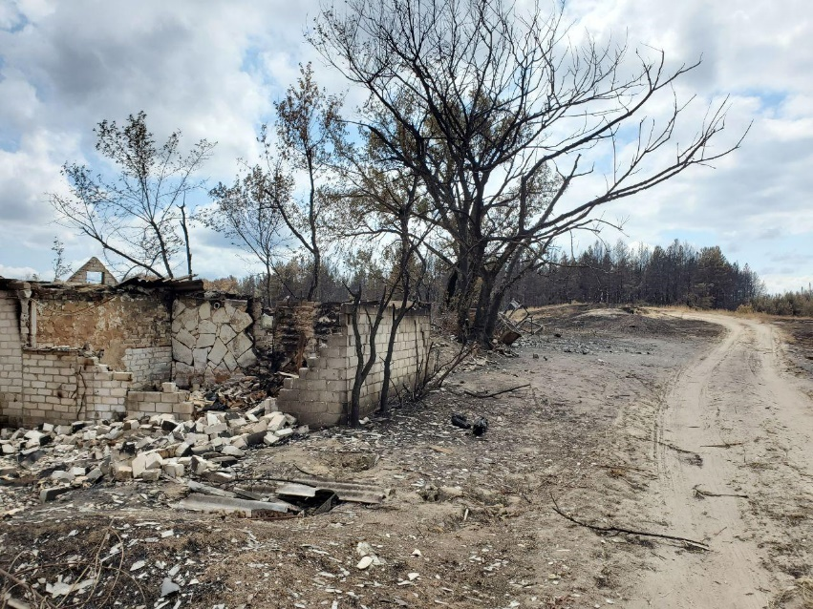
Please pray for the victims of a forest fire in the Luhansk region of Ukraine, near the front lines of the fighting in the east. Five people were confirmed dead and 34 people – including 15 children – were hospitalized. The fire damaged and destroyed nearly 140 homes and 24 buildings.

Friday – 7
“My life has been spinning out of control. I didn’t understand what was happening or why. Why was this happening to me now? My life seemed to have no meaning. But through your broadcasts, I began to realize that life was really about the soul. And the only way for your soul to be saved is through turning to Jesus and believing in Him. I have been thinking about this and I think this is where I will find true meaning.” Please pray for listeners like Inna from Russia, who are searching for the purpose of their lives. May they find it in Jesus.

Saturday – 8
“When my mother died recently, I sought help from a psychologist, but no one would help me because I don’t have any money. I turned to your programs, and when the host said that he would help me, a weight was lifted; I was no longer alone. I even went to church and prayed for you, though I’ve never been to church before. Thank you so much!” Please pray for Nadia from Irkutsk, Russia and other listeners who need support and prayer from trained Christian counselors.

Sunday – 9
Please pray for Alexey Vlasihin, the program director for FEBC-Russia, as he is recovering from surgery. Pray for a quick and complete healing.

Monday – 10
Anya is a young girl who gave her life to Jesus after calling our prayer line in Ukraine. She has been reading her Bible and has learned many Bible stories, but she particularly loves calling the prayer line so that the counselors can tell her more about God. Please pray for Anya and others like her who are hungry to know more about God.

Tuesday – 11
“Please pray with me for the salvation of my youngest son. Please pray that he returns to his family.” This is a common prayer request. Please pray with us for the salvation of the families and children Christian converts in Russia and Ukraine. Several FEBC programs are dedicated to living a healthy and godly family life. May entire families be saved and reunited in Christ.

Wednesday – 12
“I was disillusioned with Christianity. I told the host of the program that he could have my Christian books. He talked to me and convinced me to study the Bible together. Actually, most of the time we just talked about God. Now I’m growing like never before, but I know it’s not enough. I have to get back into church.” Please pray for Alexey from Russia as he is built up in his faith, and for other new believers who are growing in Christ.

Thursday – 13
Please pray for Vera, a disabled woman who is eager to attend church. She called the prayer line in Ukraine and asked if they could help and they are searching for a church in her area that can help bring her to church.

Friday – 14
“I’d never thought about God before, but I’ve been thinking about going to church and have even prayed,” wrote Elena from Samara, Russia. “I was in a depression even before the quarantine started, and afterwards it grew even worse. Until I found your broadcasts. Now I recommend them to all of my friends and family.” Please pray for Elena and others who are being introduced to God as their lives have been affected by the pandemic.

Saturday – 15
“Please pray that I would have humility.” Alexander is attending a boarding school for children with mental illnesses and called to ask for support. “And pray for wisdom, humility, and the ability to tell people about Jesus. Thank you!” Please pray for Alexander and others who are dealing with various disabilities.

Sunday – 16
“Please pray for me. I left home because my father would bring his friends home and they would get drunk. Now I am on my own and my family no longer speaks to me. I feel all alone.” Please pray for Vladimir from Ukraine and others who are affected by the alcohol dependence of loved ones, especially children whose parents drink heavily.

Monday – 17
“I have a large, young family, and your broadcasts are a real support. They fill our family with peace and good teaching. Thank you on behalf of my whole family!” Please pray for families like Ksenia’s, as they are being built up into strong, Christian families.

Tuesday – 18
“Please pray for me as I am looking for work and that I would know God’s will for my job.” There are many who are struggling with finances and joblessness across Russia and Ukraine. Please pray for wisdom and favor for Vasily from Ukraine and that God helps all those who are having difficulty supporting themselves and their families.

Wednesday – 19
“The way you talked about the Christian ideas in literature has made me want to know more about the Gospel. I am studying art in school and I’ve been in contact with several Christians, so I had some thoughts about God, and you answered several of my questions during your program. You talked about faith and Christ so clearly, it made me want to read the Bible after your show.” Please pray for Ksenia from Korolyov, Russia as she is being introduced to the Gospel. May God surround her with more believers who can help lead her to Him.

Thursday – 20
“I have cerebral palsy and have really appreciated your programs, having been locked in my home during the quarantine, on top of already being confined to a wheelchair. I love to read, but I don’t always have someone to talk to about the books I am reading, but on your programs I get to hear others who also see literature through a Christian perspective. I experience real happiness while listening to your programs, I realize that I am not alone. I even forget about my disability for a time; it’s like I come to life! Thank you for that!” Please pray for Alexander from Zelenograd, Russia, and others with disabilities who have been particularly affected by the quarantine and find themselves even more isolated than usual.

Friday – 21
“I see so much of myself in the story you told,” Alla wrote to the host of a program. “I don’t always feel God’s presence, I get angry and annoyed with people—but when I turn to the Gospel, everything changes. Thank you so much! Now I can see that I need to live in the Gospel and share it with others instead of living in negativity.” Please pray for Alla from Moscow, Russia. Pray for revival among believers in Russia and that the Gospel is proclaimed in every corner.

Saturday – 22
“Thank you for your example! I have been dealing with a lot of anxiety in my family, and the openness with which you talked about your own experience, and being able to hear from your wife as well, gave me hope that my situation could change too.” Please pray for Larisa from Kemerovo, Russia and other families who are struggling with increased anxiety in these anxious times.

Sunday – 23
A listener named Victoria wrote to ask to meet Inna Tsaruk, a host at FEBC Ukraine. They did meet and Inna was able to tell Victoria the Gospel and her own testimony. Victoria was in tears and prayed with Inna. They agreed that they would study the Bible together. Please pray that Victoria accepts Jesus as her Lord and Savior and starts attending a church.

Monday – 24
Alexander from the Chelyabinsk region in Russia wrote: “I thought Christians were hypocrites, so when I heard the host of your program start talking about God and the church, I couldn’t help myself and I got into an argument. I stopped watching the show for a time, but I couldn’t get it off my mind. When I finally returned, the host and all the listeners were so kind and welcoming that all my anger evaporated. I can no longer think of Christians as the mean, narrow-minded people I thought they were.” Please pray for our hosts, counselors, and listeners as they reach out to nonbelieving listeners with love and acceptance. May their love draw listeners to God’s grace.

Tuesday – 25
“I recently completed rehab at the age of 36—I was addicted to drugs from the age of 9,” said Edward, from Russia, who was having trouble adjusting to life. He contacted an FEBC counselor, Kristina. “She helped me work through my issues and make a plan for the future. And she told me her own story of being an addict before coming to Jesus.” Please pray for Edward, who has since become a Christian, and the growing number of people in Russia dealing with drug addictions. May they find freedom in Christ like Edward has!

Wednesday – 26
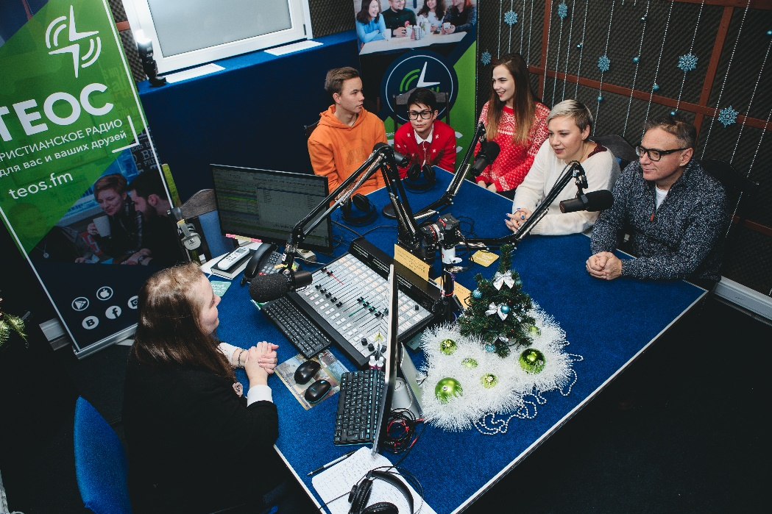
“Thank you so much for your program on adoption! We were in the process of looking for a child to take in when the coronavirus pandemic happened, and we were told it was no longer possible. We felt lost and didn’t know what to do. You answered some of our questions on the air and helped us decide what to do. Because of your program we knew we could ask for an exception to be made, and they agreed! We have already picked up our new baby!” Please pray for those who are taking in children, even in the midst of challenging times.

Thursday – 27
Please pray for the Russian church to grow as evangelists. “I was so inspired as I watched your program. I’m tired of hearing people say one thing and seeing them do another in the church. The examples of the guests on your program inspired me to stop judging others and instead get involved somewhere that I can help. Thank you for reminding me of the importance of living the Gospel, not just speaking it.”

Friday – 28
“I believed in God, like many other people, but after I started watching your broadcasts, I have been turning to God directly in prayer. God has helped me and my family greatly through your programs. Even though some of my family are Muslims, when I pray with them to Jesus, they don’t mind because, as they say, ‘we want you to pray to the God that Eugene believes in.’” Please pray for the hosts of FEBC Russia as they do extra programming for during the pandemic, some of which are dedicated to reaching Muslims, the second biggest religion in Russia.

Saturday – 29
Ludmila from Ukraine called the prayer line to talk about her marriage. She told the counselor that she had visited an Orthodox church for the first time and had prayed to several saints but didn’t feel satisfied. When the counselor told her about salvation, eternal life, and said that she could be reconciled to God, Ludmila eagerly agreed! She prayed to accept Jesus right there and called back later to say that she had found a Bible in her house and had already started reading it and looking for a church in her neighborhood. Please pray for people who are finding a true relationship with God is the only thing that can satisfy their needs!

Sunday – 30
“I didn’t think it was possible that God would ever forgive me. I didn’t think I could ever confess my sins to a person. But after you talked with me I reached out to a minister and he told me about the forgiveness of Christ. I haven’t cried since childhood. I knew that God would actually forgive me.” Please pray for people like Pavel from Ryazan, Russia who are being introduced to the Good News.

Monday – 31
“I’ve come to know God through your ministry. In my worst moments and in my crises, your consultants are always there to comfort and support me.” Please pray for FEBC Russia’s and Ukraine’s consultants, many of whom are volunteers, and who give of themselves online, over the phone, and in person to reach people for Christ, and give them support and hope for the future.
