June Prayer Focus
Monday – 1
“I have to tell you what happened! I was listening to your program the other day when my Uncle Vasya walked in. Usually he has no time to hear about Jesus, but this time something caught his attention, and he asked me to turn the volume up. After the program, I was able to talk with him about Jesus for the first time.
“After listening to me, he responded, ‘I have been chasing life for all of my 67 years and I’ve never caught up. I had money, but I didn’t have happiness. I lost the money and started to work for a living, but simple human happiness eluded me. My life has been a non-stop race with no finish line.’
“Could it be God that you’ve been running from? I asked him. ‘Now I have something to think about,’ was his response.”
- Kiril from Ukraine
Please pray that God will open the hearts of listeners and their friends.

Tuesday – 2
Please pray for Nina, FEBC-Ukraine's coordinator of the helpline. Pray for wisdom, and her efforts to build a wider network.

Wednesday – 3
Please pray for FEBC listeners who are experiencing extreme psychological pressure because of joblessness and isolation. Pray that many will use this time to find true peace in Jesus Christ.

Thursday – 4
Elena and her husband Andrei started volunteering in an orphanage mentoring program, visiting and spending time with two teenage girls. They began considering adoption, but the girls were hesitant. After talking with Tatyana, the host of a program on adoption, they began to understand that the girls felt abandoned by their parents and that it would take time to trust someone new. We advised them to consider fostering them. This would not necessarily be permanent and would give everyone time to see if they wanted to proceed. Once they got to know each other and saw what family life could be like, everyone felt much more comfortable and they decided to move forward with an adoption.
“We could have spent our whole lives as volunteers, too afraid to take the next step. Your advice, your attitude and your prayers really did wonders. We’re parents now thanks to you!”
Please keep orphans in Russia and the parents who adopt and foster them in your prayers, as well as the hosts who encourage people to get involved and provide support and resources to those who are fostering and adopting.
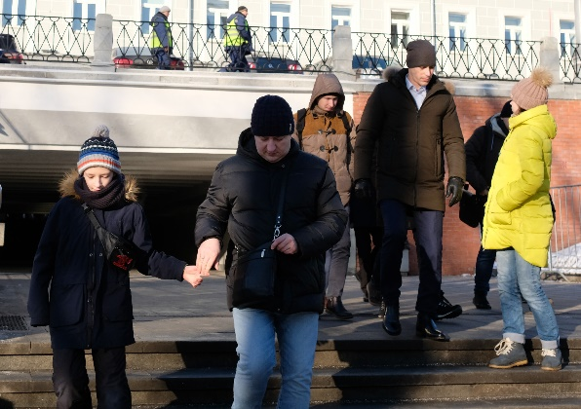

Friday – 5
Host Igor posted a TikTok video about God and quickly received more than 100,000 views. Young people were turning to Igor with questions about faith and their own personal experiences with God. Alexander, who is 16 years old, wrote that this video helped him accept the idea that God actually exists. He also made the decision that he won’t drink just because his friends do. Please pray for Alexander and other young people like him who are making decisions that will affect the rest of their lives.

Saturday – 6
FEBC's partners distribute our programs to a group of widows who lost their husbands during the war in Eastern Ukraine. They fought on different sides of the conflict. Please pray for these women and thousands of others like them who are listening to our programs on air.

Sunday – 7
“I lost my job when the coronavirus crisis started and my financial situation got so bad that I started having panic attacks. I was sitting at home, watching videos online with nothing else to do, when I stumbled on your programs. I wrote that I was feeling depressed and the presenter read my comment on air and asked the audience to support me. Several people sent me private messages with simple words of encouragement! Now I am learning to look at my future with faith. Thank you!”
- Natalia from Ufa, Russia
Please pray for people who have lost jobs during this quarantine and who are losing hope for their futures. May they come to see that God is their provider and that His plans for them are good.

Monday – 8
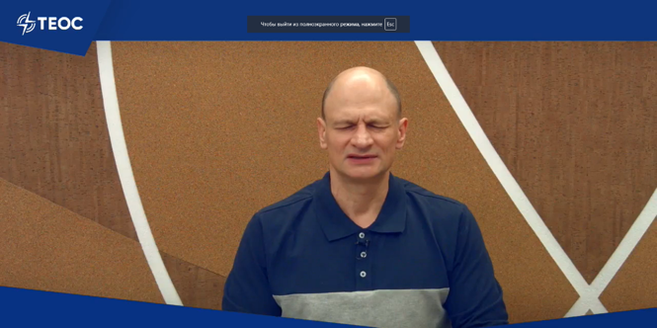
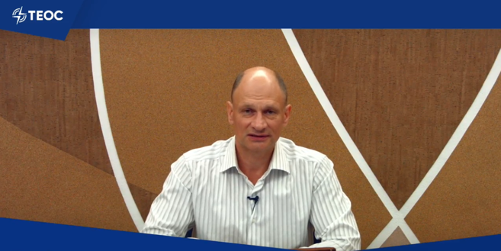
Please pray for our host in Ukraine, Mikhail, who, along with his wife, has recently recovered from the coronavirus. Praise God for his recovery with us!
Mikhail praying… … and preaching

Tuesday – 9
“When I first turned on your program, I wanted to turn it off again; more people wanting to tell me about religion and God. But then I heard Valerie talking about her pain when her mother died. I had recently lost someone I loved too. Valerie talked about how she was angry with God, but was able to accept her mother’s death once she realized that God was near; He had never left her.
“Suddenly I was crying. Her words touched me and I listened to your broadcast until the very end. I cried all evening after the broadcast and suddenly felt that God was so close. I don’t even know how to describe it. Thank you for helping me.”
- Anastasia from Livny, Russia
Please pray that those who are experiencing tragedy turn to God with their grief. May they know Him as their comforter.
Wednesday – 10
“I’ve been having trouble coping with my fears, especially with the coronavirus, but your last broadcast really helped me. Some people had accused me of mistrusting God, but there has never been a worldwide epidemic like this, and the church was not immune. I had so many questions for God that I didn’t know how to ask. You answered all my questions! After listening to your broadcast, for the first time in a long while, I felt my free of my fears. Thank you!
- Julia from Crimea
Please pray that people turn to God with their fears and questions. He is a safe place and won’t turn anyone away.

Thursday – 11
Alexander, a listener from Ukraine started listening to FEBC’s programs but clearly did not take them seriously; he was not a Christian and would often leave inappropriate jokes in the comments of videos. After a few months, however, he wrote this to one of our hosts:
“My friend wants to read the Bible. Can you tell me where he should start?”
After talking with him about the love of God and the best place to start reading the Bible, he responded with:
“I want to read the Bible too, not just my friend.” He went on to unburden his conscience for the next ten minutes, saying that the host would not want to speak to him further if he knew everything. Our host responded by telling him, “It doesn’t matter who you were. God knows you and He loves you.”
The next day Alexander wrote: “I was up reading my Bible all night!” Now he never misses a show.
Please pray for our unchurched and non-Christian listeners. May God work in their hearts to draw them to Himself like He did with Alexander.

Friday – 12
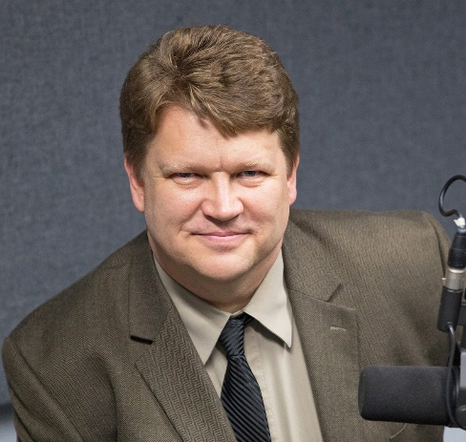
Please pray for Victor Akhterov, FEBC's leader in Russia and Ukraine, as he is leading his team to develop the ministry in the neighboring country of Belarus.

Saturday – 13
“Please pray for my son, Vasily. He was once on fire for God, but he’s no longer following Him. He is using drugs, sleeping around, and is not working. Please pray for us, I don’t know what to do!”
- Luba from Ukraine
With the lack of employment and political instability in Ukraine, many young people are suffering and feeling hopeless. Please pray that they find their solution in God instead of drowning their sorrows in the world.

Sunday – 14
“I called your helpline before and you really helped me; I wanted to tell you how God has answered our prayers! We lived in the war zone in eastern Ukraine in a cramped living space, surrounded by gunfire, and on top of all that, I became pregnant at 43! I called you after hearing about you on the radio and you prayed for me.
“God has turned everything in our lives around. My family moved to Happiness city, far from the fighting—the name of the city is Happiness, can you believe that! My husband was offered a job there and now our lives are calm, no more shooting. I gave birth to a healthy baby and now I am back to work. All glory to God! Thank you so much for your support. Luckily, your signal reaches us in Happiness, so we can continue to listen to the program. Keep up the good work!”
- Olga from Happiness, Ukraine
Praise God for answering our prayers! We have recently opened a new helpline in Ukraine and people have been incredibly responsive. Please pray that God continues to bless this ministry and gives us wisdom as we continue to develop it.
Monday – 15
Three friends called for prayer after hearing about us on the radio. Maryann is 11, Alyona is 9, and Haden is 8. “Please pray for healing for Haden’s mom, she’s in the hospital. And please pray for us and all of our families too!” All three of them prayed in unison with the counselor and thanked her for agreeing with them in prayer.
Please keep children like Haden, whose families are suffering in the pandemic, in your prayers. And praise God for turning their hearts towards Him in their difficulties!

Tuesday – 16
Igor Popov is FEBC-Russia's key broadcaster. His teenage daughter is recovering from a difficult case of double pneumonia. Pray for full restoration.
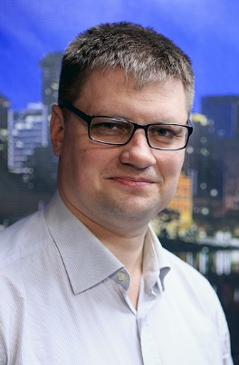

Wednesday – 17
“Thank you so much for your station. Your programs are a spiritual lifeline to me, especially in the pandemic. We don’t have the internet where I live so you are our only resource! Thank you for your service to us.
- Vitaly from Ukraine
FEBC gave away 3,000 radios in Ukraine in 2019, focusing on poor and rural areas where people may not have access to the internet. In some cases, entire neighborhoods are listening to FEBC, not just the families that received the radio. Please pray with us that the Good News is spread to every person in Russia and Ukraine, and across all of Central Asia.

Thursday – 18
Andrei from Mikhailovka, Ukraine continued talking with our host Tatiana after the end of a program and accepted Jesus as his Lord and Savior over the phone. He continued talking with our counselors and shared his past life with them: “I was a drug addict, I spent time in prison; but today, my life began again with God.” Later, his mother called the counselors and started asking them about God, about praying, and about reading the Bible. Please pray for Andrei and his mother and for others like them who are coming to know God.

Friday – 19
Svetlana from Pershotravensk, Ukraine called our helpline with a prayer request. She has had a fever that won’t go away for over a year and is getting desperate as no one has been able to figure out what is wrong with her. She also has severe asthma which makes her especially afraid of contracting COVID-19. After receiving prayer, she asked to be sent a Bible in large print. Please pray for those who are suffering from illnesses, whether related to COVID-19 or not, and pray that God uses their trials to draw them to Himself.

Saturday – 20
Vladimir from Gorlovka, Ukraine called to ask for help with his alcoholism. He’d also been suffering with thoughts of suicide and was worried about his brother, who had gone missing. As he talked with the counselor, Vladimir agreed to meet with a pastor, and the counselor connected him with the pastor of a local church. Please pray for people like Vladimir who are dealing with drug dependence and depression, so that they may find help in God and in other believers.

Sunday – 21
“I was in the war in eastern Ukraine, and since I got back, I can’t stop drinking. How can I stop?”
- Ruslan from Chernivtsi, Ukraine
Please pray for listeners who have served or are currently serving in the military in Ukraine. Many veterans do not receive adequate psychological and spiritual support after serving in the war.

Monday - 22
Please pray for listeners who have been affected by the war in eastern Ukraine. The war has claimed the lives of more than 13,000 Ukrainians. Thankfully our transmitters cover the war-torn area and we receive many calls from there. Please pray that God opens their hearts to His truth and protects them.

Tuesday – 23
Nikolai called our helpline after having a stroke. He had been reassessing his life and wanted to start reading the Bible. The counselor spoke to him about God and sent him a Bible and some additional Christian literature. Please pray that God continues to use all situations to turn people to Himself.

Wednesday – 24
A young girl named Dasha in Ukraine called to say that she liked our children’s programs about God and that she had started reading the Bible. The counselor talked with her about the love of God and what Jesus did for us. That day Dasha “became friends” with Jesus and prayed for the first time in her life. Please pray for the many children who are listening to our programs and are coming to know Jesus through them.

Thursday – 25
“I have no money, there is no work, and I’ve spent all my savings. My children don’t live nearby and they couldn’t help me anyways. I am completely alone. Please pray that I can find work so that I can survive this crisis.”

Friday – 26
Please pray for those who have lost their jobs in today’s crisis. In Ukraine, the state does not provide assistance to people who lost their jobs due to the quarantine, people are left to survive as well as they can.

Saturday – 27
Sergei from Severodonetsk, Ukraine called to ask for prayer: “I was wounded in my hip during the war and I am always in and out of the military hospital. I am also often tormented by fears because of the war and I can’t sleep at night.”
He prayed with the consultant and called back the next day. “For the first time in a long time I was able to fall asleep easily and quickly. Thank you! Please also pray for my newborn granddaughter Arina.” Please pray for Sergei and other veterans as they learn how to live their lives after the war.
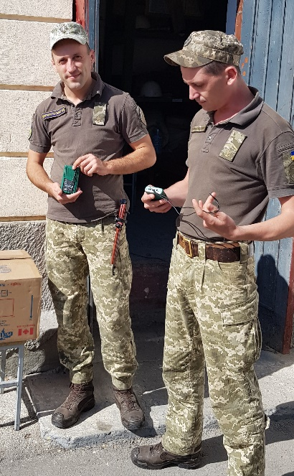

Sunday – 28
Lyudmila used to be a leader in the criminal world in Russia but became a Christian in prison. She wrote to FEBC to thank them for changing her life. “My life was filled with many difficulties, but God used them all to bring me to Him. I want to thank you for your work. Your programs are filled with God’s love and your desire to help people is clear. I can see how your programs give the people who watch and listen hope and answers to their questions.”
Please pray for Lyudmila and other listeners in the prison system as they hear the Good News through our programs and are meeting God at last.

Monday – 29
Olga raises an autistic daughter with her husband in Moscow, Russia. She wrote in to “Nothing Special,” a program about raising children with disabilities. “The quarantine was a real test because of the coronavirus pandemic. My husband is now working from home and I am going stir crazy. I have been living off your family programs, but especially “Nothing Special.” It makes me feel like I am not alone, there are other families like ours out there. This program didn’t only help me emotionally, but it also taught me how to use my energy well with my family. Your advice really works! Thank you!”
Please pray for families who are struggling in the quarantine, especially those with family members who need special attention.

Tuesday – 30
Olga grew up in an Orthodox family in St. Petersburg, Russia, but she had never attended church or read the Bible. She had always considered herself a Christian but now realized that she knew nothing about the faith or the church. So when she decided to do a Bible study with her children to give them a firm foundation to build their lives on, she didn’t know what to do, and began to look for help online. There she found our evangelist, Vlad. He sent her a Bible and some Christian literature and now she’s doing regular Bible studies with her kids. Please pray that God opens the hearts of even those who think they know Him but actually know very little about the faith, like Olga and many other Orthodox believers.

