Sunday – 1
Please pray for us as we look for a new building that will serve as our Media Evangelism Center in Kiev. We are asking for God’s guidance us as we look for this new building. This is a key moment for the entire ministry in Ukraine.

Monday – 2
Please pray for Oleg Cherny’s father, Victor, who has been in poor health. In the past three years he has dealt with two life threatening diseases. He is stable now and continues to serve God in his local church and remains his son’s biggest supporter.

Tuesday – 3
“I was raised by my grandmother and by my school. I never had a real family. And I still feel like a street kid at 24. I am afraid of starting my own family; scared of having children. Will I be a good mother? I always thought you learned how to be a mother from experience, from your own mother. I didn’t have a mother to learn from.”
- Nina from Tomsk, Russia
Please pray for Nina and all those like her who grew up without families in Russia. Pray that she comes to see God as her father and the church as her family.

Wednesday – 4
Please pray for FEBC-Eurasia coordinator Rudi Wiens as he’s working on building a stronger team in Kazakhstan. Pray that God will send new people to bring Christ to the people of this Muslim country.

Thursday – 5
“I am physically fine, but I feel spiritually exhausted. I want to move forward in my life, in my job, but I don’t seem to have the strength.”
Please pray for this listener from Severodonetsk, Ukraine, and the many others feeling worn out by the difficult situation in Ukraine. May God revive their spirit and give them the strength and hope to move forward, relying on Him.

Friday – 6
At a recent conference our staff attended in Russia a man approached us and told us this story.
“I am from Ussuriysk, in the far east of Russia. I started listening to your radio station when I was 8 years old. I lost you guys when they no longer allowed you to broadcast on FM radio, but I found you again later on the internet. I’ve been listening to you ever since. My favorite program is Thru the Bible. This program has helped me develop a habit of daily bible reading and meditating on God’s word.”
Please pray that God would reveal himself to our listeners through his word.

Saturday – 7
Please pray for Victor Akhterov, as he’s leading the ministry in Russia, Ukraine, Moldova, and Belarus. Pray for strength and wisdom; also please pray for Victor’s wife Oksana and their two sons.

Sunday – 8
A chaplain serving in eastern Ukraine, in the conflict, wrote that he was worried. “I feel empty. I put everything aside to help somebody, but I’m left with a heaviness on my soul. I’ve helped pull people from the brink of despair, only to have them treat me as an enemy. It’s a burden.” After speaking to a follow-up counselor, the listener thanked him for the opportunity to share his experiences.
Please pray for this listener and the others doing this difficult work. For God to restore their strength and wisdom to communicate with those they serve.

Monday – 9
Please pray for FEBC-Ukraine as we are focusing on reaching people in large cities such as Dnipro, Odessa, and Kiev. We are especially focusing on young families. The vast majority of them have never visited an evangelical church.

Tuesday – 10
Tatyana from Domodedovo, Russia wrote to the host of the program Nothing Special, a program about raising children with special needs. “Your programs really help us parents of children with disabilities. It’s uplifting to know there are Christian communities offering help to these people and their families.”
Please pray for listeners with special needs or who have loved ones with special needs. May the Lord support them, give them strength, joy, and anything else they may need.

Wednesday – 11
In an environment where several major ministries left Russia and Ukraine in the past 6 months, FEBC’s work is becoming even more important. Pray that we’ll be able to reach many Russians and Ukrainians for Christ before the end of this year.

Thursday – 12
Please pray for FEBC listeners in the Ukrainian city of Pokrovsk as we are focusing on inviting them to evangelical churches in this city in April and May.

Friday – 13
Irina and her husband, in their 40s and childless, listened regularly to the program “Exceptional Family,” a program about adoption. After thinking about it for some time, and after overcoming some fears with the help of the program, they adopted a five-year-old girl. Please pray for listeners who are considering adoption today and for those who have already taken this step. May God give all of them peace and guidance.

Saturday – 14
Please pray for Alexey Vlasikhin, FEBC-Russia’s program director who lives in St. Petersburg. Please support in prayer his family, who recently had several serious health challenges.

Sunday – 15
Please pray for our ministry in Russia as religious freedoms continue to be curtailed. The Central Baptist Seminary just had its educational license revoked on February 27, 2020. Please pray for all the ministries currently undergoing difficulties in Russia.
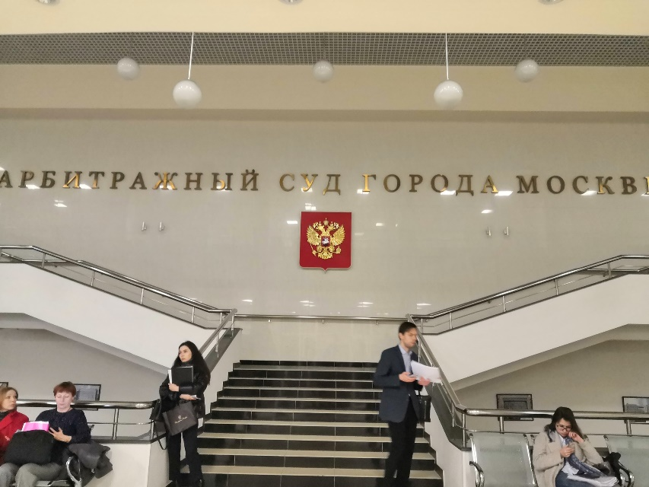

Monday – 16
Please pray for FEBC-Russia’s efforts to reach Muslim populations in Russia and in surrounding countries. This year we are planning to reach at least 15 thousand Muslims with the message of the Gospel.

Tuesday – 17
Gennady was serving a life sentence after committing two murders when he heard Victor Kurilenko on the radio and called the studio (he was allowed a radio and a phone).
“As I listened to the show, he felt warmth, openness, humor, and life—I realized that even I still had hope.”
He still calls Victor from time to time and continues reading his Bible and praying. Please pray for Gennady and thank God for reaching out to people in hopeless situations and giving them life.

Wednesday – 18
Elena from Russia was having a crisis of faith. She wrote in to the host of the program Immersion and they talked. Later she sent us this update.
“On Sunday I went to a church service; I spent a long time on the internet choosing it. After the service I approached the pastor, and he spent an hour and a half talking and praying with me. He spoke with such love and patience that I finally understood how close God was to me. All my questions and doubts were a test of my faith.
Please pray for Elena and all those who are struggling with their faith or may have even stepped away from it. Pray that they too experience God’s love and return to their father.

Thursday – 19
Please pray for Oleg Cherny, FEBC’s administrative and technical director of FEBC-Russia. Oleg has multiple responsibilities and is also helping the ministry in Ukraine and Central Asia.

Friday – 20
Victor from St. Petersburg, Russia had been an alcoholic for a long time. He grew up with his grandmother after his mother committed suicide when he was a child. After his grandmother died he went completely off the deep end. They brought his to our follow-up worker in a bad state. They went to a church service together, and he was taken to a rehab center afterwards. He slept for nearly 2 weeks after arriving. Please pray that he finishes the rehab and comes to see the people waiting for him in church.

Saturday – 21
Alena from Krasnoyarsk, Russia wrote in:
“I was on the verge of depression. I couldn’t have children, my husband left, things were hard at work—I was hopeless. I didn’t want to live anymore. One woman talked about her terrible situation, how she was diagnosed with stage 4 cancer. The way you supported her—you gave her practical recommendations, and then you suggested that everyone who believes in God pray for her right in the broadcast. I began to pray for her with you. I had never prayed before, I wasn’t even a believer. Now, after having prayed, I feel like a believer.”
Please pray for all of our listeners who are taking their first steps in the faith.

Sunday – 22
Please pray for Ulanbek, FEBC’s leader in Central Asia. Pray for wisdom, and also his family, especially for his wife, Assyl’s, health.

Monday – 23
After the Ukranian UIA flight was shot down in Tehran, we made a video asking for prayer for the families of the victims. Christa from Lviv, Ukraine wrote in to express her condolences and share her own experience. “My grandmother died. My life has stopped. The pain is unbearable.” Please pray for listeners like Christa and the families of the UIA flight victims, who have experienced tragedy in their lives. May God comfort their hearts.

Tuesday – 24
Please pray for the opportunity to open FEBC’s station in the Ukrainian city of Kremenchuk. Pray that God will provide the needed recourses for the station.

Wednesday – 25
Please pray for FEBC-Eurasia counselors, who work with listeners who respond to our programs. Especially pray for Vlad, Viktor, and Yulia. Please pray that the Holy Spirit will make changes in the lives of listeners.

Thursday – 26
Alexandra serves in a youth ministry and is making preparations for a new class on how to talk with young people about real and difficult topics. She noticed that churches are afraid to bring up difficult subjects with young people, leaving them to fend for themselves during these times when they need the most help and support. Please pray for Alexandra and for the youth she is trying to reach. That God will use her ministry and her course to help many people grow in confidence and ability when talking to young people in Russia and Ukraine.

Friday – 27
Evangelist Vlad recently met with a man named Daria after agreeing to pass on a New Testament and connected him with a youth group from a church. Please pray that people who are seeking answers turn to God.

Saturday – 28
Please pray for FEBC ministry in Buryat Republic (part of Russia). Pray that God will change hearts of many Buryat people; many of them practice shamanism.

Sunday – 29
A mother reached out to our evangelist Vladislav when her son, Nikolai, was in intensive care after overdosing on methadone. He started using drugs because he couldn’t cope with what he had to see in his job in the Ministry of Emergencies. He did not want to acknowledge he had a problem for a long time, but agreed to go to a rehab center after talking to Vlad. Please pray for our listeners who are addicted. May God show them the way out of their addictions.

Monday – 30
Please pray that we will be able to minister to millions who are worried about the Coronavirus in post-Soviet countries. We have special programs prepared for people who have fears and anxiety; Ukraine has already experienced riots because of these issues, and many Russians are in a state of panic.

Tuesday -- 31
Sergey, 27, from Kiev, Ukraine wrote in:
“I am married to a beautiful woman named Olga and we have a daughter named Julia. I try to be a good husband and father, but it’s not always easy. I am working 2 jobs to somehow make ends meet and don’t get to spend enough time with my family. And then Julia got sick and all of our money went towards her. Then I heard a Family Bible Hour program on this topic. I learned how to properly manage my finances and find time for my family. I also began to trust God to take care of us. Everything seems to be getting better now. I got a promotion and we got through our crisis. Thank you for the great advice!”
Please pray that listeners like Sergey may find freedom by trusting in God and following his principles.

