FEBRUARY

Saturday – 1
Please pray for FEBC’s programs for women to help many of them get out of difficult situation and find freedom in Christ. In particular, women’s alcoholism in Russia is becoming a serious problem.

Sunday – 2
Please uplift in prayer Evgeny Sarapulov, FEBC’s popular broadcaster, who’s reaching many teens for Christ. Pray that God will continue to use Eugene mightily. Also pray for his wife Svetlana, and especially for their four children.

Monday – 3
“Thank you for the warm meeting. I hope we meet again. Your determination and positivity are inspiring,” said a young man who went to a listener meetup with some hosts in Kiev.

Please pray for listeners who meet with our hosts and counselors and share their hearts. Pray for God to give wisdom to leaders, and the right words to bring them closer to God.
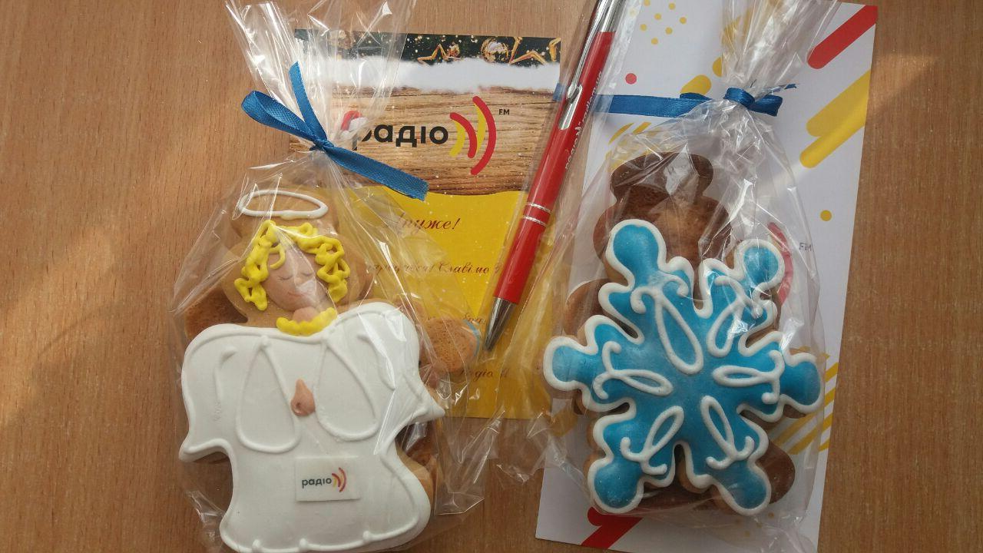

Tuesday – 4
Please pray for the leaders of FEBC-Eurasia: Rudi, Victor, Alexey, Eduard, and Ulanbek. Pray for wisdom, health, and God’s protection on their families.

Wednesday – 5
Fedor from Kuban, Russia, wrote in with a question about the Bible. “What can such an ancient book have to say to modern man?” The host Igor Popov responded and they have stayed in contact. They continue to talk about spiritual issues today.

Please pray for Fedor and for all listeners who do not know how essential God is to their lives.

Thursday – 6
Pray for FEBC listener Anna, who stopped going to church and became disillusioned with Christianity. Pray for Anna and other like her to come back to the church and continue to follow Christ.

Friday – 7
Please pray for the success of the two new projects that were recently launched, led by the military chaplain Igor Bad. Igor has a deep faith and can convey Christian truths simply and understandably to an unchurched audience. Please pray that as many people as possible can hear the Good News.

Saturday – 8
The final details are being worked out for the acquisition of a new building in Kiev that will function as our Evangelism Center. Please pray that everything goes according to God’s will. This is an important and key moment for the entire ministry in Ukraine.
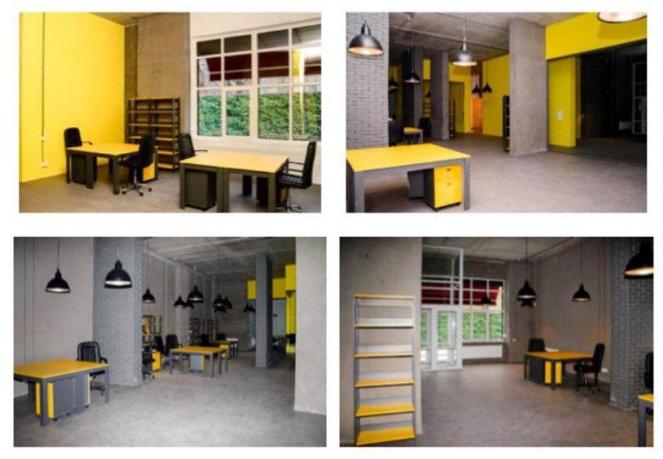

Sunday – 9
Alexandra from St. Petersburg knew almost nothing about God when she started talking with the host Vladislav. Now, after talking with him both online and in person, she is attending a church and is in community with other young people. Please pray that all listeners come to a living faith in Jesus Christ.

Monday – 10
Please pray for FEBC’s efforts to provide helpful tools for the Christ-centered churches to be more evangelistically-minded. FEBC exists to assist the Church in Russia and Ukraine and, specifically, to help it grow.

Tuesday – 11
Alexei from St. Petersburg wrote to host and evangelist Vlad Yurtov. He knew little about Christianity, but said he believed in God and in doing good to others. They eventually met in person and Vlad preached the gospel to him and gave him a New Testament. Alexei almost cried when the host told him that Jesus died for every sinner.

Today Alexei is eager to go to church, to a homegroup—anywhere, as long as he can grow as a Christian. Please pray for our evangelists and that God touches our listeners hearts, both online and in person.

Wednesday – 12
Natalia wrote in for advice about her sister.

“My sister is always angry and seems to hate everyone. She lost her entire family: her children and her husband. There’s nothing worse than burying your children and having to go on living!”
Please pray for Natalia and her sister, and all our listeners who are experiencing tragedy in these turbulent times. May the Lord comfort their hearts.

Thursday – 13
Please pray for our broadcasters in Ukraine. They recently had a seminar in Kiev with broadcasters from Russia and Central Asia, sharing techniques and ideas. Pray that God uses this partnership and help to make the broadcasts even more effective and spreading the Good News.
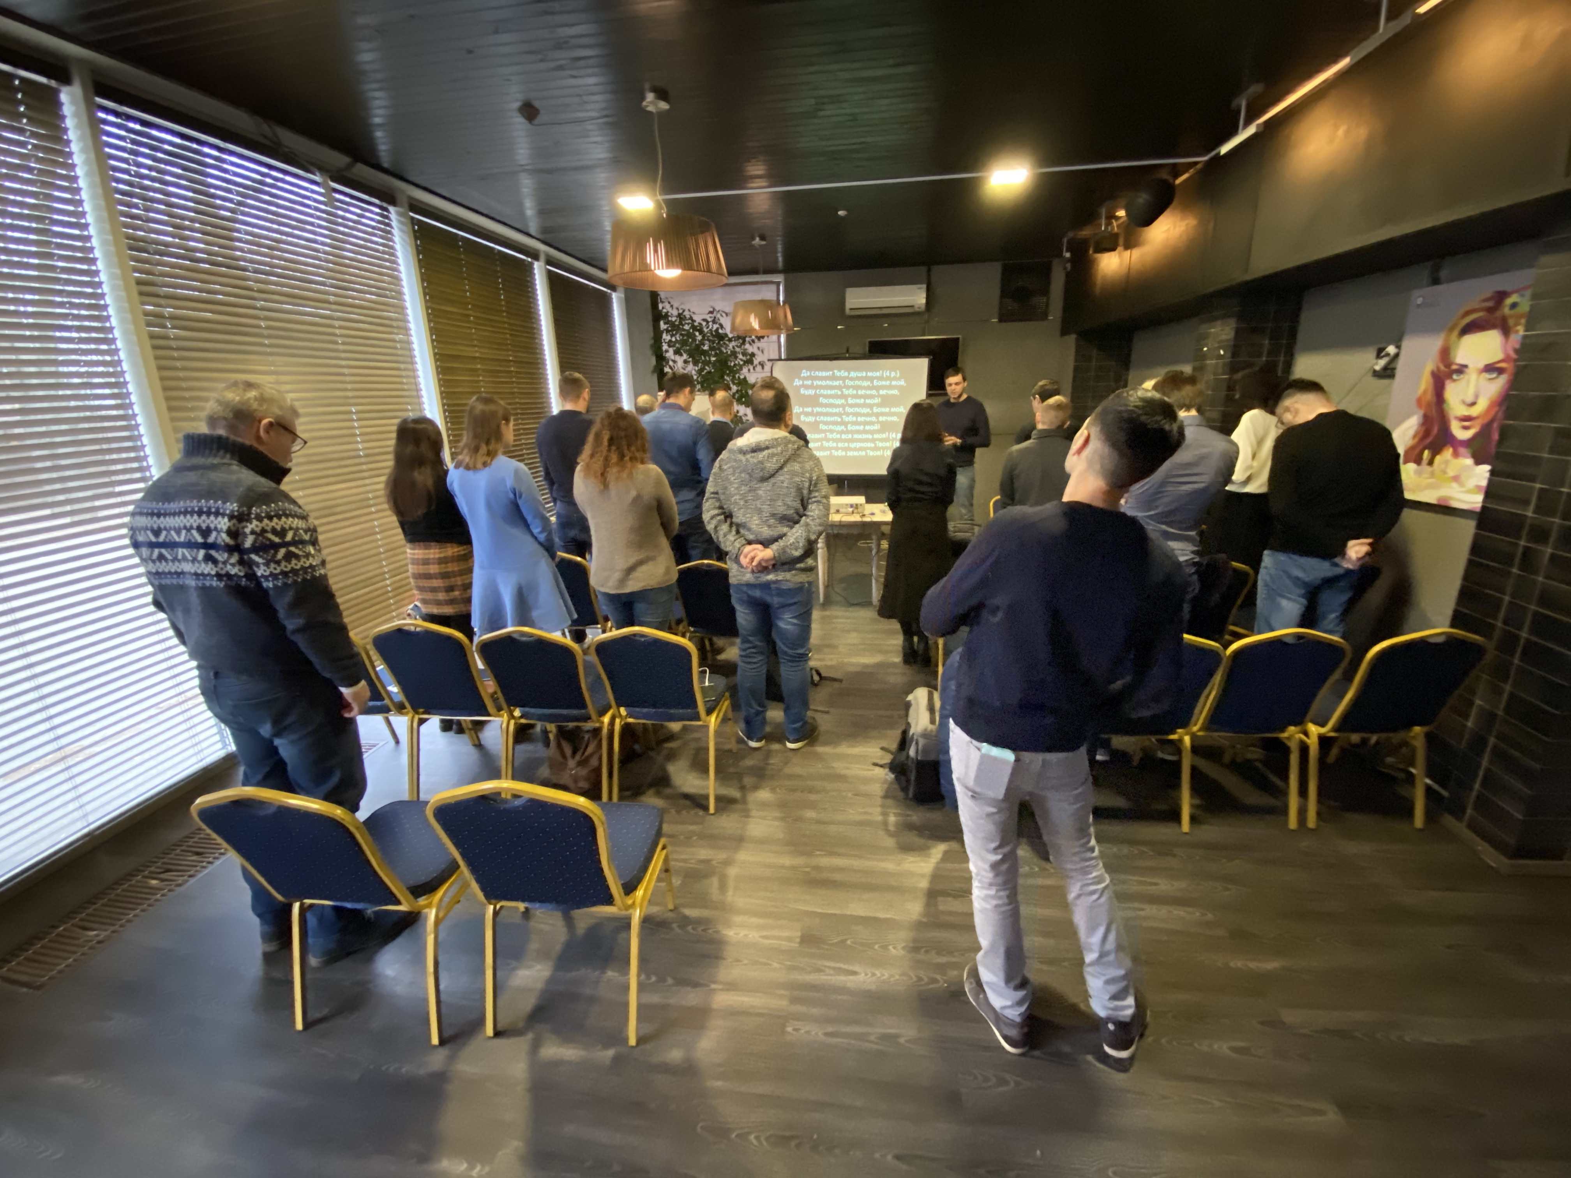

Friday – 14
Please keep the youth in Russia and Ukraine in your prayers. Though some identify as Orthodox, most have never heard the gospel and rarely if ever go to church. Pray that God brings this next generation to a knowledge of himself.

Saturday – 15
One listener wrote in suffering from severe anxiety. He was unable to make decisions and could not concentrate or relax. After talking with a consultant for 2 hours, his mind had cleared and his head ceased to hurt; he now had hope, perspective, and understood what he had to do.

Please pray for listeners who are lost without the light and clarity that only comes from God’s truth. Pray for those who turn to our consultants for help with their troubles, that they may be open to hearing the Good News.

Sunday – 16
“Thank you for your program Epigraph. I’m just starting to get interested in matters of faith and religion and you answered many of my questions. There were many references in classic literature that I had never understood, and you showed me that many of them pointed to the Bible. I am no longer afraid that the Bible is just some ancient book beyond my understanding.”

- Artem, from Kuznetsk, Russia

We have continued communicating with Artem and praying for him. Please pray for Artem and for all listeners who are taking their first steps in the faith.

Monday – 17
Please pray for key radio programmers in Russia: Alexey, Oleg, Igor, Elvira, Eugene, Vlad, and Yuri. Pray for God’s blessing on their ministry.
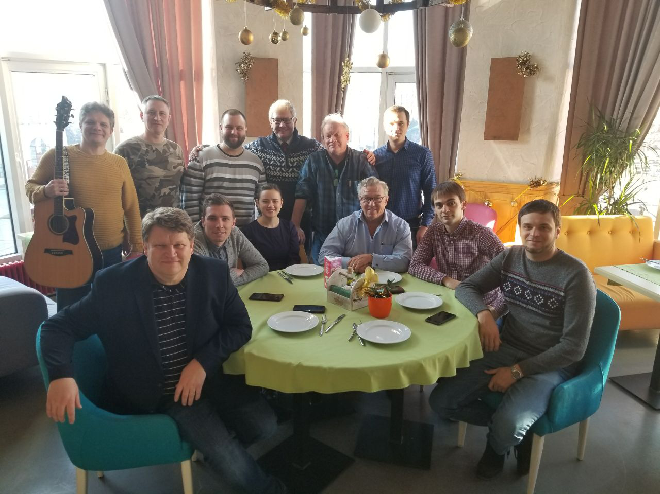

Tuesday – 18
Please pray for Ukraine as it works to protect and establish family values as the Ukrainian family is seriously suffering. The Ukrainian parliament has announced the creation of the largest inter-factional association on “Values, Dignity, Family,” aiming to protect family values.

Wednesday – 19
Svetlana shared her story with the host of Excellent Family, our program on adoption:

“Your program was such a help as we went on this journey. You took us from a place of frightened interest to actually becoming a foster family and waiting for our first child!

“We were able to listen to the different specialists you had on the program, and you discussed many of the problems that foster families can face and what the solutions were. This gave us courage and made us feel more confident.

“The programs where you had foster kids themselves on were especially helpful. Thank you very much, all of you! Your program is a wonderful help and support.”

Please pray for families like Svetlana’s, who have made the incredible decision to adopt or foster.

Thursday – 20
Please pray for Dr. Victor Akhterov, as he is continually developing leadership teams in Russia and Ukraine. Pray as he and his team are working together to adjust our strategic plans to connect more listeners in that part of the world to local churches.
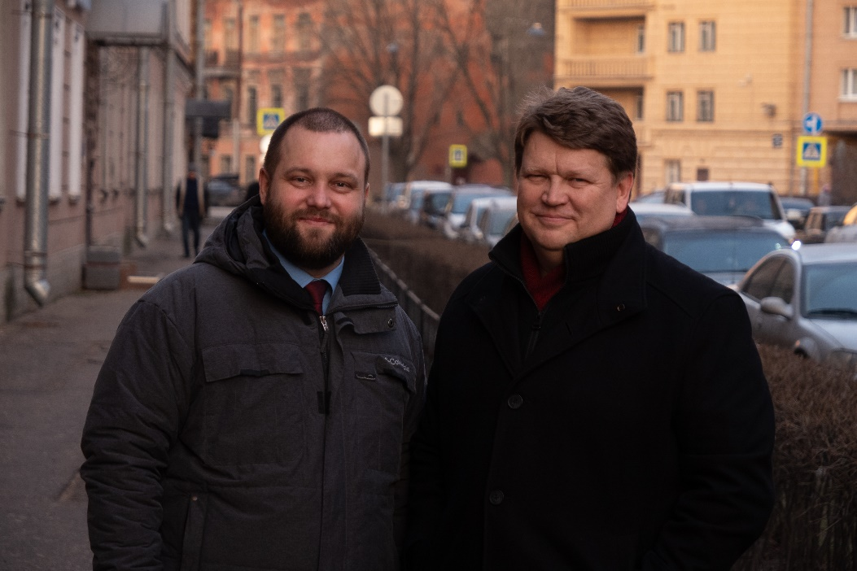

Friday – 21
Please pray for FEBC’s ministry in Buryat Republic. We need to take the ministry to the Buryat people to a new level. Many of them are Buddhists, while others are living in the darkness of shamanism.

Saturday – 22
Please pray for our servicemen in eastern Ukraine. Pray that their hearts are open to the preaching of the gospel in these difficult circumstances. Our FM stations cover the area and chaplains work visit and work there regularly. A publisher who was a guest on one of our programs recently donated some books.
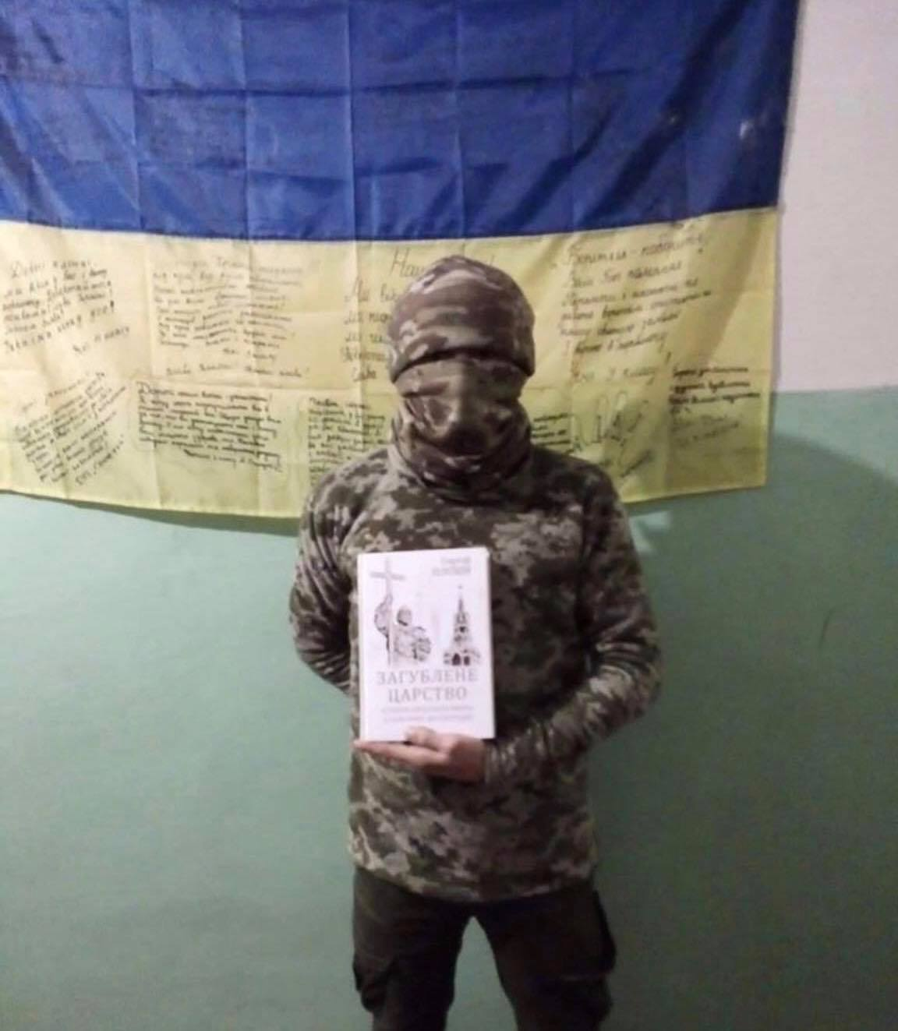

Sunday – 23
Please pray for FEBC’s efforts to reach many Muslims in Russia, where 20 million of them reside. While we do not publicize our efforts widely, we are doing a lot to bring the Good News to the Muslims of Russia.

Monday – 24
Please pray for Irina, an FEBC listener in Slavyansk, Eastern Ukraine. Irina is a history teacher, who lived through many difficulties in her life. Pray that God will help her open her heart to the love and grace of God.

Tuesday – 25
Please pray for our technical support teams in Ukraine and Russia. A meeting of the technical staff of the two countries recently took place and brought a lot of fresh ideas. Pray for the effectiveness and cooperation of our staff who live in different cities and countries

Wednesday – 26
Sveta from Khabarovsk wrote to Eugene, the host of the program Good Day:

“I found your program by accident, but it was the perfect timing. I was on the verge of collapse; I was so depressed. When I watched your broadcast, I felt lighter. I was able to cry and even pray, which surprised me! I saw that I was not alone. That I was in this with everyone and with God. I can’t believe it, you have actually led me to believe in God!”

Please pray that more listeners are able to open their hearts to the Lord.

Thursday – 27
“It’s painful. I don’t even have hope. I just want to sleep all the time. This stress is to much to handle. I can’t imagine what my future will be like, I can’t go on like this.”

Olesya, from Moscow, is a single mom raising a son with special needs. She tuned in to the program Nothing Special and talked with the host.

“But for some reason I felt better when you told me about your faith in God. How it helped you when you were afraid or felt insecure.”

Please pray for Olesya and her son as our broadcasters and experienced follow-up counselors continue to communicate with her. Pray that God comforts all who are overwhelmed and heavy laden.

Friday – 28
Please pray for FEBC listeners in Belarus. Pray for FEBC’s efforts to build a stronger connection with churches in Belarus, so we can direct more listeners to those churches. At the present, we don’t have any staff in Belarus, a nation of 10 million people.
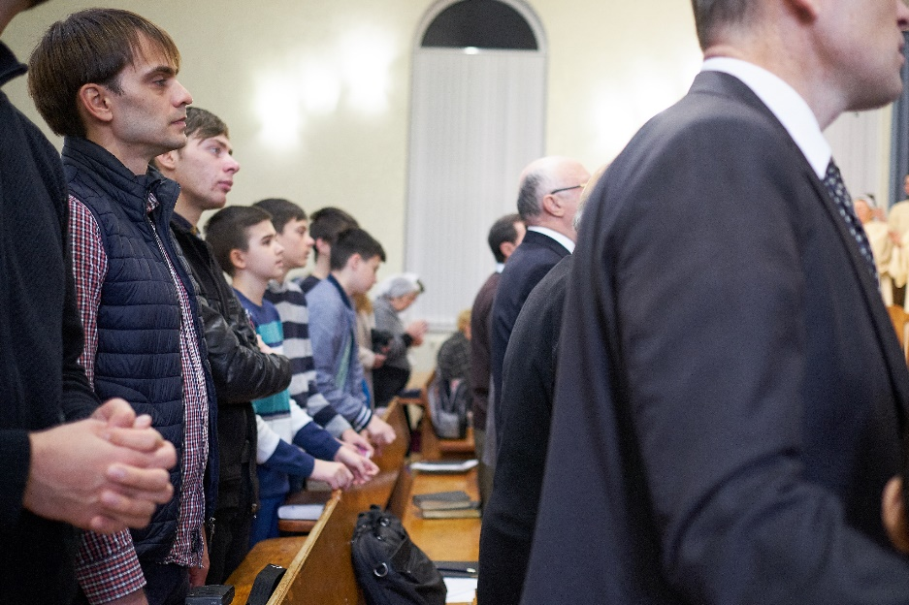

Saturday – 29
“You are a great resource and help for me; I can always write in with a question. And thank you for introducing me to a member of a nearby church. We are even planning to put on a program for the people in the nursing home where I work.

- Lena, from Podolsk, Russia

Please pray for Lena, who is sharing the Good News with those around her. Pray that God raises up many more like her through FEBC to reach out to the lost.

