FEBC-Ukraine Prayer Needs

Saturday – 1
Please pray for FEBC-Moldova’s ministry to the youth of Moldova. We are meeting with them weekly, studying the bible together and learning, and helping them through serious personal issues—some have parents who are alcoholics, some are orphans, some have parents who are working out of the country. Please pray for this ministry, and for the young people of Moldova who desperately need the Good News.

Sunday – 2
Please pray for Olya, who is helping lead FEBC-Moldova’s prayer helpline. In addition to helping manage the team, she spends a great deal of time counseling our listeners, praying with them and leading many to Christ. She is especially effective at working with the young people of Moldova. Please pray for God’s strength and wisdom as she does this important work.

Monday – 3
Please pray for the political situation in Moldova. They recently had elections, in which the pro-Russia party lost, and is now trying to cause unrest in the country. Please pray for peace and protection for Moldova as it faces this pressure from Russia.

Tuesday – 4
Please pray for Andrey, FEBC-Moldova’s popular vlogger. He reaches a great number of people with the message of the Gospel, including many Muslims. Please pray for the Lord’s peace, strength, and guidance as he goes through a difficult time.

Wednesday – 5
Please pray for the young audience of FEBC-Moldova’s children’s content from Muslim countries. Recently, a large part of our audience has been coming from post-Soviet Muslim countries. Please pray for their hearts and the hearts of their family to be open to the Gospel through these programs.

Thursday – 6
During one of our in-person meetings for Project Embrace, a woman who was strongly antagonistic to God came to our meeting with her son. Her son, a soldier, was a Christian and brought his mother to our meeting while on a 10-day leave from the military. From the beginning, it was clear that she did not want to be there, sitting silently with her arms crossed. But as the meeting continued, she began to change. At the end of the meeting, she prayed the prayer of repentance. Please pray for everyone who takes part in our projects — online or offline. That each one would sincerely accept God into their heart and follow Him.
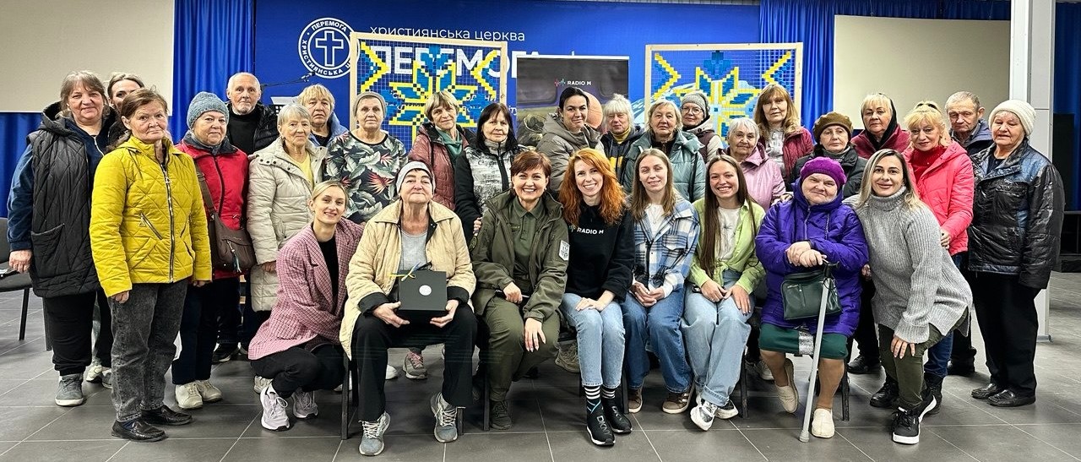

Friday – 7
“I felt a deep lack in my heart,” said Aisulu, a listener from Kazakhstan. “It was infecting every part of my life. Nothing felt fulfilling anymore. I was looking for anything that might help me. That’s when I found you. The way you talked, I could sense that there was something different about you. I started to see how beautiful Jesus was. When I heard about how God works in His people’s lives, it made me want to believe.” Aisulu gave her life to Jesus after coming to church with one of FEBC-Kazakhstan’s broadcasters. Please pray for her spiritual walk as she begins her relationship with Christ.

Saturday – 8
Please pray for listeners like Lyuba from Ukraine, who is going through treatment for cancer. “Some days, I just feel so weak, so hopeless. I have been praying some traditional prayers I found in a book, but I’m not sure if God hears me.” We shared the Gospel with Lyuba and prayed with her, where she put her faith in Jesus. “I feel so much lighter. Thank you!”

Sunday – 9
Every Saturday, FEBC-Kazakhstan’s young team hosts gatherings for young people who don’t yet believe in Christ. We invite neighbors, coworkers, friends, classmates, relatives, and anyone who has heard about Jesus through our projects. We focus on creating a space where they can experience God’s love through our kindness, words, and actions. Please pray for our team—that the Lord would give us wisdom, strength, and love to help lead even more people to Him.

Monday – 10
Please pray for those in Ukraine who have been unable to come home from the war. We are continuing to pray for the safe return of Denis, a relative of one of our broadcasters, who is still missing in action. And also for the brother of one of our helpline volunteers who is currently being held in Russian captivity. Please pray for them to return home to their families alive and unharmed.

Tuesday – 11
Please pray for the health of Umida, a former Muslim who came to know the Lord, and is now reaching the people of Uzbekistan with the Good News. Please pray for the Lord to bless her with good health and a strong immune system.

Wednesday – 12
Please continue to pray for all of the members of our team who are currently on the front lines. In recent months, two more of our staff members have been drafted— Oleksii Arutiunov, our designer, and Ruslan Shkuratov, our managing editor. Please pray for their safety and that God would use them wherever they are.
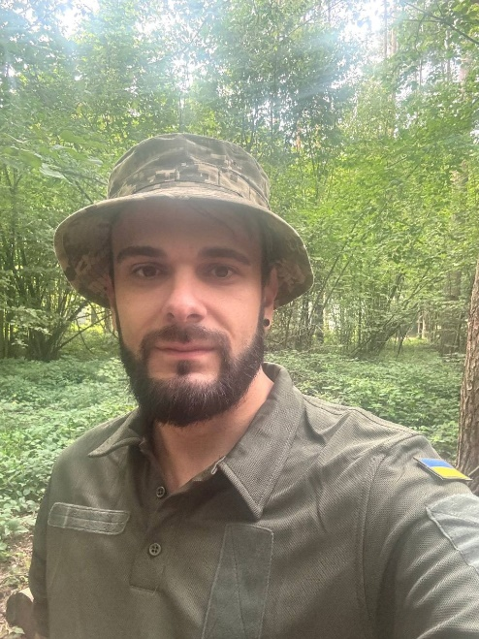
Thursday – 13
Please pray for FEBC’s follow-up team in Uzbekistan as they create programs for the Muslims in their country, interacting with them in the comments, and leading them to the Truth found only in Jesus Christ. Please pray for Kamila and her family’s housing situation, for Hayot as he interacts directly with Muslims and for his wife’s health as she is pregnant, and for Esther’s children to be led by the Lord and for their housing situation. This team is doing a great work for the Lord in difficult circumstances. May God bless them mightily.

Friday – 14
Please pray for those in the FEBC-Ukraine team who are stepping in to replace team members currently serving in the military. Right now, Varia is fulfilling the duties of managing editor, and Mariia has taken over the designer’s position. Please pray for wisdom for each person on our team, for our flexibility, and for our ability to adapt to constantly changing conditions.

Saturday – 15
A Kazakh teen named Arina was searching for God, for the true God, but she was scared of what she was finding. She wrote to us, saying, “I want to accept Christianity, but I’m scared. My parents, and everyone else around me, are against it. They say that I’m betraying my Kazakh identity. They yell at me and curse me.” We helped Arina find answers to her questions about the Trinity and the reliability of the Bible and shared the Gospel with her. Please pray for the Lord to help her find the true path, removing all fears and obstacles that are preventing her from knowing the Living God.

Sunday – 16
Please pray for the FEBC-Ukraine team to have electricity and heat this winter, both at home and in the studio, so that we can continue to share the Good News. Please pray that Ukraine’s critical infrastructure would not be damaged by Russian attacks.

Monday – 17
Please pray for young people in Kazakhstan who are growing curious about Christianity. “I visited a church after watching your videos,” said Asem. “Then I started reading the Bible, but the language was so old…it made no sense to me. Anyways, why bother reading a book that was changed by man? Just tell me, why you are a Christian.” After our conversation, Asem decided that she would try reading the Bible again. Please pray for the Holy Spirit to lead Asem to a relationship with Christ.

Tuesday – 18
Please join us in continuing to pray for a swift and just peace in Ukraine. That every soldier would return home alive and unharmed. That children would be able to study outside of bomb shelters. That all hospitals and educational institutions could operate in warmth and with electricity. And that everyone who is currently held in Russian captivity would return home to their families.

Wednesday – 19
Please pray for a trip FEBC Kazakhstan’s team is taking to Urzhar, a village in the east of the country. Many of the people in this village have heard the Gospel and want to learn more. Our team will be going to this village, sharing the Gospel and giving out Bibles. Please pray that the Lord blesses this trip, protects the team, and leads many in the village to Himself.

Thursday – 20
Please continue to pray for our prayer helpline. Our team receives a large number of messages and calls every day. Many people are experiencing loss, living in fear, battling depression, or struggling with suicidal thoughts. People are afraid of the uncertainty of what tomorrow will bring. Please pray for the team, and also for everyone who writes or calls — that they would come to know Jesus and find comfort in the Lord.

Friday – 21
Please pray for the leadership of FEBC’s team in Uzbekistan, including Umida and Sardor. May the Lord give them wisdom, guidance, help them continue to build relationships with local churches, and give them new and innovative ideas to reach the people of Uzbekistan with the Good News.

Saturday – 22
Project “Embrace” was created to bring hope and support to the families of military servicemen. Every week, Emma Sereda leads a radio program with a wide audience. We also hold live meetings where these families can find care and encouragement. Please pray for Emma, her husband Ihor, and their two daughters.
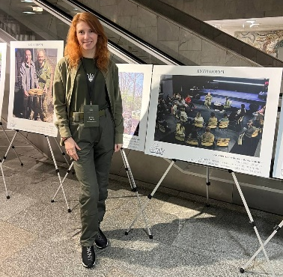
Sunday – 23
Please pray for young people like Yelena, who is taking care of her four-year-old brother with the help of her grandmother, while her mother is abroad and her father is travelling around the country. Many families in Ukraine are separated during this time of war, and young people are struggling. We prayed with Yelena, and she accepted Christ as her Lord and Savior. Please pray for the many young people like Yelena who are struggling in this difficult time.

Monday – 24
Please pray for FEBC-Eurasia’s listeners — on the radio and social media. Many of them write to us online with questions, meet with our hosts in person, and even visit our studio. Please pray that God would work in their hearts and that each of them are able to build a personal relationship with God.

Tuesday – 25
Please pray for FEBC-Russia’s leadership, Victor, Alexey, and Oleg, as they minister in the midst of great darkness. As they lead the team through these challenging times, with increasing government restrictions.

Wednesday – 26
Please pray for listeners like Olena, who serves in the infantry of the Armed Forces of Ukraine. She listens to our morning broadcasts every day. Some time ago, she wrote to us, asking if we could send her Bibles. She is now giving those Bibles out to her fellow soldiers and is sharing the Gospel with them. Please pray for her safety and for the Lord to lead many soldiers to faith in Christ through her testimony.

Thursday – 27
Please pray for FEBC-Russia’s broadcasters and follow-up team as they are reaching the Russian people with the Good News. Many Russians feel trapped, isolated, and are growing more and more fearful for the future. They are looking for hope somewhere, and they are not seeing it in the world around them. So many are coming to know the Lord through FEBC’s programs and conversations with the team.

Friday – 28
At a meeting for the wives of soldiers, a woman came with her young son. The boy was very troubled, arguing with everyone. His mother shared that when his father went off to war, her son’s behavior turned unbearable, and she no longer knew how to reach him. But through the consistent love and attention shown to this family during that meeting, something in him began to change. In time, he agreed to attend a church camp. There, for the first time, he opened up his heart to God. Today he acts completely differently, treating others with kindness and even praying. Thank you for helping bring healing, hope, and new beginnings to families who carry the heavy burden of war.
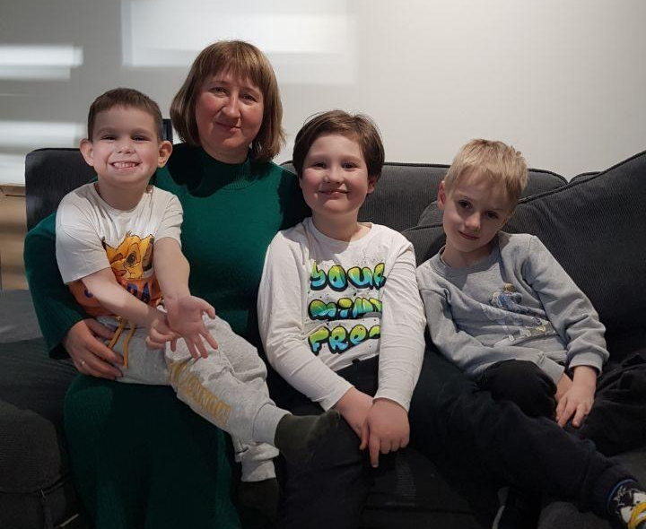

Saturday – 29
Please pray for FEBC-Kyrgyzstan’s family programs, which are popular among Muslims, who value family, but often do not know what healthy family life looks like. Abuse, physical and verbal, is common, and many listeners feel helpless. As they write in with personal questions, we are able to help them with their situations while introducing them to the Gospel. Please pray for our broadcasters and follow-up team as they have these careful conversations.

Sunday – 30
We are also planning to launch special in-person meetings in FEBC-Ukraine’s studio as part of the “Embrace” project. These meetings are for those who have lost a loved one during the war. Please pray that the Lord would touch each participant in a special way and that they would find comfort in the Heavenly Father.

